CREATED TABLE SHARES:

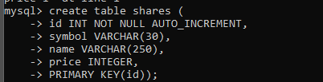

SHOW CREATE TABLE:

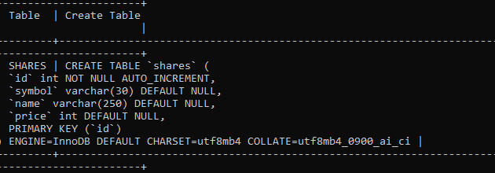

Virtual environment

λ .\venv\Scripts\activate.bat

set FLASK_APP=server

set FLASK_ENV=development

flask run

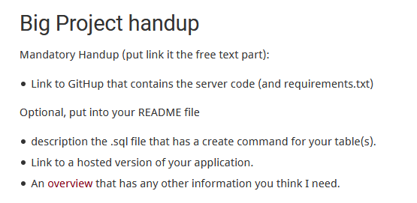

Pythonanywhere

Setting up your virtualenv

Open up a new Bash console from your [Dashboard](https://www.pythonanywhere.com/consoles) and run

mkvirtualenv --python=/usr/bin/python3.7 my-virtualenv *# use whichever python version you prefer*

pip install flask

workon my-virtualenv

pip freeze to see whats in there