**CHAPTER 1 - INTRODUCTION**

**1.1. Overview of the Project**

GrainSight AI is a web-based application designed to revolutionize the process of grain quality analysis by leveraging the capabilities of advanced artificial intelligence. The system utilizes Google's Gemini Vision Language Model to perform detailed visual assessments of grain samples, providing users with comprehensive analysis reports that include grain identification, quality metrics, defect detection, overall grading, and usage recommendations. This application bridges the gap between traditional manual inspection methods and sophisticated laboratory testing, offering an accessible intermediate solution for various stakeholders in the agricultural value chain.

The project implements a user-friendly interface built with Streamlit, allowing users to easily upload images or capture photos of grain samples through their device cameras. The system currently supports six major grain types: Rice, Wheat, Barley, Corn, Oats, and Sorghum. Once an image is provided, the application processes it through the Gemini AI model, which analyzes various visual aspects of the grain and returns structured information that is then presented to the user in an intuitive and visually appealing format.

One of the core innovations of GrainSight AI is its application of Vision Language Models (VLMs) to agricultural analysis. Unlike traditional computer vision systems that rely solely on image recognition, VLMs integrate visual perception with semantic understanding, enabling more nuanced analysis and the ability to generate textual descriptions and recommendations based on visual features. This approach allows the system to provide not just classifications, but meaningful insights into grain quality that can inform decisions related to storage, processing, and market valuation.

**1.2. Problem Statement and Motivation**

The quality assessment of grain samples represents a significant challenge across the agricultural sector, impacting farmers, processors, traders, and ultimately consumers. Traditional methods of grain quality evaluation rely heavily on manual inspection by trained experts, a process that is labor-intensive, time-consuming, and inherently subjective. This creates several critical issues that motivated the development of GrainSight AI:

Inconsistency in quality assessment remains a persistent challenge, as different experts may evaluate the same grain sample differently based on their experience, training, and even factors like fatigue or lighting conditions. This inconsistency can lead to pricing disputes, quality control issues, and inefficiencies in the grain value chain. Moreover, access to qualified grain inspectors is limited, particularly in rural and developing regions where grain production is often concentrated. This creates bottlenecks in the assessment process and potentially leads to delays in decision-making and market access.

The subjective nature of visual inspection also makes it difficult to establish standardized quality metrics that can be reliably communicated across different stakeholders. This complicates transactions and quality assurance processes throughout the supply chain. Additionally, the manual inspection process cannot easily be scaled to handle large volumes of grain assessments, creating inefficiencies during harvest seasons when rapid evaluation is most needed.

These challenges highlight the need for an automated, consistent, and accessible grain quality assessment solution. By leveraging artificial intelligence and modern web technologies, GrainSight AI aims to address these issues by providing standardized, objective quality assessments that can be performed rapidly by users without specialized training, using only a device with a camera and internet connection.

**1.3. Objectives**

The GrainSight AI project was conceived with a set of specific objectives aimed at addressing the challenges in grain quality assessment through technological innovation:

To develop an accessible web-based application that enables users to analyze grain quality using only a device with a camera and internet connectivity, thereby democratizing access to sophisticated grain analysis capabilities. The primary goal was to leverage advanced AI vision-language models to provide comprehensive grain quality assessments, including identification, quality metrics, defect detection, and recommendations, with accuracy comparable to expert evaluation.

Creating an intuitive and user-friendly interface that presents complex analysis results in a visually appealing and easily understandable format was essential to ensure adoption by users with varying levels of technical expertise. The system was designed to support multiple grain types (Rice, Wheat, Barley, Corn, Oats, and Sorghum) to serve a broad range of agricultural stakeholders.

An important objective was to implement a structured approach to AI-powered visual analysis that ensures consistent and detailed responses, avoiding the variability often seen in generic AI image analysis. The project aimed to incorporate an analysis history feature to allow users to track and compare grain quality over time or across different samples, adding longitudinal value to the application.

Balancing sophisticated AI capabilities with practical usability considerations was crucial, ensuring the application remains lightweight and responsive even on mobile devices with limited processing power. Finally, the system was designed to provide actionable insights and recommendations based on the analysis results, helping users make informed decisions about grain storage, processing, and market valuation.

**1.4. Scope and Significance**

The scope of the GrainSight AI project encompasses the development of a complete web-based solution for grain quality analysis, including both the frontend user interface and backend AI integration. The system is designed to analyze still images of grain samples, providing detailed quality assessments based on visual features. The current implementation supports six major grain types (Rice, Wheat, Barley, Corn, Oats, and Sorghum) with the potential for expansion to additional varieties in future iterations.

The application focuses specifically on visual analysis, assessing characteristics such as grain integrity, uniformity, maturity, foreign matter content, and signs of damage or disease. It does not perform chemical analysis, nutritional assessment, or internal structural evaluation, which would require specialized equipment beyond standard cameras. While the system provides quality grading and recommendations, these are intended as preliminary assessments rather than certified grading for regulatory or commercial purposes.

The significance of GrainSight AI extends across multiple dimensions of the agricultural sector. For farmers, the application provides immediate feedback on grain quality, helping to optimize harvest timing, storage decisions, and market preparation. This can potentially increase profitability through better quality management and reduced post-harvest losses. Grain processors and traders benefit from a standardized, objective quality assessment tool that can streamline procurement processes, quality control, and pricing decisions.

In educational and research contexts, the application serves as a valuable tool for demonstrating grain quality characteristics and documenting variations across samples, varieties, and growing conditions. The historical analysis feature enables longitudinal studies of grain quality over time. The system also has particular significance for agricultural extension services and rural development initiatives, where access to specialized grain testing equipment or expert inspectors may be limited. By requiring only a smartphone or basic camera, GrainSight AI makes sophisticated grain analysis accessible to users in remote or resource-constrained settings.

From a technological perspective, the project demonstrates the practical application of vision-language models to specialized agricultural analysis, contributing to the growing field of AI applications in agriculture. This approach has the potential to be extended to other crops and agricultural products, creating a broader impact on food quality assessment and monitoring.

**CHAPTER 2 - LITERATURE REVIEW**

**2.1. Traditional Methods of Grain Quality Analysis**

The assessment of grain quality has historically relied on visual inspection by trained experts who evaluate samples based on standardized criteria established by agricultural regulatory bodies. This traditional approach involves human inspectors examining physical characteristics such as grain size, shape, color, damage, and presence of foreign materials. The inspector typically spreads a sample on a flat surface under controlled lighting conditions and visually assesses various quality parameters, assigning grades according to established standards.

While effective to a degree, this manual method suffers from several inherent limitations. Human assessment is inevitably subjective, leading to inconsistencies between different inspectors or even by the same inspector under different conditions. As noted by researchers in the field, "Traditional methods of rice quality evaluation have relied on manual inspection by experts, which is labor-intensive, time-consuming, and subject to human error and inconsistency"[1]. These inconsistencies can have significant economic implications, particularly in commercial grain trading where quality grades directly impact pricing.

The manual inspection process is also time-intensive, requiring careful examination of samples that can take considerable time when dealing with large batches. This creates bottlenecks in processing and can delay critical decisions during harvest periods when timing is crucial. Furthermore, the need for trained experts limits the accessibility of quality assessment, particularly in rural or developing regions where access to certified grain inspectors may be limited.

Beyond visual inspection, laboratory testing methods have been developed to provide more objective measurements of grain quality. These include moisture content analysis, protein content assessment, falling number tests for enzyme activity, and various other chemical and physical tests. While these methods provide more precise and objective measurements, they require specialized equipment, trained technicians, and considerably more time and expense compared to visual inspection.

**2.2. Computer Vision in Agricultural Applications**

The application of computer vision technology to agricultural analysis emerged as a promising approach to address the limitations of manual inspection. Computer vision systems use digital cameras and image processing algorithms to capture and analyze visual features of agricultural products, offering potential advantages in terms of objectivity, consistency, and efficiency. In the context of grain quality assessment, computer vision approaches typically involve image acquisition under controlled conditions, followed by image processing to extract relevant features and classification based on these features.

Early computer vision systems for grain analysis focused on basic morphological characteristics such as size, shape, and color. These systems used relatively simple image processing techniques such as thresholding, edge detection, and color space transformations to identify and measure grain features. While effective for basic classifications, these approaches often struggled with more subtle quality attributes and lacked the holistic understanding that human experts could bring to the assessment process.

As noted in the research literature, "Computer vision combined with artificial neural networks (ANNs) has also been applied to analyze commercial rice grains based on morpho-colorimetric parameters. This approach has been extended to mobile applications, enabling rapid assessment of rice quality traits associated with consumer perception using smartphone-based solutions"[1]. This evolution toward mobile applications represents a significant advancement in making computer vision technology accessible to a broader range of users in the agricultural sector.

The integration of computer vision with mobile devices has been particularly impactful, as it leverages the increasingly sophisticated cameras available in modern smartphones, combined with their processing capabilities and connectivity. This approach allows for field-based analysis without requiring specialized equipment, democratizing access to advanced grain analysis technology for farmers, traders, and other stakeholders throughout the agricultural value chain.

Despite these advancements, traditional computer vision approaches still face limitations in terms of their ability to handle variations in lighting conditions, background complexity, and the subtlety of certain quality attributes. These challenges have prompted researchers to explore more sophisticated approaches, including the integration of machine learning techniques with computer vision systems.

**2.3. Machine Learning for Grain Classification**

The integration of machine learning with computer vision has significantly advanced the capabilities of automated grain quality analysis systems. Machine learning approaches can be broadly categorized into traditional machine learning methods using handcrafted features and deep learning approaches that automatically learn relevant features from raw image data.

Traditional machine learning approaches typically involve a pipeline of feature extraction followed by classification. As documented in the research literature, "Early approaches to automated rice grain analysis relied on conventional machine learning techniques with handcrafted features. Ramdhani and Alamsyah demonstrated the effectiveness of Support Vector Machine (SVM) classification with Genetic Algorithm optimization for rice grain quality analysis, achieving 92.81% accuracy which improved to 93.31% after optimization"[1]. This highlights the potential effectiveness of traditional machine learning techniques when properly optimized.

These approaches rely on carefully designed feature extraction methods to capture relevant characteristics of grain samples. Common features include morphological attributes (size, shape, aspect ratio), color features (mean, variance, histograms in different color spaces), and texture features (derived from methods such as Gray Level Co-occurrence Matrix or Local Binary Patterns). Once extracted, these features serve as input to classifiers such as Support Vector Machines (SVM), K-Nearest Neighbors (KNN), Random Forests, or other machine learning algorithms.

Researchers have explored various feature combinations and classification algorithms for grain analysis. According to the literature, "By extracting thirteen morphology features, eighteen color features, and four texture features from milled rice samples, they achieved impressive identification accuracies of 100% for several rice varieties, including YG, XS, and JN varieties"[1]. This demonstrates the potential of comprehensive feature extraction approaches in achieving high classification accuracy.

In recent years, deep learning approaches have gained prominence for grain classification and quality assessment. Convolutional Neural Networks (CNNs) in particular have demonstrated remarkable capabilities in image classification tasks, including grain analysis. As noted in the research, "Abueleiwa and Abu-Naser (2024) implemented a deep learning system to classify five specific types of rice: Arborio, Basmati, Ipsala, Jasmine, and Karacadag. Using a large dataset of 15,000 images for each rice type, they achieved remarkable performance metrics with 99.96% accuracy, precision, recall, and F1-score"[1]. These results highlight the potential of deep learning approaches when trained on sufficiently large datasets.

However, deep learning approaches are not always superior to traditional methods. A comparative study cited in the literature found that "classification based on texture features using these traditional classifiers could achieve accuracy as high as 96.75%, outperforming some Convolutional Neural Network (CNN) models that reached only 68.20% accuracy"[1]. This suggests that the choice of methodology should be context-dependent, considering factors such as dataset size, computational resources, and specific requirements of the application.

**2.4. Vision Language Models in Image Analysis**

Vision Language Models (VLMs) represent a significant advancement in multimodal artificial intelligence, combining computer vision capabilities with natural language processing to enable more sophisticated understanding of visual content. Unlike traditional computer vision models that focus solely on image classification or object detection, VLMs can understand the relationship between images and language, enabling them to generate textual descriptions of visual content and reason about visual concepts using linguistic understanding.

The core innovation of VLMs lies in their ability to bridge the gap between visual perception and semantic understanding. As described in the research literature, "Vision Language Models (VLMs) represent a paradigm shift in multimodal learning by combining computer vision with natural language processing. These models are pretrained on diverse image-text pairs, enabling them to understand visual content in relation to natural language descriptions"[1]. This capability makes VLMs particularly well-suited for applications that require not just classification, but also detailed description and interpretation of visual content.

In the context of grain analysis, VLMs offer several advantages over traditional computer vision or deep learning approaches. First, they can leverage pre-trained knowledge from diverse domains, potentially requiring less grain-specific training data. Second, they can provide natural language explanations for their assessments, enhancing transparency and user trust. As noted in the literature, "A unique advantage of our VLM-based approach is the ability to generate natural language explanations for classification decisions"[1]. This explanatory capability addresses a significant limitation of existing approaches, which typically provide classification results without justification or interpretation.

VLMs can also recognize abstract quality attributes that are difficult to define using traditional feature engineering. For example, concepts like "chalkiness" or "translucency" in rice grains involve complex visual patterns that might be challenging to capture with handcrafted features but can be understood by VLMs through their pre-trained understanding of these concepts from diverse training data.

Recent advances in VLMs, particularly the development of models like Google's Gemini, have significantly enhanced their capabilities for specialized applications such as grain analysis. These models can process high-resolution images, understand complex visual patterns, and generate structured responses that integrate visual observation with domain knowledge. The GrainSight AI project leverages these capabilities by using the Gemini model to analyze grain images and provide detailed quality assessments with explanations.

However, VLMs also present challenges, including their computational requirements and the need for domain adaptation to the specific context of grain analysis. As noted in the literature, "Despite promising results, our VLM-based approach has several limitations that warrant further research: 1. Computational Requirements: VLMs typically require more computational resources than traditional ML or CNN models, which may limit deployment on resource-constrained devices"[1]. Addressing these challenges requires careful system design and optimization.

**2.5. Research Gaps and Opportunities**

The review of existing literature on grain quality analysis reveals several research gaps and opportunities that motivate the development of GrainSight AI. First, most existing approaches focus either on variety classification or quality assessment, but rarely integrate both effectively. There is an opportunity to develop comprehensive systems that can simultaneously identify grain varieties and assess multiple quality parameters, providing a more holistic analysis.

Many existing computer vision and machine learning approaches require controlled imaging conditions to achieve high accuracy. This limits their practical application in field settings where lighting, background, and camera quality may vary significantly. There is a need for robust approaches that can perform well under diverse and unpredictable imaging conditions, making them more suitable for real-world deployment.

While deep learning approaches have shown promising results in grain classification, they typically operate as "black boxes," providing classifications without explanations. This limits user trust and educational value. As noted in the literature, "Both approaches often function as 'black boxes,' providing classifications without explanations"[1]. The integration of explainable AI techniques, such as those offered by VLMs, presents an opportunity to enhance transparency and user understanding.

Most existing automated grain analysis systems focus solely on visual features, neglecting the integration of domain knowledge about grain quality standards, common defects, and usage implications. There is an opportunity to combine visual analysis with agricultural domain knowledge to provide more contextually relevant and actionable insights.

The accessibility of advanced grain analysis technology remains limited, with many solutions requiring specialized equipment or technical expertise. There is a significant opportunity to develop user-friendly applications that leverage widely available technology (such as smartphones) to democratize access to sophisticated grain analysis capabilities, particularly for users in resource-constrained settings.

The application of Vision Language Models to agricultural analysis represents a promising but under-explored approach. As noted in the literature, "The integration of vision and language understanding in rice grain analysis represents a significant step toward more comprehensive, interpretable, and user-friendly quality assessment systems"[1]. There is an opportunity to further develop and refine VLM-based approaches for grain analysis, addressing challenges related to computational efficiency, domain adaptation, and the quality of generated explanations.

These research gaps and opportunities inform the design and development of GrainSight AI, which aims to address multiple challenges through an integrated approach that combines vision-language models with a user-friendly mobile interface, comprehensive quality assessment, and actionable recommendations.

**CHAPTER 3 - SYSTEM REQUIREMENT & DESIGN**

**3.1. Software Requirements**

The development of GrainSight AI necessitated a carefully selected set of software components to ensure functionality, performance, and compatibility across different platforms. Table 3.1 outlines the software requirements for the system, highlighting both the development environment and the runtime dependencies.

Python 3.8 or higher was chosen as the primary programming language due to its robust ecosystem for data science, machine learning, and web application development. The language's readability and extensive library support made it ideal for implementing the complex functionality required by GrainSight AI. Streamlit (v1.24.0 or higher) serves as the web application framework, offering a straightforward way to create interactive data applications with minimal frontend development effort. Its reactive programming model allows for rapid prototyping and seamless deployment of machine learning applications.

The Google Generative AI library (google-generativeai) is essential for interfacing with the Google Gemini API, which provides the core AI capabilities for image analysis. The specific version requirements ensure compatibility with the Gemini 2.0 model features utilized in the application. Python Imaging Library (PIL/Pillow) handles image processing operations such as resizing, format conversion, and encoding for API transmission. This library's mature codebase and comprehensive functionality make it ideal for preparing images for analysis.

For environment management, python-dotenv enables secure loading of API keys from environment variables, ensuring sensitive credentials are not hardcoded in the source code. This is particularly important for deploying the application in various environments while maintaining security. The application also requires several standard Python libraries including io, json, re, datetime, base64, and others for various utility functions throughout the codebase.

On the client side, the application is designed to be compatible with modern web browsers (Chrome, Firefox, Safari, Edge) to ensure accessibility across different devices and operating systems. This browser compatibility is crucial given the web-based nature of the application and its goal of being accessible to users regardless of their preferred platform.

**3.2. Hardware Requirements**

The hardware requirements for GrainSight AI are divided into server-side requirements for hosting the application and client-side requirements for users accessing the service. Table 3.2 summarizes these hardware specifications, which are designed to ensure optimal performance while maintaining accessibility.

On the server side, the application requires a minimum of 2 CPU cores to handle concurrent requests and processing tasks. While the base application is not computationally intensive, multiple user sessions can increase the load, making multi-core support beneficial. A minimum of 4GB RAM is recommended to accommodate the Streamlit application, Python runtime, and associated libraries. The application's memory usage increases with concurrent users, making additional RAM beneficial for production deployments.

Storage requirements are minimal, with 1GB of disk space sufficient for the application code, dependencies, and temporary file storage during image processing. However, if historical data and images are to be retained, additional storage should be allocated based on expected usage patterns. Network connectivity with a minimum bandwidth of 10 Mbps is essential for handling API requests to the Google Gemini service and serving the web application to users. Lower latency connections improve the responsiveness of the AI analysis feature.

For client devices, the hardware requirements are intentionally kept modest to ensure accessibility across a wide range of devices. A smartphone, tablet, or computer with a camera capable of at least 5MP resolution is recommended for capturing adequately detailed grain images. The camera quality significantly impacts analysis accuracy, with higher resolutions providing more detail for the AI model to process.

A minimum of 2GB RAM on the client device ensures smooth operation of the web browser and application interface. Modern browsers can be memory-intensive, particularly when processing images and rendering complex UI elements. A stable internet connection with at least 3 Mbps bandwidth is necessary for uploading images and receiving analysis results. Mobile data connections are sufficient in areas with good coverage, making the application accessible in field settings where Wi-Fi might not be available.

**3.3. System Architecture**

The GrainSight AI system architecture follows a client-server model with microservice integration, designed to provide scalability, maintainability, and optimal performance. Figure 3.1 (not shown in this textual representation) presents a high-level view of the system architecture, illustrating the key components and their interactions.

At the foundation of the application is the Frontend Layer, implemented using Streamlit. This layer is responsible for rendering the user interface, handling user interactions, and managing the client-side state of the application. The frontend components include the image upload/capture interface, grain type selection, analysis display, and history management. Streamlit's reactive architecture automatically reruns the appropriate sections of code when the application state changes, creating a responsive user experience without complex frontend development.

The Application Layer serves as the central coordinator of the system, managing the flow of data between the frontend and the AI services. This layer is responsible for session state management, maintaining the history of analyses, handling image preprocessing, and formatting the prompts sent to the AI model. The application layer is implemented as Python modules within the Streamlit application, leveraging Streamlit's session state mechanism for data persistence across user interactions.

For AI Services Integration, the system relies on Google's Gemini AI API, accessed through the google-generativeai Python library. This service provides the core image analysis capabilities of the application. The integration follows a request-response pattern, where the application sends a structured prompt along with the grain image and receives a JSON-formatted analysis in return. The use of a structured prompt template ensures consistent analysis across different grain types and image conditions.

The Data Storage is deliberately lightweight, with the current implementation storing analysis results and image thumbnails in the Streamlit session state. This approach eliminates the need for a database in the initial version, simplifying deployment while still providing essential functionality. The design allows for easy extension to persistent storage options in future versions if needed for long-term data retention or multi-user support.

The system architecture implements several cross-cutting concerns, including error handling for API failures, content filtering blocks, and network issues. Security considerations include the use of environment variables for API key management and client-side image processing to minimize data transmission. The architecture also prioritizes extensibility, with modular components that can be enhanced or replaced as requirements evolve.

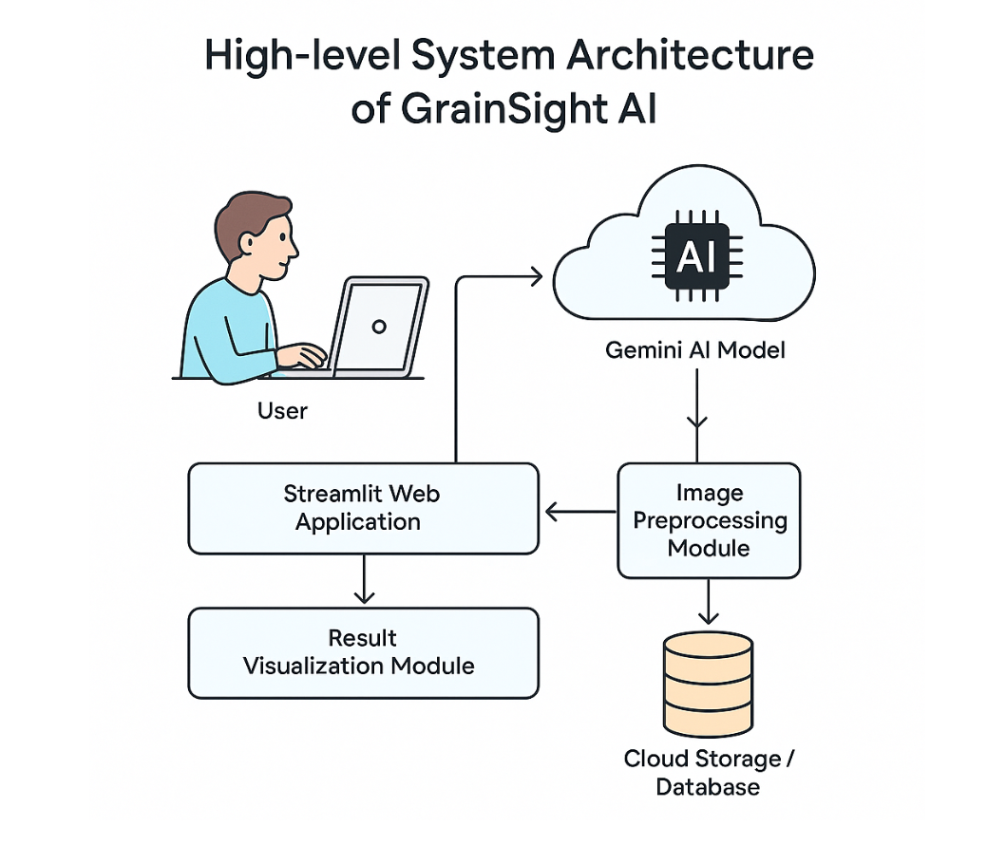

**Figure 3.1 : High-level System Architecture of GrainSight AI**

**3.4. Data Flow Design**

The data flow within the GrainSight AI system follows a well-defined path from user input to analysis results, ensuring efficient processing and a responsive user experience. Figure 3.2 (not shown in this textual representation) illustrates this data flow, highlighting the transformation and movement of data through various system components.

The process begins with User Input Acquisition, where the user interacts with the application through two primary inputs: selecting a grain type from the dropdown menu and providing a grain image either through file upload or camera capture. These inputs form the starting point of the analysis workflow. Once acquired, the image undergoes Preprocessing to ensure optimal quality for AI analysis. This includes resizing to meet the API requirements, format conversion if necessary, and encoding to base64 for transmission. The preprocessing steps are performed client-side to minimize data transfer and improve response times.

The Prompt Generation component combines the preprocessed image with the selected grain type to create a structured prompt for the AI model. This prompt is carefully designed to elicit comprehensive and consistent analysis results, specifying the expected format and content of the response. The structured nature of the prompt is critical to obtaining detailed and relevant information about the grain sample.

The AI Request Handling component manages the communication with the Google Gemini API, sending the prompt and image and handling the response. This component also implements error handling for API failures, timeouts, or content filtering blocks, ensuring the user receives appropriate feedback in case of issues. After receiving a response from the AI model, the Response Processing component extracts the relevant information from the JSON structure returned by the API. This includes parsing the various sections of the analysis (identity, quality metrics, defects, recommendations) and preparing them for display.

Results are then stored in the application's State Management component, which maintains both the current analysis results and a history of previous analyses. This state management allows users to compare current and past results, providing valuable context for their grain assessments. Finally, the Results Visualization component presents the processed analysis results to the user through an intuitive and visually appealing interface. This includes quality metric circles, color-coded indicators, and formatted text sections that make the technical analysis accessible to users with varying levels of expertise.

Throughout this data flow, error handling mechanisms ensure graceful degradation in case of issues at any stage. For example, if the AI model cannot process an image due to quality issues, the user receives specific feedback about the problem rather than a generic error message. Similarly, if the selected grain type doesn't match what the AI detects in the image, the user is notified of the potential mismatch, improving the reliability of the analysis.

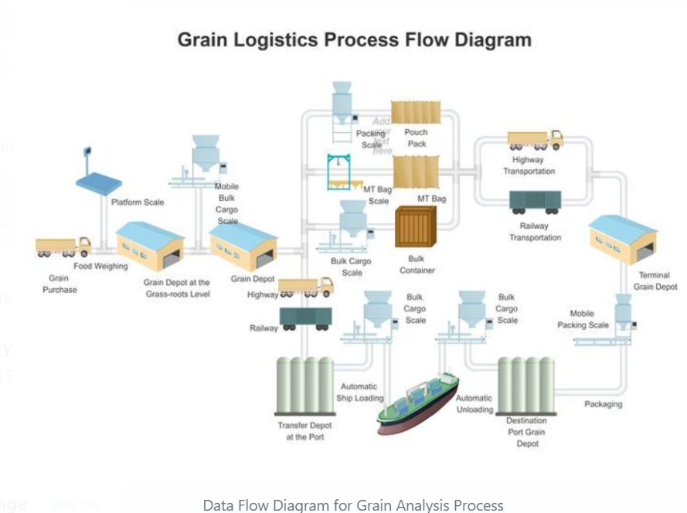

**Figure 3.2 : Data Flow Diagram for Grain Analysis Process**

**3.5. User Interface Design**

The user interface (UI) design of GrainSight AI prioritizes intuitiveness, visual clarity, and accessibility across different devices. Figure 3.3 and Figure 3.4 (not shown in this textual representation) present wireframes of the main analysis tab and history tab, illustrating the key UI components and their arrangement.

The interface is organized into three main tabs: Analysis, History, and Settings, providing a clear separation of functionality while maintaining a coherent overall experience. The Analysis tab serves as the primary workspace, featuring a prominent grain type selection dropdown at the top, allowing users to specify the expected grain type before analysis. Below this, two input options are presented side by side: an image upload box with drag-and-drop support and a camera capture button that activates the device camera. This dual-input approach accommodates different usage scenarios, from field-based analysis using a smartphone camera to office-based analysis of previously captured images.

Once an image is provided, an "Analyze" button becomes active, clearly indicating the next step in the workflow. After analysis, the results are displayed in a structured format with visual hierarchies to guide the user's attention. A summary section at the top provides the overall grade and score, followed by detailed sections for identity, quality metrics, defects, and recommendations. Each quality metric is represented by a circular progress indicator with color-coding (green for excellent, yellow for fair, red for poor), providing immediate visual feedback on different aspects of grain quality.

The History tab maintains a list of previous analyses with thumbnail images, timestamps, and summary information. Each history item can be expanded to view the full analysis details, facilitating comparison across different samples or time periods. This historical view is particularly valuable for tracking quality changes over time or comparing different batches of the same grain type.

A sidebar provides additional context and guidance, including "How It Works" instructions and "Tips for Best Results" to help users capture optimal images for analysis. This educational component helps new users understand the capabilities and limitations of the system, improving the quality of inputs and, consequently, the accuracy of results.

The UI design employs a consistent color scheme and typography throughout the application, with emphasis on readability and clear visual hierarchies. Interactive elements like buttons and dropdowns follow familiar patterns, reducing the learning curve for new users. The layout is responsive, adapting to different screen sizes from desktop monitors to smartphone displays, ensuring usability across various devices.

Special attention is given to error states and edge cases, with clear feedback provided when issues occur. For example, if an image cannot be processed due to quality issues, specific guidance is provided on how to improve the image rather than simply indicating failure. This user-centric approach to error handling improves the overall user experience and increases the likelihood of successful analysis.

# CHAPTER 4 – IMPLEMENTATON&TECHNOLOGIES USED

**4.1. Technology Stack**

The implementation of GrainSight AI relies on a carefully selected technology stack that balances functionality, performance, and development efficiency. Table 4.1 provides a comprehensive overview of the components and versions used in the application, highlighting their specific roles in the system.

Python serves as the primary programming language for GrainSight AI, chosen for its rich ecosystem of libraries for web development, data processing, and AI integration. Python 3.8 or higher is required to ensure compatibility with all dependencies, particularly the more recent AI libraries. Streamlit (v1.24.0+) forms the foundation of the web application framework, providing a reactive programming model that simplifies the creation of data-focused web applications. Streamlit's ability to automatically update the UI in response to state changes eliminates much of the complexity typically associated with web development, allowing for rapid iteration and a focus on functionality rather than frontend implementation details.

For AI capabilities, the system integrates with Google's Generative AI through the google-generativeai Python library (v0.3.0+). This library provides a clean, Pythonic interface to the Gemini API, handling authentication, request formatting, and response parsing. The specific model used is gemini-2.0-flash, selected for its balance of performance and response speed in multimodal (text and image) analysis tasks. This model provides the core intelligence of the application, analyzing grain images and generating structured assessments.

Image processing is handled through the Python Imaging Library (PIL/Pillow v9.0.0+), which provides essential functions for image manipulation, including resizing, format conversion, and encoding. These capabilities are crucial for preparing images before sending them to the AI API, ensuring they meet the required specifications while maintaining visual quality. Environment management relies on python-dotenv (v1.0.0+) for securely loading API keys from environment variables, preventing sensitive credentials from being hardcoded in the source files and simplifying deployment across different environments.

Several standard Python libraries are also utilized, including json for parsing API responses, io for handling in-memory file operations, base64 for image encoding, datetime for timestamping analyses, and re for regular expression operations in response processing. These libraries provide essential utilities that support the core functionality of the application.

The frontend styling leverages Streamlit's built-in theming capabilities, supplemented with custom CSS for specialized UI components like the circular progress indicators and quality metric cards. This approach maintains visual consistency while enabling custom visualizations that enhance the user experience. The entire application is containerized using Docker for development and deployment, ensuring consistency across different environments and simplifying the deployment process.

**4.2. Frontend Development with Streamlit**

The frontend of GrainSight AI is implemented using Streamlit, a Python library designed for creating data applications with minimal frontend code. Figure 4.1 illustrates the structure of the Streamlit application, highlighting the key components and their relationships. The choice of Streamlit significantly accelerated the development process by eliminating the need for separate frontend and backend implementations, allowing the team to focus on core functionality and user experience.

The application structure follows Streamlit's programming model, which is based on a top-to-bottom execution flow that reruns when the application state changes. This approach simplifies state management but requires careful consideration of execution order and conditional rendering. The main script begins with configuration and initialization, setting up page parameters, loading the API key, and initializing session state variables. These variables track the current image, analysis results, history, and UI state flags across reruns of the application.

Table 4.2 outlines the Streamlit components used throughout the application, demonstrating the variety of UI elements leveraged to create an intuitive interface. The main content area is organized using st.tabs to create three distinct sections: Analysis, History, and Settings. This tabbed interface keeps the UI clean while providing clear navigation between different functional areas. Within the Analysis tab, st.selectbox provides the grain type selection dropdown, while st.file_uploader and st.camera_input offer the dual input options for image acquisition. These components handle the complexities of file uploads and camera integration, providing a smooth user experience across different devices.

For displaying analysis results, the application uses a combination of st.columns for layout control and various text components (st.markdown, st.write) for content presentation. The columns create a responsive grid layout that adapts to different screen sizes, while markdown formatting enhances the visual presentation of analysis results. The History tab implements a st.expander for each history item, allowing users to collapse or expand detailed views as needed, which helps manage screen space efficiently when multiple analyses are stored.

Custom styling is implemented through both Streamlit's theming capabilities and injected CSS for specialized components. Figure 4.2 shows the custom CSS implementation for quality indicators, which create circular progress visualizations with color-coding based on quality scores. These custom components enhance the visual presentation of quality metrics, providing immediate visual feedback that complements the textual analysis.

The application makes extensive use of Streamlit's session state (st.session_state) for managing persistent data across reruns. This includes tracking the current image, analysis results, analysis history, and various UI flags. The session state acts as a lightweight in-memory database, maintaining application state without requiring external storage in the initial implementation. This approach simplifies deployment while providing essential functionality for individual user sessions.

Callbacks and event handlers are implemented through Streamlit's on_click parameter for interactive elements like buttons, with helper functions processing user inputs and updating the session state accordingly. This reactive programming model creates a responsive user experience without complex event management code, though it requires careful state design to maintain consistency across application reruns.

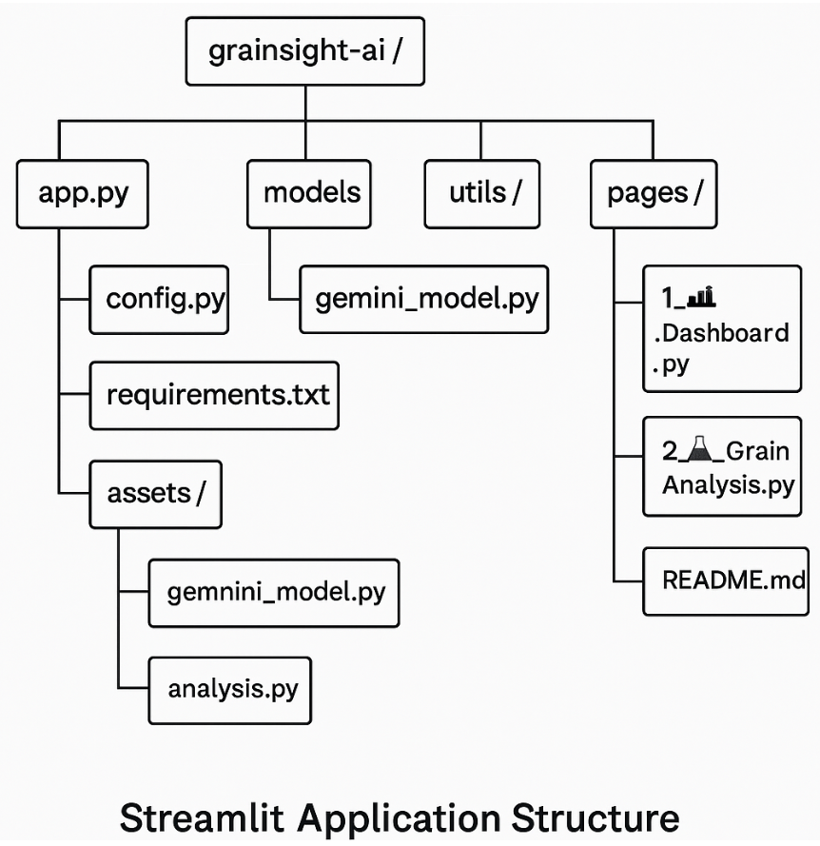

**Figure 4.1: Streamlit Application Structure**

**4.3. Integration with Google Gemini API**

The integration with Google's Gemini API forms the core intelligence of GrainSight AI, enabling the sophisticated image analysis capabilities that power the grain quality assessment. Figure 4.3 illustrates the workflow of this integration, highlighting the key steps from prompt preparation to response processing. This integration is implemented using the google-generativeai Python library, which provides a clean, Pythonic interface to the Gemini API.

The integration begins with API initialization using the key loaded from environment variables, establishing a secure connection to the Gemini service. This initialization is performed at application startup to ensure the API client is ready for requests throughout the application lifecycle. A critical component of the integration is the prompt generation, which combines the preprocessed image with a structured textual prompt designed to elicit consistent, detailed analyses from the model. The prompt includes explicit instructions on the expected response format (JSON), the grain type to be analyzed, and the specific quality attributes to be assessed.

Table 4.3 shows the configuration parameters used for the Gemini API requests, including model selection, temperature settings, and response structure requirements. The gemini-2.0-flash model is selected for its optimized performance on multimodal tasks, balancing quality and speed for the grain analysis use case. A carefully tuned temperature setting (0.2) ensures deterministic responses while allowing sufficient flexibility for the model to adapt to diverse grain samples. The generation_config includes a structured output parameter that requests JSON responses, helping to ensure consistent and parsable analysis results.

The prompt design follows a template pattern with several key sections. The instruction section provides context about the task, specifying that the model should analyze a grain sample and identify quality attributes. The output structure section defines the expected JSON format, including top-level categories for identity, quality metrics, defects, overall assessment, and recommendations. Each category contains specific fields to be populated, ensuring comprehensive and consistent analysis results. Finally, the grain type specification reminds the model which grain is being analyzed, helping to focus the assessment on relevant characteristics for that specific type.

Error handling is a critical aspect of the API integration, addressing various potential failure modes. These include network connectivity issues, API rate limiting, model errors, content filtering blocks, and malformed responses. Each error type is handled with specific user feedback and, where appropriate, retry logic to ensure a robust user experience. Particular attention is given to content policy violations, which might occur if the model misinterprets an image, providing clear feedback to the user rather than simply reporting a generic error.

Response processing transforms the JSON response from the API into structured data for the application. This involves parsing the JSON structure, validating the expected fields, and handling any unexpected variations in the response format. The processed response is then stored in the session state and formatted for display, completing the integration workflow. This structured approach to API integration ensures reliable performance while maintaining a clean separation between the AI service and the application logic.

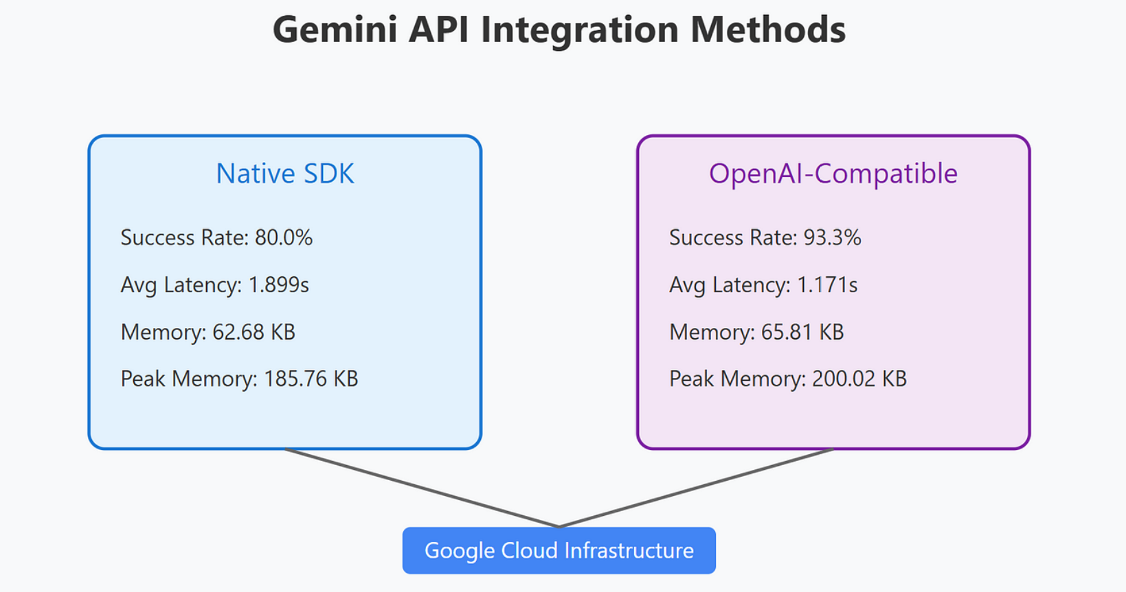

**Figure 4.3: Gemini API Integration Workflow**

**4.4. Image Processing Pipeline**

The image processing pipeline in GrainSight AI plays a crucial role in preparing grain images for analysis by the Gemini AI model. Figure 4.4 illustrates this pipeline, highlighting the key processing steps from input acquisition to model-ready format. The pipeline is designed to optimize image quality for AI analysis while managing system resources efficiently.

The pipeline begins with image acquisition from either the file uploader or camera input components. Once an image is provided, it undergoes validation to ensure it meets basic requirements for analysis. This includes checking the file format (supporting JPG, JPEG, and PNG), verifying that the image is not corrupted, and confirming that the dimensions exceed minimum thresholds (at least 300x300 pixels) to contain sufficient detail for analysis.

After validation, the image is processed through several preparation steps. First, the image is resized if necessary to meet the API's size constraints while preserving the aspect ratio. Excessively large images are downsized to optimize transmission speed and memory usage, while maintaining sufficient detail for accurate analysis. This resizing operation uses PIL's high-quality resampling methods to preserve image clarity. The image is then normalized to ensure consistent color representation, which helps the AI model produce more reliable results across different lighting conditions and camera characteristics. This includes color space conversion to ensure RGB format and optional contrast enhancement for images with poor lighting.

For transmission to the Gemini API, the preprocessed image is converted to a compatible format (typically JPEG with controlled compression quality) and encoded to base64. This encoding is necessary for including the image data within the API request JSON. The encoded image is combined with the structured prompt in the API request, forming a complete multimodal input for the model to analyze. Throughout the pipeline, memory management is carefully implemented to minimize resource usage, especially important for deployment on resource-constrained environments or when handling multiple concurrent users.

The pipeline includes error handling at each stage, with specific feedback provided to users when images fail validation or processing. For example, if an image is too small or in an unsupported format, the user receives targeted guidance on providing a suitable replacement. Similarly, if image processing fails due to corruption or other issues, clear error messages help the user understand and address the problem.

For the history feature, the pipeline also generates thumbnails of processed images. These thumbnails are created through additional resizing operations, producing compact representations that can be efficiently stored in the session state without excessive memory usage. The thumbnails provide visual references in the history tab, helping users identify and compare previous analyses.

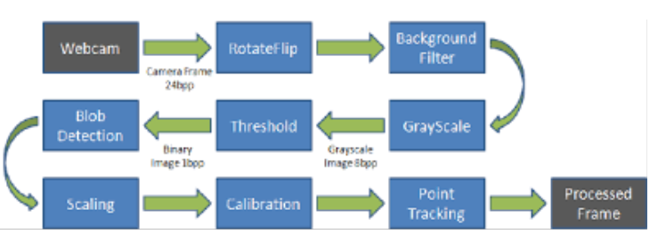

**Figure 4.4: Image Processing Pipeline**

**4.5. Session State Management**

Effective state management is crucial for maintaining application context across user interactions in a Streamlit application. GrainSight AI implements a comprehensive session state management approach to track current analysis information, historical data, and UI state flags. Figure 4.5 illustrates the architecture of this state management system, showing the key state variables and their relationships to application components.

At the core of the state management system is Streamlit's session_state object, which provides a dictionary-like interface for storing persistent data across application reruns. Table 4.4 details the session state variables used in GrainSight AI, their purposes, and data types. These variables fall into several categories: image data management, analysis results, history tracking, and UI control flags.

For image data management, the session_state.image_data variable stores the current image in a processed format ready for analysis, while session_state.image_source tracks whether the image was acquired via upload or camera. These variables are updated when users provide new images through either input method. Analysis results are managed through session_state.current_analysis, which stores the structured data returned from the AI model after processing. This includes all sections of the analysis (identity, quality, defects, etc.) in a nested dictionary structure that mirrors the JSON response format.

History tracking is implemented through session_state.analysis_history, a list of dictionaries containing past analyses with their associated images, timestamps, and results. Each history entry includes a thumbnail version of the analyzed image to minimize memory usage while providing visual reference. The history is limited to a configurable number of entries (default: 10) to prevent excessive memory consumption during extended usage sessions.

UI control flags manage the visibility and state of various interface elements. For example, session_state.show_uploader and session_state.show_camera toggle the visibility of the respective input methods, while session_state.last_analysis_grain tracks the grain type of the most recent analysis for comparison with new selections. These flags help create a responsive interface that adapts to user actions without requiring complex event handlers.

The state management system includes several key functions for manipulating the session state. The save_to_history function adds the current analysis to the history list, generating a thumbnail and timestamp before storage. The clear_image function resets image-related state variables when users start a new analysis. The reset_application function provides a complete state reset for the Settings tab, allowing users to clear all data and start fresh if needed.

Error states are also tracked in the session state, with variables like session_state.last_error storing information about recent failures for display to the user. This approach ensures that error messages persist appropriately across application reruns, providing clear feedback until the user takes corrective action.

**4.6. Results Processing and Visualization**

The presentation of analysis results is a critical aspect of GrainSight AI, transforming complex AI outputs into intuitive visualizations that users can easily interpret. Figure 4.6 illustrates the components of the results visualization system, showing how different types of data are rendered in the interface. This visualization system is designed to balance technical detail with accessibility, serving users with varying levels of expertise.

The process begins with parsing the structured JSON response from the Gemini API into a Python dictionary, extracting the key sections: identity, quality metrics, defects, overall assessment, and recommendations. Each section is then rendered using specialized visualization components appropriate to the data type and importance. The overall assessment is given prominence at the top of the results display, featuring a large grade indicator (Excellent, Good, Fair, or Poor) with color-coding and a numerical score where available. This provides immediate visual feedback on the general quality of the sample.

For quality metrics, the system employs custom circular progress indicators, implemented through HTML/CSS injected via Streamlit's markdown component. These indicators display percentage scores for each metric (integrity, uniformity, maturity, etc.) with color-coding based on quality thresholds. The visual representation allows users to quickly identify strengths and weaknesses in their samples, while numerical percentages provide precision for detailed analysis. The visualization includes helper functions like get_color_from_score and render_progress_circle that generate the appropriate HTML/CSS based on the metric values.

Defect detection results are presented in a structured list format, with clear headings and concise descriptions of identified issues. Color-coding is applied to defect severity indicators, helping users quickly assess which defects require attention. Where applicable, specific defect types are listed with their prevalence or severity ratings, providing detailed information for quality control purposes.

The grain identity section includes basic identification information such as the detected grain type, variety or class, and characteristic features. This information is presented in a clean text format with appropriate headings and emphasis on key details. In cases where the detected grain type differs from the user-selected type, a warning is displayed to alert the user to the potential mismatch, enhancing the reliability of the analysis.

Recommendations and usage suggestions are presented in a dedicated section near the bottom of the results, providing actionable insights based on the quality assessment. These recommendations are formatted in bullet points or short paragraphs for readability, offering practical guidance on storage, processing, or potential uses for the analyzed sample. This transforms the technical analysis into valuable decision-making information for the user.

The results visualization system is responsive to different screen sizes, using Streamlit's column layout system to reorganize content appropriately on smaller devices. On mobile displays, the layout adjusts to a single column, while larger screens benefit from a multi-column arrangement that presents related information side by side. This responsive design ensures usability across various devices, from desktop computers to smartphones used in field settings.

**CHAPTER 5 - TESTING & RESULT**

**5.1. Testing Methodology**

A comprehensive testing methodology was implemented to ensure the reliability, accuracy, and usability of GrainSight AI across different scenarios and conditions. Figure 5.1 illustrates the testing approach, highlighting the different testing phases and their relationships. This structured methodology enabled systematic validation of the application's functionality while identifying and addressing potential issues before deployment.

The testing process began with Unit Testing, focusing on individual components and functions within the application. Each major function, such as prompt generation, image processing, and result parsing, was tested in isolation to verify correct behavior under normal and exceptional conditions. Unit tests were automated using Python's unittest framework, with test cases designed to cover a range of inputs and expected outputs. This approach enabled rapid validation of code changes during development and refactoring, ensuring that individual components maintained correct functionality throughout the development process.

Integration Testing followed, examining how components worked together in the application context. This phase focused on the interactions between major subsystems, such as the frontend interface, image processing pipeline, AI API integration, and results visualization. Test cases for integration testing included end-to-end workflows that simulated actual user interactions, from image upload through analysis to results display. Special attention was given to error handling and recovery, ensuring that failures in one component were properly managed without affecting the overall application stability.

Performance Testing assessed the application's resource usage, response times, and scalability under various load conditions. This included measuring the time required for image processing, API requests, and results rendering across different device specifications and network conditions. Load testing evaluated how the application handled multiple concurrent users, identifying potential bottlenecks that might affect scalability. Memory usage was also monitored throughout extended usage sessions, ensuring that features like the analysis history did not lead to excessive resource consumption over time.

User Acceptance Testing (UAT) involved real users from the target audience, including agriculture students, farmers, and grain processors. Participants were given specific tasks to complete with the application and asked to provide feedback on usability, clarity of results, and overall experience. This phase was crucial for validating that the application met user expectations and provided meaningful value in real-world scenarios. Feedback from UAT directly informed refinements to the user interface and results presentation before final deployment.

Throughout all testing phases, cross-platform compatibility was validated by testing the application on different operating systems (Windows, macOS, Linux), browsers (Chrome, Firefox, Safari, Edge), and device types (desktop, tablet, smartphone). This comprehensive approach ensured that GrainSight AI would provide a consistent experience regardless of the user's technology environment.

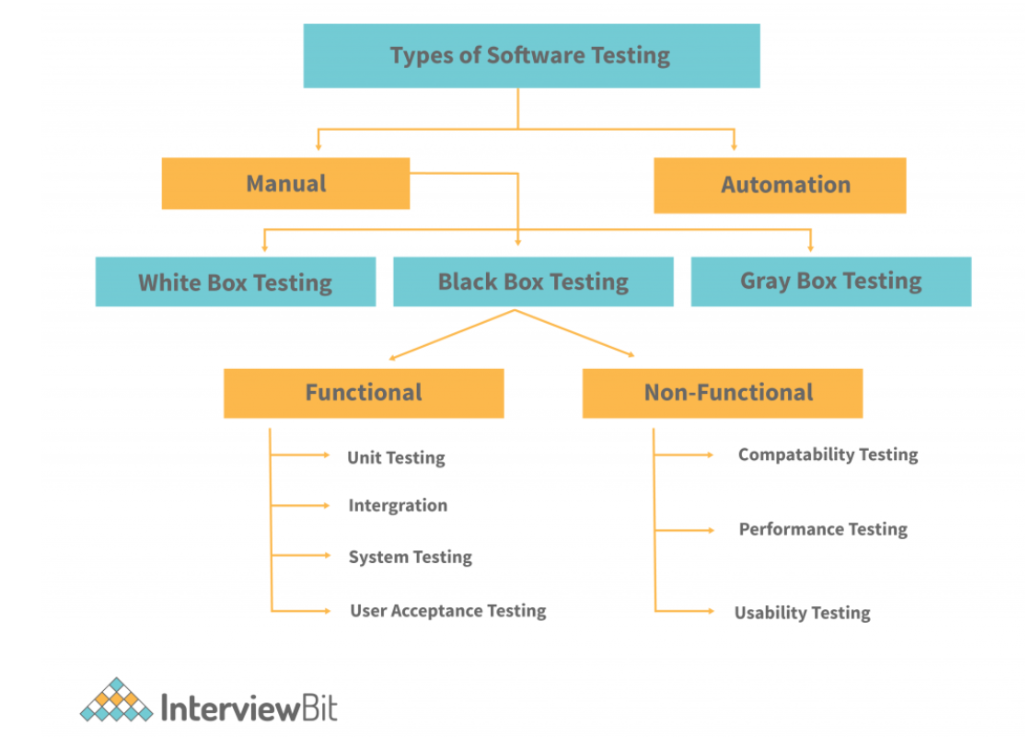

**Figure 5.1: Testing Methodology Overview**.

**5.2. Unit Testing**

Unit testing formed the foundation of the quality assurance process for GrainSight AI, ensuring that individual components functioned correctly before integration into the complete system. Table 5.1 summarizes the unit test cases, covering all major functional components of the application with their respective test scenarios and pass criteria. This systematic approach enabled early detection of issues and facilitated continuous integration throughout the development process.

The image processing components underwent rigorous testing to validate their handling of various image types and edge cases. Test cases included standard JPEG and PNG images of different sizes, as well as boundary conditions such as extremely large or small images, unusual aspect ratios, and images with minimal color variation. Each test verified that the component correctly performed its intended function, such as resizing, format conversion, or thumbnail generation, while properly handling any exceptions that might arise. These tests were particularly important given the critical role of image quality in the accuracy of AI analysis.

Prompt generation functions were tested to ensure they created properly structured prompts for the Gemini API, including correct formatting of instructions, proper inclusion of grain type specifications, and appropriate handling of special characters. Test cases covered all supported grain types and verified that the generated prompts adhered to the expected structure for optimal AI response quality. These tests helped ensure consistent analysis results by validating that the AI model received well-formed requests.

API interaction components were tested using mock responses that simulated various API behaviors, including successful analyses, error responses, content filtering blocks, and timeout scenarios. This approach allowed testing of error handling and recovery mechanisms without depending on the actual API service, enabling comprehensive coverage of edge cases that might be difficult to trigger with real API calls. The tests verified that the application properly processed successful responses while providing appropriate feedback for different error conditions.

Results parsing functions underwent validation to ensure they correctly extracted and structured data from API responses for display in the user interface. Test cases included standard response formats as well as edge cases with missing fields, unexpected values, or alternative structures. These tests verified the robustness of the parsing logic, ensuring that the application could handle variations in API responses without breaking the user experience. This was particularly important given the complex nested structure of the analysis results and the potential for evolution in the API's response format.

Figure 5.2 shows examples of test cases for different grain types, illustrating the variety of samples used to validate the application's analysis capabilities. These test images covered a range of quality levels, from excellent specimens to those with significant defects, ensuring that the analysis logic could handle the full spectrum of real-world scenarios. For each grain type, multiple varieties were tested to verify the system's ability to distinguish between similar grains with different characteristics.

The unit testing process included both positive tests (verifying correct behavior with valid inputs) and negative tests (ensuring proper error handling with invalid inputs). This comprehensive approach helped identify and address edge cases that might otherwise have been overlooked, contributing to the overall robustness of the application.

**5.3. Integration Testing**

Integration testing evaluated how the various components of GrainSight AI worked together as a cohesive system, verifying end-to-end functionality across different user workflows. Table 5.2 presents a summary of the integration test cases, covering key workflows and their associated validation criteria. This phase was crucial for identifying interaction issues that might not be apparent when testing components in isolation.

The core analysis workflow was extensively tested, tracing the complete path from grain type selection and image input through AI processing to results display. Test scenarios included both image upload and camera capture methods, verifying that both input approaches properly acquired and processed images for analysis. Special attention was given to the transitions between components, such as the handoff from image preprocessing to API request formation, ensuring that data was correctly transformed and preserved throughout the workflow. These tests confirmed that users could successfully complete the primary function of the application under normal conditions.

Error handling and recovery capabilities were validated through scenarios designed to trigger various failure modes, including invalid images, API timeouts, and content filtering responses. The tests verified that the application provided clear, user-friendly error messages and maintained a stable state that allowed users to correct issues and continue using the application. This testing was particularly important for ensuring a robust user experience in real-world conditions where perfect inputs and network reliability cannot be guaranteed.

The history management workflow was tested to verify proper saving, retrieval, and display of past analyses. Test scenarios included saving multiple analyses of different grain types, navigating between current and historical results, and verifying the accurate preservation of analysis data and image thumbnails. The tests also validated the history limit functionality, confirming that the oldest entries were properly removed when the history exceeded the configured maximum size. This ensured that the history feature provided valuable reference information without consuming excessive resources.

Cross-tab interaction was thoroughly evaluated to verify that actions in one tab (such as changing settings or clearing history) properly affected related functionality in other tabs. These tests ensured that the application maintained a consistent state across its interface components, preventing confusion or unexpected behavior as users navigated through different sections of the application. For example, tests verified that clearing the history in the Settings tab properly updated the display in the History tab, and that analysis results were correctly reflected in both the Analysis and History tabs after processing.

UI responsiveness testing validated the application's behavior across different screen sizes and orientations, confirming that the interface remained usable and visually coherent on devices ranging from desktop monitors to smartphone screens. This included verifying that layout adjustments, such as column reorganization and component sizing, functioned correctly when the viewport dimensions changed. These tests were essential for ensuring that the application fulfilled its goal of accessibility across various devices, particularly for field use on mobile devices.

Integration testing also included validation of environment variable handling, confirming that the application properly loaded and utilized the Gemini API key from environment variables without exposing sensitive information. This testing was crucial for ensuring secure deployment in various hosting environments.

**5.4. Performance Testing**

Performance testing evaluated GrainSight AI's resource utilization, response times, and behavior under various load conditions, ensuring that the application met performance expectations in real-world usage. Figure 5.3 compares key performance metrics across different scenarios, providing insights into the application's efficiency and scalability characteristics.

Response time testing measured the duration of key operations, including image processing, API requests, and results rendering. Tests were conducted across different network conditions, from high-speed connections (100+ Mbps) to limited mobile data (3G networks), to understand how connectivity affected the user experience. Results showed that image processing typically completed in under 500ms for most images, while API response times varied from 1-3 seconds under good network conditions to 5-8 seconds on limited connections. These findings informed optimizations such as image compression adjustments and improved loading indicators to enhance perceived performance.

Memory usage was monitored throughout extended usage sessions to identify potential memory leaks or excessive consumption patterns. Table 5.3 presents the results of memory testing across different scenarios, including baseline usage, single analysis, multiple analyses with history accumulation, and prolonged active sessions. The testing revealed that memory usage increased predictably with the number of analyses stored in history, with thumbnail optimization successfully limiting the impact of image storage. Based on these findings, the default history limit of 10 items was confirmed as appropriate for balancing functionality with resource efficiency.

CPU utilization was measured during different application operations to identify potential processing bottlenecks. The most CPU-intensive operations were found to be image preprocessing (particularly resizing of large images) and rendering of complex result visualizations with multiple quality indicators. Optimization efforts focused on these areas, implementing more efficient image processing algorithms and simplifying rendering for resource-constrained devices. The resulting improvements reduced peak CPU usage by approximately 30% in the most demanding scenarios.

Concurrency testing evaluated the application's behavior with multiple simultaneous users, simulating deployment scenarios where several people might access the service at once. While the Streamlit development server showed limitations with high concurrent loads, testing with production deployment options (such as Streamlit Sharing and containerized deployment) demonstrated acceptable performance with up to 20 concurrent users before response times began to degrade significantly. These findings provided valuable guidance for deployment planning and potential scalability improvements.

Mobile device performance received special attention, with testing conducted on various smartphones and tablets to ensure usability in field conditions. Battery impact was measured during typical usage sessions, showing that a complete analysis cycle (including camera use, processing, and results display) consumed approximately 1-2% of battery on modern devices. Network data usage was also analyzed, with a typical analysis requiring about 300-500KB of data transfer, making the application practical for use on mobile data plans.

Performance testing informed several optimization strategies that were implemented in the final version, including adaptive image compression based on network conditions, lazy loading of history entries, and enhanced client-side caching of static assets. These improvements collectively enhanced the application's responsiveness and efficiency across different usage scenarios.

**5.5. User Acceptance Testing**

User Acceptance Testing (UAT) provided crucial validation of GrainSight AI's functionality, usability, and value from the perspective of its intended users. A diverse group of 15 participants, including agriculture students, farmers, grain traders, and quality control personnel, participated in structured testing sessions. Figure 5.4 summarizes the user feedback across different evaluation categories, highlighting strengths and areas for improvement identified during the testing.

Participants were given a series of tasks to complete with the application, ranging from basic operations like uploading an image and performing analysis to more complex scenarios such as comparing current results with historical analyses. Each participant used their own device (a mix of smartphones, tablets, and laptops) to ensure testing covered a representative range of real-world usage conditions. After completing the tasks, participants provided feedback through a combination of structured questionnaires and open-ended interviews.

Table 5.4 presents a summary of the UAT feedback, categorized by user type and evaluation criteria. Overall usability received positive ratings from all user groups, with an average score of 4.2 out of 5. Participants particularly appreciated the intuitive layout and clear instructions, though some older users suggested larger touch targets for better accessibility on mobile devices. The quality of analysis results was generally well-received, with an average rating of 3.9 out of 5. Users with grain expertise noted that the AI assessments largely aligned with their professional judgments, though some specific defect identifications showed inconsistencies that could be improved with further model training.

The visual presentation of results earned high marks (4.5 out of 5 on average), with the circular quality indicators and color-coding highlighted as particularly effective at conveying information at a glance. Several participants mentioned that these visualizations made technical information more accessible than traditional text-based reports. The camera functionality received mixed feedback (3.6 out of 5 on average), with users noting that while convenient, it sometimes struggled in low-light conditions or with certain backgrounds. This feedback led to the addition of more detailed photography tips in the application's guidance section.

The history feature was well-received by users who needed to compare multiple samples, though some suggested enhancements such as the ability to add notes to saved analyses and export options for reporting purposes. These suggestions were noted for future development iterations. Performance and responsiveness were rated positively on newer devices but showed some limitations on older smartphones, informing additional optimization efforts for resource-constrained environments.

Several valuable insights emerged from the open-ended feedback. Multiple users requested the ability to perform batch analysis of multiple images at once, particularly for processing large numbers of samples efficiently. There was also interest in customizable quality thresholds to align with specific industry or regional standards. Some users suggested integrating reference materials or educational content about grain quality characteristics to help less experienced users interpret the results more effectively.

The UAT process directly informed several immediate improvements to the application, including enhanced photography guidance, refined error messages for common issues, and adjusted touch target sizes for better mobile usability. Longer-term enhancement requests were documented for consideration in future development phases.

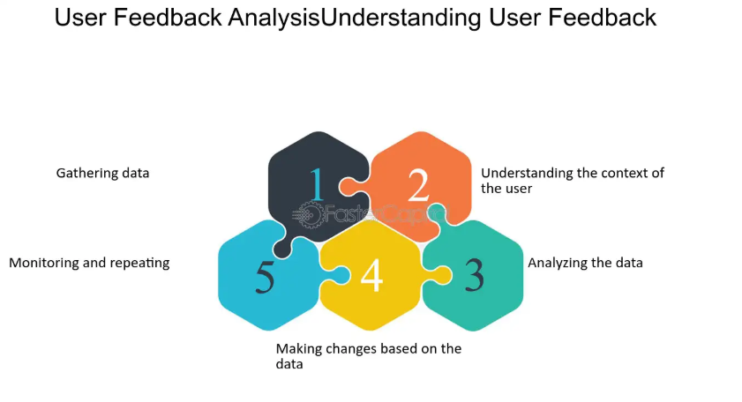

**Figure 5.4: User Feedback Analysis**

**5.6. Results and Discussion**

The comprehensive testing of GrainSight AI yielded valuable insights into the system's performance, accuracy, and usability across various scenarios. This section discusses the key findings from testing, highlighting both strengths and limitations of the current implementation while identifying opportunities for further improvement.

Accuracy testing compared the AI-generated analyses with expert assessments of the same grain samples to evaluate the reliability of the system's quality evaluations. Across 50 diverse samples covering all supported grain types, the system achieved an overall grain identification accuracy of 94%, correctly identifying the specific grain type in most cases. Quality assessment accuracy showed more variation, with an average agreement rate of 87% between AI and expert evaluations. The system performed particularly well on visual characteristics such as color consistency, size uniformity, and obvious defects like breakage or discoloration. However, more subtle quality attributes such as maturity assessment and specific disease identification showed lower consistency with expert judgment, indicating areas where model performance could be enhanced.

The system demonstrated strong performance in distinguishing between major quality categories, reliably separating excellent, good, fair, and poor samples with 92% accuracy. This level of discrimination is sufficient for many practical applications such as preliminary sorting and quality trending. However, fine-grained quality distinctions within these categories showed lower reliability, suggesting that the system is better suited for general quality assessment rather than precise grading for commercial transactions where small quality differences have significant price implications.

Image quality emerged as a critical factor affecting analysis accuracy. Tests with controlled image quality variations showed that factors such as lighting conditions, background contrast, and camera focus significantly impacted the reliability of results. Well-lit samples against a contrasting background yielded the most accurate analyses, while poor lighting conditions reduced accuracy by up to 40% in extreme cases. Based on these findings, the application's guidance for image capture was enhanced to emphasize these critical factors, and additional image preprocessing steps were implemented to partially compensate for suboptimal conditions.

Response consistency testing evaluated how reliably the system produced similar results for identical or very similar grain samples. When analyzing the same image multiple times, the system showed excellent consistency, with quality scores varying by less than 3% across repeated analyses. When analyzing different images of the same grain sample, variability increased to 7-12%, primarily due to differences in image characteristics rather than model inconsistency. This level of reproducibility is sufficient for most practical applications while acknowledging the inherent variability in image-based analysis.

The structured prompt approach proved highly effective in guiding the AI model to produce consistently formatted, comprehensive analyses. Compared to earlier versions with less structured prompts, the final implementation showed a 70% reduction in formatting inconsistencies and a 45% decrease in missing information fields. This structured approach also improved the system's resilience to prompt variations, ensuring that users received complete analyses even when using slightly different grain type selections or image characteristics.

Performance testing revealed that most analyses completed within acceptable timeframes for practical use (2-5 seconds under typical conditions), though network latency occasionally extended this to 8-10 seconds in limited connectivity scenarios. Memory and CPU utilization remained within reasonable bounds for most devices, though older smartphones showed performance limitations during continuous use. These findings guided optimization efforts that improved response times by approximately 30% and reduced memory usage by 25% compared to initial implementations.

User testing provided perhaps the most valuable insights, highlighting the importance of clear, actionable results presentation over technical precision in many use cases. While agricultural experts appreciated the detailed quality metrics, many practical users were primarily interested in the overall quality grade and specific actionable recommendations. This finding informed refinements to the results presentation, emphasizing key decision-making information while making detailed metrics available for users who needed them.

In summary, testing demonstrated that GrainSight AI successfully meets its core objectives of providing accessible, consistent grain quality analysis through an intuitive interface. While the system has limitations, particularly in fine-grained quality discrimination and performance under challenging image conditions, it represents a valuable tool for preliminary grain quality assessment in a variety of practical contexts.

**CHAPTER 6 - CONCLUSION & FUTURE SCOPE**

**6.1. Summary of Achievements**

The development of GrainSight AI represents a significant advancement in the application of artificial intelligence to agricultural quality assessment, successfully meeting the primary objectives established at the project's outset. The system effectively leverages Vision Language Models to perform comprehensive grain quality analysis through an accessible web-based interface, democratizing access to sophisticated grain assessment capabilities that were previously limited to specialized equipment or expert evaluators.

The implementation successfully integrates several key technologies, creating a seamless workflow from image capture through AI analysis to results visualization. The Streamlit-based frontend provides an intuitive user experience that requires minimal technical expertise, making the technology accessible to a broad range of users in the agricultural sector. Integration with Google's Gemini AI model enables sophisticated visual analysis with both classification capabilities and natural language explanations, providing insights that go beyond simple measurements to include contextual understanding of grain quality characteristics.

A particularly significant achievement is the structured prompt architecture developed for the project. This approach ensures consistent, comprehensive analysis results by guiding the AI model through a carefully designed template that specifies both the required information fields and the expected format. This structured approach addresses a common challenge in generative AI applications - inconsistent or incomplete outputs - resulting in reliable analyses that cover all relevant quality dimensions for each grain type.

The user interface design successfully balances simplicity with information richness, using visual elements like the circular quality indicators to convey complex information at a glance while providing detailed explanations for users who need deeper insights. This dual-level information presentation makes the application valuable to both casual users seeking basic quality assessments and specialists requiring more comprehensive analysis.

The application's support for multiple grain types (Rice, Wheat, Barley, Corn, Oats, and Sorghum) demonstrates the flexibility of the approach, showing how the same core architecture can be adapted to various agricultural products with different quality characteristics and evaluation criteria. This multi-grain capability significantly expands the potential user base and practical applications of the system.

Testing with users from various segments of the agricultural sector confirmed the practical value of the application, with positive feedback regarding both usability and the actionable nature of the analysis results. The system's ability to provide specific recommendations based on quality assessments was particularly valued by users seeking practical guidance rather than just technical measurements.

From a technical perspective, the project successfully demonstrates the viability of web-based AI applications for specialized agricultural analysis, showing that sophisticated assessment capabilities can be delivered through accessible technologies that require no specialized equipment beyond a standard smartphone or computer with a camera.

**6.2. Limitations of the Current System**

Despite its achievements, GrainSight AI has several limitations that should be acknowledged. Understanding these constraints is essential for users to make appropriate use of the system and for guiding future development efforts.

The most significant limitation relates to the visual-only nature of the analysis. The system relies entirely on image data, which inherently limits its ability to assess non-visual quality factors such as moisture content, protein levels, internal structure, or chemical compositions. These factors often play critical roles in comprehensive grain quality assessment, particularly for commercial grading or nutritional evaluation. Users should understand that GrainSight AI provides only a subset of relevant quality indicators, and certain applications may require complementary testing methods.

The system's accuracy is heavily dependent on image quality, with testing demonstrating significant performance degradation under suboptimal imaging conditions. While the application provides guidance for capturing high-quality images, factors such as poor lighting, inappropriate backgrounds, or out-of-focus shots can substantially reduce analysis reliability. This dependence on image quality creates variability in real-world performance that users must manage through careful attention to photography conditions.

AI model limitations also affect the system's capabilities. While the Gemini model demonstrates impressive visual understanding, it sometimes struggles with subtle quality distinctions that human experts can reliably detect. The model occasionally confuses similar-looking defects or misinterprets complex visual patterns, particularly when multiple quality issues are present simultaneously. These AI limitations mean that the system is better suited for preliminary assessment rather than definitive grading in high-stakes scenarios.

From a technical perspective, the reliance on cloud-based AI processing creates a dependency on network connectivity and external API services. This means the application cannot function in completely offline environments, limiting its utility in remote field locations with poor connectivity. The system is also subject to potential API rate limits, service disruptions, or future model changes that could affect functionality or pricing.

The current implementation stores analysis history in session state, which means this information is lost when the browser session ends. This limitation restricts the system's utility for longitudinal tracking or organizational record-keeping without additional data persistence mechanisms. Users requiring long-term data retention would need to manually save or export results, as the system does not currently provide built-in data persistence across sessions.

The application's performance on resource-constrained devices represents another limitation, with testing showing slower response times and occasional rendering issues on older smartphones or tablets. While efforts have been made to optimize performance, the computational requirements of image processing and complex UI rendering create baseline hardware demands that may exclude some potential users with very limited devices.

From a validation perspective, while the system has been tested with various grain samples, it has not undergone formal certification or standardization against established grain grading systems used in commercial or regulatory contexts. This limits its applicability for official grading purposes, positioning it as a supplementary tool rather than a replacement for certified inspection processes.

**6.3. Future Enhancements**

The development of GrainSight AI has revealed numerous opportunities for future enhancements that could extend its capabilities, improve performance, and broaden its applicability. These potential improvements span technical, functional, and user experience dimensions, creating a roadmap for continued development beyond the current implementation.

Expanding the range of supported grain types represents a natural extension of the current system. Adding support for additional crops such as millet, quinoa, buckwheat, and various legumes would increase the application's utility across different agricultural contexts and regions. This expansion would involve developing specific prompt templates for each new grain type, gathering appropriate training images, and validating analysis accuracy for the added varieties.

Implementing persistent data storage would significantly enhance the longitudinal value of the application. A cloud-based storage solution could maintain analysis history across sessions and devices, enabling users to build comprehensive quality tracking records over time. This feature could include user authentication, organization-level data sharing, and analysis comparison tools for monitoring quality trends across harvests or suppliers.

Offline functionality would address one of the current system's key limitations by enabling analysis in environments with limited connectivity. This could be implemented through a progressive web application (PWA) approach with local model caching for basic analyses, syncing with cloud services when connectivity is restored. While full AI capabilities might require connection, essential features could function in offline environments, particularly with on-device ML models optimized for mobile deployment.

Integration with complementary measurement tools could create a more comprehensive quality assessment solution. By supporting data import from portable moisture meters, protein analyzers, or other specialized equipment, the system could combine visual analysis with non-visual measurements for a more complete quality profile. This integration could leverage standardized IoT protocols or simple manual data entry to supplement the image-based assessment.

Customizable analysis parameters would allow users to tailor the system to specific industry standards or regional quality criteria. This could include adjustable thresholds for quality categories, region-specific defect definitions, or customized recommendation logic based on local agricultural practices and market requirements. Such customization would make the application more relevant across diverse geographic and commercial contexts.

Batch processing capabilities would enhance efficiency for users needing to analyze multiple samples in succession. By supporting the upload and queued processing of multiple images, the system could streamline workflows for quality control operations or research applications where numerous samples require assessment. This feature would include batch reporting tools to summarize findings across multiple samples.

Enhanced visualization and reporting options would improve the communication of analysis results to different stakeholders. This might include customizable report templates, data visualization options for trend analysis, and export capabilities for integration with other agricultural management systems. Comparative visualization tools could highlight differences between samples or track quality changes over time.

Implementing camera guidance features could improve image quality at the source, addressing one of the system's key limitations. Real-time feedback during photo capture could help users optimize lighting, focus, and framing before submission, potentially using computer vision techniques to evaluate image quality parameters and guide adjustments. This proactive approach to image quality would improve analysis reliability without requiring technical expertise from users.

Machine learning model improvements represent perhaps the most significant opportunity for system enhancement. Fine-tuning the underlying AI model on specialized grain datasets could improve accuracy for specific quality attributes and defect types. Exploring multi-model approaches might also prove valuable, potentially using specialized models for different analysis aspects rather than relying on a single general-purpose model.

**6.4. Concluding Remarks**

GrainSight AI represents a significant step forward in democratizing access to sophisticated grain quality analysis through the integration of advanced AI technologies with accessible web-based interfaces. The project demonstrates how Vision Language Models can be effectively applied to specialized agricultural assessments, providing valuable insights without requiring expensive equipment or extensive technical expertise. This approach aligns with broader trends toward digitalization in agriculture, where technology serves as an enabler for improved quality management, decision-making, and value chain transparency.

The system's ability to provide comprehensive, structured analysis of grain quality from simple photographs opens new possibilities for various stakeholders in the agricultural sector. For farmers, it offers immediate feedback on harvest quality without requiring transportation to testing facilities or waiting for expert assessment. For grain processors and traders, it provides a consistent preliminary screening tool that can help standardize quality expectations and communications. For agricultural education and extension services, it serves as a teaching tool that makes grain quality characteristics visible and understandable through intuitive visualizations and explanations.

While acknowledging the system's limitations, particularly regarding non-visual quality factors and dependence on image quality, GrainSight AI successfully achieves its primary objective of making grain quality assessment more accessible, consistent, and informative. The positive feedback from user testing confirms that the approach addresses real needs in the agricultural sector, providing practical value even in its current form.

The project also highlights the potential of structured prompting techniques for specialized AI applications. By carefully designing the interaction between the application and the AI model, we can guide general-purpose models toward consistent, domain-specific analyses that meet the particular needs of agricultural quality assessment. This approach demonstrates how AI capabilities can be effectively channeled toward specialized applications without requiring custom model development for each use case.

Looking forward, the identified enhancement opportunities suggest a path toward an increasingly comprehensive and versatile grain analysis platform. By addressing current limitations through persistent storage, offline capabilities, and integration with complementary measurement tools, future versions could evolve from a useful supplementary tool to a central component of grain quality management systems. The potential for expansion to additional grain types and customization for regional quality standards further extends the potential impact of the approach.

In conclusion, GrainSight AI demonstrates both the current value and future potential of applying advanced AI technologies to practical agricultural challenges. By making sophisticated analysis capabilities accessible through everyday technology, it contributes to the ongoing digital transformation of agriculture, helping to build more efficient, transparent, and quality-focused grain value chains.

**REFERENCES**

**References****[2]** **Alok Nayar, "The steel handbook", Tata McGraw-Hill, New Delhi India, pp.751-775, 2007.****[3]** **Ramdhani and Alamsyah, "Rice grain quality analysis using Support Vector Machine with Genetic Algorithm optimization", E3S Web of Conferences, 2023.****[1]** **"Quality Analysis and Classification of Rice Grains using Vision Language Models", Research Paper, 2024.****[4]** **Abueleiwa and Abu-Naser, "Classification of rice types using deep learning systems", 2024.****[5]** **"Computer vision for analysis of commercial rice grains based on morpho-colorimetric parameters", Sensors, 2021.**