DPIT 128

OBJECT ORIENTED DESIGN AND PROGRAMMING

November 20, 2024

Minh Huy Loi

(8557639)

SWS Campus

Table of Contents

1. Description of the object-oriented design 2

Library Items Class 2

Book Class 2

Member Class 2

Library Class 2

Relationships Between Classes 3

2. UML Class Diagrams 3

3. Running Screen Shot 3

Show Book Collection: 3

Add New Book: 4

Search Book: 4

Show Member List: 5

Add Member: 6

Find member using member ID: 6

Borrow Book: 7

Return Book: 8

# **Description of the object-oriented design**

## Library Items Class

* **Description**: Serves as the base class for library items, primarily books, andcan be extended for other types of items in the future.
* **Attributes**:

+ Title: The title of the library item.

* **Methods**: None.
* **Relationships:** The Book class inherits from this class to gain access to the title attribute.

## Book Class

* **Description**: Inherits from Library Items and represents books in the library.
* **Attributes**:

+ bookID: A unique identifier for each book.

+ author: The author of the book.

+ available: A boolean indicating whether the book is available for borrowing.

* **Methods**: None (relies on Library methods for operations).
* **Relationships:** Books are managed within the library class.

## Member Class

* **Description**: Represents members of the library who can borrow books.
* **Attributes**:

+ memberID: A unique identifier for each member.

+ name: The name of the member.

+ borrowed_books: A list of books borrowed by the member.

* **Methods**: None (relies on Library methods for operations).
* **Relationships:**

+ Members are managed within the Library class.

+ Members interact with books through borrowing and returning.

## Library Class

* **Description**: Acts as the central class, managing books and members, and their interactions.
* **Attributes**:

• books: A list of all Book objects in the library.

• members: A list of all Member objects in the library.

• next_book_id: A counter to assign unique IDs to new books.

* **Methods**:

+ show books(): Displays all books in the library with their details and availability status.

+ add book(title, author): Adds a new book to the library collection.

+ search book(title): Searches for books by title and displays matching results.

+ show members(): Displays a list of all members and their borrowed books.

+ add member(name): Adds a new member to the library.

+ borrow book(memberID, bookID): Allows a member to borrow a book if available.

+ return book(memberID, bookID): Allows a member to return a borrowed book.

## Relationships Between Classes

1. **Inheritance**:

* Book inherits from Library Items, sharing the title attribute and any future common functionality.

1. **Aggregation**:

* Library contains a collection of Book and Member objects, managing their interactions.

1. **Association**:

* Member objects have a list of borrowed Book objects, establishing a direct relationship between members and books.

# **UML Class Diagrams**

# **Running Screen Shot**

Add book and Members:

* I added book and new member in the function make easier to run, debug and check bugs.

Library Main Menu:

* Basic Interaction Menu for Books and Members Managements.

Show Book Collection:

## Add New Book:

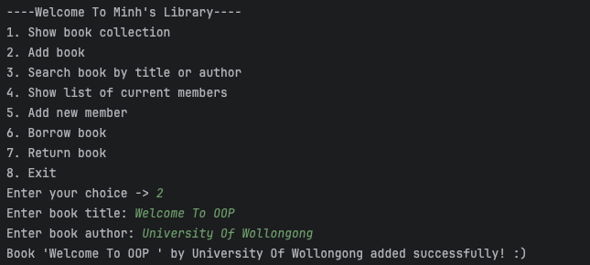

* Check If it shown in the library

## Search Book:

* Using title and author:

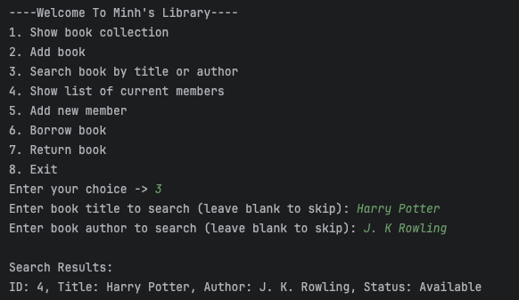

* Using title only:

-Using Author only:

## Show Member List:

## Add Member:

## Find member using member ID:

## Borrow Book:

We can borrow many books:

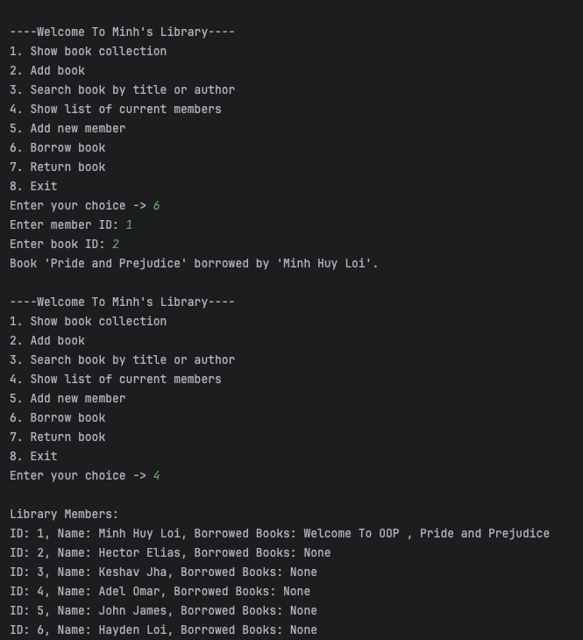

## Return Book:

You can’t return Book that you haven’t borrow or in the book list

## Exit:

