Detailed Technical Report

UAV 3D Path Planning Based on Integrated Particle Swarm Optimization and Artificial Potential Field Method

Report Based on the Research Paper and Our Python/GUI Implementation
Focus: FPAPF Methodology, Implementation Mapping, GUI-Based Testing, Smooth Path Improvement, and Dynamic Obstacle Response
.
Muhammad Huzaifa 539641
Shahab Shinwari 539515

Course instructor: Dr Karam Dad

Date: May 11, 2026

Abstract
This report explains and evaluates the research paper titled "UAV 3D Path Planning Based on Integrated Particle Swarm Optimization and Artificial Potential Field Method" and maps its methodology to our reproduced Python/GUI implementation. The paper proposes FPAPF, a hybrid method that combines Artificial Potential Field (APF) guidance with Particle Swarm Optimization (PSO) to improve three-dimensional UAV path planning in obstacle-rich environments. The main technical motivation is clear: classical APF is computationally fast, but it can suffer from local minima, unreachable targets, oscillatory behavior, and unsafe closeness to obstacles. The paper responds to these weaknesses by introducing a Gaussian-based repulsive force and using PSO to refine the APF-guided next waypoint.
Our implementation follows the central FPAPF idea but adds practical engineering features for GUI-based testing, obstacle editing, path feasibility checking, safety margins, line-segment verification, drone-radius consideration, and smooth path generation. The most important implementation-level improvement is that our generated path is smoother than the author-reported output shown in the paper figure, which visually contains sharp vertical and horizontal transitions. This report therefore does not simply summarize the paper; it also distinguishes the paper method from our actual implementation work and explains how the GUI experiments support robustness, especially after obstacle addition.
The report is structured as a technical document with methodology, mathematical model explanation, implementation mapping, experimental observations, figure-based discussion, limitations, and future improvements. Figures from the research paper and figures generated from our Python GUI are placed at the appropriate sections.

Table of Contents
- 1. Introduction
- 2. Research Paper Overview
- 3. Classical APF and Its Core Problems
- 4. Proposed FPAPF Methodology
- 5. Evaluation Metrics and Controller Verification in the Paper
- 6. Our Python/GUI Implementation Based on the JSON File
- 7. GUI Sandbox and Obstacle Configuration
- 8. Experimental Results from Our Implementation
- 9. Dynamic Obstacle Addition and Robustness Discussion
- 10. Comparison Between Paper Output and Our Smooth Path Output
- 11. Critical Discussion, Limitations, and Future Work
- 12. Conclusion
- References
- Appendix A: Figure Placement and Source Notes

1. Introduction
Unmanned aerial vehicle path planning is the process of generating a safe and efficient route from a starting point to a target point while avoiding obstacles. In a three-dimensional environment, the problem is more difficult than simple two-dimensional navigation because the UAV must decide not only how to move left or right, but also how to climb, descend, and maintain safe clearance from obstacles with different heights. A planned path must therefore satisfy several requirements at the same time: it should be short, collision-free, smooth, computationally feasible, and practical enough for a controller to follow.
The research paper addresses this problem by combining two well-known ideas: Artificial Potential Field and Particle Swarm Optimization. APF is attractive because it is simple and fast. It treats the goal as an attractive source and obstacles as repulsive sources. The UAV moves according to the resultant force. However, APF alone is weak in complex obstacle fields because the attractive and repulsive forces can cancel each other, causing the UAV to stop at a false equilibrium point. APF can also produce abrupt path changes near obstacle boundaries, especially when the repulsive force switches suddenly from inactive to active.
Particle Swarm Optimization provides a complementary ability. Instead of accepting the APF direction blindly, PSO creates a group of candidate particles around the APF-guided point and searches for a better local waypoint. This makes the planner less dependent on a single force direction. The paper calls the hybrid method FPAPF, meaning Fusion of Particle Swarm Optimization and Artificial Potential Field.
Our work reproduces the core FPAPF concept in a Python-based GUI environment. The implementation is not a plain copy of the paper. It adds custom sandbox controls, cylindrical obstacle modeling, parameter controls, safety checks, smoothing logic, and dynamic obstacle-addition tests. The goal of our project is to understand the paper deeply and convert the method into a practical simulation tool that can visually demonstrate the difference between classical APF and the improved FPAPF approach.

1.1 Purpose of the Report
The purpose of this report is to provide a detailed technical explanation of the research paper and our implementation. It focuses on four areas: the theoretical FPAPF method proposed by the authors, the problems of classical APF, the mapping of paper equations into our Python/GUI work, and the visual results obtained from our implementation. Particular attention is given to the smoothness improvement in our path output, because the author-reported figure in the paper shows sharp vertical and horizontal transitions, while our implementation produces smoother path behavior.

1.2 Scope
The report covers the paper methodology, paper evaluation metrics, selected numerical results, controller verification concept, JSON-based implementation details, GUI sandbox controls, qualitative comparison between classical APF and FPAPF, and dynamic obstacle addition. It does not claim that the current GUI fully reproduces every controller-level tracking experiment from the paper. The paper includes PID, LQR, and ELQR controller verification, whereas our current work focuses primarily on path generation, visualization, safety checking, and smoothness improvement.

2. Research Paper Overview
The paper proposes a three-dimensional UAV path-planning method for complex environments. The method is designed to generate a feasible path while reducing the common failures of classical APF. Its main contribution is not the invention of APF or PSO separately, but the way both are combined: APF provides fast directional guidance and PSO locally refines the next waypoint. The authors also add a Gaussian repulsive function to produce smoother obstacle repulsion than the classical APF model.
The paper compares the proposed FPAPF method with several planning algorithms, including traditional APF variants, RRT, improved APF approaches, MAPF, and GWOAPF. The comparison is conducted across static, dynamic, and more complex obstacle environments. The major evaluation criteria include path success, computation time, path length, average safety distance, and minimum safety distance. The paper also includes controller-level verification to test whether the planned path can be tracked by UAV control strategies.

2.1 Main Contributions Reported in the Paper
A Gaussian-based repulsive force is introduced to reduce discontinuity near obstacle influence boundaries and improve obstacle perception.
APF and PSO are fused so that PSO can locally refine APF-guided trajectory points and reduce the risk of local minima and target inaccessibility.
A multi-metric evaluation framework is proposed using path length, average safety distance, and minimum safety distance.
A trajectory executability verification framework is proposed using different controllers, including PID, LQR, and ELQR.

2.2 Why This Paper Matters for UAV Path Planning
The paper is useful because it targets a real weakness in fast path planners. A planner may look good in a simple environment but fail in dense obstacle settings. Classical APF often moves quickly toward the target but becomes unreliable when obstacles are close, when the target is near an obstacle, or when new obstacles disturb the potential field. The hybrid FPAPF method is an attempt to keep APF speed while using PSO to provide local decision flexibility.
Table 1. Selected FPAPF Results Reported in the Research Paper
Environment | Scenario | Time (s) | Length (m) | Avg. safety (m) | Min. safety (m) | Key interpretation
Env. 1 | Static, 8 obstacles | 3.41 | 236 | 12.42 | 2.38 | Shortest path among compared algorithms
Env. 2 | Static, 10 obstacles | 3.06 | 210 | 10.35 | 2.03 | Shortest and fastest among compared algorithms
Env. 3 | Static, dense obstacles | 3.55 | 276 | 9.40 | 1.90 | Successful where several APF variants failed
Env. 4 | Static + dynamic obstacles | 3.89 | 201 | 20.72 | 5.42 | Strong dynamic-environment performance
Env. 5 | Complex environment | 13.67 | 224 | 16.54 | 4.45 | Highest weighted score in paper discussion

The data show the general trend emphasized by the paper: FPAPF is usually faster and more compact while maintaining acceptable safety margins. In Environment 3, several competing methods fail, while FPAPF still reaches the target. This directly supports the argument that PSO-based local correction helps APF escape difficult regions.

3. Classical APF and Its Core Problems
Classical APF models the environment as a virtual force field. The target attracts the UAV, while obstacles repel it. In simple cases, this produces a direct and efficient trajectory. However, the simplicity of APF is also the reason for its weakness. When the force field becomes complex, the resultant force may point in a poor direction or may become zero before the UAV reaches the goal.

3.1 Attractive and Repulsive Potential
The total potential field can be described as U(q) = Uatt(q) + Urep(q), where q is the current UAV position, Uatt is the attractive potential generated by the goal, and Urep is the repulsive potential generated by obstacles. The attractive force usually points from the current position to the target. The repulsive force points away from obstacle surfaces. The planned movement direction is obtained by combining these forces.
The classic attractive force can be written as Fatt(q) = -katt(q - qgoal), or equivalently as a vector pointing from the UAV toward the goal. The classical repulsive potential becomes active only when the UAV enters an obstacle influence distance. This creates a sharp change at the influence boundary, which can cause oscillation or sudden turns near obstacles.

3.2 Local Minimum Problem
The local minimum problem occurs when the attractive and repulsive forces cancel each other at a point that is not the target. At that moment, the UAV has no useful direction to move. It may stop, hover, or oscillate around that point. This is particularly common when an obstacle lies directly between the UAV and the target or when the UAV enters a narrow passage between obstacles.

3.3 Target Inaccessibility
Target inaccessibility occurs when the target is close to obstacles. As the UAV approaches the target, the attractive force becomes weaker because the distance to the goal is smaller. At the same time, the repulsive force from nearby obstacles may become stronger. If the repulsive force dominates, the UAV cannot reach the target even though the goal is visible and close.

3.4 Why Classical APF Fails in Practical UAV Simulation
For UAVs, a path must be executable, not merely collision-free in a geometric plot. A jerky path with abrupt changes in direction can become difficult for a real flight controller to track. If the path passes too close to obstacles, even small control errors or disturbances may produce collision risk. This is why our implementation compares classical APF with FPAPF visually and focuses strongly on smoothness and clearance.

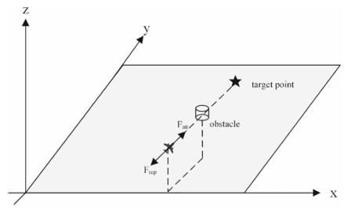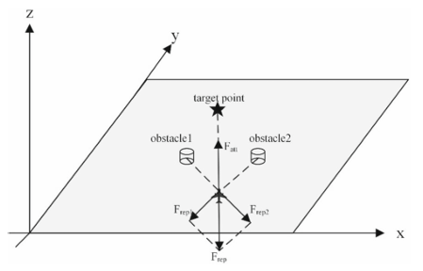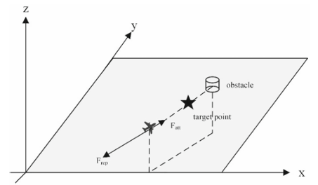
Figure. Classical APF limitations: local minimum and target inaccessibility diagrams. Source: Research paper.

4. Proposed FPAPF Methodology
The FPAPF method improves classical APF through two main mechanisms. First, it replaces the abrupt classical repulsive behavior with a Gaussian repulsive force so that obstacle influence fades smoothly with distance. Second, it uses PSO to search locally around the APF-guided candidate point. This means the algorithm does not completely trust a single APF force direction. Instead, it evaluates multiple nearby candidate points and selects the most suitable one.

4.1 Gaussian Repulsive Function
The Gaussian repulsive function is used to make obstacle avoidance smoother. In classical APF, the repulsive force can suddenly become active when the UAV crosses the obstacle influence boundary. In the Gaussian model, repulsion changes gradually. The closer the UAV is to an obstacle, the stronger the repulsion; the farther it is, the weaker the influence. This improves local responsiveness and reduces oscillation near obstacle boundaries.
In simplified implementation terms, the Gaussian repulsive force can be understood as a repulsive vector multiplied by an exponential decay term. The decay term controls how smoothly the obstacle influence disappears with distance. This is important for cylindrical obstacles because the UAV may approach a curved boundary from different directions and heights.
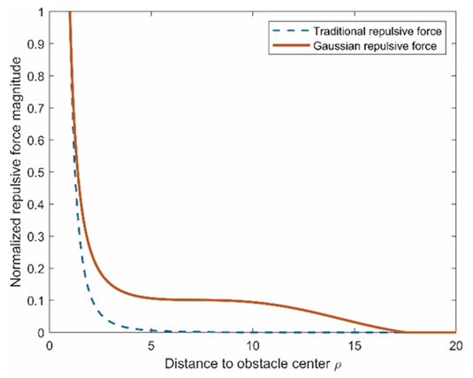
Figure Placeholder. Comparison between classical repulsive force and Gaussian repulsive force. Source: Research paper.

4.2 PSO Local Refinement
After APF computes the guidance direction, the algorithm generates an APF candidate point. Instead of immediately using this point as the next waypoint, PSO initializes particles around it. Each particle represents a possible next waypoint. The particles update their positions according to personal best and global best information, and each candidate is evaluated using a fitness function.
The paper fitness function is based mainly on distance to the goal plus obstacle penalty. Our implementation extends this idea by adding a heading smoothness penalty, which discourages sharp turns. This is a meaningful practical addition because a smooth path is easier for UAV control and looks more realistic in simulation.
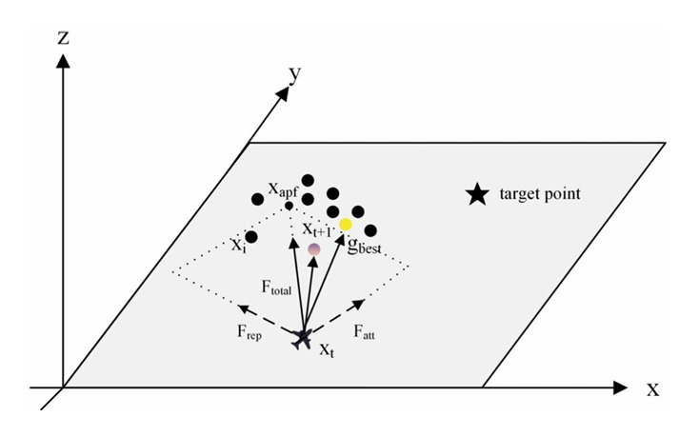
Figure 1. Schematic representation of the APF-PSO fusion mechanism from the research paper. APF provides the guidance direction, while PSO searches around the APF candidate point to identify an improved next waypoint. Source: Research paper figure.

4.3 Final Fusion of APF and PSO
The final next point is produced by fusing the APF-guided point and the PSO global-best point: x_next = alpha*x_apf + (1-alpha)*g_best. The coefficient alpha controls the balance between APF guidance and PSO refinement. A high alpha trusts APF more, which usually creates more direct movement. A low alpha trusts PSO more, which can improve safety but may introduce variability if not controlled.
In our implementation, the default alpha value is 0.35, which means the final point gives stronger influence to the PSO-selected candidate than to the raw APF suggestion. This is consistent with the goal of making the final trajectory smoother and safer than classical APF.

5. Evaluation Metrics and Controller Verification in the Paper
The paper does not evaluate path quality only by visual appearance. It uses measurable criteria, including path length, average safety distance, and minimum safety distance. A short path is efficient, but it is not necessarily safe. A path with high average clearance may still have one dangerous segment with very small minimum clearance. Therefore, using both average and minimum safety distance gives a more complete assessment.

5.1 Composite Weighted Score
The paper uses a weighted score that combines inverse-normalized path length, average safety distance, and minimum safety distance. The final rounded weights are 0.7 for path length, 0.2 for average safety distance, and 0.1 for minimum safety distance. This means the paper prioritizes efficiency but still includes safety in the final ranking. This is reasonable for time-sensitive UAV missions, but it also means that an algorithm with a slightly safer but much longer path may rank lower.
Table 2. Evaluation Metrics Used in the Paper and Our Implementation
Metric | Meaning | Paper use | Our GUI/implementation use
Path length | Total travel distance | Used in weighted score | Reported as direct metric
Average safety distance | Average clearance from obstacles | Used in weighted score | Reported through clearance metrics
Minimum safety distance | Worst-case clearance | Used in weighted score | Reported to identify dangerous passages
Planning time | Computation cost | Used for algorithm comparison | Relevant for GUI responsiveness
Path smoothness | Continuity of direction changes | Discussed indirectly through executability | Improved directly through smoothness logic and qualitative outputs

5.2 Controller-Level Verification
A strong point of the research paper is that it goes beyond offline path generation. The authors also test whether the generated path can be tracked by controllers such as PID, LQR, and ELQR. The UAV motion is modeled using velocity and position update equations, where acceleration command is the control input. This matters because a path may be geometrically collision-free but still difficult to execute if it contains sharp turns or abrupt altitude changes.
The controller comparison reported in the paper shows that PID performs poorly under disturbances and nonsmooth trajectories, whereas LQR improves tracking accuracy. ELQR further improves robustness by adding enhanced compensation. However, this part is not fully reproduced in our GUI at the controller level. Our implementation focuses instead on generating smoother paths and checking feasibility before controller tracking is attempted.
Table 3. Controller Tracking Results Reported in the Paper
Controller | RMSE | Max error | Final error | Mean jerk | Robustness | Interpretation
PID | 62.494 | 107.91 | 107.91 | 35.455 | 0.0011 | Poor tracking under disturbance
LQR | 6.1948 | 10.47 | 5.5022 | 66.539 | 0.1901 | Much better tracking than PID
ELQR | 5.4567 | 8.1312 | 5.1389 | 64.612 | 0.2436 | Best tracking among the three controllers

The key lesson for our project is direct: path planning should not stop at obstacle avoidance. Smoothness matters because it affects tracking performance. This justifies the added smoothness logic in our implementation.

6. Our Python/GUI Implementation Based on the JSON File
The JSON file explains how the paper was translated into our project implementation. It defines the big picture, important terms, equations, implementation files, parameter controls, metrics, and limitations. The most important point is that our work follows the FPAPF concept but adds practical features that are necessary for an actual simulation tool.

6.1 Main Implementation Files
Table 4. Main Files in Our Implementation
File | Role in the implementation
app/simulation/planner.py | Main FPAPF planner implementation, including APF force, Gaussian repulsion, PSO refinement, fusion, safety, and smoothing logic.
app/simulation/classic_apf.py | Classical APF baseline used for comparison with FPAPF.
app/simulation/geometry.py | 3D vector math, cylinder obstacle model, environment data types, clearance and direction functions.
app/simulation/environments.py | Preset 3D environments for testing.
app/simulation/metrics.py | Path length and clearance metric calculations.
app/gui/main_window.py | GUI controls, planner selection, parameter input, visualization, and custom sandbox interaction.

6.2 Obstacle Model
Our implementation models obstacles as vertical cylinders. Each cylinder has an X-Y center, radius, height, base elevation, and color. This is suitable for representing towers, buildings, chimneys, columns, and similar vertical threats in UAV simulation. The clearance function calculates the distance from the UAV point to the cylinder surface. The direction function returns the unit vector from the closest obstacle surface toward the UAV point. These two functions are essential because repulsive force requires both magnitude and direction.

6.3 Planning Loop in Our Implementation
Set the current point and start the path from the start coordinate.
Check whether the current point is close enough to the goal.
Compute attraction toward the target using the attraction gain.
Compute Gaussian repulsion from every cylindrical obstacle.
Add forces and normalize the resultant direction.
Create the APF guidance point using the configured step scale.
- Initialize PSO particles around the APF guidance point.
Evaluate particles using goal distance, obstacle penalty, and heading smoothness penalty.
Fuse the APF point and PSO global best using alpha.
Apply feasibility checks, vertical-step limits, segment-clearance checks, and repair if needed.
Append the accepted point and smooth the final path only if safety is preserved.

6.4 Important Differences from the Paper
The paper provides the FPAPF method at algorithm level. Our implementation adds practical checks that are not fully detailed in the paper. These include segment safety checks, drone-radius modeling, heading smoothness penalty, repair of unsafe moves, and final safe smoothing. These additions are not cosmetic. They address the gap between a theoretical waypoint generator and a simulation tool that produces visually stable and more executable paths.
Table 5. Paper Method vs Our Implementation
Aspect | Paper | Our implementation
Fitness function | Goal distance + obstacle penalty | Goal distance + obstacle penalty + heading smoothness penalty
Obstacle model | General 3D obstacles in experiments | User-defined vertical cylinders in GUI sandbox
Safety handling | Evaluated through safety distance metrics | Segment clearance checks, drone radius, collision margin, unsafe-step repair
Executability | PID/LQR/ELQR controller verification | Path feasibility, visualization, smoothing, and metrics; full controller module not reproduced
User interaction | Research simulation setup | Interactive GUI with custom obstacle editing and sandbox tests
Smoothness improvement | Path quality discussed, paper output can appear sharp | Smooth path generation emphasized and visually demonstrated

7. GUI Sandbox and Obstacle Configuration
A major practical part of our work is the GUI sandbox. Instead of only running fixed test cases, the user can add, update, remove, and clear obstacles. This makes the implementation useful for testing how the planner responds when the environment changes. The sandbox also supports manual adjustment of obstacle geometry, which is important for debugging and comparing classical APF with FPAPF.
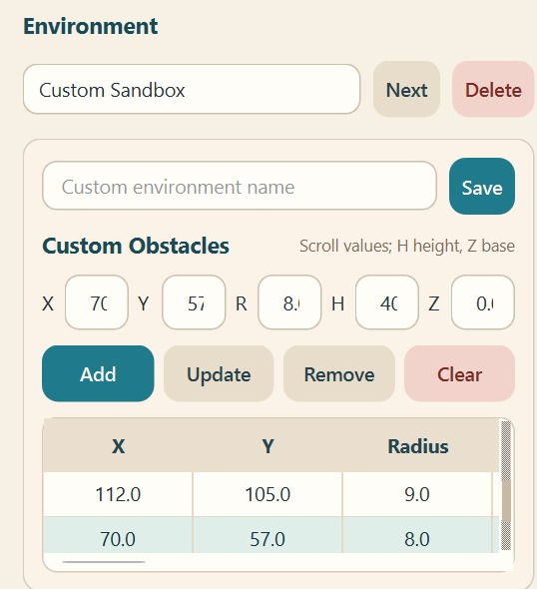
Figure 2. Custom sandbox interface developed in the GUI to define and modify cylindrical obstacles using X-Y position, radius, height, and Z-base parameters. Source: Our Python GUI implementation.
The custom sandbox controls allow obstacle parameters to be edited directly. Each obstacle is represented using X and Y coordinates, radius, height, and Z base. This design is appropriate for cylindrical threats and makes it easy to reproduce cases where the path is blocked, narrowed, or changed after a new obstacle is introduced.

7.1 Parameter Controls
Table 6. Visible FPAPF Parameters in the GUI
Parameter | Typical range/default | Effect on path behavior
Step scale | 0.1 to 3.0; default 0.5 | Controls how far the APF guidance point is from the current point. Larger values create longer jumps; smaller values create denser paths.
Fusion alpha | 0.05 to 0.95; default 0.35 | Controls trust between APF guidance and PSO best point. Lower alpha gives more influence to PSO.
Swarm size | 10 to 100; default 40 | Controls how many candidate points are searched locally. Larger swarms improve search but increase computation.
PSO iterations | 5 to 100; default 35 | Controls how long the particles refine candidate waypoints. More iterations improve local search but increase time.

7.2 Sandbox Visualization
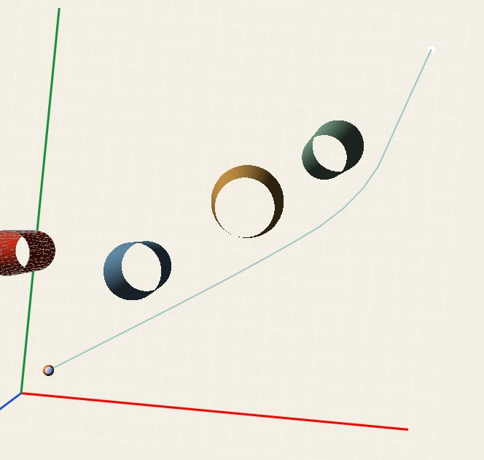
Figure 3. Sandbox simulation output of the FPAPF planner in a 3D cylindrical-obstacle environment, showing a feasible route from the start point to the target. Source: Our Python GUI implementation.
The sandbox visualization confirms that our implementation produces a continuous 3D path through a cylindrical obstacle field. The figure is useful as a general implementation output because it connects the GUI inputs with the resulting trajectory. It also demonstrates that the project is not only a theoretical explanation of the paper but a working simulation environment.

8. Experimental Results from Our Implementation
The key qualitative comparison in our implementation is between classical APF and our FPAPF output. Classical APF is expected to be fast, but it often produces unstable path behavior in cluttered environments. In the GUI result below, the classical APF path becomes jerky and passes very close to obstacles. This is exactly the kind of behavior that motivates the FPAPF approach.

8.1 Classical APF Baseline Behavior
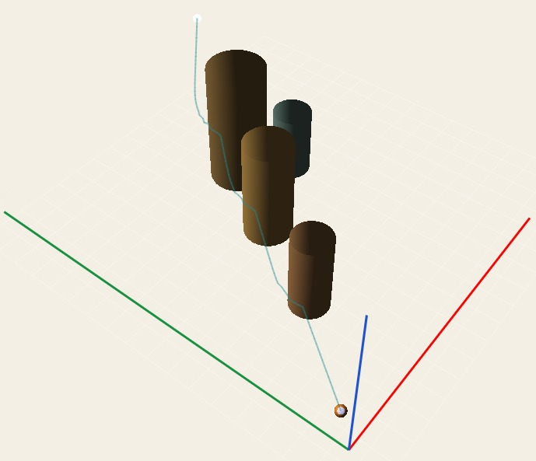
Figure 4. Classical APF trajectory in a 3D obstacle environment, showing jerky path behavior and close passage near obstacles. Source: Our Python GUI implementation.
The classical APF result shows why relying only on attraction and repulsion is not enough. The path does not maintain a clean, smooth transition around the cylindrical obstacles. It also approaches obstacles too closely, which creates a safety concern. For a UAV, this is not merely a visual issue. A path that changes abruptly or passes too close to obstacles may become difficult to track under real control constraints.

8.2 Smooth FPAPF Output from Our Implementation
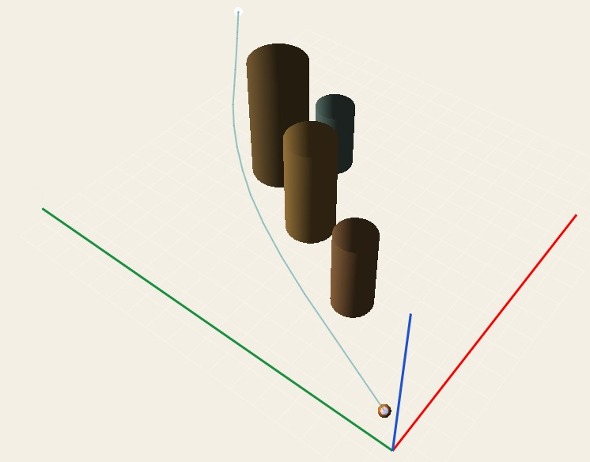
Figure 5. Trajectory generated by our implemented FPAPF method, showing a smoother path and improved obstacle avoidance compared with the classical APF baseline. Source: Our Python GUI implementation.
The FPAPF output generated by our implementation is visibly smoother. This is due to the combined effect of Gaussian repulsion, local PSO refinement, heading smoothness penalty, and safe smoothing. The result is more suitable for UAV navigation because it avoids the abrupt variations observed in classical APF. The improvement is qualitative in the current report; for a stronger quantitative claim, future work should compute curvature, jerk, and waypoint-angle statistics.
Table 7. Qualitative Comparison of Classical APF and Our FPAPF Output
Criterion | Classical APF | Our implemented FPAPF
Path smoothness | Jerky and oscillatory behavior visible | Smoother, more continuous trajectory
Obstacle clearance | Passes too close to obstacles | Maintains more practical separation
Robustness | Can become trapped or unstable | Improved through local PSO correction
Execution suitability | Less suitable due to abrupt direction changes | More suitable because of smoother path shape
Main weakness | Sensitive to force cancellation and obstacle boundaries | Needs parameter tuning and currently lacks full controller verification

9. Dynamic Obstacle Addition and Robustness Discussion
One of the most useful tests in our GUI is obstacle addition. This does not necessarily prove full moving-obstacle tracking, but it does test whether the planner can respond when the environment changes. The figures in this section show three cases: the FPAPF path before obstacle addition, the FPAPF path after obstacle addition, and the classical APF response after obstacle addition.

9.1 FPAPF Before Obstacle Addition
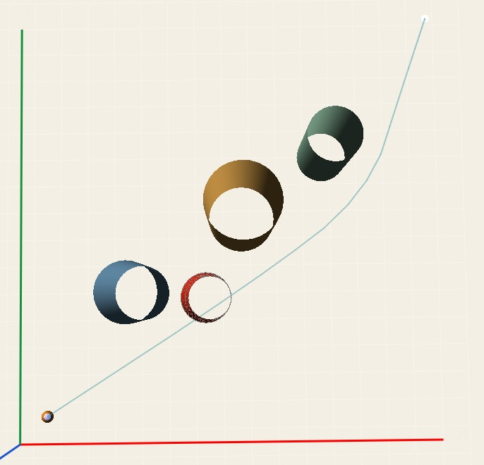
Figure 6. Initial FPAPF trajectory before adding the new obstacle. The planned path avoids the existing cylindrical obstacles and reaches the target using a smooth 3D route. Source: Our Python GUI implementation.

9.2 FPAPF After Obstacle Addition
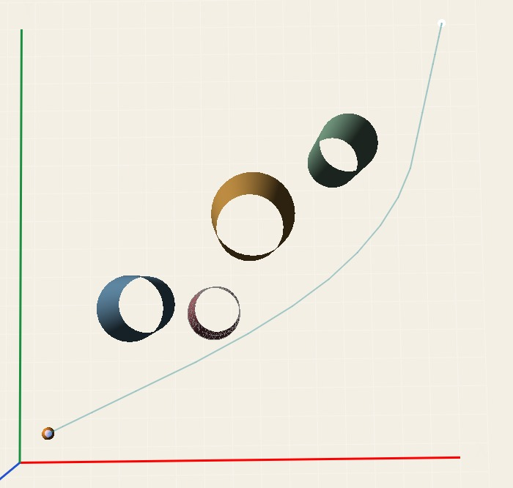
Figure 7. FPAPF trajectory after adding a new obstacle. The path changes to maintain feasibility, demonstrating adaptive replanning under environmental change. Source: Our Python GUI implementation.
The comparison between Figure 6 and Figure 7 shows that after adding a new obstacle, the FPAPF trajectory changes instead of continuing along an unsafe route. This supports the idea that the APF direction alone is not the final decision; PSO refinement and safety checks allow the next waypoint selection to adapt to the changed obstacle layout. The correct wording is important: this result demonstrates robustness to obstacle addition and environmental change, while full dynamic obstacle avoidance would require time-dependent moving obstacles and continuous replanning analysis.

9.3 Classical APF Failure After Obstacle Addition
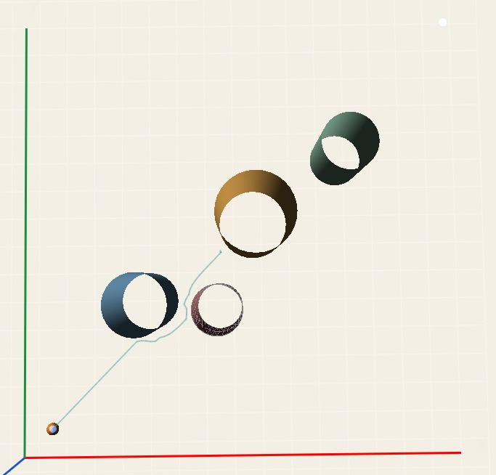
Figure 8. Classical APF behavior after obstacle addition. The path becomes trapped or fails to progress properly, illustrating weak robustness of the baseline under changed obstacle conditions. Source: Our Python GUI implementation.
The classical APF case shows weaker robustness. After obstacle addition, the path becomes stuck or fails to progress properly. This behavior is consistent with the known APF limitations discussed in the paper. It also strengthens the practical argument for using FPAPF rather than classical APF in environments where the obstacle arrangement can change.

10. Comparison Between Paper Output and Our Smooth Path Output
A key observation from the author-reported figure is that some trajectory segments appear Manhattan-like, with sharp vertical and horizontal changes. Such a path may be mathematically valid, but it is not ideal for UAV execution because abrupt changes can increase tracking difficulty. Our implementation focuses on improving this practical weakness by generating a smoother path. The improvement is visible when comparing the paper figure with our GUI-generated FPAPF result.
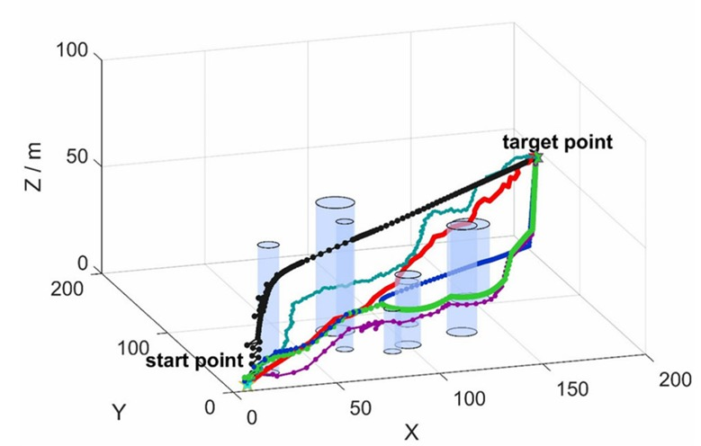
Figure 9. Author-reported path-planning output from the research paper. The path contains visually sharp vertical and horizontal transitions, which motivated our implementation-level focus on smoother trajectory generation. Source: Research paper figure.
Figure 9 is useful because it shows the kind of trajectory behavior that our implementation tries to improve. The author-reported output includes paths that move with sharp changes in direction and height. In a real UAV application, smoother path curvature is generally preferable because it reduces controller burden and can lower jerk, acceleration changes, and tracking error.

10.1 Our Smoothness Improvement
Our improvement is not that we changed the theoretical foundation of FPAPF completely. Instead, we strengthened the practical implementation around it. The core paper idea remains APF-guided PSO waypoint refinement. The improvement comes from how candidate points are evaluated, how unsafe movement is repaired, how drone size is considered, and how final smoothing is applied only when safety is preserved.
The most important implementation choices behind smoothness are: normalized APF step scaling, PSO local search near the APF candidate, heading smoothness penalty in the fitness function, maximum vertical-step handling, segment-clearance checking, and safe post-processing. These are the reasons our path appears smoother than the author-reported output.

10.2 Honest Interpretation
The visual improvement is strong, but it should not be oversold. A proper academic comparison should later include quantitative smoothness metrics such as turning-angle variation, curvature, mean jerk, maximum jerk, waypoint density, and controller tracking RMSE. At this stage, the evidence is primarily visual and implementation-based. That is still valuable, but it must be presented honestly.
Therefore, the correct claim is: our implementation improves visual path smoothness and practical feasibility compared with the displayed paper output and the classical APF baseline. A future version should convert this qualitative observation into numerical evidence.

11. Critical Discussion, Limitations, and Future Work

11.1 Strengths of the Research Paper
The paper addresses real weaknesses of classical APF instead of only presenting a minor parameter adjustment.
The APF-PSO fusion is logical because APF provides fast direction and PSO provides local correction.
The Gaussian repulsive function is a reasonable way to reduce abrupt repulsion near obstacle boundaries.
The paper evaluates path quality with both efficiency and safety metrics.
The controller-executability section is valuable because it connects planning with actual trajectory tracking.

11.2 Weaknesses or Gaps in the Paper
Some visual outputs still appear sharp or Manhattan-like, which raises concerns about smoothness and controller burden.
The weighted score gives dominant importance to path length, which may underweight safety in high-risk applications.
The paper reports strong results, but real UAV deployment would require more detailed dynamic constraints, energy modeling, and hardware validation.
The method may still require careful parameter tuning in dense or maze-like environments.
The paper itself notes that path length may increase in highly complex environments and computational burden can rise in dynamic settings.

11.3 Strengths of Our Implementation
The GUI sandbox makes obstacle testing interactive and easier to understand.
The implementation includes cylinder-based obstacle geometry with editable radius, height, and base elevation.
The planner considers drone radius and safety margins, making the output more realistic than a point-mass-only planner.
The path-generation loop includes repair logic for unsafe moves.
The heading smoothness penalty and safe smoothing improve visual continuity and practical path quality.
- Obstacle-addition tests show that FPAPF can adapt when the environment changes.

11.4 Limitations of Our Current Work
The current implementation is a strong planning and visualization reproduction, but it is not yet a complete UAV execution framework. The most important missing part is full controller-level verification using PID, LQR, and ELQR, as done in the paper. Our implementation includes feasibility checks and smoother path generation, but it does not yet calculate full trajectory-tracking RMSE, final error, robustness index, or disturbance attenuation ratio.
Another limitation is that the smoothness improvement is currently shown mainly through visual figures. A rigorous report or publication should include numerical smoothness indicators. Without these metrics, the argument remains convincing visually but incomplete academically.

11.5 Future Work
- Implement PID, LQR, and ELQR tracking modules to reproduce controller-level verification.
- Add moving obstacles with time-dependent trajectories instead of only obstacle addition.
- Compare the same environment using classical APF, FPAPF without smoothing, and FPAPF with smoothing.
- Create CSV output for all metrics so that results can be documented numerically.
- Tune parameters using grid search or learning-based optimization.
- Extend the GUI to export figures automatically with captions and metric summaries.

12. Conclusion
The research paper presents FPAPF as a hybrid method for UAV 3D path planning in complex environments. Its central idea is strong: APF gives fast directional guidance, while PSO locally refines the next waypoint to reduce local-minimum risk and improve path feasibility. The Gaussian repulsive function further improves obstacle avoidance by making repulsion smoother near obstacle boundaries. The paper supports the method with comparisons across static, dynamic, and complex environments and includes controller-level executability verification.
Our work takes the paper further at the implementation level. The Python/GUI reproduction includes a custom sandbox, editable cylindrical obstacles, FPAPF parameter controls, classical APF baseline comparison, obstacle-addition testing, drone-radius consideration, safety checks, repair logic, and safe smoothing. The result is a smoother trajectory than the classical APF output and visually smoother than the author-reported figure from the paper.
The strongest conclusion is that FPAPF is more practical than classical APF for 3D obstacle environments because it combines fast guidance with local optimization. The strongest contribution of our implementation is the practical smoothness improvement and GUI-based testing environment. The main remaining weakness is the lack of full controller-level verification and numerical smoothness metrics. These should be the next steps if the project is to be presented as a rigorous research reproduction and extension.

References
Zhang, W., Sun, Y., Gao, Y., Guo, C., & Miao, R. (2025). UAV 3D Path Planning Based on Integrated Particle Swarm Optimization and Artificial Potential Field Method. International Journal of Computational Intelligence Systems, 18, 287. https://doi.org/10.1007/s44196-025-01009-w
Project JSON file. Explanation of the FP-APF Paper and Our Implementation. File: fp_apf_detailed_explanation.json.
Khatib, O. (1986). Real-time obstacle avoidance for manipulators and mobile robots. International Journal of Robotics Research.
Kennedy, J., & Eberhart, R. (1995). Particle Swarm Optimization. Proceedings of IEEE International Conference on Neural Networks.

Appendix A: Figure Placement and Source Notes
The figures in this report come from two sources: the research paper and our Python/GUI implementation. The paper figures are used to explain the original FPAPF methodology and to compare the author-reported trajectory output with our smoother implementation. The GUI figures are used to demonstrate our custom sandbox, baseline classical APF behavior, FPAPF path output, and response to obstacle addition.
Table 8. Uploaded Figure Placement Map
Figure | Section | Source | Purpose
Figure 1 | Methodology: APF-PSO Fusion | Research paper figure | Schematic representation of the APF-PSO fusion mechanism from the research paper. APF provides the guidance di...
Figure 2 | Comparison with Paper Output | Research paper figure | Author-reported path-planning output from the research paper. The path contains visually sharp vertical and ho...
Figure 3 | Implementation: GUI and Sandbox | Our Python GUI implementation | Custom sandbox interface developed in the GUI to define and modify cylindrical obstacles using X-Y position, r...
Figure 4 | Implementation Result | Our Python GUI implementation | Sandbox simulation output of the FPAPF planner in a 3D cylindrical-obstacle environment, showing a feasible ro...
Figure 5 | Baseline Comparison | Our Python GUI implementation | Classical APF trajectory in a 3D obstacle environment, showing jerky path behavior and close passage near obst...
Figure 6 | Baseline Comparison | Our Python GUI implementation | Trajectory generated by our implemented FPAPF method, showing a smoother path and improved obstacle avoidance ...
Figure 7 | Dynamic Environment Test | Our Python GUI implementation | Initial FPAPF trajectory before adding the new obstacle. The planned path avoids the existing cylindrical obst...
Figure 8 | Dynamic Environment Test | Our Python GUI implementation | FPAPF trajectory after adding a new obstacle. The path changes to maintain feasibility, demonstrating adaptive...
Figure 9 | Dynamic Environment Test | Our Python GUI implementation | Classical APF behavior after obstacle addition. The path becomes trapped or fails to progress properly, illust...

Note: The report intentionally distinguishes obstacle addition from fully dynamic moving-obstacle tracking. The uploaded figures support robustness to environmental change, while full real-time dynamic tracking would require moving obstacles, continuous replanning, and controller-level validation.

