**GUI Description**

The GUI for Nine Men's Morris consists of 4 parts: the board, the menu, the tool bar and the status field.

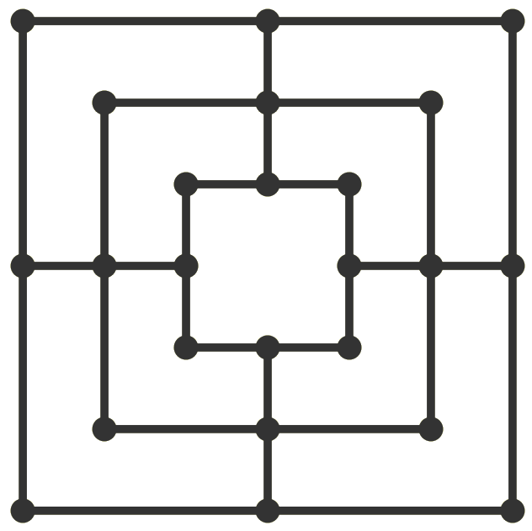

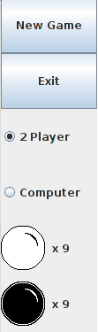

The board holds the game's board.

The menu has options to start a new game, show the game instructions, or exit the game.

The tool bar has buttons to start a new game or exit. It also has options to choose a 2 player game or a game versus the computer. There are also images that show how many pieces each player has left.

The status field is a text field that displays what the current player is supposed to do and any errors if the player tries to do an illegal move.



