**UNIVERSITY OF ASIA PACIFIC**

Department of Computer Science and Engineering



**Course Title :**

**Artificial Intelligence and Expert Systems Lab**

**Course Code : CSE 404**

|  |  |
| --- | --- |
| **Submitted By:**   1. MD. Meherub Hossain Yemon 20201037 2. Raihan Kabir 20201048 3. Md. Sohel Rahman 20201054 | **Submitted to:**  **Dr. Nasima Begum**  Associate Professor  Deparment of CSE, UAP |

# Project Name: Solving Maze Problem using A* Algorithm

**Introduction:**

The project problem is to Solving Maze Problem, using A* search algorithm and then find out the optimal path. A* algorithm is a searching algorithm that searches for the shortest path between the initial state to the final state. In this project, I will find the most optimal path from starting to the destination(goal node) using A* search algorithm.

**Objective:**

The objective of this project is to find an optimal path from starting to the goal node.

**Tools And Languages:**

* **Map Designing:** Draw.io
* **IDE:** PyCharm
* **Programing Language:** Python

**Designed Grid:**

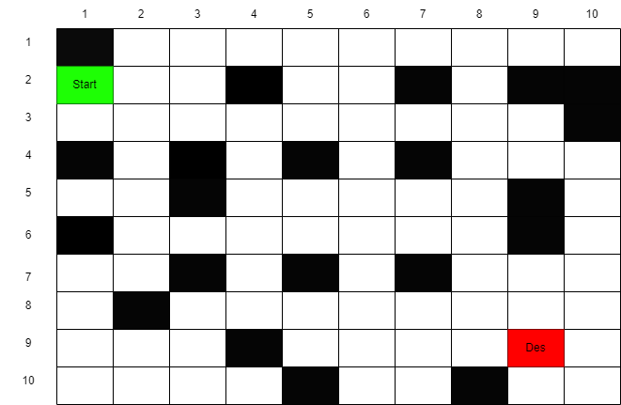

**Final Grid:**

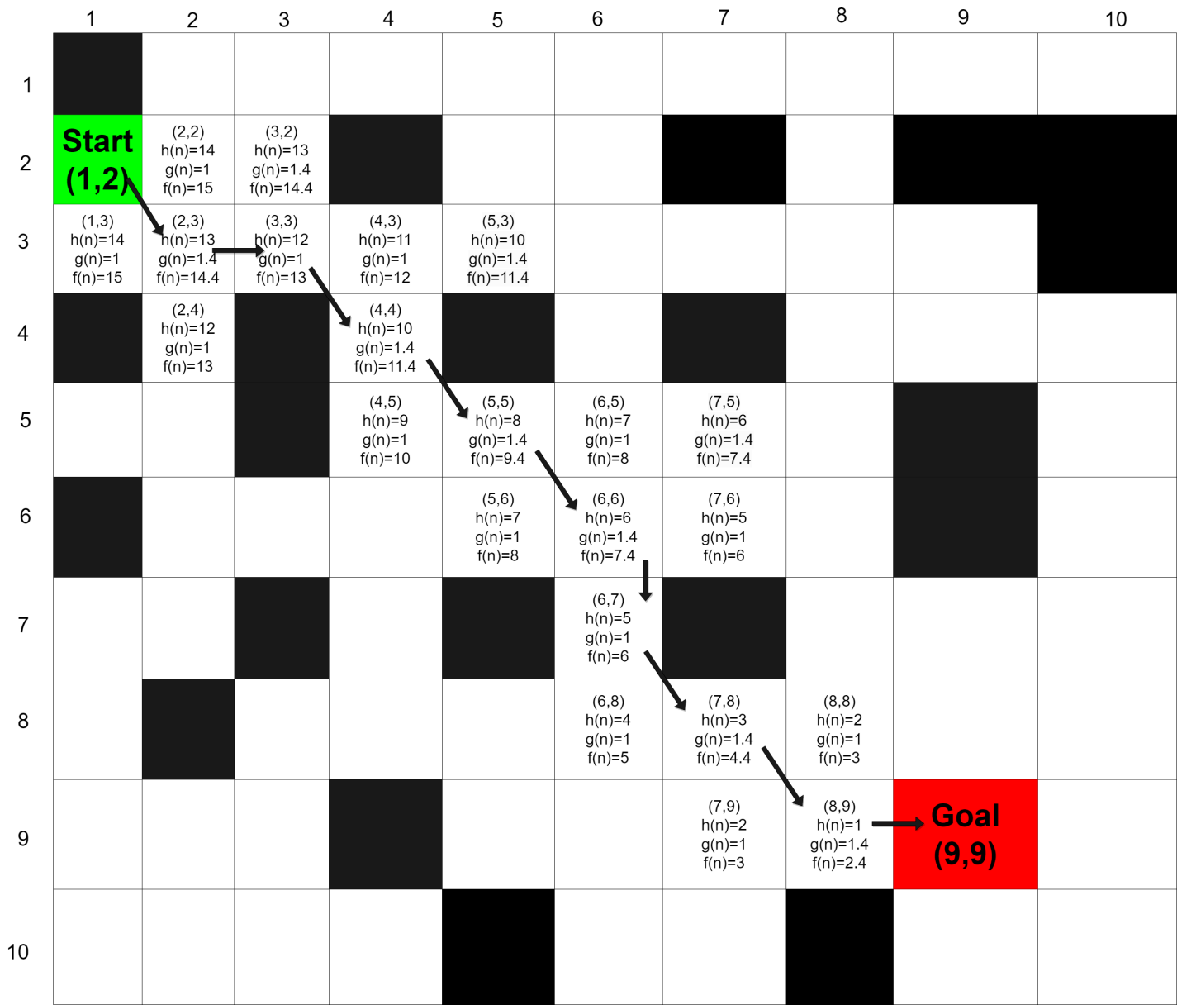

Here,

**Start Node** : Green

**Goal Node** : Red

Cost in Distance : kilometer (km)

**Implemented using python:**

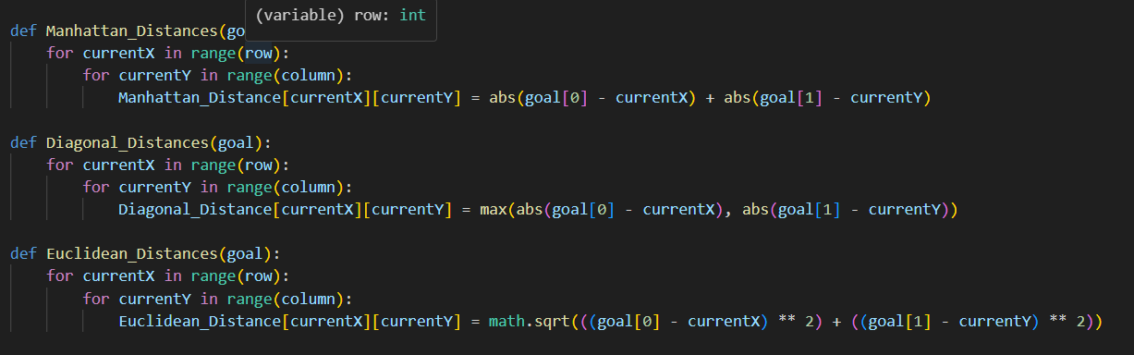

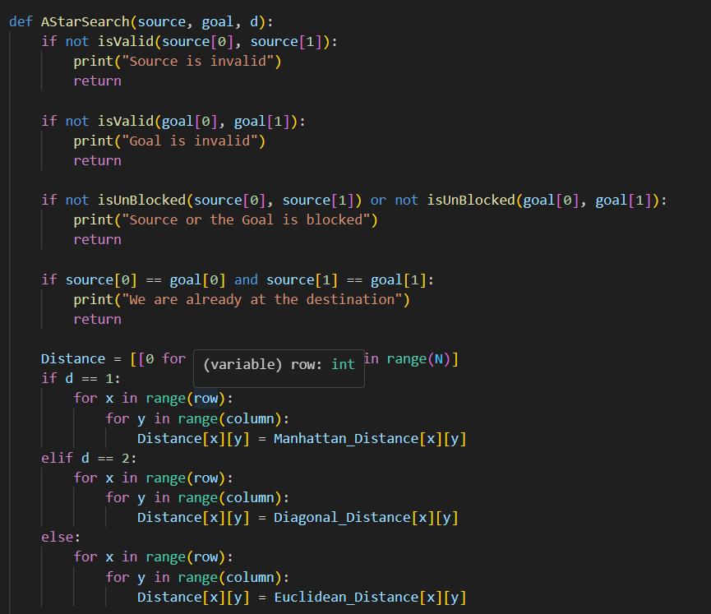

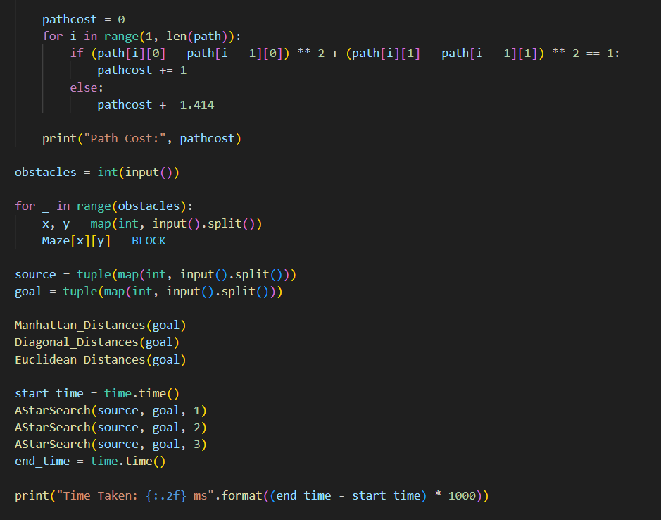

**INPUIT:**

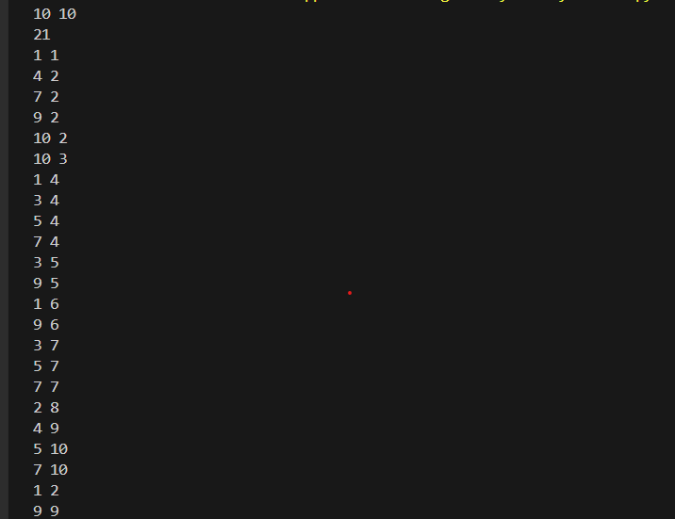

**Output:**

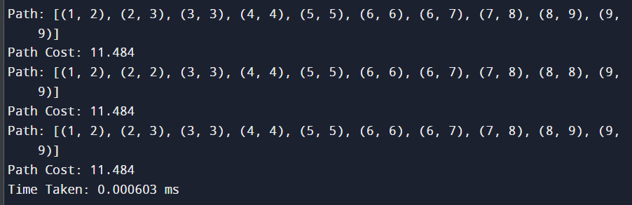

**Result Analysis:**

After Using A* Search Algorithm on this designed map, on output we can find the shortest path:

So, we can say that that is the most optimal and shortest path.

**Conclusion:**

In this project, after successful implementation, A* search algorithm gives the most optimal path as output. In conclusion, A* search algorithm is a powerful and beneficial algorithm with all the potential. So we can use this algorithm for approximate the shortest path in real-life situation, like - in maps, games etc.