JADE Web Services Integration Gateway (WSIG)

Guide

USAGE RESTRICTED ACCORDING TO LICENSE AGREEMENT.
Version: 2.0
Last update: 8-Sep-2008.
Authors: JADE Board

Copyright (C) 2007 Telecom Italia
Copyright (C) 2008 Telecom Italia

JADE - Java Agent DEvelopment Framework is a framework to develop multi-agent systems in compliance with the FIPA specifications. JADE successfully passed the 1st FIPA interoperability test in Seoul (Jan. 99) and the 2nd FIPA interoperability test in London (Apr. 01).
Copyright (C) 2000 CSELT S.p.A. (C) 2001 TILab S.p.A. (C) 2002 TILab S.p.A. (C) 2003 TILab S.p.A.
(C) 2004 TILab S.p.A (C) 2005 TILab S.p.A
This library is free software; you can redistribute it and/or modify it under the terms of the GNU Lesser General Public License as published by the Free Software Foundation, version 2.1 of the License.
This library is distributed in the hope that it will be useful, but WITHOUT ANY WARRANTY; without even the implied warranty of MERCHANTABILITY or FITNESS FOR A PARTICULAR PURPOSE. See the GNU Lesser General Public License for more details.
You should have received a copy of the GNU Lesser General Public License along with this library; if not, write to the Free Software Foundation, Inc., 59 Temple Place - Suite 330, Boston, MA 02111-1307, USA.

TABLE OF CONTENTS
1 Introduction 4
1.1 Goal 4
1.2 Compliance to standards 4
1.3 Compatibility 4
1.4 Requirements 5
2 ARCHITECTURE 6
3 Exposing agent services as web services 7
3.1 DF Service-Description to WSDL conversion overview 8
3.2 WSDL generation details 8
3.3 Service name prefix 12
3.4 Customizing the WSDL by means of an ontology mapper 12
3.5 Current limitations 13
4 INSTALLATION 14
4.1 Deployment 15
4.2 Configuration 15
4.3 WebSphere Application Server configuration 16
5 Administration GUI 18
6 APPENDIX I. Description of the examples 21

Introduction

This document describes the Web Service Integration Gateway (WSIG) add-on that provides support for invocation of JADE agent services from Web service clients. More in details section 2 outlines the architecture of WSIG and shows the mapping between a DF service-description and the corresponding WSDL, section 3 presents useful indications about deploying and configuring WSIG and section 4 gives a step-by-step guidance about how to expose agent services as Web Services by means of WSIG.
The reader is assumed to be familiar with both JADE and the Web Service technology. For those new to JADE we strongly recommend first reading the JADE Administrators Guide and Programmers Guide or the JADE Programming Tutorial, available on the JADE web site (http://jade.tilab.com).
All bugs, issues, contributions and new feature requirements should be posted to the main JADE bug reporting system, and to the standard JADE mailing lists.
Version 2.0 of the WSIG add-on was developed by the JADE Board and is only guaranteed to work with JADE release 3.5 or later.

Goal
The services web, also known as WEB SERVICES, are becoming one of the most important topics in the panorama of software development and a sort of de facto standard for interconnecting different applications. The objective of WSIG is to expose services provided by agents and published in the JADE DF as web services with no or minimal additional effort, though giving developers enough flexibility to meet specific requirements then may have.
The process involves the generation of a suitable WSDL for each service-description registered with the DF and possibly the publication of the exposed services in a UDDI registry.

Compliance to standards
The WSDL service description language defines different binding styles (rpc and document) and uses (encoded and literal). WSIG supports the most commonly adopted combinations:
- rpc/encoded according to W3C standards (http://www.w3c.org)
- document/literal wrapped in compliance with the WS-I basic profile specification (http://www.ws-i.org).
Section 4.2 describes which one to use.
All Date fields are encoded according to the ISO-8601 format.

Compatibility
WSIG 2.0 has been successfully tested with web services clients developed using AXIS 1.1, 1.2 (http://ws.apache.org/axis) and 2.0 (http://ws.apache.org/axis2) and CXF 2.0 (http://cxf.apache.org) .

Requirements
The WSIG add-on requires Java JRE v5.0 (http://java.sun.com/javase/), JADE v3.5 or later and a Servlet container such as Jakarta Tomcat (http://jakarta.apache.org/tomcat/). Furthermore, if the automatic UDDI publication feature is turned on, a suitable UDDI registry must be available.
The WSIG makes use of the following third party libraries already included in the WSIG distribution:
- Apache Axis v1.4 (http://ws.apache.org/axis/)
- Apache Commons (http://jakarta.apache.org/commons/)
- UDDI4J v2.0.5 (http://uddi4j.sourceforge.net/)
- WSDL4J v1.6.2 (http://sourceforge.net/projects/wsdl4j)
- Eclipse EMF v2.3.0 (http://www.eclipse.org/emf/)

ARCHITECTURE

The WSIG add-on supports the standard Web services stack, consisting of WSDL for service descriptions, SOAP message transport and a UDDI repository for publishing Web services using tModels. As depicted in Figure 1 WSIG is a web application composed of two main elements:
- WSIG Servlet
- WSIG Agent

The WSIG Servlet is the front-end towards the internet world and is responsible for
- Serving incoming HTTP/SOAP requests
- Extracting the SOAP message
- Preparing the corresponding agent action and passing it to the WSIG Agent
Moreover once the action has been served
- Converting the action result into a SOAP message
- Preparing the HTTP/SOAP response to be sent back to the client

The WSIG Agent is the gateway between the Web and the Agent worlds and is responsible for
- Forwarding agent actions received from the WSIG Servlet to the agents actually able to serve them and getting back responses.
- Subscribing to the JADE DF to receive notifications about agent registrations/deregistrations.
- Creating the WSDL corresponding to each agent service registered with the DF and publish the service in a UDDI registry if needed.

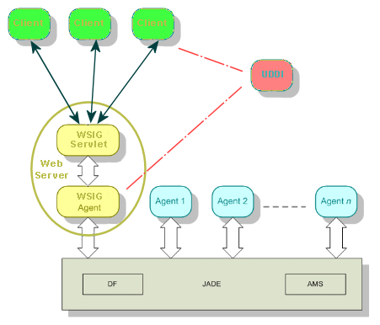
Figure 1. WSIG Architecture
Two main processes are continuously active in the WSIG web application:
- The process responsible for intercepting DF registrations/deregistrations and converting them into suitable WSDLs. As mentioned, this process is completely carried out by the WSIG Agent and is described in section 3.1.
- The process responsible for serving incoming web service requests and triggering the corresponding agent actions. This process is carried out jointly by the WSIG Servlet (performing the necessary translations) and the WSIG Agent (forwarding requests to agents able to serve them).

Exposing agent services as web services
JADE agents publish their services in the DF (Directory Facilitator) providing a structure called DF-Agent-Description and defined by the FIPA specification (www.fipa.org). A DF-Agent-Description includes one or more Service-Description each one actually describing a service provided by the registering agent. A Service-Description typically specifies, among others, one or more ontologies that must be known in order to access the published service. The actions the registering agent is actually able to perform are those defined in the specified ontologies.

In order to expose an agent service as a web service it is sufficient to set the wsig property to true in the properties of the Service-Description at DF registration time as below

……
ServiceDescription sd = new ServiceDescription();
……
sd.addProperties(new Property(“wsig”, "true"));
……

DF Service-Description to WSDL conversion overview
Each Service-Description including the wsig property set to true will be mapped to a WSDL. All actions defined in the ontologies specified in the Service-Description will be mapped to WSDL operations as depicted in Figure 2.
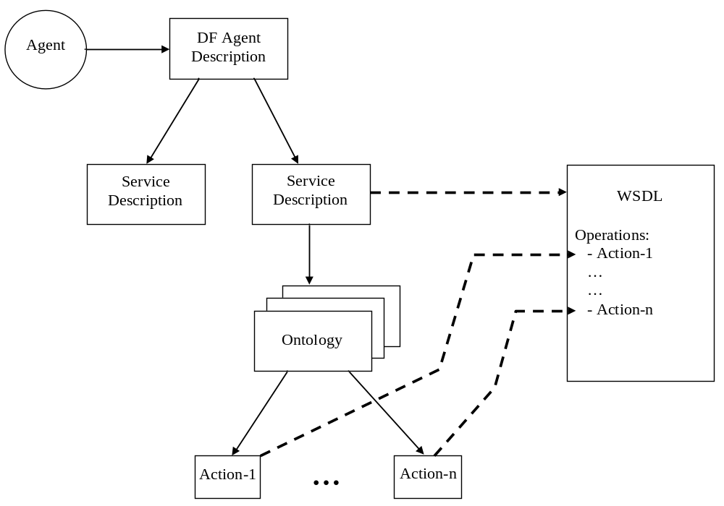
Figure 2. Mapping between DF Service-Description and WSDL
Whether or not a WSDL is also published in a UDDI registry depends on the WSIG configuration as will be presented in 4.2.
Similarly when an agent deregisters from the DF, all its services (if any) are automatically removed from the WSIG.

WSDL generation details
This section describes in details the default rules that are followed by the WSIG Agent to generate the WSDL corresponding to a Service-Description including the wsig property set to true.
- WSDL TNS (Target Name Space) = value of the name slot of the Service-Description
- For each AgentActionSchema defined in the ontology referenced by the ontology slot of the Service-Description an operation is added in the WSDL with
  - operation name = agent action schema name
  - operation parameters (name and type) = agent action schema slots (name and type)
  - operation result = agent action schema result
- Agent action result/slots whose schema is a PrimitiveSchema are mapped to basic types defined in the standard schema http://www.w3.org/2000/10/XMLSchema
- Agent action result/slots whose schema is a ConceptSchema are mapped to complex types defined within the WSDL itself
- Agent action result/slots whose schema is an AggregateSchema are mapped to complex types (labeled as ArrayOfTtt where ttt is the type of the aggregate elements) defined within the WSDL itself
- The same mappings apply recursively in case of complex result/slots.
- If an agent action slot is optional, the related operation parameter is marked with minOccurs = “0”.
- If the wsdl.writeEnable configuration property is set to true (see 4.2) → WSDL file = value of the name slot of the Service-Description plus the .wsdl extension

The WSDL document is built using network services definition standard elements:
- Types – a container for data type definitions using some type system (such as XSD).
- Message – typed definition of the data being communicated.
- Operation – description of an action supported by the service.
- Port Type – set of operations supported by one or more endpoints.
- Binding – a concrete protocol and data format specification for a particular port type.
- Port – a single endpoint defined as a combination of a binding and a network address.
- Service – a collection of related endpoints.

The WSDL service description language defines different binding styles (rpc and document) and uses (encoded and literal). WSIG only supports the most commonly adopted combinations i.e. rpc/encoded and document/literal wrapped. Section 4.2 describes which one to use. As an example the WSDL corresponding to the sumcomplex (sum of 2 complex numbers) operation of the MathService included among the WSIG examples is reported below for both supported styles.

WSDL for the document/literal wrapped style

<?xml version="1.0" encoding="UTF-8"?>
<wsdl:definitions name="MathFunctions" targetNamespace="urn:MathFunctions" xmlns:impl="urn:MathFunctions" xmlns:wsdlsoap="http://schemas.xmlsoap.org/wsdl/soap/" xmlns:xsi="http://www.w3.org/2001/XMLSchema-instance" xmlns:xsd="http://www.w3.org/2001/XMLSchema" xmlns:wsdl="http://schemas.xmlsoap.org/wsdl/">
<wsdl:types>
<xsd:schema targetNamespace="urn:MathFunctions" xmlns:impl="urn:MathFunctions" xmlns:xsd="http://www.w3.org/2001/XMLSchema"><xsd:annotation/><xsd:element name="sumcomplex"><xsd:complexType><xsd:sequence><xsd:element name="firstComplexElement" type="impl:complex"/><xsd:element name="secondComplexElement" type="impl:complex"/></xsd:sequence></xsd:complexType></xsd:element><xsd:complexType name="complex"><xsd:sequence><xsd:element name="real" type="xsd:float"/><xsd:element minOccurs="0" name="immaginary" type="xsd:float"/></xsd:sequence></xsd:complexType><xsd:element name="sumcomplexResponse"><xsd:complexType><xsd:sequence><xsd:element name="sumcomplexReturn" type="impl:complex"/></xsd:sequence></xsd:complexType></xsd:element></xsd:schema>
</wsdl:types>
<wsdl:message name="sumcomplexRequest">
<wsdl:part name="parameters" element="impl:sumcomplex">
</wsdl:part>
</wsdl:message>
<wsdl:message name="sumcomplexResponse">
<wsdl:part name="parameters" element="impl:sumcomplexResponse">
</wsdl:part>
</wsdl:message>
<wsdl:portType name="MathFunctionsPort">
<wsdl:operation name="sumcomplex">
<wsdl:input message="impl:sumcomplexRequest">
</wsdl:input>
<wsdl:output message="impl:sumcomplexResponse">
</wsdl:output>
</wsdl:operation>
</wsdl:portType>
<wsdl:binding name="MathFunctionsBinding" type="impl:MathFunctionsPort">
<wsdlsoap:binding style="document" transport="http://schemas.xmlsoap.org/soap/http"/>
<wsdl:operation name="sumcomplex">
<wsdlsoap:operation soapAction="urn:MathFunctionsAction"/>
<wsdl:input>
<wsdlsoap:body use="literal"/>
</wsdl:input>
<wsdl:output>
<wsdlsoap:body use="literal"/>
</wsdl:output>
</wsdl:operation>
</wsdl:binding>
<wsdl:service name="MathFunctionsService">
<wsdl:port name="MathFunctionsPort" binding="impl:MathFunctionsBinding">
<wsdlsoap:address location="http://localhost:8080/wsig/ws/MathFunctions"/>
</wsdl:port>
</wsdl:service>
</wsdl:definitions>

WSDL for the rpc/encoded style

<?xml version="1.0" encoding="UTF-8"?>
<wsdl:definitions name="MathFunctions" targetNamespace="urn:MathFunctions" xmlns:impl="urn:MathFunctions" xmlns:wsdlsoap="http://schemas.xmlsoap.org/wsdl/soap/" xmlns:xsi="http://www.w3.org/2001/XMLSchema-instance" xmlns:xsd="http://www.w3.org/2001/XMLSchema" xmlns:wsdl="http://schemas.xmlsoap.org/wsdl/">
<wsdl:types>
<xsd:schema targetNamespace="urn:MathFunctions" xmlns:impl="urn:MathFunctions" xmlns:xsd="http://www.w3.org/2001/XMLSchema"><xsd:annotation/><xsd:complexType name="complex"><xsd:sequence><xsd:element name="real" type="xsd:float"/><xsd:element minOccurs="0" name="immaginary" type="xsd:float"/></xsd:sequence></xsd:complexType></xsd:schema>
</wsdl:types>
<wsdl:message name="sumcomplexRequest">
<wsdl:part name="firstComplexElement" type="impl:complex">
</wsdl:part>
<wsdl:part name="secondComplexElement" type="impl:complex">
</wsdl:part>
</wsdl:message>
<wsdl:message name="sumcomplexResponse">
<wsdl:part name="sumcomplexReturn" type="impl:complex">
</wsdl:part>
</wsdl:message>
<wsdl:portType name="MathFunctionsPort">
<wsdl:operation name="sumcomplex">
<wsdl:input message="impl:sumcomplexRequest">
</wsdl:input>
<wsdl:output message="impl:sumcomplexResponse">
</wsdl:output>
</wsdl:operation>
</wsdl:portType>
<wsdl:binding name="MathFunctionsBinding" type="impl:MathFunctionsPort">
<wsdlsoap:binding style="rpc" transport="http://schemas.xmlsoap.org/soap/http"/>
<wsdl:operation name="sumcomplex">
<wsdlsoap:operation soapAction="urn:MathFunctionsAction"/>
<wsdl:input>
<wsdlsoap:body use="encoded" encodingStyle="http://schemas.xmlsoap.org/soap/encoding/"/>
</wsdl:input>
<wsdl:output>
<wsdlsoap:body use="encoded" encodingStyle="http://schemas.xmlsoap.org/soap/encoding/"/>
</wsdl:output>
</wsdl:operation>
</wsdl:binding>
<wsdl:service name="MathFunctionsService">
<wsdl:port name="MathFunctionsPort" binding="impl:MathFunctionsBinding">
<wsdlsoap:address location="http://localhost:8080/wsig/ws/MathFunctions"/>
</wsdl:port>
</wsdl:service>
</wsdl:definitions>

Service name prefix
Considering the mapping described in the previous section it is clear that if two agents register two Service-Descriptions with the same name there is a conflict due to the fact that two WSDL definitions have the same name. To avoid this conflict it is possible to use the wsig-prefix Service-Description property (as exemplified in the code snippet below) to specify a label that will be used to prefix both the Target Name Space and the WSDL file name (if generated).

……
ServiceDescription sd = new ServiceDescription();
……
sd.addProperties(new Property(“wsig”, "true"));
sd.addProperties(new Property(“wsig-prefix”, "prefix"));
……

Customizing the WSDL by means of an ontology mapper
In many cases it is highly desirable to customize the exposed web services operations. For instance in case of an action with several optional slots that are only used in particular conditions, one may wish to expose an operation with only those parameters that are meaningful when the operation is invoked by an external Web Service client. Similarly in many cases an agent may be able to support (or may whish to expose as web service operations) only a subset of the actions included in an ontology.
To meet these customization requirements the WSIG add-on provides a flexible mechanism based on so called “ontology mapper” classes. An ontology mapper is a class providing a set of methods of the form
public <action-class> to<action-name>(<parameters>) {
…
}
When an ontology mapper is specified in a DF Service-Description, for each action my-action defined in the ontology referenced by the Service-Description and associated to an AgentAction class MyActionClass, the WSIG agent searches for a method with signature
public MyActionClass toMyAction(…)
in the mapper class. If one such method is found, the slots of the my-action action are ignored and the parameters of the toMyAction() method are used (names and types) as parameters of the my-action web service operation. Furthermore if the toMyAction(...) method is annotated with the @OperationName annotation (included in the com.tilab.wsig.store package), the value of the name attribute of that annotation will be used (instead of my-action) to name the exposed web service operation.
When the web service operation is invoked, the WSIG agent extracts the operation parameters from the SOAP message and uses them to call the toMyAction() method of the ontology mapper. This method is responsible for building the MyActionClass action object that will be forwarded to the target agent.
Summarizing, the role of an ontology mapper is twofold;
- At service registration time the signatures of its methods define the parameters (and possibly the name) of the web service operations to be exposed.
- At service invocation time its methods are used to create the objects representing the actions the target agent is actually requested to perform.
The MathOntologyMapper class included among the examples packaged with the WSIG distribution provides an example of ontology mapper class.

By means of the @SuppressOperation annotation it is then possible not to expose as web service operation a given ontology action. as exemplified in the code snippet below.

@SuppressOperation
public MyActionClass toMyAction() {
return null;
}

In order to specify an ontology mapper the wsig-mapper service description property must be used as exemplified in the code snippet below.

……
ServiceDescription sd = new ServiceDescription();
……
sd.addProperties(new Property(“wsig”, "true"));
sd.addProperties(new Property(“wsig-mapper”,”com.tilab.wsig.examples.MathOntologyMapper"));
……

It should be noted that parameters of the toXXX() methods in an ontology mapper class must be either primitive types, complex types defined in the reference ontology or array of the above types.

Current limitations
Version 2.0 of the WSIG add-on has the following known limitations.
- The JADE main container must be already up and running when the WSIG web application is started.
- Even if a Service-Description can reference several ontologies, WSIG is able to handle only one.
- When using an ontology mapper, arguments of the toXXX() methods of the mapper class cannot be Java collections. Arrays must be used instead.
- All slots/results that are aggregates of elements of a given type (i.e. slots defined by means of the add(String slotName, TermSchema schema, int cardMin, int cardMax) method) must have the same cardinality.
- In rpc/encoded style the MULTIREF soap request is not supported. Note that AXIS 1.x use this formalism as default → In order to create AXIS 1.x based clients able to access Web services exposed by WSIG it is necessary to disable the MULTIREF option (see the AXIS documentation for details).

INSTALLATION

The Web Service Integration Gateway is a JADE add-on and, as such, requires JADE 3.5 or later to be already installed. Furthermore, being WSIG a web application, it is necessary to have a Servlet Container such as Apache Tomcat, properly installed and configured (the details on servlet container installation and configuration are out of the scope of this document).
In order to install the WSIG add-on the following steps must be performed.
Download the WSIG distribution file from the add-ons area of the JADE web site (http://jade.tilab.com).
Unzip the WSIG distribution file in the JADE home directory. You should end-up with a directory structure like that depicted in Figure 3.
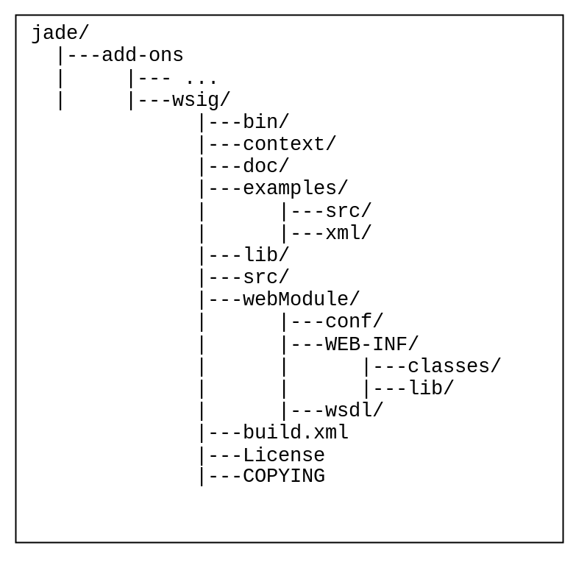
Figure 3. WSIG directory structure

A brief description of the content of each directory is presented hereafter.
- bin: contains a number of startup scripts both in bat (Windows) and sh (Linux/Unix) form.
- context: contains the WSIG web application context file that can be used for customized installations
- doc: contains the WSIG documentation including this guide
- examples: contains the source files of the WSIG example (MathAgent)
- lib: contains third party libraries used by the WSIG add-on (including the related licenses) mentioned in 1.4
- src: contains the WSIG source code
- webModule: contains the structure of the WSIG web application as it will appear in the wsig.war file.
- build.xml: this is the ANT build file by means of which it is possible to compile, and deploy the WSIG web application as will be described in the following section

Deployment
As mentioned WSIG is a web application that must be deployed in a servlet container such as Apache Tomcat and will be executed within the JVM of the servlet container. As a consequence both the WSIG own classes, the third party libraries used by WSIG, and all ontologies and mapper classes the WSIG will have to deal with must be included in the WSIG web application classpath.
Considering the above requirement the typical process to deploy the WSIG add-on in a real application involves the following steps:
- Prepare the WSIG web application content in the webModule directory. This step can be performed by means of the build target of the ANT build file included in the WSIG distribution.
- Copy ontology and mapper application specific jar files in the webModule/WEB-INF/lib directory.
- Edit the webModule/conf/wsig.properties file to specify required WSIG configurations as will be described in 4.2.
- Create the WSIG war file by zipping the content of the webModule directory. This step can be performed by means of the createWar target of the ANT build file included in the WSIG distribution. The produced war file is put in the (newly created if necessary) webapps directory.
- Copy the WSIG war file into the webapps directory of the servlet container.
Alternatively one can create the (application agnostic) WSIG war file by means of the war target of the ANT build file included in the WSIG distribution, copy it into the webapps directory of the servlet container and then copy application specific ontology and mapper jar files and edit WSIG configurations directly in the servlet container directory structure.

Configuration
All WSIG configurations can be set by editing the webModule/conf/wsig.properties file. This file includes both the configurations of the JADE container that will host the WSIG agent (such as the host and port of the Main Container) and the WSIG specific configurations. For the configurations of the JADE container the reader is redirected to the JADE Administrator’s guide since all JADE configuration options can be used. WSIG specific configurations are summarized in Table 1.
Parameter | Description | Default value
wsig.agent | Fully qualified class name of the WSIG agent in case one needs to extend/modify the base functionality of the WSIGAgent class | com.tilab.wsig.agent.WSIGAgent
wsig.uri | URL to invoke the WSIG | http://localhost:8080/wsig/ws
wsig.style | Defines the style to use. Supported values are rpc (indicates rpc/encoded) and document (indicates document/literal wrapped) | document
wsig.timeout | Timeout (in milliseconds) for the execution of agent actions corresponding to WSIG invocations | 30000
wsdl.localNamespacePrefix | TNS prefix used in WSDL construction | impl
wsdl.writeEnable | Tells WSIG whether or not to store generated WSDL descriptions to .wsdl filess | false
wsdl.directory | The directory, relative to the WSIG web application root (webModule) where to store generated WSDL files. Has no effect if wsdl.writeEnable is set to false | wsdl
UDDI registry configuration section
uddi.enable | Flag that specifies whether or not generated WSDLs must be published in a UDDI registry too. If this option is set to false all other options in this section are ignored | false
uddi.queryManagerURL | UDDI inquiry URL
uddi.lifeCycleManagerURL | UDDI publication URL
uddi.businessKey | UDDI business key
uddi.userName | UDDI username
uddi.userPassword | UDDI password
UDDI4j configuration section
org.uddi4j.logEnabled | Flag used to turn on/off UDDI4j logs | true
org.uddi4j.TransportClassName | The class implementing the protocol used to interact with the UDDI registry | org.uddi4j.transport.ApacheAxisTransport
Ontologies section
onto.<ontology-name>
Table 1. WSIG configuration properties
The ontologies section includes a number of application specific properties describing the ontologies the WSIG will have to deal with. In particular for each such ontology there must be a property of the form
onto.<ontology-name>=<ontology-fully-qualified-classname>
For instance if the WSIG is expected to expose as web services agent services referring to the math-ontology implemented by the com.tilab.wsig.examples.MathOntology class, the wsig.properties file must include a property of the form
onto.math-ontology=com.tilab.wsig.examples.MathOntology

WebSphere Application Server configuration
Only when deploying WSIG applications on IBM WebSphere Application Server (WAS) 6.0 or 6.1, you must configure the server to use the application's class loader before the container or system class loaders; this will ensure that the WSDL4J classes that are in /WEB-INF/lib directory will be loaded before those in $WAS_HOME/lib.
If you are developing and deploying your application through IBM Rational Application Developer (RAD), you can make the required changes by setting the class loader mode to PARENT_LAST.
If you are installing your application through the WAS admin console, select Enterprise Applications > Your Application > Class loading and update detection. You should then check the boxes labeled as follows:
- Classes loaded with application class loader first
- Single class loader for application
Making these changes should not affect your other applications.

Administration GUI

The WSIG add-on comes with a simple administration Web GUI by means of which it is possible to check the exposed web services. If the standard installation described in section 4 is followed the WSIG administration GUI can be reached at the http://localhost:8080/wsig URL.
As depicted in Figure 4 the main page shows the list of exposed web services and the configuration parameters.

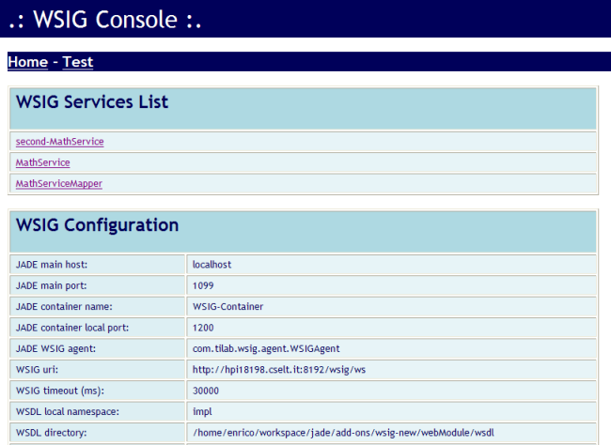
Figure 4. The WSIG Administration GUI

By clicking on a service in the services list the relevant information about that service will be shown. These include the agent providing the service, the referenced ontology, the mapper and prefix if any, the list of available operations and a link to the WSDL (see Figure 5).
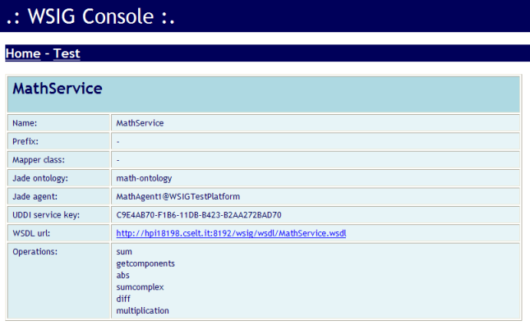
Figure 5. WSIG Administration GUI: Service details
The WSIG GUI also includes a test page by means of which it is possible to trigger SOAP requests towards an exposed web service. This is done by pasting an XML request message in the SOAP Request area and clicking on the Send button. The response message will appear in the SOAP Response area (see Figure 6). A number of XML request messages referring to the MathAgent example are included in the examples/xml directory of the WSIG distribution.

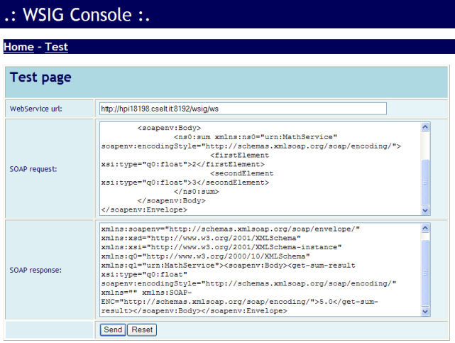
Figure 6. WSIG Administration GUI: Test page

APPENDIX I. Description of the examples

The WSIG add-on comes with some examples that aim at clarifying how to exploit it to expose agent services as web services. These examples refer to a minimal MathOntology defining concepts and actions dealing with simple mathematical operations such as SUM, and MULTIPLICATION of possibly COMPLEX numbers. The bin directory includes .bat and .sh scripts to start these examples.
In order to try the WSIG examples the following steps should be performed (the same sequence of steps apply to the .sh scripts in case you are working on a Linux/Unix machine).
- Launch the runJade.bat script to start the JADE Main Container
- Create the WSIG web application including the WSIG examples by means of the war-examples target of the ANT build file included in the WSIG distribution.
- Deploy the webapps/wsig.war file (produced in the previous step) in Tomcat.
- Start Tomcat
- Look at the JADE administration GUI (RMA): a new container including the WSIG agent should appear.
- Launch the runMathAgent.bat script to start (in a new container) an agent registering a service (called MathService) referring to the MathOntology
- Launch the runMathAgentPrefix.bat script to start (in a new container) an agent registering the same MathService but specifying a prefix
- Launch the runMathAgentMapper.bat script to start (in a new Container) an agent registering another service (called MathServiceMapper) and specifying an ontology mapper.
- Use the WSIG test console or the runSoapClient.bat script to perform web service invocations on the services exposed by the agents started in the previous steps. The directory examples/xml contains several raw SOAP requests to be used to query that services.

If the document/literal style is used the type is ignored
Since version 3.5 of JADE, it is possible to associate a result to an agent action by means of the setResult(TermSchema ts) and setResult(TermSchema ts, int cardMin, int cardMax) methods of the AgentActionSchema class.

