How to install and run wsig-examples in 5 steps
Author : Sebastien Heymann <sebastien.heymann@tremplin-utc.net>
Date : 2008-29-12

Requirements :
- Be familiar with Eclipse IDE
- Be familiar with Jade
- Knowing how to install and set up Tomcat (out of consideration here)

Notes :
- This document is about the setting of a development environment for WSIG, do not use it in production mode.
- The tutorial is based on the WSIG guide (v2.1), especially the MathAgent example.

Distribution :
- JADE v3.6.1 - http://jade.tilab.com
- WSIG v2.1 - http://jade.tilab.com/community-addons.php

Softwares installed during this tutorial :
- Java Run Time Environment v1.5 necessary (tested in v1.6)
- Eclipse 3.4+ - http://www.eclipse.org
- Eclipse Web Tools Project (WTP) 3.0.3+
- Java EE Developer Tools minimum installation
- Subclipse 1.4.7+ - http://subclipse.tigris.org
- Apache Tomcat 5.5 - http://tomcat.apache.org

Step 1 – Installing Tomcat and Eclipse
First install Tomcat. It is available in official repositories for Ubuntu. In this system, do not forget to remove the autostart daemon by the following command line :

sudo update-rc.d -f tomcat5.5 remove

Install the Eclipse you want (http://www.eclipse.org/downloads/ ). We use the Classic distribution in this tutorial.
Illustration 1: http://www.eclipse.org/downloads/
- Create an empty workspace dedicated to the project, and restart Eclipse to use it.
- Go to Help > Software Updates, then add http://download.eclipse.org/webtools/updates.
- Install Java EE Developer Tools (in Eclipse Web Tools Project (WTP) 3.0.3). Note that Axis is not required because WSIG distribution contains it.
- Finally add the site http://subclipse.tigris.org/update_1.4.x, and download Subclipse, an integrated SVN tool.

Step 2 – Getting the project
- Click on File > New > Other... > SVN > Checkout Projects from SVN

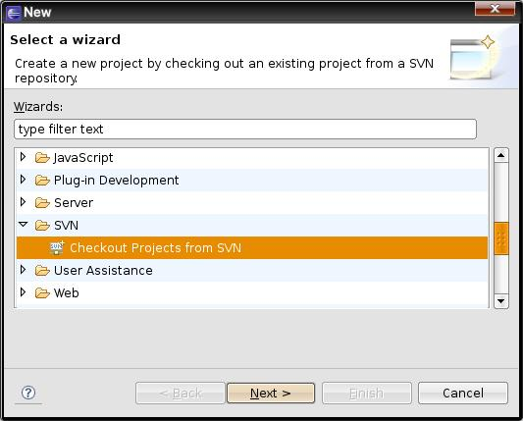
- Click on create a new repository location
- Then add https://wsig-examples.googlecode.com/svn/trunk/.
- Select wsig-examples-read-only (or wsig-examples if you have the right perrmissions for on the SVN) and finish.

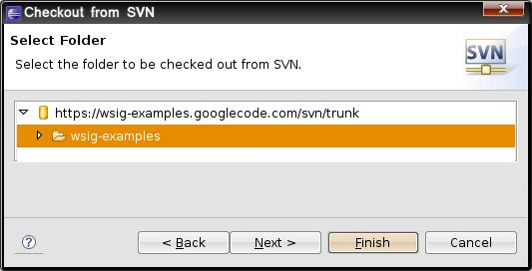
This project is a Dynamic Web Project. Once the repository content downloaded and the workspace automatically updated, Eclipse declares an error :

"Target runtime Apache Tomcat v5.5 is not defined. wsig-examples Unknown Faceted Project Problem"

This is normal at this stage, we will define a server in step 4.

Step 3 – Jade platform and agents
Create and start the following Debug Configurations as Java Application :
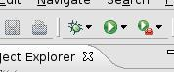

runJadePlatform
Project | wsig-examples
Main class | jade.Boot
Program arguments | -gui
Click on Debug to launch the Jade platform.

runMathAgent
Project | wsig-examples
Main class | jade.Boot
Program arguments | -gui -container "MathAgent1:com.tilab.wsig.examples.MathAgent(MathFunctions false)" -name "WSIGTestPlatform"
Click on Debug to launch the MathAgent1 agent, instance of MathFunctions.

runMathAgentPrefix
Project | wsig-examples
Main class | jade.Boot
Program arguments | -gui -container "MathAgent2:com.tilab.wsig.examples.MathAgent(MathFunctions false second)" -name "WSIGTestPlatform"
Click on Debug to launch the MathAgent2 agent, instance of MathFunctions.

runMathAgentMapper
Project | wsig-examples
Main class | jade.Boot
Program arguments | -gui -container "MathAgent3:com.tilab.wsig.examples.MathAgent(MathFunctionsMapper true)" -name "WSIGTestPlatform"
Click on Debug to launch the MathAgent3 agent, instance of MathFunctionsMapper.

Please refer to the WSIG guide for more details on these agents.

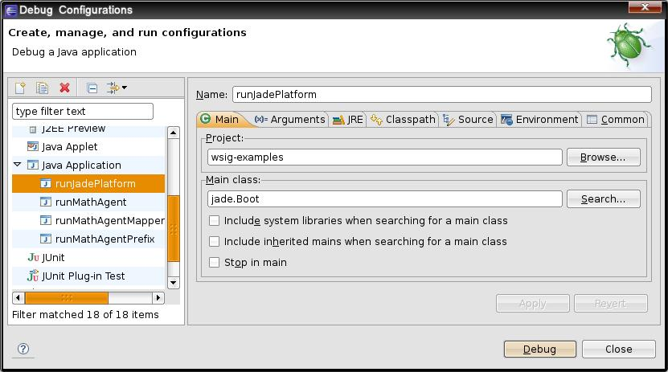

Launch
In the future, agents will be directly launchable through the toolbar :
Debug > runJadePlatform
Debug > runMathAgent
Debug > runMathAgentPrefix
Debug > runMathAgentMapper
The Jade Platform GUI must have appeared. You can now see the 3 agents evolving in 3 different containers. These agents are independent from each other.

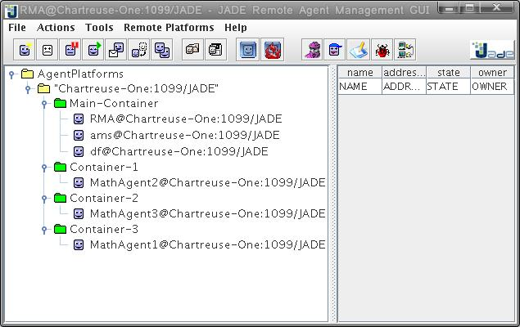Illustration 2: Jade Platform GUI

Step 4 – Adding the serveur

Procedure
- Switch on JavaEE perspective.
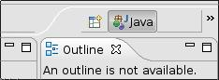

=>

- Select the wsig-examples project in the projects list.

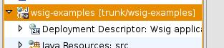
- Create the application's Debug Configuration (Debug > Debug As > Debug on server) : choose Manually define a new server of type Apache > Tomcat v5.5 Server, tick Always use this server when running this project, and click on Next.

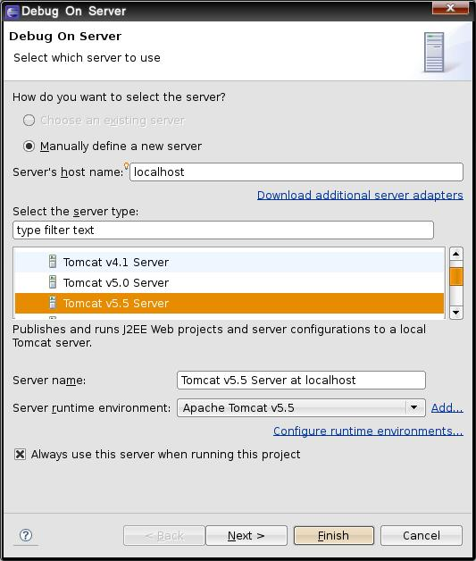

- Fill in the installation path of Tomcat, /usr/share/tomcat5.5 on Ubuntu 7.10, and click on Next.
- Add wsig-examples to the projects configured for this server, and finish.

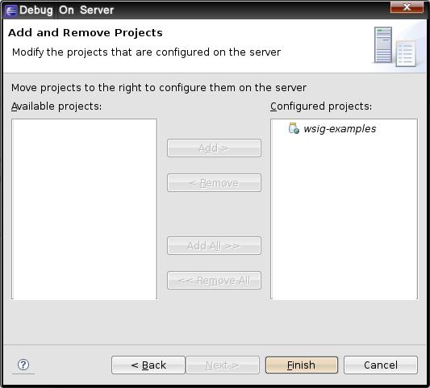

Settings
In projects view, a new project appeared : Servers. It contains a directory with Tomcat setting files inside (the XML files).

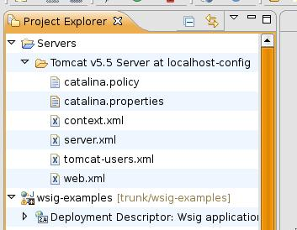
To know the listened port by the server, open server.xml. This is my default configuration :

<!-- Define a non-SSL HTTP/1.1 Connector on port 8180 -->
<Connector acceptCount="100" connectionTimeout="20000" disableUploadTimeout="true"
enableLookups="false" maxHttpHeaderSize="8192" maxSpareThreads="75" maxThreads="150"
minSpareThreads="25" port="8180" redirectPort="8443"/>
...
<!-- Define an AJP 1.3 Connector on port 8009 -->
<Connector enableLookups="false" port="8009" protocol="AJP/1.3" redirectPort="8443"/>

If you change the ports, modifications will be synchronized immediately.

The wsig-examples application is declared at the end of the file :

<Context docBase="wsig-examples" path="/wsig-examples" reloadable="true"
source="org.eclipse.jst.j2ee.server:wsig-examples"/></Host>

When reloadable is true, the modifications are directly propagated on the server, which is very useful to test source code on the fly. Without this mechanism, you would have to package the application in a war archive and deploy it on the server each time you want to test it.

Step 5 – Deployment and use
The server starts immediately after having been added, and deploys the application. The ControlWSIG agent is then created inside WSIG-Container. The WSIG console is available on http://localhost:8180/wsig-examples/ (depends on the port you set) with your favorite browser.

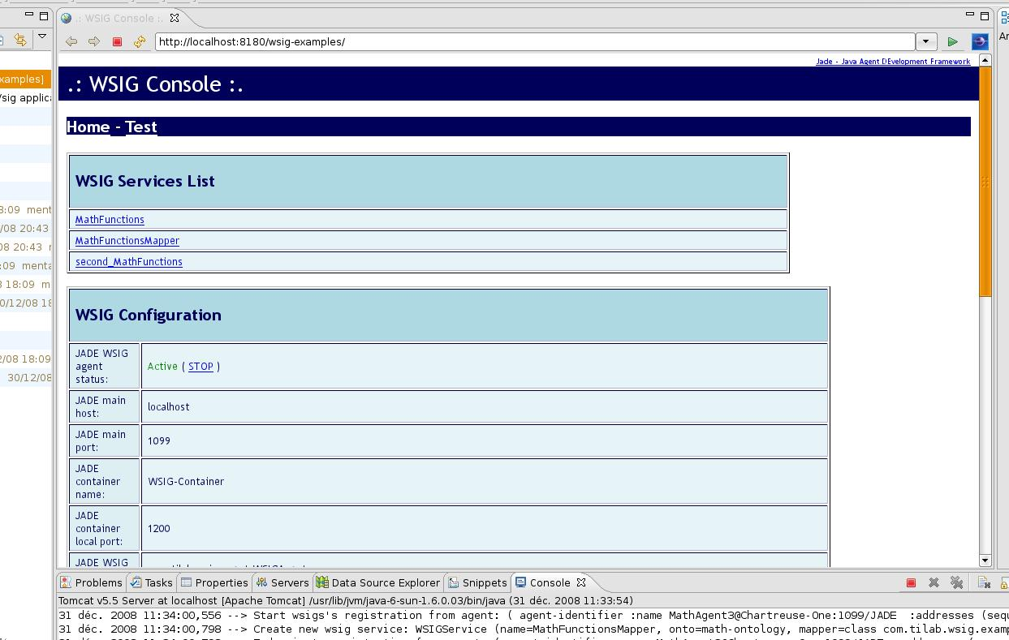Illustration 3: WSIG's web console

Use
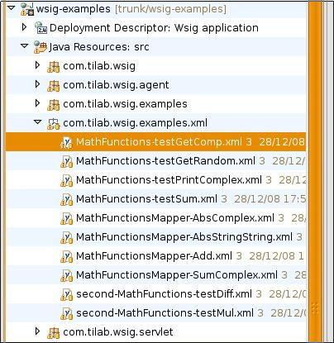
The web services corresponding to our agents are listed in Home page, in WSIG Services List. The sample SOAP requests are in src/com.tilab.wsig.examples.xml :

Go to the Test page to execute the sample requests proposed in this package : copy the XML content to test in SOAP request. Send the request, and that's it !

Note that :
- If the server replies that the web service doesn't exist ("Service xxx not present in wsig"), you should check that the corresponding agent is started.
- If you deactivate the ControlWSIG agent through the web console and reactivate it, the other agents will be stopped. Start them again (without stopping the server), and refresh the Home page to see them again in the list.

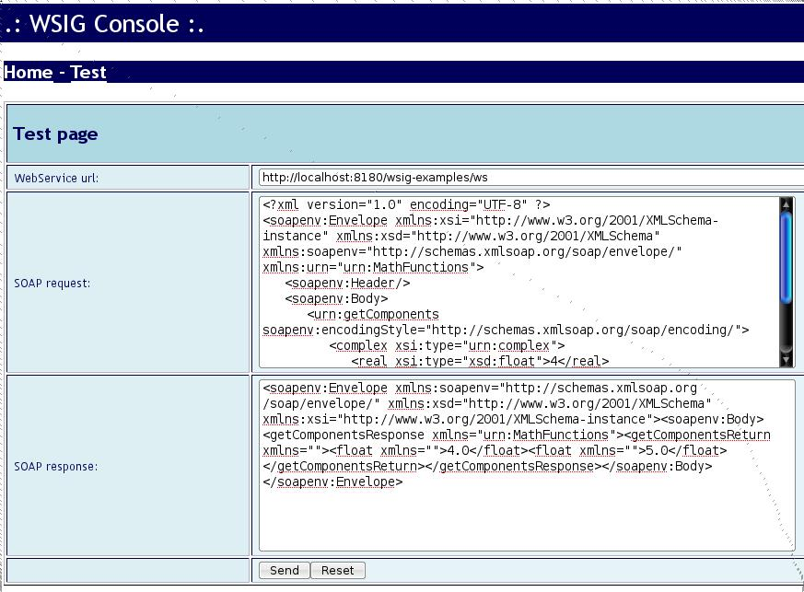Illustration 4: SOAP request test

Manual launch
- Launch the Jade platform
- Launch the agents
- In the Servers tab on the bottom of the screen, right click on the server name and click on Debug, or directly launch wsig-examples through the Run > Debug menu or the toolbar.

Stop
To stop everything properly :
- Right click on the server name and click on Stop.
- Then stop Jade through the GUI by clicking on File > Shut down Agent Platform.

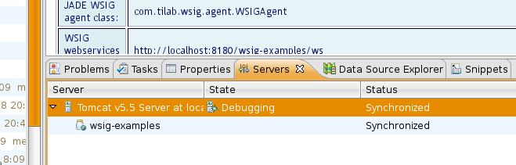

For more details on Jade and WSIG, please refer to their guides.

