1.编译该工程：

mvn clean install -Dmaven.test.skip

2.把生成的libgdx-game-engine-support-0.0.1.jar 复制到ligGdx项目*-core的libs文件夹下，如果没有该文件夹就新建一个

3.修改ligGdx工程的依赖

进入到libGdx项目：找到build.gradle文件：在project(":core")的dependencies中增加：

compile files("libs/libgdx-game-engine-support-0.0.1.jar")

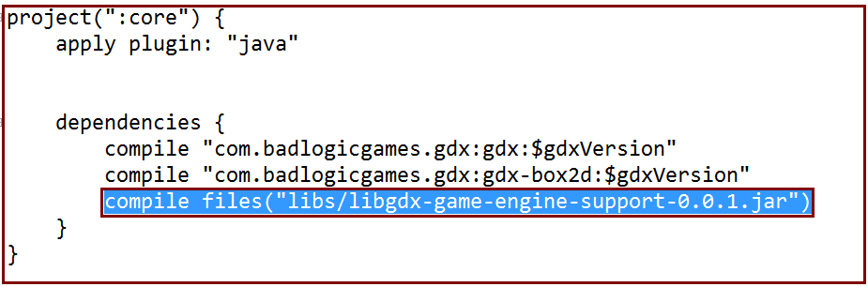

4.将*-core项目的程序入口类继承GameEngine

比如：

public class MyGdxGame extends GameEngine{

…………………..

public MyGdxGame() { }

public MyGdxGame(GameEvent event) {

super(event);

}

…………………..

}

调用：mainGame.getEvent().onEvent2Android("hi bad body");//发送消息到android

其中mainGame是类MyGdxGame的引用

5.*-android项目

5.1-新建类TestGameEvent继承GameEventAdapter<MyGdxGame>

代码如下：

public class TestGameEvent extends GameEventAdapter<MyGdxGame> {

Context context;

public TestGameEvent(Context context) {

this.context = context;

}

Handler mHandler = new Handler() {

public void handleMessage(android.os.Message msg) {

Toast.makeText(context, (String)msg.obj, Toast.LENGTH_SHORT).show();

};

};

@Override

public void onEvent2Android(String msg) {

System.out.println(msg);

Message message = Message.obtain();

message.obj = msg;

message.what = 1;

mHandler.sendMessage(message);

}

@Override

public void onEvent2LibGdx(String msg) {

getGameEngine().setScreen(getGameEngine().getStartScreen());

}

}

5.2-修改入口类public class AndroidLauncher extends AndroidApplication

代码如下：

public class AndroidLauncher extends AndroidApplication {

Button mButton;

@Override

protected void onCreate(Bundle savedInstanceState) {

super.onCreate(savedInstanceState);

setContentView(R.layout.activity_main)

AndroidApplicationConfiguration config = new AndroidApplicationConfiguration();

// initialize(new MyGdxGame(), config);

final TestGameEvent testGameEvent = new TestGameEvent(getApplicationContext());

final MyGdxGame myGdxGame = new MyGdxGame(testGameEvent);

SurfaceView gameView = (SurfaceView) initializeForView(myGdxGame, config);

addContentView(gameView, createLayoutParams());

mButton = (Button) findViewById(R.id.btn);

mButton.setOnClickListener(new View.OnClickListener() {

@Override

public void onClick(View v) {

testGameEvent.onEvent2LibGdx("hello");

}

});

}

protected FrameLayout.LayoutParams createLayoutParams() {

FrameLayout.LayoutParams layoutParams = new FrameLayout.LayoutParams(

android.view.ViewGroup.LayoutParams.MATCH_PARENT, 800);

layoutParams.gravity = Gravity.CENTER;

return layoutParams;

}

}

5.3-XML文件修改layout/activity_main.xml

代码如下：

<?xml version="1.0" encoding="utf-8"?>

<RelativeLayout xmlns:android="http://schemas.android.com/apk/res/android"

android:layout_width="match_parent"

android:layout_height="match_parent"

android:orientation="horizontal" >

<LinearLayout

android:layout_width="match_parent"

android:layout_height="match_parent" >

<Button

android:id="@+id/btn"

android:text="你我一下"

android:layout_width="wrap_content"

android:layout_height="wrap_content" />

</LinearLayout>

</RelativeLayout>