**Olist E-commerce Data Analysis Report**

**------------------------------------------------------------------------------------------------------------------------**

* **What is the Average Order Value (AOV), and how does it vary by product category and payment method?**

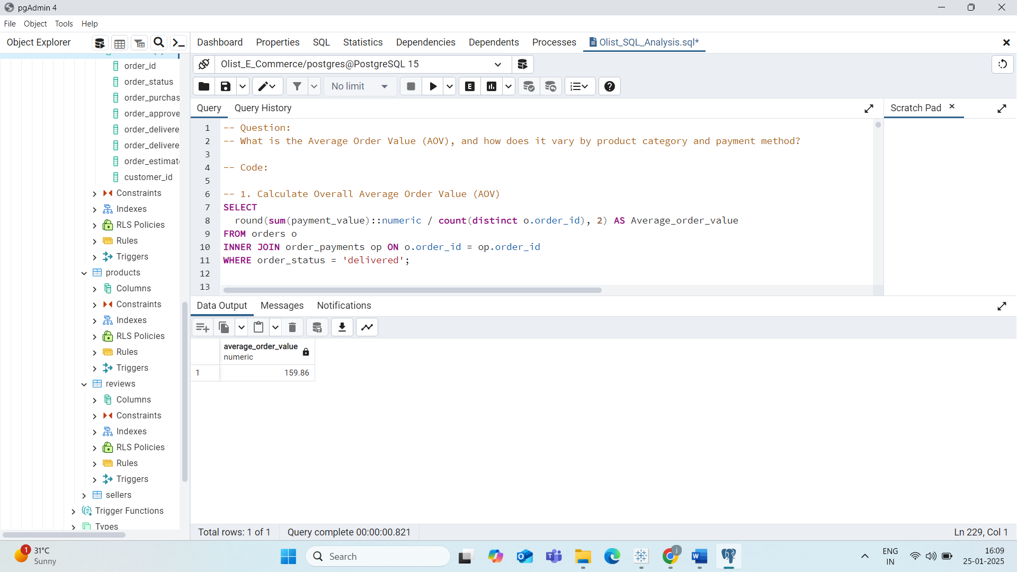

* The Average Order Value (AOV) for Olist customers is **159.86**.

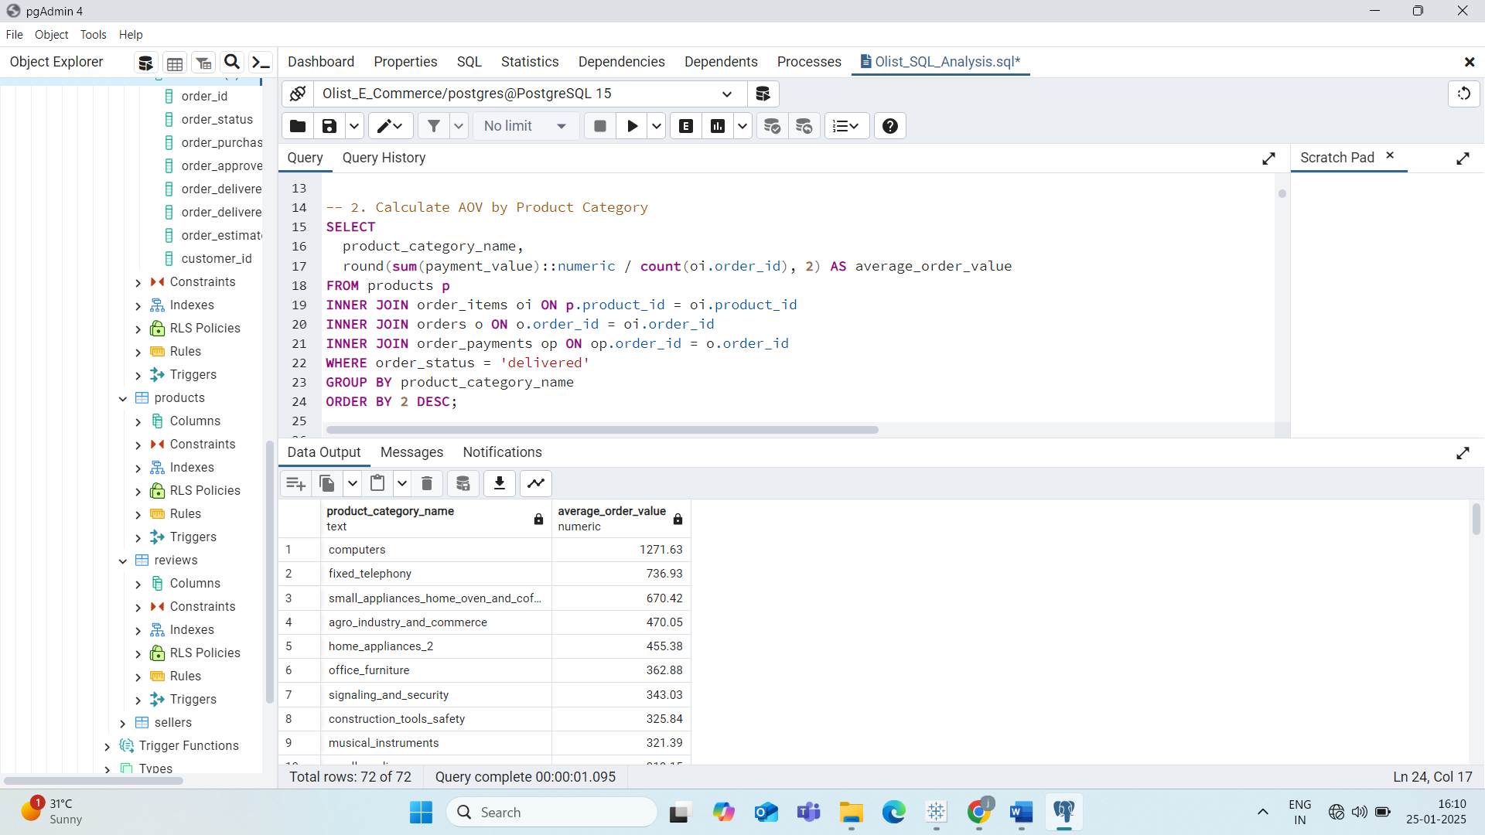

* **AOV by Product Category:**
  + **Top 5 Highest AOV Categories**:
    1. Computers: 1271.63
    2. Fixed Telephony: 736
    3. Small Appliances (Home Oven and Coffee): 670
    4. Agro Industry & Commerce: 470
    5. Home Appliances: 455
    6. These categories have high AOV because they consist of high-value, one-time purchase items.

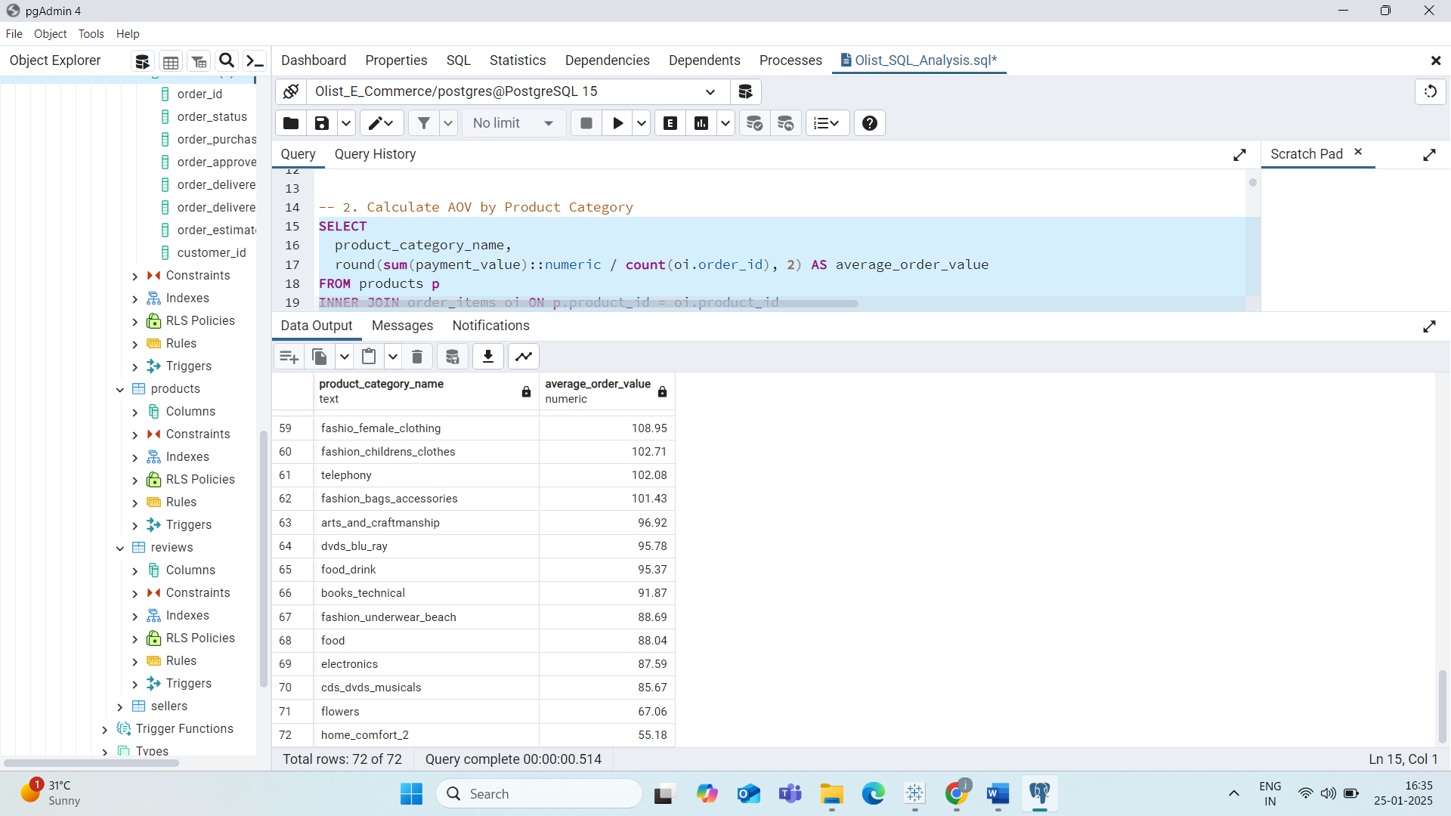

* + **Lowest AOV Categories**: Electronics, CDs & DVDs, Food, Flowers, and Home Comfort, all with AOV below 90.

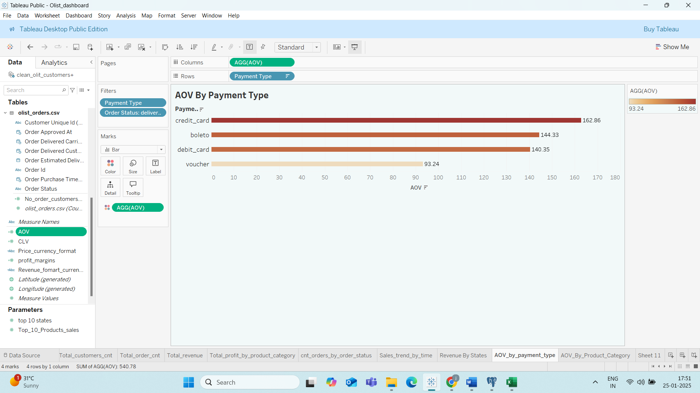

* Customers using **Credit Cards**, **Boleto**, and **Debit Cards** tend to have higher AOV.
* Customers using **Vouchers** have the lowest AOV.

**--------------------------------------------------------------------------------------------------------------**

* **How does the customer lifetime value (CLV) differ across product categories?**

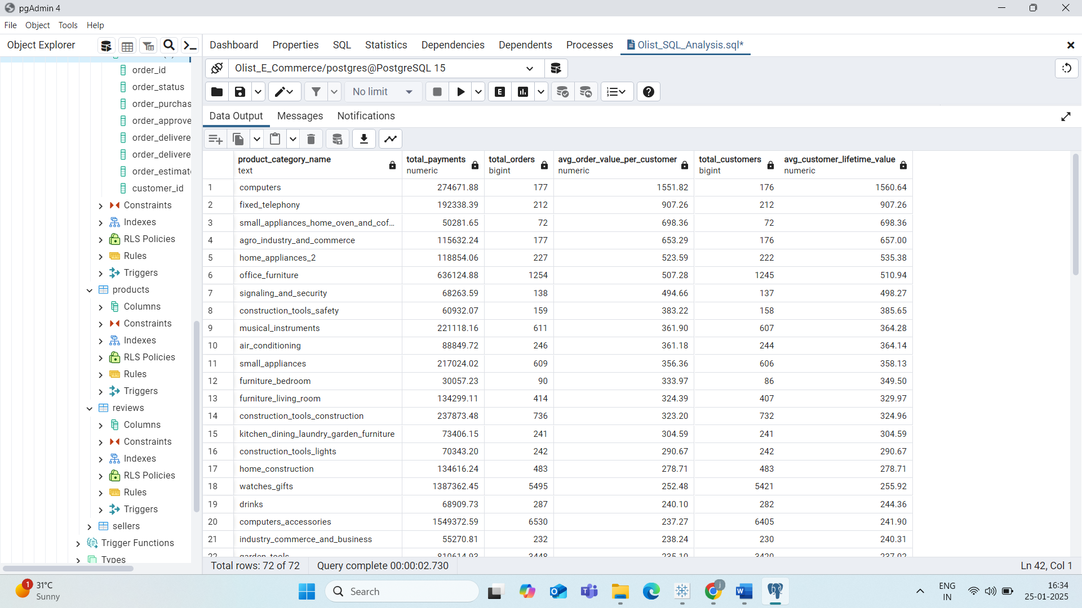

* **High CLV Categories:** Computers, Fixed Telephony, Small Appliances (Home Oven and Coffee), and Agro Industry & Commerce.
  + **Recommendation**: Olist should ensure sufficient stock and competitive pricing for these high-CLV products to maintain and grow revenue.

**--------------------------------------------------------------------------------------------------------------**

* **How many customers have made repeated purchases, and what percentage of total sales do they contribute?**

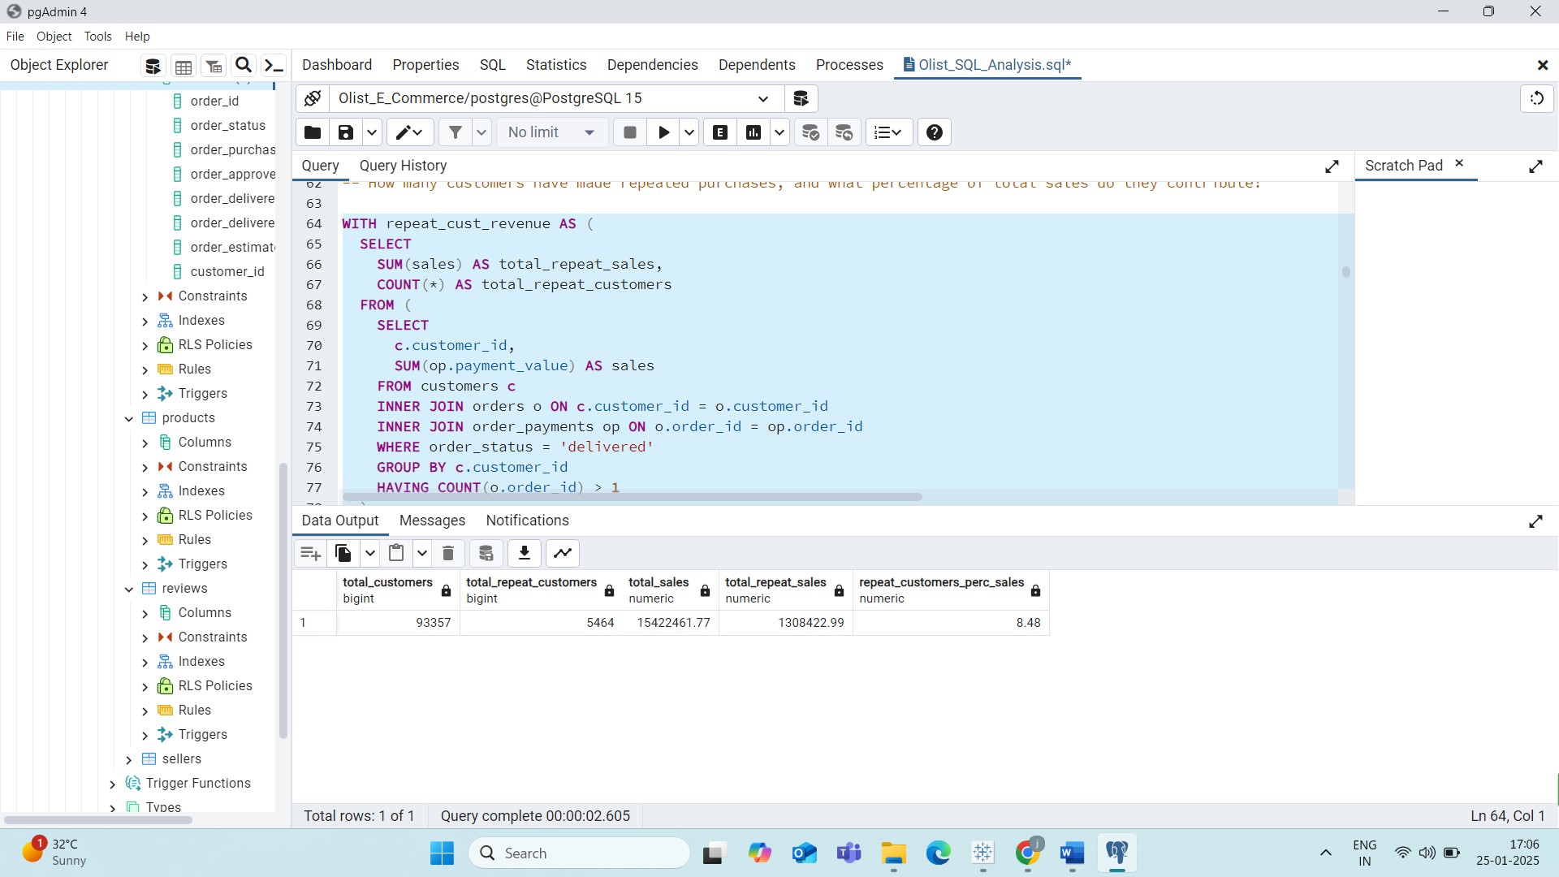

* **Total Customers: 93,357.**
* **Repeat Customers:** Only 5,464 customers made repeat purchases, contributing to 8.42% of total sales.
  + **Insight:** Olist has a predominantly one-time purchase customer base, indicating challenges in customer retention.

**--------------------------------------------------------------------------------------------------------------**

* **Which product categories have the highest profit margins on Olist, and how can the company increase profitability across different categories?**

* **High Profit Margin Categories**: Fixed Telephony, Computers, Small Appliances (Home Oven and Coffee).
* **Recommendation**: Focus on marketing high-margin products and optimizing pricing strategies to increase profitability across all categories.

**--------------------------------------------------------------------------------------------------------------**

* **Which payment methods are most commonly used by Olist customers**

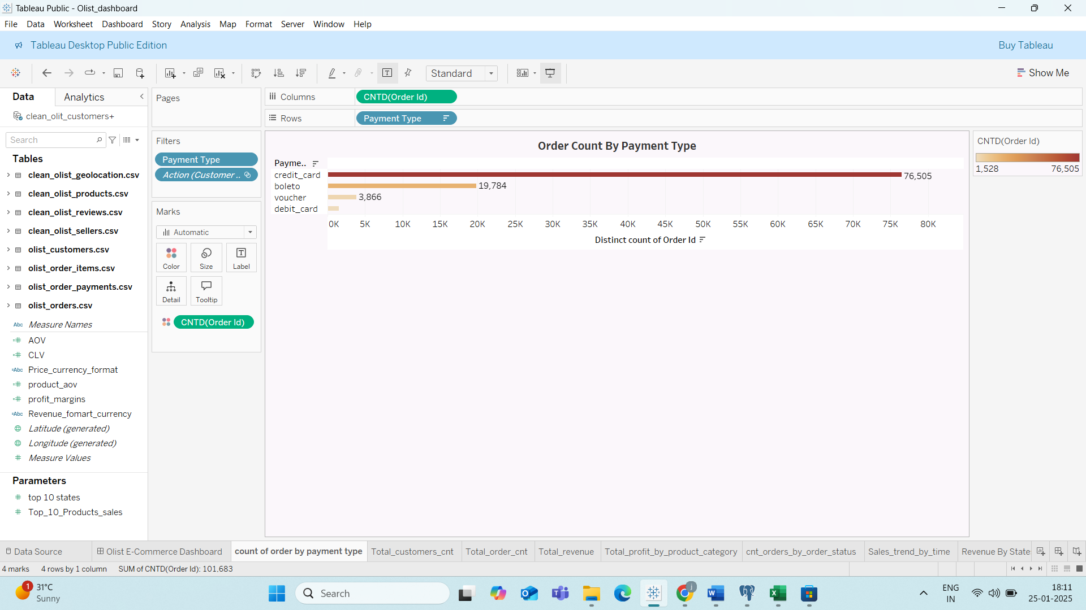

**Most Popular Payment Method**: **75%** of orders are paid via **Credit Cards**.

**Recommendation:** Introduce offers and rewards for customers paying via credit cards to boost engagement and sales

**--------------------------------------------------------------------------------------------------------------**

* **What are the most popular product categories on Olist, and how do their sales volumes compare to each other?**

Top Product Categories by Sales Volume and Revenue:

* Health & Beauty
* Watches & Gifts
* Bed, Bath & Table
* Sports & Leisure
* Computer Accessories

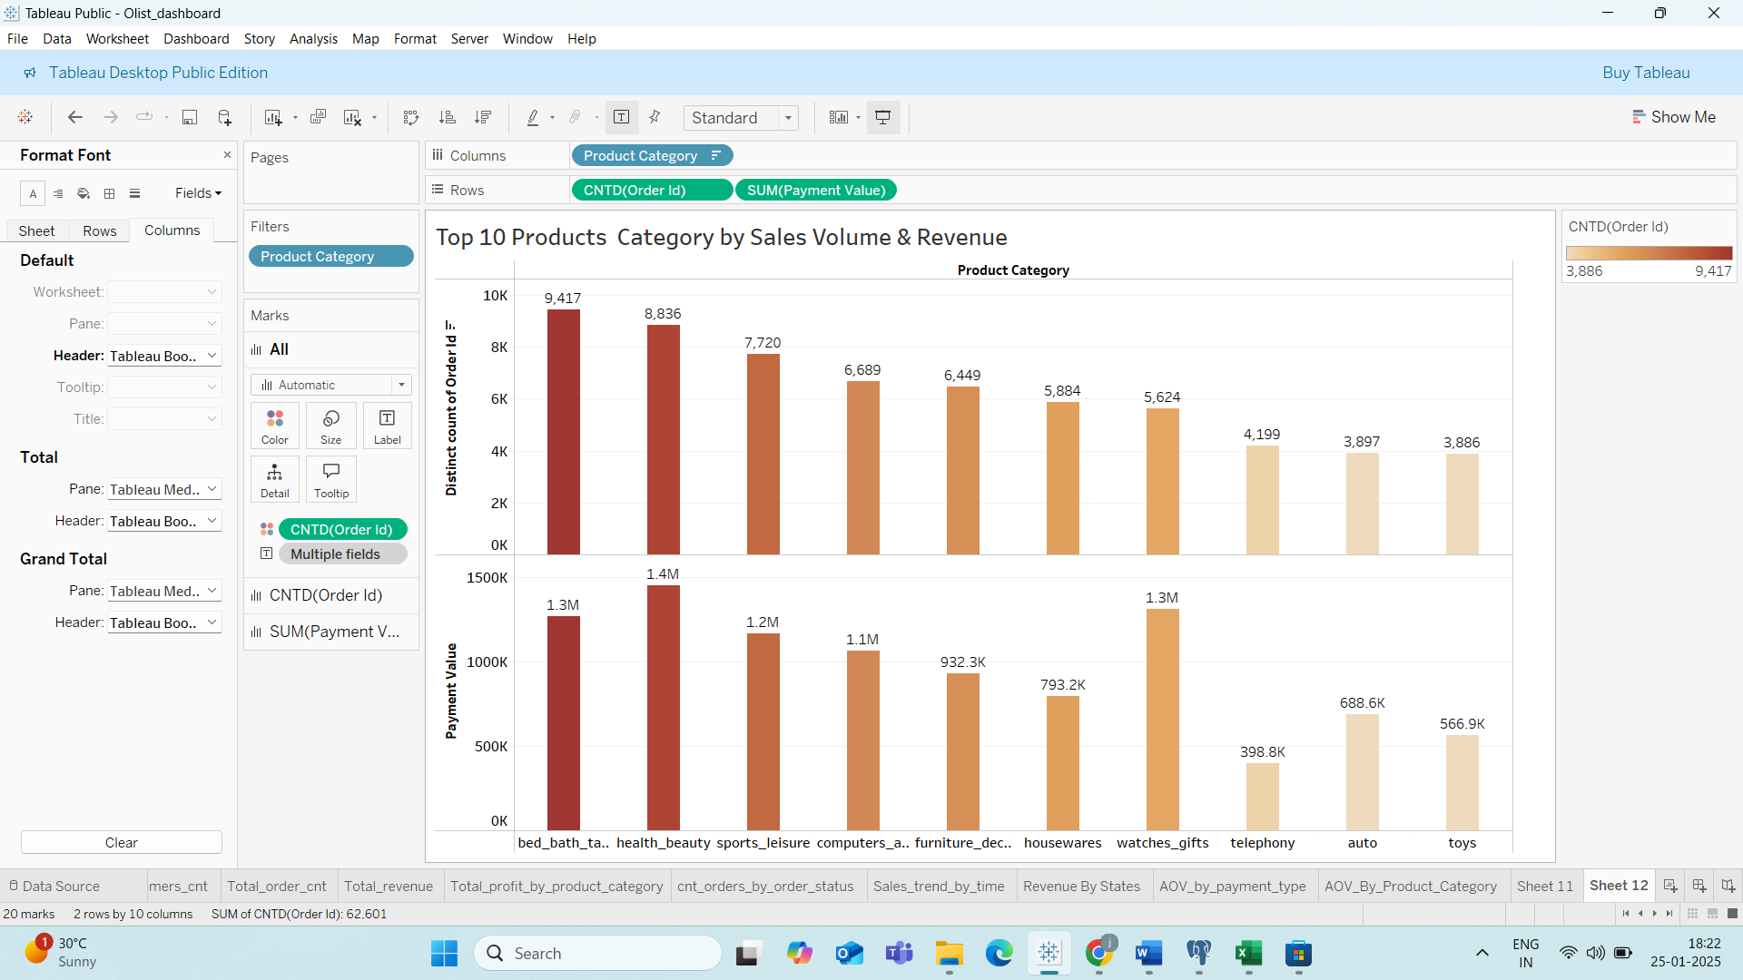

**--------------------------------------------------------------------------------------------------------------**

* **What percentage of orders on Olist experience late deliveries, and how does this impact customer satisfaction and operational efficiency?** 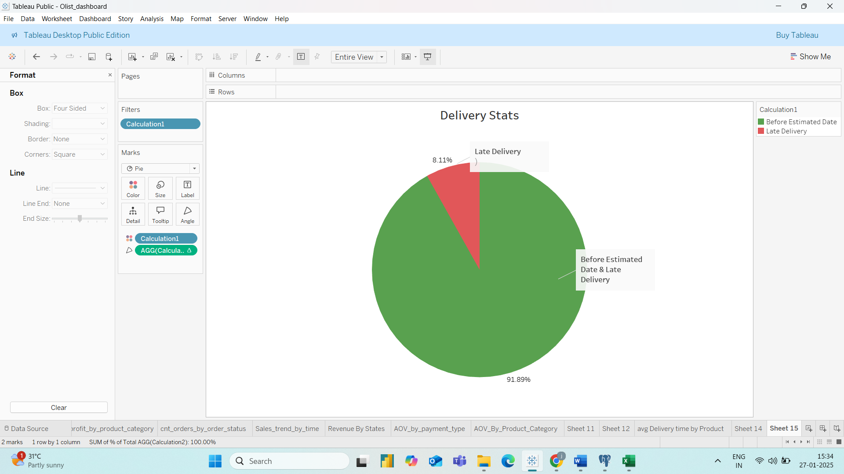
* **On-Time Delivery**: **92%** of orders were delivered before the estimated delivery date.
* **Late Deliveries**: **8.11%** of orders were delivered late.
* **Recommendation**: Collect and analyse data from delivery partners to identify reasons for delays and improve operational efficiency to enhance customer satisfaction.

**--------------------------------------------------------------------------------------------------------------**

* **What is the overall order cancellation rate on Olist, and which factors (e.g., product categories, customer demographics, order size) contribute most to cancellations?**

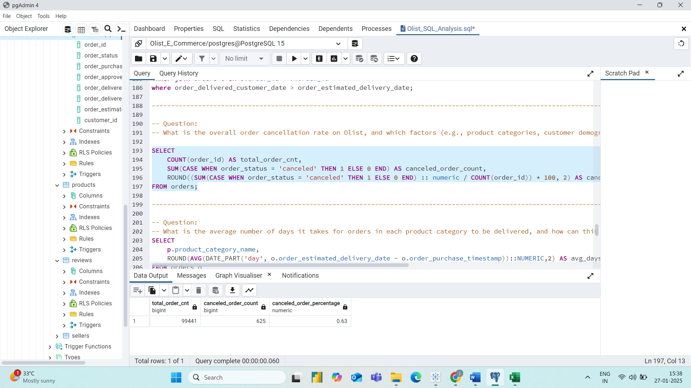

* **Cancellation Rate:** Only 0.63% of orders were canceled.
  + Insight: The low cancellation rate indicates efficient order processing and customer satisfaction.

**--------------------------------------------------------------------------------------------------------------**

* **What is the average number of days it takes for orders in each product category to be delivered, and how can this information be used to improve inventory management and customer satisfaction?**

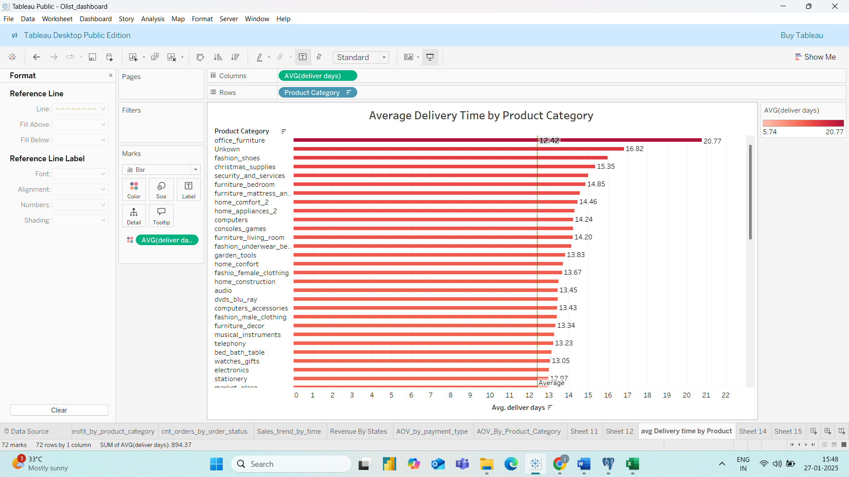

* **Overall Delivery Time**: The average delivery time is 12.4 days.
* **Categories with Longer Delivery Times**:
  + Office Furniture, Unknown Categories, Fashion Shoes, Christmas Supplies.
* **Insights**:
  + Furniture requires additional logistics due to size and vehicle requirements.
  + Small products like Fashion Shoes taking longer than average delivery times need further investigation.
* **Recommendation**: Optimize logistics and work with delivery partners to reduce delivery times for categories with longer-than-average delivery periods.

**--------------------------------------------------------------------------------------------------------------**

* **Which product categories have the highest average customer review scores for delivered orders, and how do they compare to each other?**

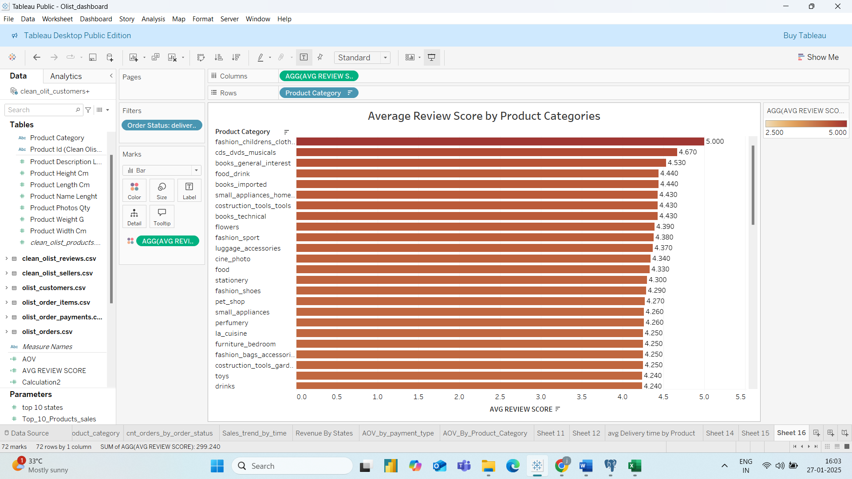

* Fashion children clothes have the highest average customer review score of 5 .
* 70 product categories have review greater than 0 only security & services have 2.5 review score.

**--------------------------------------------------------------------------------------------------------------**

* **How many orders were placed on Olist, and how does this vary by month or season?**

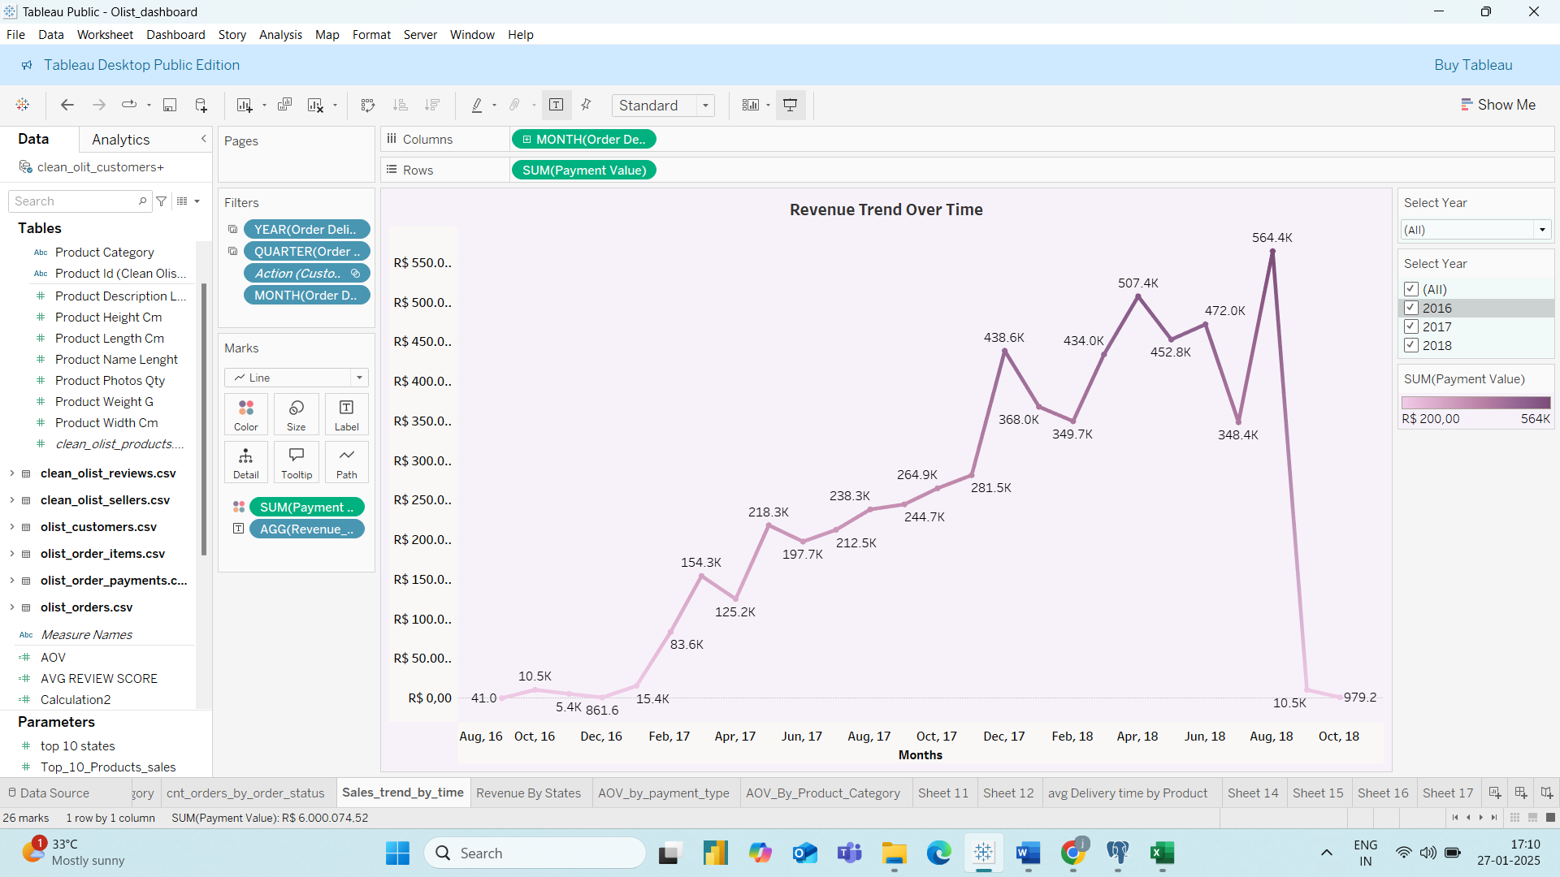

* Sales have increase over time from 2016 to August 2018
* There is a sudden drop in sales from August 2018

**--------------------------------------------------------------------------------------------------------------**

**## Key Insights**

* The Average Order Value on Olist is **160.**
* **Credit Cards** are the most preferred payment method, contributing to higher AOV.
* **Repeat Customers** contribute only **8.42%** of total sales, highlighting a need for improved customer retention strategies.
* **High Profit Margins** are observed in categories like Fixed Telephony, Computers, and Small Appliances.
* **75% of orders** are paid via Credit Cards, indicating customer preference for this payment method.
* **Popular Categories** like Health & Beauty, Watches & Gifts, and Bed & Bath Table drive the highest sales volumes and Revenue.
* The **average delivery time** is **12.4 days**, with Furniture and Fashion Shoes experiencing longer delivery times.
* **Late Deliveries** account for **8.11%** of orders, necessitating improvements in logistics and delivery operations.
* **Customer Reviews** are generally positive, with Fashion Children’s Clothes receiving the highest ratings.

**--------------------------------------------------------------------------------------------------------------**

**## Recommendation**

1. **Increase Repeat Purchases**:
   * Implement loyalty programs, such as discounts and rewards for repeat purchases.
   * Use personalized marketing campaigns to re-engage one-time buyers.
2. **Optimize Inventory Management**:
   * Increase stock for high-demand and high-margin categories like Computers, Fixed Telephony, and Small Appliances.
3. **Improve Delivery Efficiency**:
   * Collaborate with delivery partners to reduce delivery times, especially for categories like Furniture and Fashion Shoes.
   * Collect and analyse data on late deliveries to identify and address root causes.
4. **Enhance Customer Experience**:
   * Address issues in low-rated categories like Security & Services to improve customer satisfaction.
   * Provide additional incentives for customers using Credit Cards, such as cashback or discounts.

By implementing these recommendations, Olist can enhance operational efficiency, improve customer satisfaction, and drive sustainable revenue growth.

**--------------------------------------------------------------------------------------------------------------**

Thank You

**--------------------------------------------------------------------------------------------------------------**