class05.R

meggg

2022-02-05

####################################  
# Author: Meg Robinson  
# Class 5  
# Section 5: Scatter Plots  
####################################  
  
  
# load the ggplot2 package after installation  
library(ggplot2)  
  
# Use the built-in 'cars' dataset for visualization   
  
# Look at whats in the dataset  
head(cars)

## speed dist  
## 1 4 2  
## 2 4 10  
## 3 7 4  
## 4 7 22  
## 5 8 16  
## 6 9 10

# Use ggplots 3 layers: data, aes, geoms  
# To visualize 'cars' as a scatterplot  
# Use + to add layers  
plot = ggplot(cars) +  
 aes(x=speed, y=dist) + geom_point()   
plot

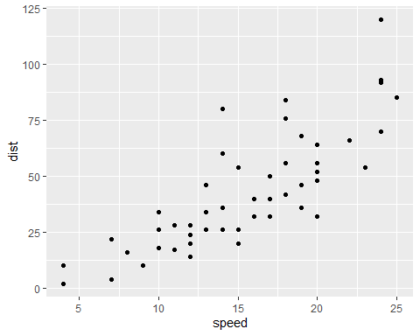

# Add geom_smooth() to show the relationship between variables  
plot = plot + geom_smooth(method='lm', se=FALSE)  
plot

## `geom_smooth()` using formula 'y ~ x'

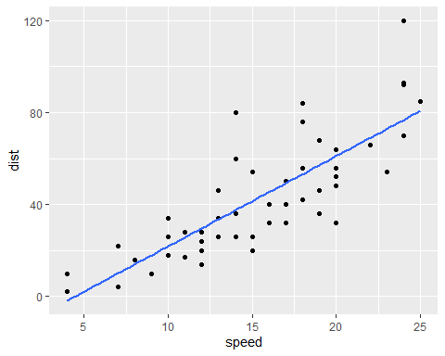

plot = plot + labs(title='Speed vs Distance of Cars',   
 x="Speed (mph)",  
 y="Distance to stop (ft)") +  
 theme_bw()  
plot

## `geom_smooth()` using formula 'y ~ x'

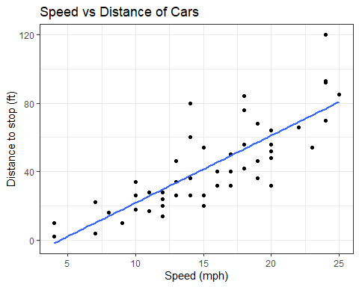

# Read in the results of DE analysis  
url <- "https://bioboot.github.io/bimm143_S20/class-material/up_down_expression.txt"  
genes <- read.delim(url)  
head(genes)

## Gene Condition1 Condition2 State  
## 1 A4GNT -3.6808610 -3.4401355 unchanging  
## 2 AAAS 4.5479580 4.3864126 unchanging  
## 3 AASDH 3.7190695 3.4787276 unchanging  
## 4 AATF 5.0784720 5.0151916 unchanging  
## 5 AATK 0.4711421 0.5598642 unchanging  
## 6 AB015752.4 -3.6808610 -3.5921390 unchanging

# How many genes are in the dataset?  
nrow(genes)

## [1] 5196

# How many columns are in the dataset?  
ncol(genes)

## [1] 4

# What are the column names?  
colnames(genes)

## [1] "Gene" "Condition1" "Condition2" "State"

# How many upregulated genes are there?  
table(genes$State)

##   
## down unchanging up   
## 72 4997 127

# What percent of up regulated genes?  
round(table(genes$State)/nrow(genes)*100,2)

##   
## down unchanging up   
## 1.39 96.17 2.44

# Make a scatter plot of the genes df  
ggplot(genes) +   
 aes(x=Condition1, y=Condition2) +  
 geom_point()

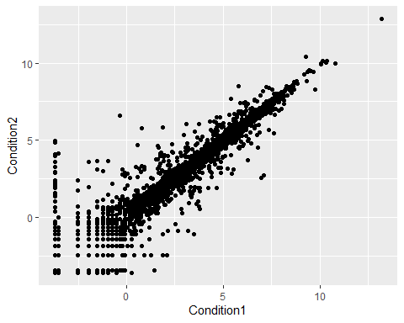

# Map the the column State to color  
gene_plot = ggplot(genes) +   
 aes(x=Condition1, y=Condition2, col=State) +  
 geom_point()  
gene_plot

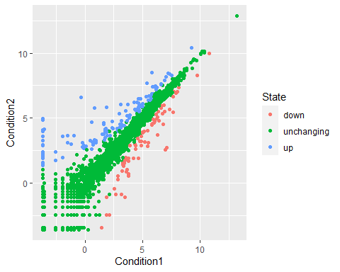

# add titles etc  
gene_plot = gene_plot + theme_bw() + scale_colour_manual(values=c("blue","gray","red")) +  
 labs(title="Gene Expresion Changes Upon Drug Treatment",  
 x="Control (no drug) ",  
 y="Drug Treatment")  
gene_plot

