Week 5: R Functions

Meg Robinson

2/5/2022

Q1. Write a function grade() to determine an overall grade from a vector of student homework assignment scores dropping the lowest single score. If a student misses a homework (i.e. has an NA value) this can be used as a score to be potentially dropped. Your final function should be adquately explained with code comments and be able to work on an example class gradebook such as this one in CSV format: “<https://tinyurl.com/gradeinput>” [3pts]

# Example input vectors to start with  
student1 <- c(100, 100, 100, 100, 100, 100, 100, 90)  
student2 <- c(100, NA, 90, 90, 90, 90, 97, 80)  
student3 <- c(90, NA, NA, NA, NA, NA, NA, NA)

Average of student 1

student1

## [1] 100 100 100 100 100 100 100 90

mean(student1)

## [1] 98.75

Use ‘min()’ to find lowest score

min(student1)

## [1] 90

Find index at which min occured using which.min()

which.min(student1)

## [1] 8

Get everything except lowest score using minus (“-”) and caclulate mean (as long as no “NA” in vector)

mean(student1[-which.min(student1)])

## [1] 100

Try it on student 2

mean(student2[-which.min(student1)])

## [1] NA

It does not work because mean() function doesn’t allow for **NA** values. Now find **NA** values

is.na(student2)

## [1] FALSE TRUE FALSE FALSE FALSE FALSE FALSE FALSE

Replace *NA* with zero

student.prime = student2  
student.prime[is.na(student.prime)] = 0  
student.prime

## [1] 100 0 90 90 90 90 97 80

Now get mean()

mean(student.prime[-which.min(student.prime)])

## [1] 91

Which we can see is the value of *student2*

mean(c(100,90,90,90,90,97,80))

## [1] 91

So now do the above with *student3*

x = student3  
x[is.na(x)] = 0  
mean(x[-which.min(x)])

## [1] 12.85714

So we can write our function

#' Calculate avg scores for a vector hw socres  
#' Drop lowest homework score  
#' Missing values treated as 0  
#'  
#' @param x Numeric vector of homework scores  
#'  
#' @return average score  
#' @export  
#'  
#' @examples  
#' student = c(100,NA,90, 80)  
#' grade(student)  
#'   
grade = function(x){  
 # Map NA missing hw vals to 0  
 # Assign hw scores 0  
 x[is.na(x)] = 0  
 # Drop the lowest score  
 mean(x[-which.min(x)])  
}

And use it

grade(student1)

## [1] 100

grade(student2)

## [1] 91

grade(student3)

## [1] 12.85714

### Now grade entire class

url = "https://tinyurl.com/gradeinput"  
gradebook = read.csv(url, row.names=1)  
gradebook

## hw1 hw2 hw3 hw4 hw5  
## student-1 100 73 100 88 79  
## student-2 85 64 78 89 78  
## student-3 83 69 77 100 77  
## student-4 88 NA 73 100 76  
## student-5 88 100 75 86 79  
## student-6 89 78 100 89 77  
## student-7 89 100 74 87 100  
## student-8 89 100 76 86 100  
## student-9 86 100 77 88 77  
## student-10 89 72 79 NA 76  
## student-11 82 66 78 84 100  
## student-12 100 70 75 92 100  
## student-13 89 100 76 100 80  
## student-14 85 100 77 89 76  
## student-15 85 65 76 89 NA  
## student-16 92 100 74 89 77  
## student-17 88 63 100 86 78  
## student-18 91 NA 100 87 100  
## student-19 91 68 75 86 79  
## student-20 91 68 76 88 76

Use **apply()** to grade all of the students using our **grade()** function

apply(gradebook,1,grade)

## student-1 student-2 student-3 student-4 student-5 student-6 student-7   
## 91.75 82.50 84.25 84.25 88.25 89.00 94.00   
## student-8 student-9 student-10 student-11 student-12 student-13 student-14   
## 93.75 87.75 79.00 86.00 91.75 92.25 87.75   
## student-15 student-16 student-17 student-18 student-19 student-20   
## 78.75 89.50 88.00 94.50 82.75 82.75

Q2. Using your grade() function and the supplied gradebook, Who is the top scoring student overall in the gradebook? [3pts]

finalgrades <- apply(gradebook,1,grade)  
which.max(finalgrades)

## student-18   
## 18

max(finalgrades)

## [1] 94.5

**student 18 is the top scoring student with an average score of 94.5**

Q3. From your analysis of the gradebook, which homework was toughest on students (i.e. obtained the lowest scores overall? [2pts

Average hw’s

hwavg = apply(gradebook,2,mean, na.rm=TRUE)  
which.min(hwavg)

## hw3   
## 3

Median of hw’s

hwmed = apply(gradebook,2,median, na.rm=TRUE)  
which.min(hwmed)

## hw2   
## 2

Since results were different look at plot of gradebook

boxplot(gradebook)

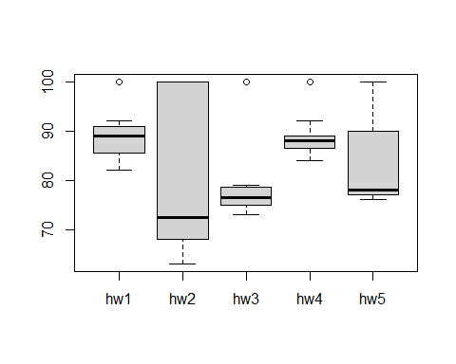 It looks like **homework 2** is the toughest.

Q4. Optional Extension: From your analysis of the gradebook, which homework was most predictive of overall score (i.e. highest correlation with average grade score)? [1pt]

Use the **cor()** function

gradebook[is.na(gradebook)] = 0  
cor(finalgrades, gradebook$hw1)

## [1] 0.4250204

apply(gradebook, 2, cor, x=finalgrades)

## hw1 hw2 hw3 hw4 hw5   
## 0.4250204 0.1767780 0.3042561 0.3810884 0.6325982

**Homework 5** was most predictive of a studen’t overall score