Population Scale Analysis

Meg Robinson

2/19/2022

## Section 4: Population Scale Analysis

Q13: Read this file into R and determine the sample size for each genotype and their corresponding median expression levels for each of these genotypes.

expr <- read.table("exp.txt")  
head(expr)

## sample geno exp  
## 1 HG00367 A/G 28.96038  
## 2 NA20768 A/G 20.24449  
## 3 HG00361 A/A 31.32628  
## 4 HG00135 A/A 34.11169  
## 5 NA18870 G/G 18.25141  
## 6 NA11993 A/A 32.89721

nrow(expr)

## [1] 462

There are 462 individuals we have this data for. But how many for each genotype?

table(expr$geno)

##   
## A/A A/G G/G   
## 108 233 121

summary(expr)

## sample geno exp   
## Length:462 Length:462 Min. : 6.675   
## Class :character Class :character 1st Qu.:20.004   
## Mode :character Mode :character Median :25.116   
## Mean :25.640   
## 3rd Qu.:30.779   
## Max. :51.518

This ‘summary()’ function gives us the overall median expression levels, but we want to see it per genotype.

summary(expr$exp[expr$geno == "A/A"])

## Min. 1st Qu. Median Mean 3rd Qu. Max.   
## 11.40 27.02 31.25 31.82 35.92 51.52

summary(expr$exp[expr$geno == "G/G"])

## Min. 1st Qu. Median Mean 3rd Qu. Max.   
## 6.675 16.903 20.074 20.594 24.457 33.956

summary(expr$exp[expr$geno == "A/G"])

## Min. 1st Qu. Median Mean 3rd Qu. Max.   
## 7.075 20.626 25.065 25.397 30.552 48.034

ANSWER: Genotype A/A has a median expression level of 31.25. Genotype G/G has a median expression level of 20.074. Genotype A/G has a median expression level of 25.065.

Lets make a summary figure to display these results.

Q14: Generate a boxplot with a box per genotype, what could you infer from the relative expression value between A/A and G/G displayed in this plot? Does the SNP effect the expression of ORMDL3?

library(ggplot2)

bplot <- ggplot(expr) + aes(x=geno, y=exp, fill=geno) + geom_boxplot(notch=TRUE) + xlab("Genotype") + ylab("Expression")   
  
bplot

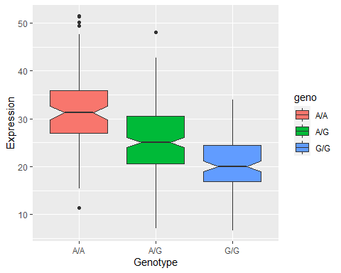

ANSWER: Based on this box plot, I can infer that the relative expression of G/G is markedly lower than the expression of A/A. Yes, it seems that SNP influences ORMDL3 gene expression (known for asthma)