Build 12

Functional Design MI2
MEDICS Desktop Application

Prepared by: Allen Racho
Date: 02/07/2007

Table of Contents

Table of Contents 2
Revision History 3
Required Document Signoff 4
Overview of Business Requirements 5
Functional Design 6
Appendix A – Patient Entry Field Screen Shots 13
Appendix B – XML Export Datastructure 21
Appendix C – Import Mapping (imports_defs.ini) 26

Revision History
This section records the change history of this document.
Name | Date | Reason For Changes | Version
Allen Racho | 02/07/2007 | Initial Draft | 1.0
Aron Racho | 02/14/2007 | Made changes requested by client:  - Removed references to remote server passphrase  - User login password is now validated against the local key pair passphrase  - Added concept of required fields  - Modified file naming convention  - Updated exported XML document, import file spec  - Split PCP field into subfields  - Added DOB field | 1.1

Required Document Signoff
This section records acceptance of this document by its stakeholders.
Name | Party | Date | Signature
Allen Racho | Sigilent Technologies, Inc.
Tony McCormick | MI2, Inc.

Overview of Business Requirements
Client requires the creation of an application to gather PHI from patients which allows easy upload to a server for further processing. Said application will be a standalone application (i.e. running on a desktop) that initially stores collected patient information locally in an encrypted format using PGP technology.

Application will be a data-collection desktop application developed in Java using the Swing GUI toolkit. Application will allow for the collection of patient information locally for temporary storage before upload to a server for further processing. Solution will:

- Present a static questionnaire; i.e. the desktop application will not include a questionnaire builder; depending on the final local data storage and presentation method, limited edit ability may be possible via editing of text files
- Allow viewing and editing of captured patient data; this is intended only to facilitate corrections such as name spellings, addresses, and similar
- Allow manual data transfer from the local store to a server; the server is responsible for decrypting data encrypted by the desktop application
- Be easy to install; deployment will be made as automated as possible

No built-in printing capability from the application is required.

Functional Design
SUMMARY:
MEDICS will maintain local patient records encrypted using a local private / public key pair. Users may add records manually, or import them. Users may export local records to an outgoing directory, which will render the records unavailable to the local user by deleting the local copy, and storing a copy encrypted using a remote server’s public key to an outgoing directory. All exported records will be in XML format.

- MEDICS Desktop Application is designed for a “drop-in” (i.e. simple file copy) installation process, with a simple installation tool for aiding with the proper configuration of GPG keys.
  - A zip file, MEDICS.ZIP, will contain the installation tool and the application itself. The zip file must be extracted using a 3rd party unzip tool onto a suitable location on the client machine.
  - Under MEDICS\, a batch file can be executed to launch the installation tool.
  - The installation tool will provide screens for capturing configuration information and for testing the configuration.
    - A screen will be provided for capturing the local username and password required to log into the system. On submit, the screen will create a local public and private key used for encryption and decryption of patient records local to the client system. The password provided will be used as the local private key pair passphrase.
    - Another screen will be provided for browsing to the local file system for the remote server’s public key, which would be previously copied onto the client file system. On selecting the server public key, the system will run tests validating both local and remote server keys. If any of the tests fail, the system will delete all installed keys, and return to the previous screen for recapturing username and password.
    - On successful test, the install tool will quit.
  - The application is launched via a standard executable batch file which specifies all libraries and paths needed by the main application. The administrator performing the install will be responsible for copying a shortcut to this batch file to a convenient location for end-users to access.
- MEDICS Desktop Application will largely consist of a single-document window with a form containing the patient data-collection form, used for record editing and creation. For layout efficiency and organization, this form will be partitioned into several tabs which group fields containing related data. Navigation from field to field within each tab can be accomplished via the mouse or tab key of the keyboard.
See Appendix A for screen shot of each tab, illustrating the placement and text of each field. These represent the set of questions end-users are engaged with during the usage of the MEDICS.
  - The Demographics tab will contain patient demographic and identifying information, such as Name, Address, and Contact Information.
  - The Family History tab will contain pertinent medical information of patient family members.
  - The Medical History tab will contain overview information related to the patient’s medical history, such as a record of allergies or surgeries undergone.
  - The Medications tab will contain a detailed record of up to 10 current medications being taken by the patient.
  - The Immunizations & Preventative Exams tab will contain a detailed record of any such procedures undergone by the patient.
  - The Physical Exams & Vitals tab will contain a detailed record of patient’s vital information, such as Weight, Height, Pulse, and BMI measurements.
  - The Patient Perceptions of Health tab will contain a detailed record of common evaluations of various aspects of patient health, such as Cardio-vascular and Respiratory.
  - The Systems Review tab will contain specific records of any ICD-9 codes associated with the patient, as well as areas for physician summaries of assessments and plans of treatment.
- MEDICS Desktop Application will render the patient data-entry user interface dynamically, based on plain-text definition files.
NOTE: Though it is possible for MI2 personnel to change the questionnaire field layout, it is not recommended. The layout engine and associated tab and field configuration files are not optimized for frequent and arbitrary changes, and should ideally be performed by or under supervision by Sigilent personnel. Sigilent is not liable for changes made to the configuration files after the MEDICS system is accepted by MI2.
  - Tabs will be defined via the definition file tabs_defs.ini, containing a number of tab definitions, standardized for each tab in the format:
[tabid]
title=tab text title
maxrowspercolumn=integer
  - Fields within tabs will be defined via the definition file field_defs.ini, containing a number field definitions, standardized for each field in the format:
[field.name]
xpath=position in XML file hierarchy
nodeposition=if more than one node is located via xpath, choose node at this index
label=text label
type=field type [ TEXT, TEXTAREA, RADIO, DROPDOWN, PURETEXT, SPACER, LINESPACER ]
tabid=id of enclosing parent tab
textrows=if fieldtype is textarea, specify how many rows
valuelist=enum of values, if radio or dropdown
mask=if textfieldtype is TEXT, restricts characters to be of a certain type
required=if true, record cannot be saved without a value
    - All text fields (textarea, text) are not constrained by length.
    - Text fields may be masked to enforce the exact entry of a phone number ( (xxx) xxx-xxxx ), or a date format (xx-xx-xxxx).
    - A way to mark a field as required will be provided. A new or edited record will be prevented from being saved if a field is marked as required in field_defs.ini but no value is provided.
  - Additionally, MEDICS Desktop Application allows for the following global application settings to be specified in the file config.ini:
[config]
outgoingdir=folder for exported patient records
apptitle=application window title
username=local user name
servergpguser=id of the public gpg key of remote server installed in public keystore
  - Configured data item fields will consist of only the following field types:
Text Fields – accommodate a single line of text or numbers
Text Areas – accommodate multiple lines of text or numbers
Drop-Down Lists – pre-defined single-selection only
Radio Button – single choice from list
  - MEDICS Desktop Application will render fields in two columns within a tab, starting at the top left of the first column. Rendering will proceed down the first column and automatically overflow into the second column to the right as necessary. ’Spacer’ type fields are used for forcing the automatic overflow to the second column.
- Users will be required to login into the system with a local username, configured in config.ini. They will also be required to enter a password, which should match the gpg passphrase which has been configured for the local key pair hosted by the client machine.
  - If username does not match, the login screen will reject the user, and require them to log in with different credentials.
  - If username matches, the system will attempt to encrypt and decrypt a test file using the local public and private keys, using the supplied passphrase. This simulates local decrypt/encrypt processes. It will also try to encrypt the test file using the public server key. This simulates patient record export.
    - If either test fails, the system will reject the login.
    - If both tests pass, the system will accept the login, and cache in memory the passphrase for future encrypt/decrypt of local records.
  - On successful authentication, the system will present the main MEDICS Desktop Application window.
- The main MEDICS Desktop Application window will present a main drop-down menu, located in the standard upper-left quadrant.
  - The Patients drop-down menu will contain basic patient record options.
    - The New Patient menu item will create a new, blank record.
    - The Edit Patient menu item will present a screen, allowing the user to view local patient records, and perform actions on them.
      - Allow users to select a single pre-existing (saved) patient record located on the local file system, and open the record for editing in the application main form.
      - Saved local records will be located in the work directory, this directory will be relative to the root of the installation location.
        - The system will use the local key and passphrase to decrypt the selected local record, and present an editable view.
      - Delete a local patient record.
      - Export a local patient record, which will delete the local record, and copy a gpg-encrypted version of the record to the outgoingdir directory specified by config.ini.
        - The server public key and will be used to encrypt the export.
        - The client will not be able to access or decrypt exported records.
    - The Save Patient menu item will save the currently open patient record to the MEDICS Desktop Application XML file format.
      - The system will encrypt the XML document using the local gpg key, and store the encrypted record in the \work directory.
      - The local naming convention used will be:
[last name]-[first name]-[memberid].xml
      - If a record already exists in the \work folder with the same [derived] name, the user will be alerted by the application and asked if the existing file should be overwritten. The application will not make any attempt to preserve multiple historical copies of patient records.
      - See Appendix B for the complete XML file format, representing exactly the entirety of patient information captured by the application.
    - The Quit menu item will exit the application, prompting the user to save the current record.
  - The Import Patients option under Tools will contain utilities for importing patient demographic data into the system.
    - Invoking the menu item will present a dialog allowing the user to browse to, and select a file containing multiple patient records located on the local file system.
    - The file contents will be parsed row by row, creating a single local, encrypted patient record for each successfully parsed row.
Each column will be mapped to a field in a patient record, controlled by import_defs.ini:
[0]
fieldid=patient.pid
[1]
fieldid=patient.lname
The items in [brackets] denote the column number, and the fieldid key value denotes which field in field_defs.ini the value in the column maps to. For example, given a CSV file with the above imports_defs.ini, and the following data in an import file:
1,racho
2,mccormick
… two records would be created:
Patient 1
PatientID: 1
Last Name: racho
Patient 2
PatientID: 2
Last Name: mccormick
See Appendix C for the complete import_defs.ini included in the MEDICS.
- Data privacy and security of patient PHI as mandated by HIPPAA regulations will be accomplished by employing PGP encryption methods during the application’s file save process. Thus, all patient records saved as XML will be encrypted on disk and rendered non-readable to third parties without access to the PGP private key and/or MEDICS Desktop Application.
  - MEDICS Desktop Application will pass arguments to the standard gpg.exe executable for local encrypt and decrypt processes, as well as the export encrypt process.
  - A local private / public key pair will be installed on the client system, as well as the remote server’s public key.
  - The remote server will be responsible for decrypting exported records encrypted on the client using the server’s public key.
- NOTES RELATING TO THE APPENDIX SECTIONS
  - MemberID, Last and First name are **REQUIRED**
  - Add a Date of Birth Field will be added between gender and ethnicity
  - The Primary care provider field will be removed, and replaced by Primary Care Provider Last Name, First Name, and PCP ID fields.

Appendix A – Patient Entry Field Screen Shots

Demographics Tab.
Primary Phone, Alternate Phone are masked to (xxx) xxx-xxxx.

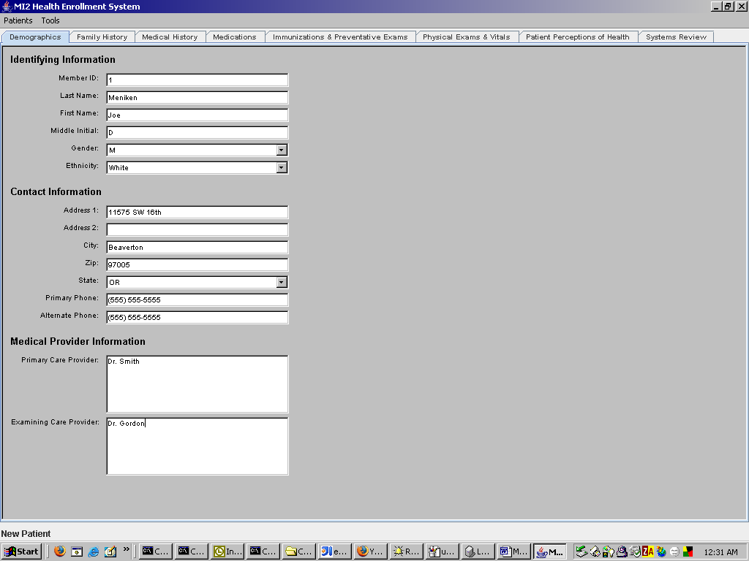
Family History Tab.
Primary Phone, Alternate Phone are masked to (xxx) xxx-xxxx.
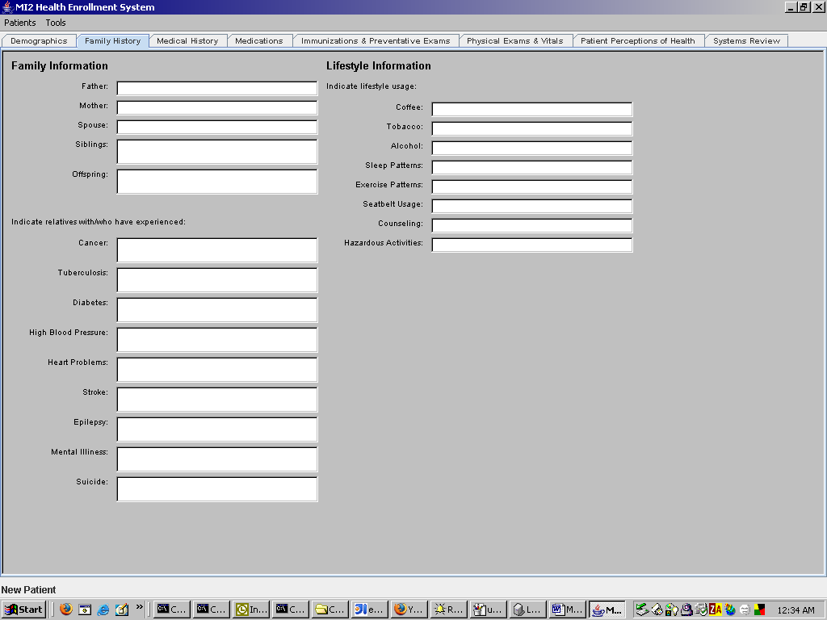
Medical History Tab
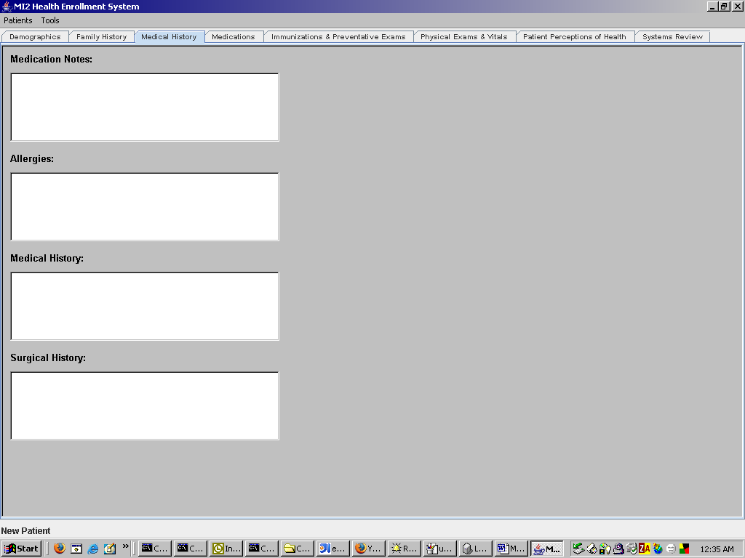
Medications Tab
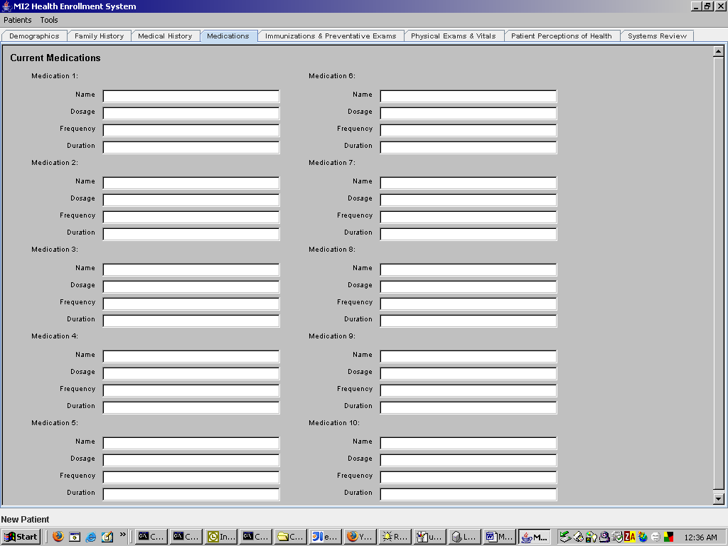
Immunizations and Preventative Exams Tab
Date fields are masked to xx-xx-xxxx.
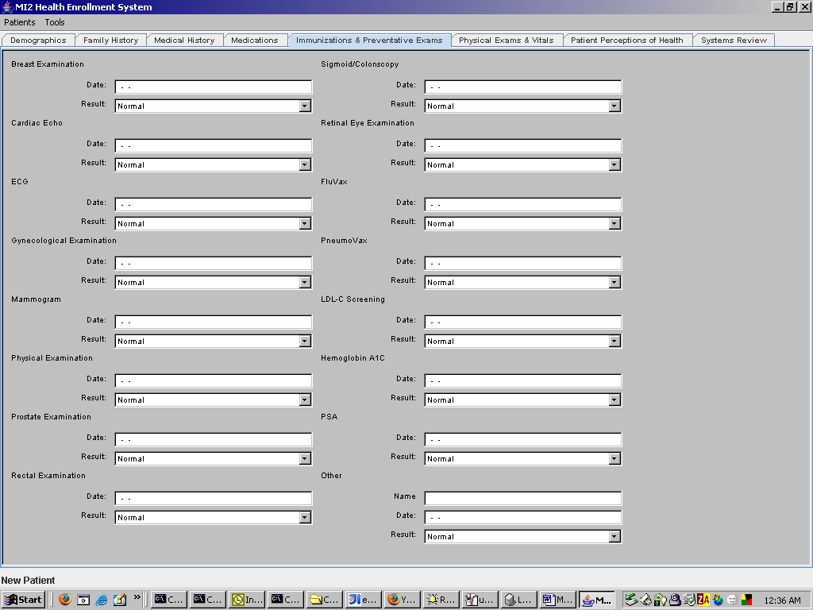
Physical Exams and Vitals Tab
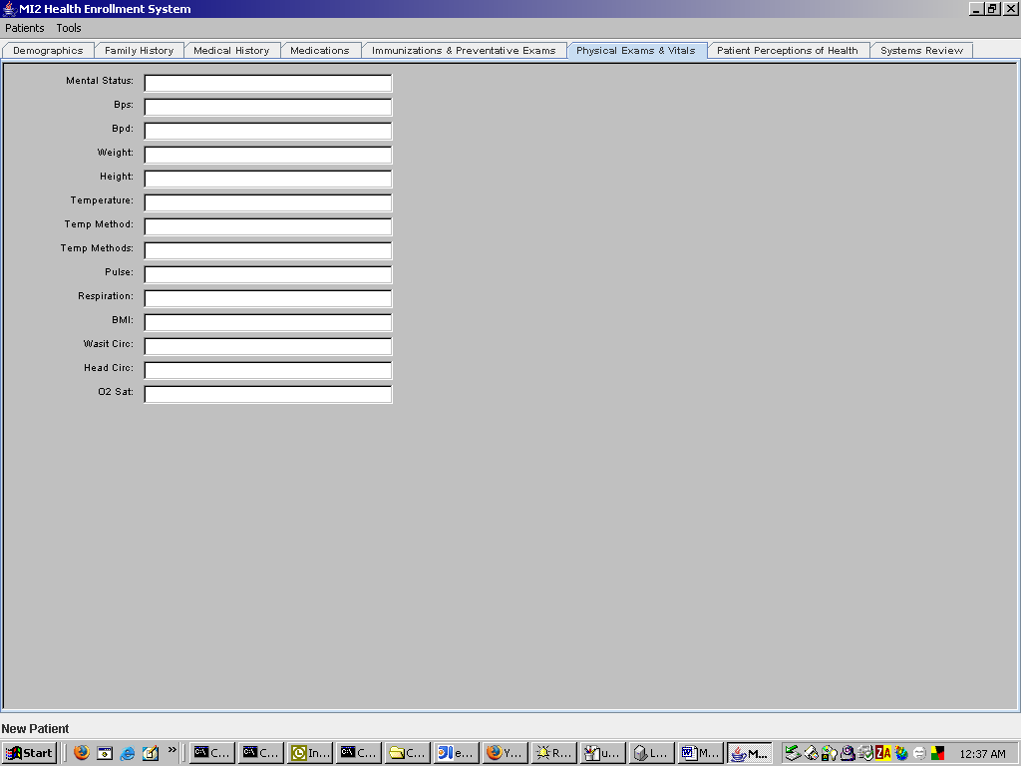
Patient Perceptions of Health Tab
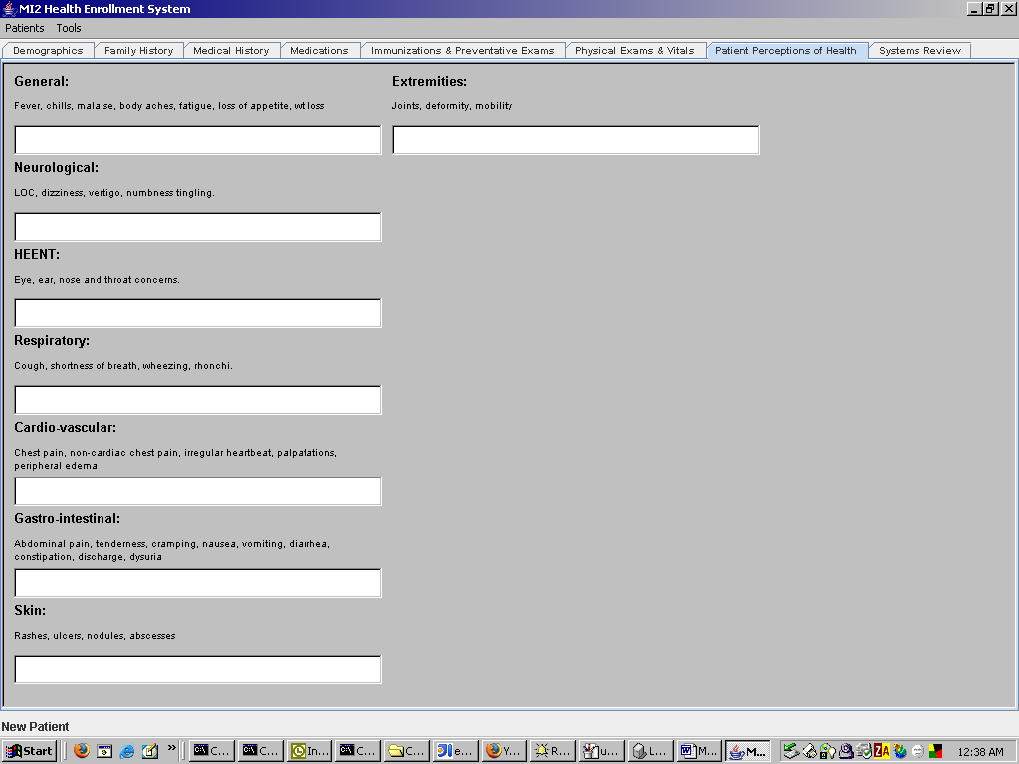
Systems Review Tab
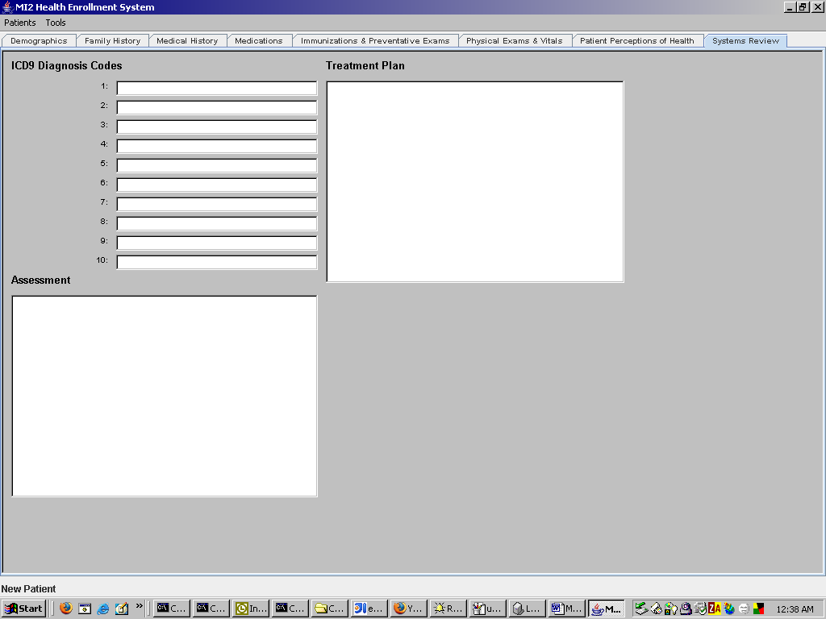

Appendix B – XML Export Datastructure
<patient>
<pid></pid>
<lname></lname>
<fname></fname>
<mname></mname>
<dob></dob>
<sex></sex>
<ethnicity></ethnicity>
<street></street>
<street2></street2>
<city></city>
<state></state>
<zip></zip>
<phone_home></phone_home>
<pcp>
<id></id>
<lname></lname>
<fname></fname>
</pcp>
<xcp>
</xcp>
<familyinformation>
<father></father>
<mother></mother>
<spouse></spouse>
<siblings></siblings>
<offspring></offspring>
</familyinformation>
<medical>
<relativesexperience>
<cancer></cancer>
<tuberculosis></tuberculosis>
<diabetes></diabetes>
<highbloodpressure></highbloodpressure>
<heartproblems>
</heartproblems>
<stroke></stroke>
<epilepsy></epilepsy>
<mentalillness></mentalillness>
<suicide></suicide>
</relativesexperience>
<lifestyleusage>
<coffee></coffee>
<tobacco></tobacco>
<alcohol></alcohol>
<sleep></sleep>
<exercise></exercise>
<seatbelt></seatbelt>
<counseling></counseling>
<hazardactivities></hazardactivities>
</lifestyleusage>
<medicalhistory>
<medicationnotes></medicationnotes>
<allergies></allergies>
<history></history>
<surgicalhistory></surgicalhistory>
</medicalhistory>
<medications>
<medication>
<name></name>
<dosage></dosage>
<frequency></frequency>
<duration></duration>
</medication>
<medication>
<name></name>
<dosage></dosage>
<frequency></frequency>
<duration></duration>
</medication>
<medication>
<name></name>
<dosage></dosage>
<frequency></frequency>
<duration></duration>
</medication>
<medication>
<name></name>
<dosage></dosage>
<frequency></frequency>
<duration></duration>
</medication>
<medication>
<name></name>
<dosage></dosage>
<frequency></frequency>
<duration></duration>
</medication>
<medication>
<name></name>
<dosage></dosage>
<frequency></frequency>
<duration></duration>
</medication>
<medication>
<name></name>
<dosage></dosage>
<frequency></frequency>
<duration></duration>
</medication>
<medication>
<name></name>
<dosage></dosage>
<frequency></frequency>
<duration></duration>
</medication>
<medication>
<name></name>
<dosage></dosage>
<frequency></frequency>
<duration></duration>
</medication>
<medication>
<name></name>
<dosage></dosage>
<frequency></frequency>
<duration></duration>
</medication>
</medications>
<preventatives>
<breastexamination>
<date></date>
<result></result>
</breastexamination>
<cardiacecho>
<date></date>
<result></result>
</cardiacecho>
<ecg>
<date></date>
<result></result>
</ecg>
<gyn>
<date></date>
<result></result>
</gyn>
<mammogram>
<date></date>
<result></result>
</mammogram>
<physicalexam>
<date></date>
<result></result>
</physicalexam>
<prostateexam>
<date></date>
<result></result>
</prostateexam>
<rectalexam>
<date></date>
<result></result>
</rectalexam>
<sigmoid>
<date></date>
<result></result>
</sigmoid>
<retinal>
<date></date>
<result></result>
</retinal>
<fluvax>
<date></date>
<result></result>
</fluvax>
<pneuvax>
<date></date>
<result></result>
</pneuvax>
<ldl>
<date></date>
<result></result>
</ldl>
<hemoglobin>
<date></date>
<result></result>
</hemoglobin>
<psa>
<date></date>
<result></result>
</psa>
<other>
<name></name>
<date></date>
<result></result>
</other>
</preventatives>
<physicalexamsvitals>
<mentalstatus></mentalstatus>
<bps></bps>
<bpd></bpd>
<weight></weight>
<height></height>
<temperature></temperature>
<tempmethod></tempmethod>
<tempmethods></tempmethods>
<pulse></pulse>
<respiration></respiration>
<bmi></bmi>
<waistcirc></waistcirc>
<headcirc></headcirc>
<o2></o2>
</physicalexamsvitals>
<perceptions>
<general></general>
<neurological></neurological>
<heent></heent>
<respiratory></respiratory>
<cardio></cardio>
<gastro></gastro>
<skin></skin>
<extremities></extremities>
</perceptions>
<systems>
<diagnosis>
<code></code>
<code></code>
<code></code>
<code></code>
<code></code>
<code></code>
<code></code>
<code></code>
<code></code>
<code></code>
</diagnosis>
<assessment></assessment>
<treatmentplan></treatmentplan>
</systems>
</medical>
</patient>

Appendix C – Import Mapping (imports_defs.ini)
[0]
fieldid=patient.pid

[1]
fieldid=patient.lname

[2]
fieldid=patient.fname

[3]
fieldid=patient.mname

[4]
fieldid=patient.sex

[5]
fieldid=patient-dob

[6]
fieldid=patient.ethnicity

[7]
fieldid=patient.street1

[8]
fieldid=patient.street2

[9]
fieldid=patient.city

[10]
fieldid=patient.zip

[11]
fieldid=patient.state

[12]
fieldid=patient.primary.phone

[13]
fieldid=patient.alternate.phone

[14]
fieldid=primary-care-provider-id

[15]
fieldid=primary-care-provider-last-name

[16]
fieldid=primary-care-provider-first-name

