Rowan Retail  
Upcoming Events

# RowanGo App Lets Customers Shop Anywhere

|  |
| --- |
| RowanGo Giveaway  To promote the new RowanGo app, customers who use the RowanGo app on a purchase of $10 or more on June 1 –5 will receive an additional coupon for $5 off any purchase between June 5–10. |
|  |
|  |

Want great savings on the go? The new RowanGo app is free and available on iOS and Android. First-time users who download the app get a coupon for 20% off their first purchase. In addition, customers using the RowanGo app to shop get a 2% discount on all future Rowan purchases. Log in using your RowanGo credentials and watch the savings pile up.

RowanGo also offers a new long-asked-for feature: mobile payment. RowanGo digitizes and replaces the credit or debit magnetic stripe card transaction at credit card terminals by allowing users to store debit cards, credit cards, gift cards, loyalty cards, and coupon codes, as well as redeeming sales promotions on their smartphone.

Mobile wallet generally refers to payment services operated under financial regulation and performed from or via a mobile device. Instead of paying with cash, check, or credit cards, a consumer can use a smartphone to pay for a wide range of services and digital or hard goods. Although the concept of using non-coin-based currency systems has a long history, only recently has the technology to support such systems become widely available.

|  |  |  |
| --- | --- | --- |
| Store | Q2 Sales | Predicted Q3 Post-Release Sales |
| Store 1 | $45,589 | $60,300 |
| Store 2 | $48,293 | $68,700 |
| Store 3 | $53,948 | $75,000 |
| Total | $147,830 | 204,000 |

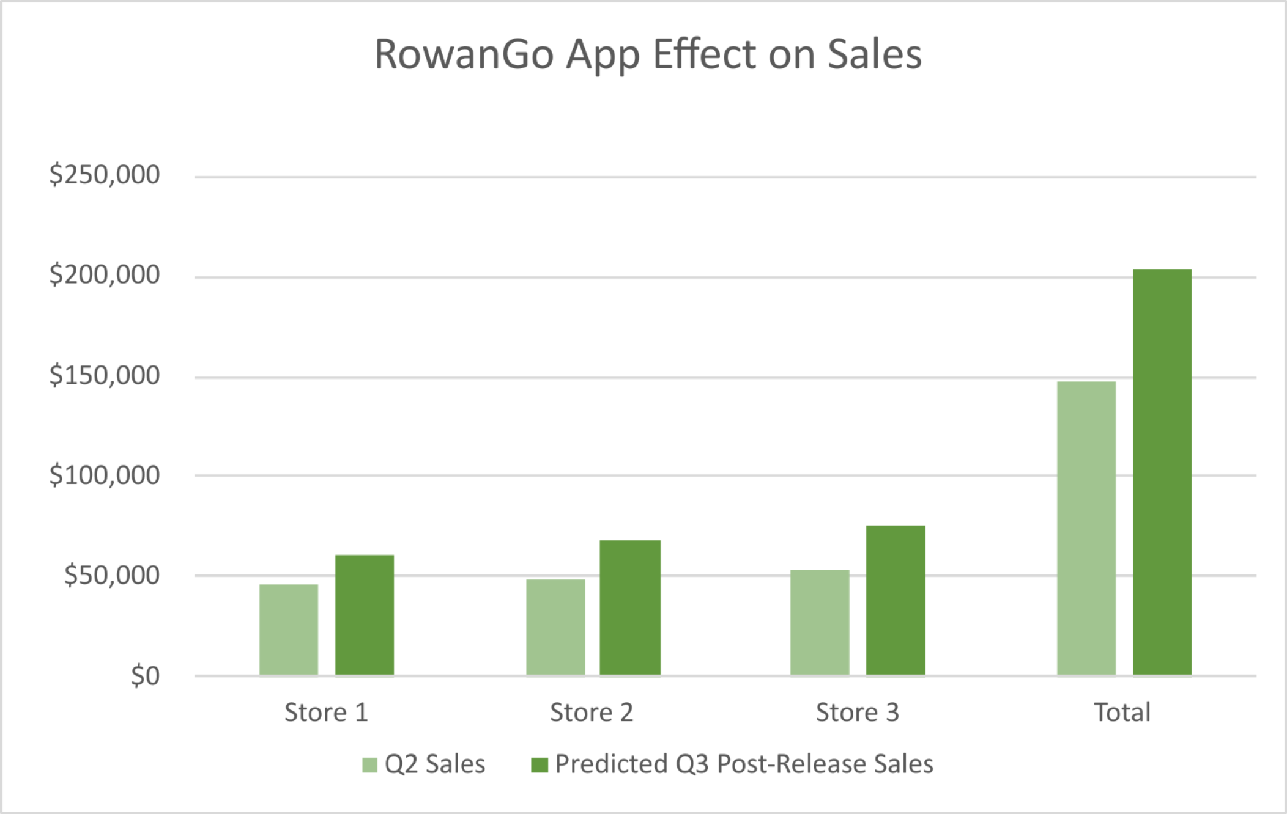

 You can review the presentation here and contact information examples here