Lab 1 - Greedy heuristics
Evolutionary Computation, Assignment 1

1. Problem
Each instance (TSPA, TSPB) has 200 nodes with coordinates (x, y) and a cost. Select exactly k = 100 nodes and connect them in a cycle. Minimise objective = cycle length + sum of selected node costs. Distances are Euclidean, rounded to integers.

2. Algorithms
200 solutions per greedy method (one starting from each node) and 200 random solutions. “Nearest” always means the best increase of the objective (distance change + node cost).
Random: tour = first k nodes of a random permutation
NN-end(start):
tour = [start]
while |tour| < k:
u = unvisited node minimising dist(last, u) + cost(u)
append u
NN-any(start):
tour = [start]
while |tour| < k:
for each unvisited u, each position p (front, between nodes, end):
delta = added length(u at p) + cost(u)
insert the (u, p) with smallest delta
Greedy-cycle(start):
v = unvisited node minimising dist(start, v) + cost(v); tour = [start, v]
while |tour| < k:
for each unvisited u, each cycle edge (a,b):
delta = d(a,u) + d(u,b) - d(a,b) + cost(u)
insert the (u, edge) with smallest delta

3. Results (objective value, 200 runs each)
Instance | Method | Min | Max | Avg | Checked
TSPA | Random | 237131 | 287973 | 263514 | yes
TSPA | NN (end only) | 84362 | 90075 | 87477 | yes
TSPA | NN (any position) | 72328 | 77022 | 74347 | yes
TSPA | Greedy cycle | 72590 | 75281 | 73797 | yes
TSPB | Random | 188214 | 231879 | 206802 | yes
TSPB | NN (end only) | 56007 | 63166 | 59397 | yes
TSPB | NN (any position) | 52915 | 66164 | 59475 | yes
TSPB | Greedy cycle | 53016 | 63736 | 59709 | yes
All best solutions were verified with the solver checker. Python, C, C++ and Rust give identical results: yes.

4. Best solutions - visualisation
Node colour and size = cost (dark/large = expensive). Grey dots are unselected nodes.

Instance TSPA
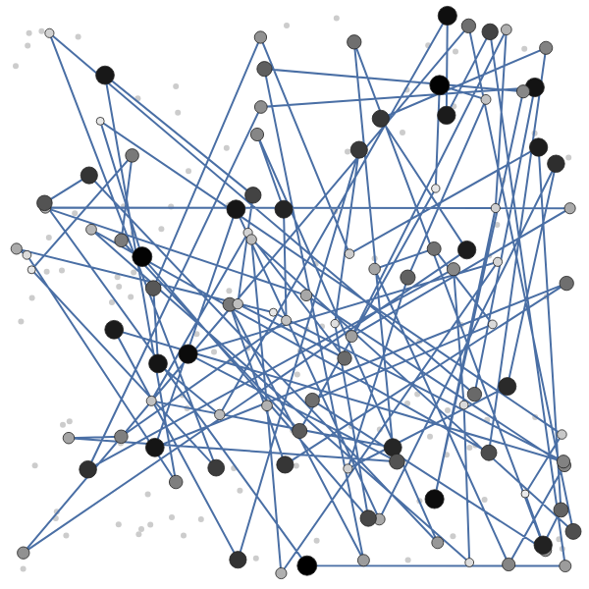
TSPA - Random: objective 237131 (length 140636 + cost 96495)
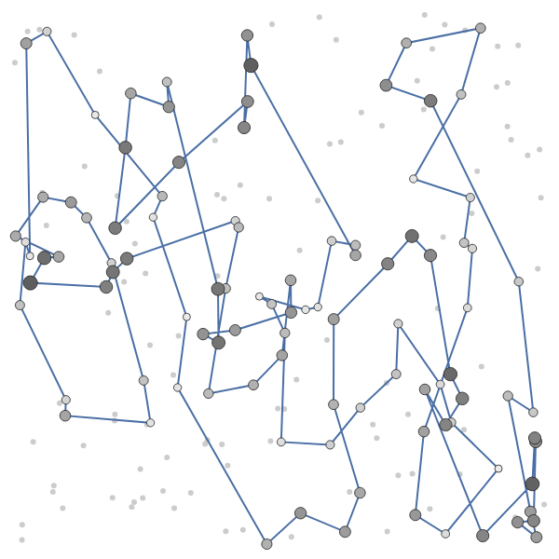
TSPA - NN (end only): objective 84362 (length 31319 + cost 53043)
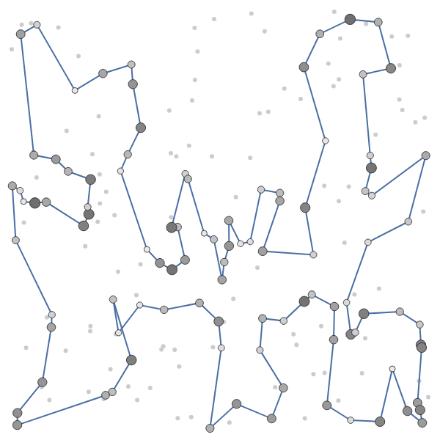
TSPA - NN (any position): objective 72328 (length 21816 + cost 50512)
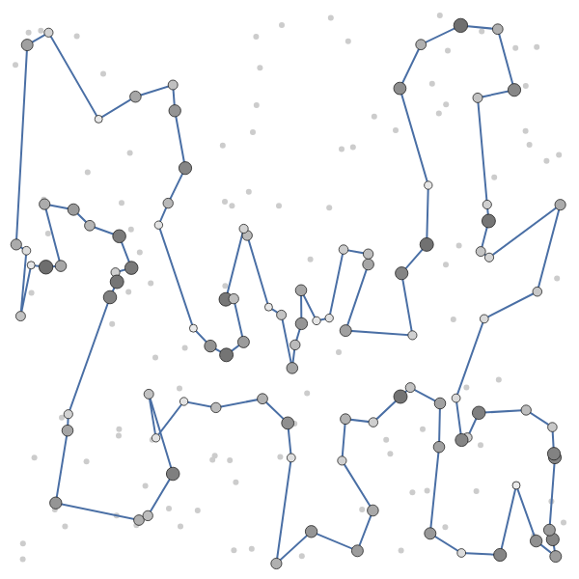
TSPA - Greedy cycle: objective 72590 (length 21570 + cost 51020)

Instance TSPB
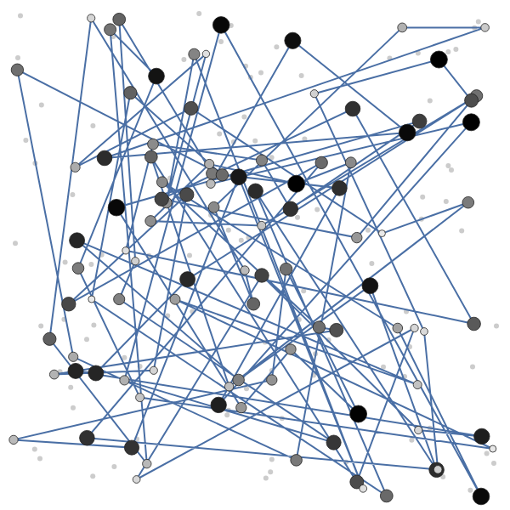
TSPB - Random: objective 188214 (length 138112 + cost 50102)
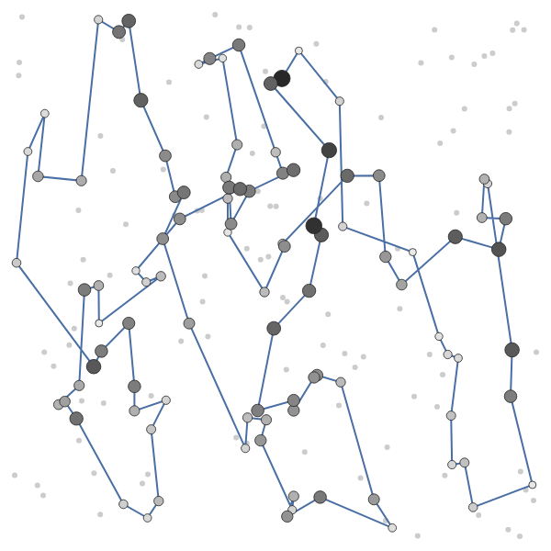
TSPB - NN (end only): objective 56007 (length 24632 + cost 31375)
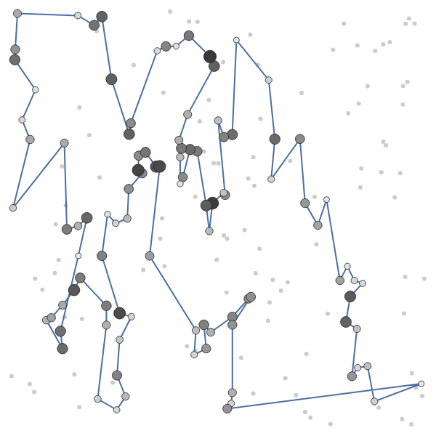
TSPB - NN (any position): objective 52915 (length 20068 + cost 32847)
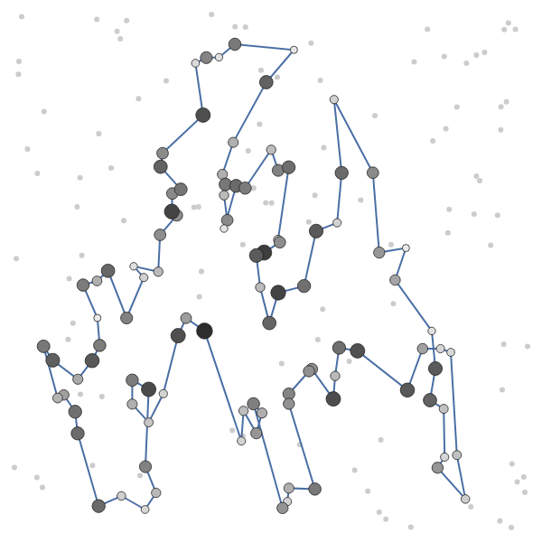
TSPB - Greedy cycle: objective 53016 (length 16704 + cost 36312)

5. Best solutions - node lists (0-based)

Instance TSPA
Random (objective 237131): 128, 34, 55, 103, 152, 57, 106, 85, 120, 112, 86, 43, 48, 96, 63, 38, 100, 61, 164, 195, 178, 194, 58, 117, 6, 158, 173, 40, 37, 121, 156, 192, 5, 101, 165, 1, 29, 131, 147, 60, 52, 170, 64, 54, 142, 93, 41, 88, 107, 159, 80, 68, 20, 36, 15, 22, 12, 146, 67, 116, 149, 189, 137, 133, 35, 99, 51, 30, 13, 154, 122, 75, 155, 33, 115, 162, 23, 87, 197, 56, 19, 78, 118, 82, 66, 182, 139, 190, 144, 161, 127, 65, 191, 50, 114, 45, 16, 26, 163, 129
NN (end only) (objective 84362): 54, 9, 33, 36, 177, 67, 144, 53, 135, 58, 134, 176, 174, 106, 89, 107, 57, 182, 151, 93, 50, 3, 1, 164, 178, 29, 136, 186, 184, 47, 159, 130, 153, 78, 88, 193, 170, 146, 75, 64, 150, 42, 113, 43, 85, 142, 8, 131, 84, 158, 192, 181, 114, 141, 180, 132, 76, 80, 48, 31, 63, 149, 168, 97, 127, 187, 30, 123, 152, 108, 60, 116, 49, 11, 119, 160, 83, 90, 51, 16, 35, 87, 45, 140, 52, 179, 185, 28, 102, 156, 157, 71, 91, 38, 100, 4, 112, 139, 115, 5
NN (any position) (objective 72328): 104, 129, 69, 127, 97, 168, 116, 149, 63, 11, 49, 160, 83, 123, 100, 152, 108, 60, 31, 48, 80, 91, 157, 71, 4, 76, 132, 180, 28, 102, 185, 35, 156, 51, 16, 67, 144, 140, 53, 179, 52, 177, 36, 33, 9, 54, 131, 174, 8, 164, 186, 136, 163, 29, 101, 178, 1, 169, 3, 50, 147, 47, 93, 106, 42, 89, 113, 130, 159, 146, 170, 153, 193, 78, 88, 107, 64, 57, 182, 151, 150, 176, 72, 134, 84, 58, 158, 192, 181, 114, 135, 73, 45, 87, 141, 187, 30, 189, 2, 171
Greedy cycle (objective 72590): 31, 116, 149, 168, 63, 11, 49, 60, 108, 152, 100, 90, 123, 83, 160, 97, 127, 69, 171, 2, 189, 30, 187, 141, 87, 45, 73, 135, 114, 181, 192, 158, 58, 84, 134, 72, 176, 150, 151, 182, 57, 64, 107, 88, 78, 193, 153, 170, 146, 159, 130, 113, 89, 42, 106, 93, 47, 147, 50, 3, 169, 1, 178, 101, 29, 163, 136, 186, 164, 142, 8, 174, 131, 54, 9, 33, 36, 177, 52, 179, 53, 140, 144, 67, 16, 51, 156, 35, 185, 102, 28, 180, 132, 76, 4, 71, 157, 91, 80, 48

Instance TSPB
Random (objective 188214): 80, 23, 16, 71, 163, 97, 140, 42, 136, 144, 107, 193, 172, 44, 12, 15, 105, 190, 160, 98, 151, 116, 103, 45, 147, 195, 177, 60, 110, 64, 153, 55, 73, 106, 188, 137, 17, 170, 50, 8, 13, 6, 88, 104, 0, 133, 38, 184, 61, 4, 113, 5, 68, 20, 111, 134, 129, 39, 191, 59, 148, 54, 63, 158, 96, 21, 198, 171, 95, 142, 1, 181, 27, 186, 34, 51, 161, 18, 75, 46, 130, 154, 56, 77, 176, 162, 139, 199, 57, 90, 2, 91, 185, 19, 168, 40, 132, 84, 66, 30
NN (end only) (objective 56007): 32, 89, 57, 76, 54, 127, 129, 90, 153, 20, 14, 2, 110, 118, 56, 114, 196, 10, 148, 143, 78, 192, 162, 104, 185, 184, 3, 151, 69, 172, 133, 120, 96, 121, 198, 48, 72, 46, 86, 117, 160, 136, 8, 21, 154, 140, 47, 170, 125, 177, 6, 132, 29, 197, 175, 134, 45, 60, 40, 71, 155, 97, 115, 180, 65, 28, 149, 145, 158, 116, 147, 42, 50, 130, 30, 183, 38, 64, 85, 59, 167, 51, 87, 179, 82, 88, 171, 99, 67, 24, 34, 181, 152, 73, 98, 27, 135, 75, 79, 156
NN (any position) (objective 52915): 110, 2, 14, 20, 74, 153, 182, 52, 90, 129, 127, 80, 54, 192, 162, 104, 76, 185, 57, 89, 86, 46, 72, 3, 184, 173, 151, 122, 117, 8, 160, 69, 172, 136, 133, 120, 156, 43, 48, 96, 198, 121, 130, 191, 50, 42, 147, 116, 37, 146, 13, 149, 28, 145, 65, 158, 177, 125, 26, 170, 197, 36, 132, 29, 6, 180, 115, 155, 71, 175, 134, 45, 157, 60, 40, 141, 97, 154, 140, 47, 38, 21, 176, 30, 183, 189, 168, 64, 59, 85, 51, 73, 167, 152, 34, 24, 181, 179, 87, 82
Greedy cycle (objective 53016): 49, 64, 33, 40, 60, 71, 155, 141, 157, 45, 134, 175, 62, 36, 197, 29, 132, 178, 103, 6, 180, 115, 170, 177, 125, 26, 97, 140, 154, 47, 38, 21, 176, 30, 183, 191, 130, 63, 121, 198, 96, 48, 89, 156, 120, 133, 136, 172, 160, 69, 8, 117, 72, 46, 86, 184, 3, 173, 122, 151, 98, 111, 27, 135, 76, 185, 57, 104, 162, 54, 192, 127, 52, 182, 153, 20, 74, 2, 14, 90, 129, 80, 150, 84, 66, 67, 31, 24, 34, 152, 181, 88, 179, 87, 82, 73, 167, 51, 59, 85

6. Source code
labs/lab1/{python,c,cpp,rust}/solver.*, shared code in common/.

7. Conclusions
- Random solutions are far worse than any greedy method (about 3-4x the objective).
- On TSPA, inserting at any position (NN-any, greedy cycle) is clearly better than appending at the end (avg ~74000 vs ~87500), because the paths become much shorter.
- On TSPA, NN-any and greedy cycle are close (best 72328 vs 72590; greedy cycle has the slightly better average).
- On TSPB all three greedy methods have similar averages (~59500); NN-any and greedy cycle reach better best values (~53000 vs 56007), so the benefit shows mainly in the best start nodes.
- Greedy methods are deterministic given the start node, so spread comes only from the start choice; trying all starts and keeping the best is cheap and worthwhile.

