Nama : Tony Riseka Putra

Nim :16050623039
Prodi :Manajemen Informatika

Tugas Basis Data Lanjut MongoDB Tree stucture

Tingkatan Field darii collection “kategori”
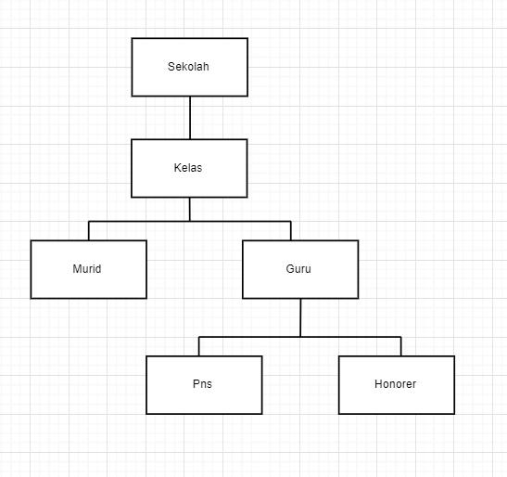

- Parrent References
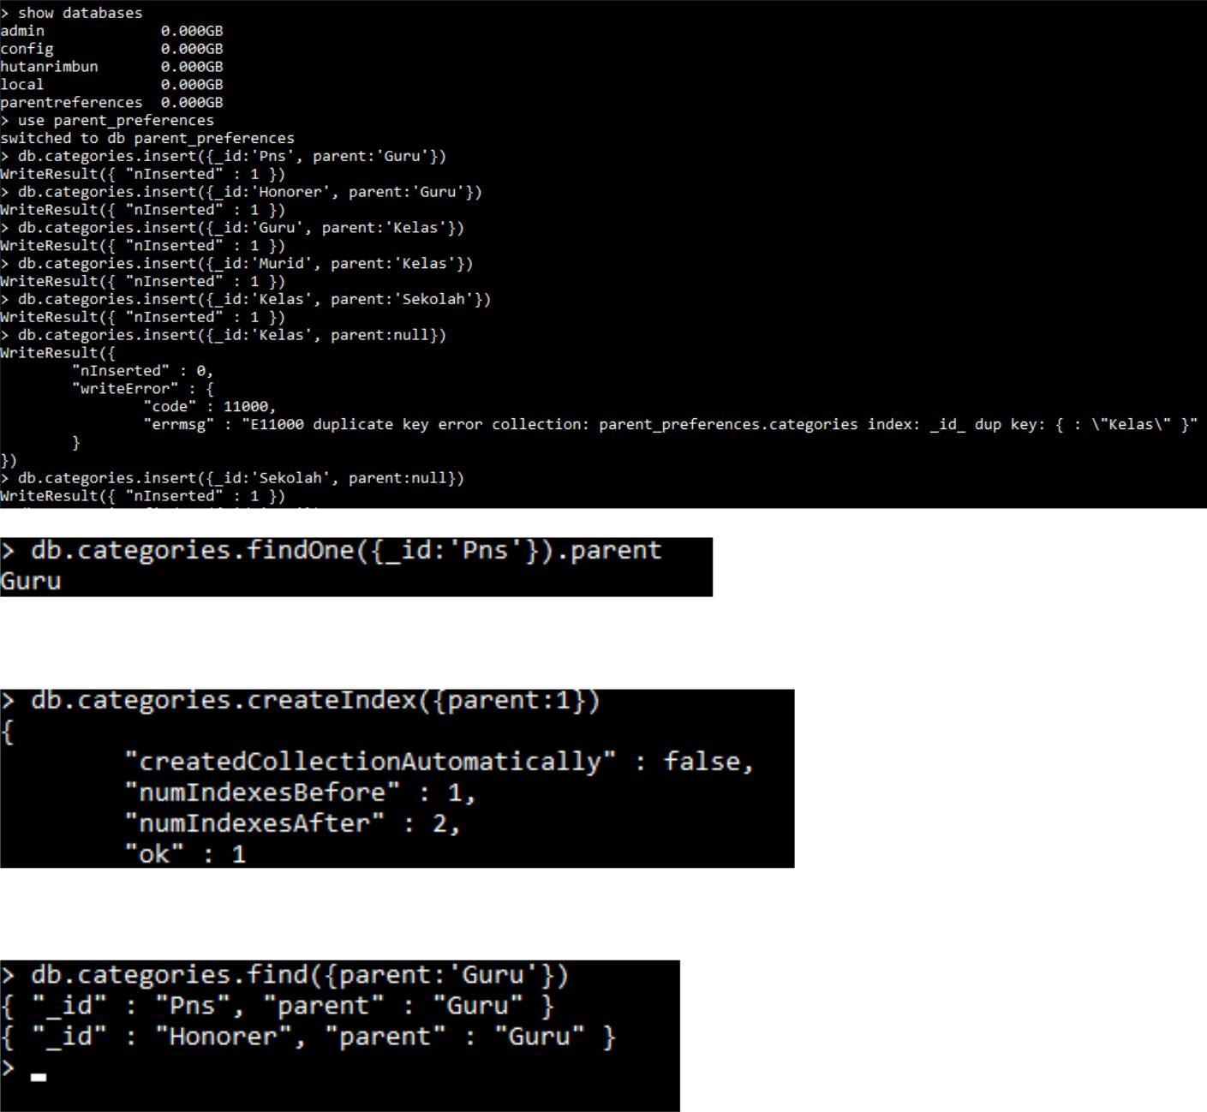

- Child References
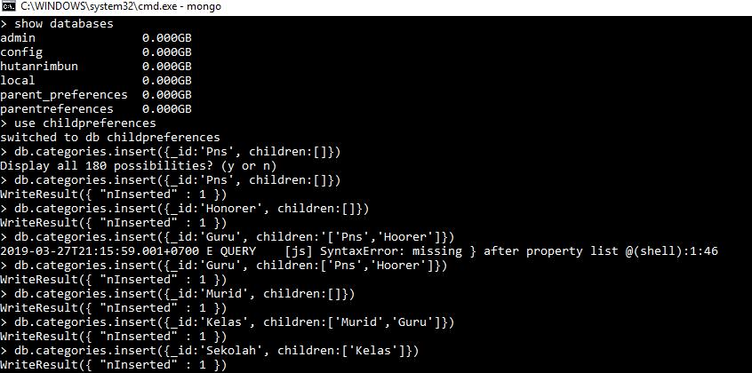
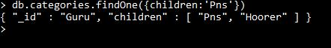

- Array Of Ancestors
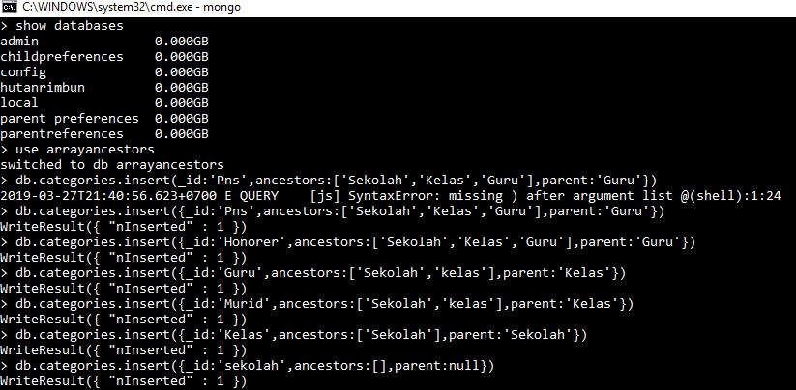
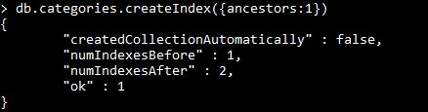
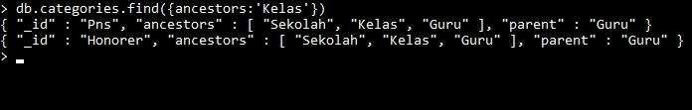

- Materialized Paths
