Nama : Dwi Febriana S

NIM : 17050623017

Prodi : D3 Manajemen Informatika

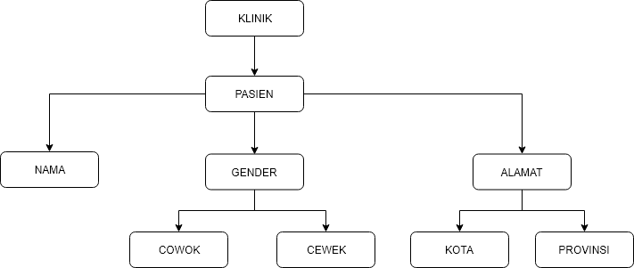

* Model Tree Structures with Parent References

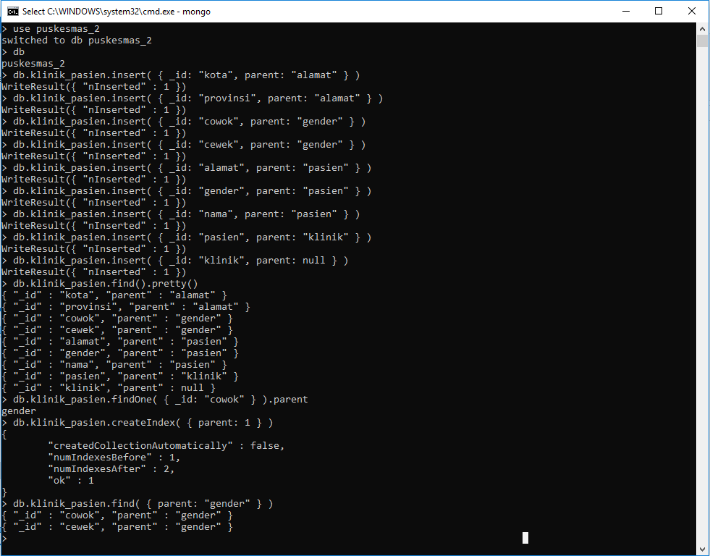

* Model Tree Structures with Child References

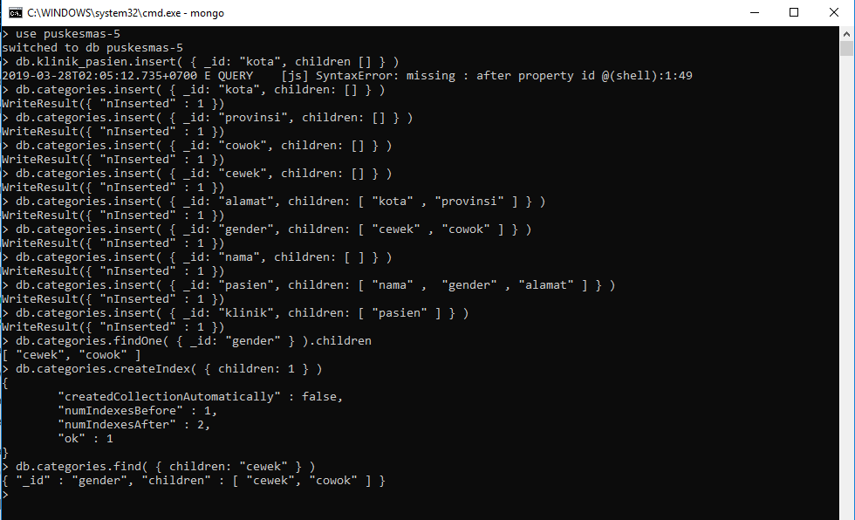

* Model Tree Structures with an Array of Ancestors

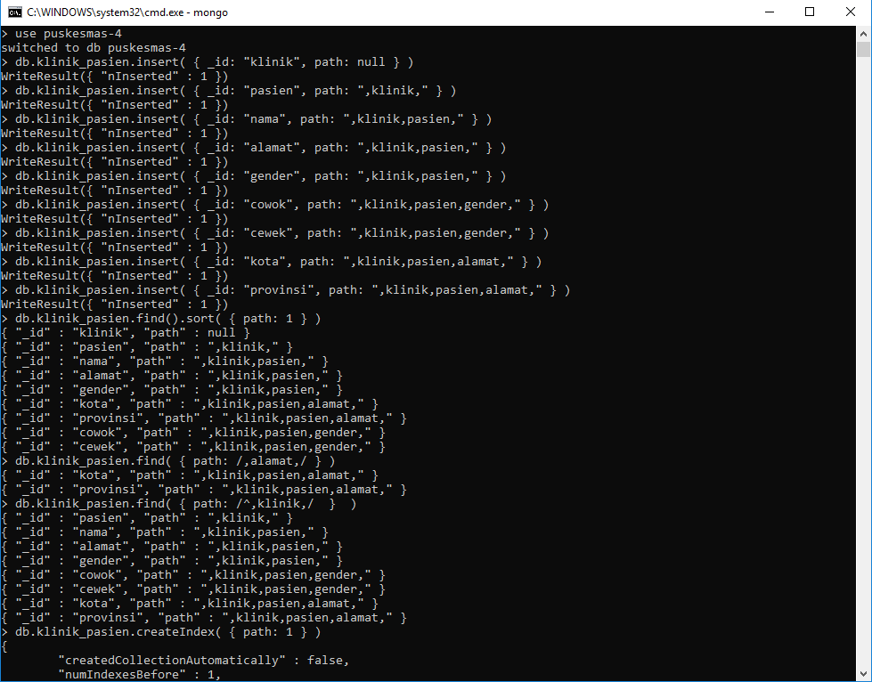

* Model Tree Structures with Materialized Paths

