**Nama : Charisma Aulya**

**NIM : 17050623014**

**PRODI : D3 Manajemen Informatika**

**TUGAS 4**

Is writable by your user before running this code.

Start up a mongo shell with the --nodb option, which allows you to start a shell that is

not connected to any *mongod*:

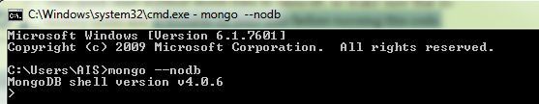

Create a replica set by running the following command:



This tells the shell to create a new replica set with three servers: one primary and two

secondaries. However, it doesn’t actually start the *mongod* servers until you run the

following two commands:





You should now have three mongod processes running locally on ports 20000, 20001,

and 20002.

Connect to the mongod running on port 20000:



Use your connection to the primary to run the *isMaster* command. This will show you

the status of the set:

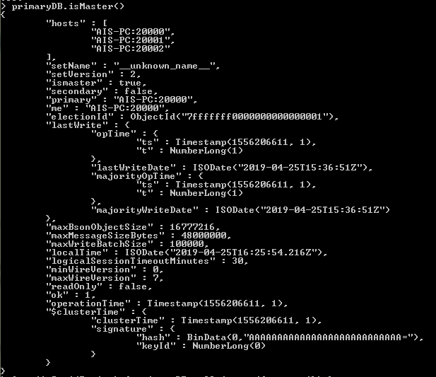

Now that you’re connected to the primary, let’s try doing some writes and see what

happens. First, insert 5 documents:





Now check one of the secondaries and verify that they have a copy of all of these documents.

Connect to either of the secondaries:



if you attempt to query a secondary, you’ll get an error that it’s not primary:

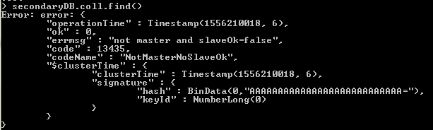

To allow queries on the secondary, we set an “I’m okay with reading from secondaries” flag, like so:



Note that slaveOk is set on the *connection* (conn2), not the database (secondaryDB).

Now you’re all set to read from this member. Query it normally:

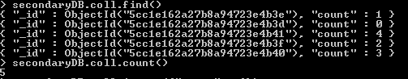

Now, try to write to a secondary:

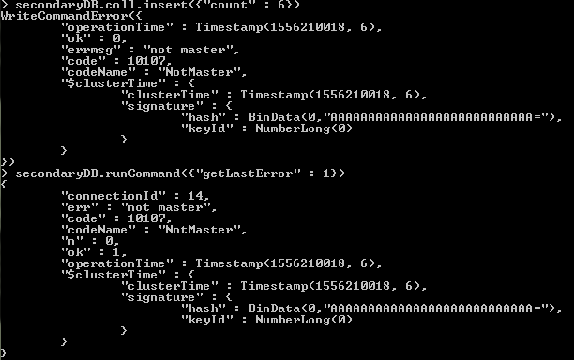

You can see that the secondary does not accept the write. The secondary will only perform writes that it gets through replication, not from clients.

There is one other interesting feature that you should try out: automatic failover. If the

primary goes down, one of the secondaries will automatically be elected primary. To try

this out, stop the primary:



Run isMaster on the secondary to see who has become the new primary:

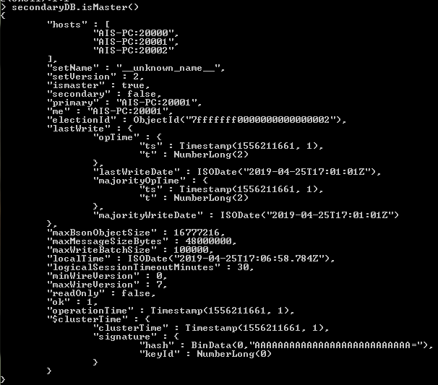

When you’re done working with the set, shut down the servers from your first shell.

This shell will be full of log output from the members of the set, so hit Enter a few times

to get back to a prompt. To shutdown the set, run:

