< Survey Builder >
Design Document

Version 1.0



Group Id: < F1202ED840 (BC080200974)>
Supervisor Name :< Adnan Asif >

- Data Flow Diagrams (DFD)
Context level diagram of survey builder:
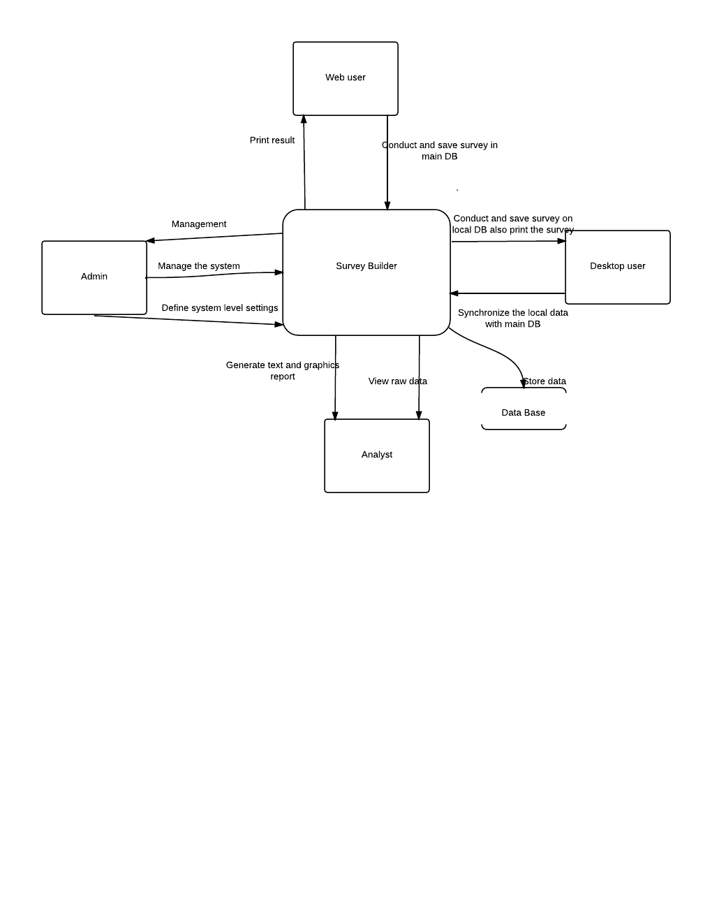

- Entity Relationship Diagram (ERD)

Admin

Analyst
Web & desktop users
Account information
Admin name
Gender
Date of birth
E-mail address
Postal address
Zip code
Admin ID
Manage CRUD
User name
userID
User password
e-mail address
Date of birth
User type
Gender
M
M
Manages
Questions
Adds
M
M
Q types
True / False
MCQs
Can see
M
M
topicID
No of Q.
Creates.
Reports
M
M
Plain reports
Graphical reports
M
M

References:-
http://vulms.vu.edu.pk/Courses/CS619/Downloads/Fall2012-Announcements.htm
http://vulms.vu.edu.pk/Courses/CS619/Downloads/HelpingMaterial.htm
(Software Engineering I & II handouts)
And
DBMS handouts

