Executive Summary 09/05/2024
Mints Project is one of flagship programs of UT Dallas. Partly funded by the TRECIS grant, OIT has supported the initiation and operation of the project since the beginning. With the TRECIS grant ending, and progress in stabilizing the UTD HPC environment, we are now evaluating options for non-HPC research computing and application infrastructure. These items are out of scope for the new team and resources activated earlier this year. The current hardware is also out of support.
With Dr. Lary’s preference to continue operations with non-cloud/on-prem infrastructure, we propose a path forward where we separate the Mints project infrastructure and operations from HPC/CI Core infrastructure.
These are the goals of this project:
- Clear costs allocation of AWS resources
- Clear primary and secondary operational support responsibility for Mints project
- Clear ownership and accountability of Mints project
- Decouple Mints from shared services for sustained, independent growth

Solution Overview
Current State
The solution is spread across two bare metal machines (Virsch, IMD) and AWS Accounts. Mints services share infrastructure with Core services due to the nature of organic growth of the solution while coupled with OIT and HPC services.

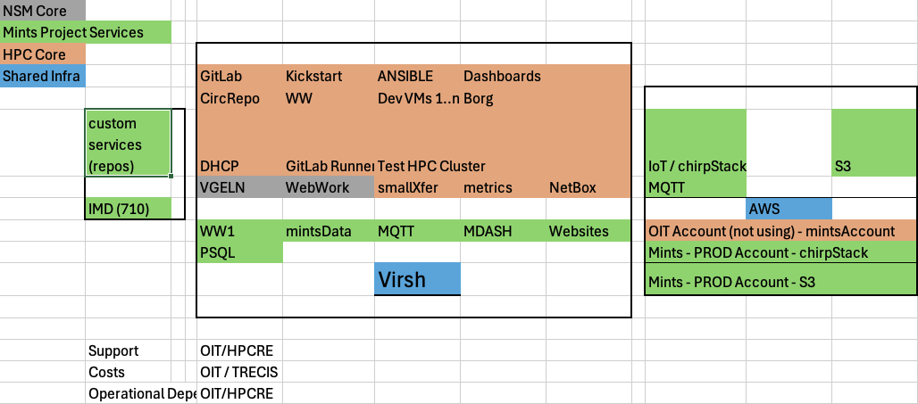

Disadvantages of this architecture include hard dependency on single machine across distinct and separate services. This created an artificial constraint on growth and evolution of each group due to being tied to the other team’s responsibilities. We also have shared costs across projects with no clear allocation of costs. Support is not optimal due to resource constraints.

Recommended State for Mints
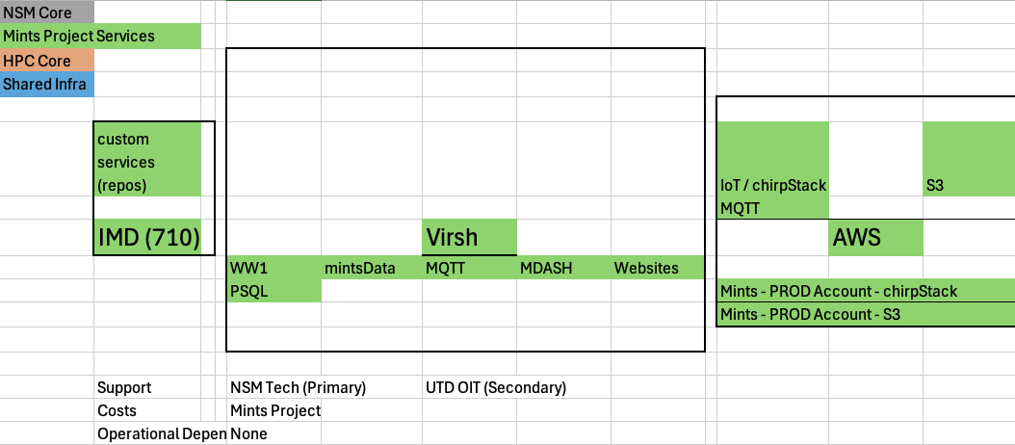
As shown, we propose to remove shared and core services from the current infrastructure. We will leave behind the running infrastructure to ensure continuity of Mints. This will also address the drawbacks of current state. With clear separation of services, Mints will have the project team and NSM Tech as primary support engineers. UTD OIT will continue to be secondary and escalation-level support for infrastructure. With dedicated AWS account for required services, Mints costs will be clearly separated from OIT costs.

Immediate High Priority Initiatives
- [For migration] Upgrade all CentOS Linux 7 and CentOS Linux 8 servers
- [Post migration] Migrate the Mints VM tech to Proxmox from KVM for stability

Cost Management
Current direct AWS cost for Mints project is about $200 per month. In addition, there are other resources setup in HPC Sandbox account that run up to $1800. Not all of this is related to Mints. We will review and itemize and allocate costs for Mints project to provide a clear cost structure for the project. Some of the costs may be due to the AWS Mints POC project, that we will have to decommission.

Projected Timelines and Tasks
- [Done] - Create and test the destination Proxmox (Luna) setup blueprint in existing hardware
  - September 2024
- [Dependency – Not yet approved] Procure destination hardware for HPCRE Core services. We can find a workaround if needed.
  - October 2024
- Decommission Mints AWS POC project and stop all related AWS services.
  - October 2024

- Install and setup destination Proxmox on new hardware for HPCRE Core services
  - November 2024
- Execute the move of VMs from Virsch to Luna
  - December 2024
- Training, transition, and operational handoff of Virsch to Mints project team
  - October 2024 – December 2024
- Ongoing support

