 

*Council for Technical Education & Vocational Training (CTEVT)*

**Lumbini Engineering College**

Bhalwari, Rupandehi

EST.2000



A Minor Project Report

Of

“Expense Tracker”

Submitted To:

Er. Binay Sharma

Lumbini Engineering College

Submitted By:

Milan Bhattarai

(DCOM-00497-020)



**Lumbini Engineering College**

*(****Council for Technical Education & Vocational Training)***

Bhalwari, Rupandehi

2002

***Certificate***

*This is to certify that the project entitled 'Expense Tracker' has been successfully completed by Mr. Milan Bhattarai under my supervision. This project is submitted in partial fulfillment of the requirements for the degree of* **DIPLOMA OF COMPUTER ENGINEERING** *awarded by* **CTEVT** *(Council for Technical Education and Vocational Training) during the academic year 2023, specifically during the 5th semester.*

Co-Ordinator:

Er. Pankaj Thakur

Supervisor:

Er. Binay Sharma

External Teacher

**ABSTRACT**

The "Expense Tracker" is a website that helps people keep track of their expenses effectively. This project helps people keep track of their money, set goals, and understand their financial situation in an easy and simple way. The Expense Tracker is a tool that helps you keep track of your expenses. It has different functions such as creating an account, logging your expenses, setting financial goals, analyzing your spending in real-time, and showing data in easy-to-understand pie charts.

Users can make accounts, keep track of what they spend every day, set goals for how much they want to spend, and get alerts if they are getting close to spending too much. The system gives detailed reports that help users understand how they spend their money. The easy-to-use interface helps users quickly understand their financial information.

The Expense Tracker is made using different technologies like HTML, CSS, PHP, and MySQL to help manage the database. When these technologies work together well, it provides a user-friendly experience and keeps data safe.

This project wants to help people have control over their money, make smart choices about their finances, and reach their savings goals. The Expense Tracker helps people learn about money and spend wisely by providing an easy-to-use platform with lots of useful tools.

**ACKNOWLEDGEMENT**

I want to say thank you to everyone who helped with the "Expense Tracker" project. I couldn't have done it without the help and support of many people, organizations, and online resources. I am very grateful for their assistance.

First and most importantly, I want to thank our respected project supervisor, Mr. Binay Sharma, for all his support and guidance. His extremely helpful advice, constant encouragement, and ongoing oversight during the project were essential in determining its direction. I am really thankful for his knowledge and opinions.

I want to thank my friends and classmates for supporting me, motivating me, and having helpful discussions that helped me overcome difficulties and stay motivated during the project's development. Their teamwork was an important factor in the success of this project.

Additionally, I want to mention the internet sources and websites that helped me a lot by giving me important information, references, and guidance during the project. These websites were very important in helping me learn more things and improve my abilities.

Overall, I want to say a big thank you to everyone who helped finish this project. Your support, whether as a supervisor, peer, or online resource, has been invaluable, and I am truly thankful for your contributions.

Sincerely,

Milan Bhattarai

**TABLE OF CONTENT**

Abstracti

Acknowledgementii

List of Abbreviation1

Chapter 1: Introduction2

***1.1 Introduction 2***

***1.2 Problem Statement 2***

***1.3 Objectives 3***

***1.4 Scope and Limitation4***

***1.5 Development Methodology 4***

***1.6 Report Organization 5***

Chapter 2: Background Study and Literature Review6

***2.1 Background Study 6***

***2.2 Literature Review 6***

Chapter 3: System Analysis and Design 7

***3.1 System Analysis 7***

***3.1.1 Requirement Analysis 7***

***I. Functional Requirements 7***

***II. Non-Functional Requirements 8***

***3.1.2 Feasibility Analysis8***

***3.1.3 Data Modeling 10***

***3.1.4 Process Model 11***

***3.2 System Design 12***

***3.3 Algorithm Details13***

Chapter 4: Implementation and Testing 14

***4.1 Implementation14***

***4.1.1 Tools Used14***

***4.2 Testing15***

***4.2.1 Test Case for Unit Testing 15***

***4.2.2 Test Case for Integrated Testing 15***

Chapter 5: Result 17

***5.1 Functionality and Features 17***

***5.2 User Experience 17***

***5.3 Performance and Scalability 17***

***5.4 Security 17***

Chapter 6: Conclusion and Future Enhancements 18

***6.1 Conclusion 18***

***6.1.1 Major Achievements 18***

***6.1.2 Positive User Experience18***

***6.1.3 Scalability and Performance 18***

***6.2 Future Enhancements18***

***6.2.1 Mobile Application 18***

***6.2.2 Notification System 18***

***6.2.3 Data Export 19***

***6.2.4 Advanced Analysis 19***

***6.2.5 Continuous Security Updates19***

***6.3 Final Thought 19***

Chapter 7: Reference 20

***7.1 Online Resources 20***

***7.2 PHP and MySQL Documentation 20***

***7.3 Educational References 20***

**LIST OF FIGURES**

Fig.1: Use Case Diagram of Expense Tracker 7

Fig.2: ER-Diagram of Expense Tracker 10

Fig.3: DFD of Expense Tracker 11

Fig.4: UI Design of Dashboard Page of Expense Tracker 12

Fig.5: UI Design of Register Page of Expense Tracker 12

Fig.6: UI Design of Login Page of Expense Tracker 13LIST OF TABLES

Table 1: Test Case for Unit Testing 17

Table 2: Test Case for Integrated Testing 18

**LIST OF ABBREVIATIONS**

**- HTML: Hypertext Markup Language**

**- CSS: Cascading Style Sheets**

**- PHP: Hypertext Preprocessor**

**- SQL: Structured Query Language**

**- CRUD: Create, Read, Update, Delete**

**- DBMS: Database Management System**

**- UI: User Interface**

**- UX: User Experience**

**- API: Application Programming Interface**

**- HTTP: Hypertext Transfer Protocol**

**- URL: Uniform Resource Locator**

**- AJAX: Asynchronous JavaScript and XML**

**- MVC: Model-View-Controller**

**- IDE: Integrated Development Environment**

**- GUI: Graphical User Interface**

**- SMTP: Simple Mail Transfer Protocol**

**- JS: JavaScript**

**- HTTPS: Hypertext Transfer Protocol Secure**

**CHAPTER 1: INTRODUCTION**

* 1. **Introduction**

The "Expense Tracker" project stands as a testament to our journey in the field of computer engineering, a culmination of dedication and hard work during the academic year 2023. This project comes out as an important solution to a common problem: managing personal finances. In today's busy world, it is very important to manage your money well. However, the usual ways of doing it are not always effective. This project wants to change how people manage their money by providing a new website where people can see and control all of their spending.

We started this project because we know that the usual ways of keeping track of expenses often don't work well, have mistaken, or are old-fashioned. Using handwritten books or difficult spreadsheets to manage money records is an old-fashioned practice. On the other hand, the "Expense Tracker" project aims to give users a simple and easy-to-use tool that helps them keep track of their daily spending. Our goal is to change how people manage their money by offering an easy-to-use system where they can record and categorize their expenses, set goals, and view helpful reports.

This report explores the details of the "Expense Tracker" app. It explains the overall design, main features, the technical structure used for creating it, and the technologies used to make it work. Moreover, it honestly tells about the difficulties experienced throughout the process of development and the creative solutions created to overcome them. The "Expense Tracker" project combines technology and finance to help people manage their money better. It aims to make personal finance easier and more enjoyable.

* 1. **Problem Statement**

In today's fast and busy digital world, people have a hard time managing their money well. Traditional ways of keeping track of expenses are difficult, take up a lot of time, and often have mistaken. This can cause frustration and make it hard to keep accurate records of finances. Furthermore, these methods do not provide the convenience required for current, active lifestyles. Additionally, these tools do not give users helpful information about how they spend their money. This makes it hard for people to make smart choices about their finances, plan their budget effectively, or reach their savings objectives.

Additionally, there are concerns about keeping financial information safe and private on personal devices or platforms that are not secure. This can be a big problem for people who want to effectively handle their money. Not having a clear way to keep track of how well we are doing on our financial goals makes things even harder for many people who have trouble saving money and reaching their financial targets.

The issue we are facing is the requirement for a solution that can record expenses while also giving users useful information, easy access, and keeping their information safe. This solution will help people easily control their money, understand how they spend it, and confidently work towards their financial goals.

The "Expense Tracker" project wants to make it easier for people to keep track of their expenses and save money. It will have a platform that is easy to use and keeps your information safe. You can use it on different devices like your phone or computer. It will also help you analyze your financial data and set goals for saving money.

* 1. **Objectives**

1. Efficient Cost Tracking: The essential objective of the "Cost Tracker" extend is to supply clients with a direct and productive implies of following their day-by-day costs. The framework ought to permit clients to easily record their consumptions, categorize them, and store them safely.
2. Smart Financial Analysis: To engage clients with a more profound understanding of their budgetary propensities, the framework will create nitty gritty reports and visualizations. Clients can get to these reports to recognize investing designs, track costs over time, and pick up bits of knowledge into ranges where cost-cutting or budget alterations are conceivable.
3. Multi-Platform Accessibility: The extend points to offer availability over different stages, counting web browsers, portable gadgets, and desktop applications. This multi-platform approach guarantees that clients can oversee their accounts helpfully, notwithstanding of their favored gadget.
4. Secure Data Management: Security could be a foremost concern when managing with individual budgetary information. The "Expense Tracker" will prioritize vigorous security measures to ensure client data. It'll execute encryption conventions, client confirmation, and information reinforcements to guarantee information security and anticipate unauthorized get to.
5. Goal Setting and Advance Monitoring: Clients will have the capability to set budgetary objectives, such as sparing for an excursion or paying off obligations. The framework will empower clients to screen their advance toward these objectives, giving inspiration and a sense of achievement.
6. User-Friendly Interface: The project will prioritize client involvement by advertising an instinctive and user-friendly interface. This incorporates highlights such as simple route, direct expense entry, and customizable categories to improve convenience.
7. Notification and Reminders: To assist clients remain on top of their money related commitments, the system will consolidate notice and update highlights. These updates will incite clients to form convenient charge installments and record costs.
8. Comprehensive Reporting: Clients will have got to a run of comprehensive monetary reports, counting pay vs. use, category-wise investing, and patterns over time. These reports will be created automatically and can be customized to suit person inclinations.
9. User Support and Assistance: The extend will incorporate a bolster framework to help clients with any inquiries or issues they may experience whereas utilizing the stage. Furthermore, a point-by-point client manual and FAQs segment will be given for self-help.
10. Continuous Improvement: The improvement group will commit to progressing enhancements and overhauls to upgrade the "Cost Tracker." User feedback will be effectively looked for and joined into future cycles, guaranteeing that the framework remains a profitable monetary management tool.

These goals collectively point to form a strong and user-centric budgetary administration arrangement that streamlines cost following, cultivates monetary mindfulness, and enables clients to realize their budgetary objectives with certainty.

* 1. **Scope and Limitation**

**Scope**

The "Expense Tracker" project wants to give people an easy-to-use website or app where they can keep track of what they spend money on every day. It also helps them understand their spending habits better. It helps you keep track of your expenses, analyze your finances, access it from different platforms, keeps it safe and secure, set goals, has an easy-to-use interface, and sends you notifications.

**Limitation**

But there are certain things to think about that might stop or control what can happen. The system needs the internet to use it on the web. Data accuracy depends on the information provided by the user, and there is no integration of external data sources. Even though there are security measures in place, the ultimate protection of data relies on how careful users are. Different mobile applications may not work well with all devices. Continuous updates rely on the availability of resources. The system does not give legal or financial advice, and users have to take care of their data privacy.

* 1. **Development Methodology**

For this project we have adopted waterfall development method. This choice arises from the clear and stable requirements of the project. The waterfall model's structured progression in stages fits well with the needs of the project.

Key steps:

* Requirements: We begin by gathering and analyzing project requirements to ensure a thorough understanding of the objectives.
* Design: Once the requirements are solidified, we proceed to design the system, detailing its architecture and specifications.
* Implementation: Follows the development phase, where we translate the designs into a working system.
* Testing: Rigorous testing, including unit, integration, and system testing, identifies and resolves any issues.
* Deployment: With successful testing, the system is deployed for use.
* Maintenance: Ongoing maintenance and support ensures smooth operation of the system post-deployment.

Reasoning for Waterfall:

We chose the waterfall model because:

* Clear Requirements: Project requirements are well defined, favoring a step-by-step approach.
* Structured Progression: Each step must be completed before moving on to the next step while maintaining a logical flow.
* Documentation Emphasis: Waterfall's focus on documentation is tailored to the project's changing resource requirements.

Given these factors, the waterfall model is the optimal choice for our web application development. It provides the necessary structure to effectively meet project objectives.

* 1. **Report Organization**

This report is structured to provide a comprehensive understanding of the project. Here is a breakdown of its organization:

Chapter 1:

This chapter presents an overview of the project, including problem definition, objectives, scope, and limitations.

Chapter 2:

Here, you'll find an exploration of basic project principles, including their core concepts and relevant terminology. In addition, it provides insights into prior projects and research conducted by other scholars in related fields.

Chapter 3:

Chapter 3 The project requirements, both functional and non-functional, are essential to ensure the smooth operation of the application. It also includes detailed feasibility studies and technical diagrams such as data flow diagrams (DFD) and entity-relationship diagrams (ERD).

Chapter 4:

In this chapter, we provide an in-depth look at the tools, programming languages, and database platforms used in the development of the project. You will also find detailed information on module implementation and various testing phases, including unit and system testing conducted to identify and resolve any issues.

Chapter 5:

The final chapter contains the results of the project and the valuable lessons learned in its development. Furthermore, it outlines future recommendations aimed at enhancing the performance and functionality of the system.

**CHAPTER 2: BACKGROUND STUDY AND LITERATURE REVIEW**

**2.1 Background Study**

In today's fast-paced digital world, efficient management of personal finances is more important than ever. The advent of web-based applications has changed the way people track and manage their expenses. This project is inspired by the growing need for streamlined expense tracking solutions.

Managing expenses manually can be time-consuming and error-prone, often leading to financial mismanagement. This project identifies these challenges and seeks to address them through the development of an expense tracker web application.

Expense Tracker is designed to provide users with a user-friendly and efficient platform for recording, categorizing and analyzing their expenses. By automating this process, users can gain better control over their finances, set budgets, and make informed financial decisions.

This background study acknowledges the importance of such tools in modern life. This underlines the project's objective of providing a practical, web-based solution that empowers individuals to manage their finances more effectively, ultimately leading to improved financial well-being.

**2.2 Literature Review**

Existing literature in the field of personal finance and expense tracking reveals a plethora of tools and applications designed to help individuals manage their finances. These tools can be broadly categorized into expense tracking tools, mobile applications, and web-based solutions.

Expense tracking tools aim to simplify the process of recording and categorizing expenses, giving users insight into their spending patterns. Mobile applications, with their real-time tracking capabilities, offer users convenience and flexibility. Web-based solutions, on the other hand, offer users the advantage of accessing their financial data from any Internet-connected device.

Security is a top concern among users, emphasizing the need for strong security measures on these devices. Advanced features such as budgeting and analytics have become increasingly popular, helping individuals set financial goals and gain valuable insights.

Finally, the literature review highlights the importance of personal finance applications in assisting individuals with expense tracking tools and financial management. Security, accessibility, and advanced features are key considerations in their development.

**CHAPTER 3: SYSTEM ANALYSIS AND DESIGN**

**3.1 System Analysis**

**3.1.1 Requirement Analysis**

**I. Functional Requirements**

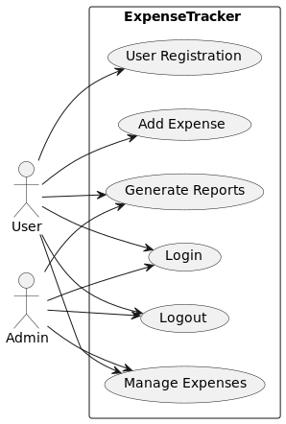

**Fig.1: Use Case Diagram of Expense Tracker**

The functional requirements, as illustrated in the use case diagram for the "Expense Tracker" project, include a set of important interactions and functionalities. This includes user registration and login, which allows users to securely access the system. Users can add, edit and delete expenses ensuring efficient management of financial records. Additionally, the system enables users to view their expenses and generate comprehensive reports for better financial insight. Finally, users can log out, ensuring the security and privacy of their data. These functional requirements collectively facilitate efficient expense tracking and management within the system.

**II. Non-Functional Requirements**

Non-functional requirements for the "Expenditure Tracker" project include:

* Performance: The system should respond quickly, ensuring a seamless user experience, even during peak usage. It should be able to handle a substantial number of concurrent users without significant performance degradation.
* Security: Strong security measures must be in place to protect user data and financial information. This includes encryption for data transmission and storage, secure user authentication, and authorization protocols.
* Usability: The user interface should be intuitive and user-friendly to accommodate users of varying technical proficiency. Appropriate documentation and user support should be available for assistance.
* Scalability: The system must be scalable to accommodate potential future growth in user base and data volume without major architectural changes.
* Reliability: The system should be highly reliable with minimal downtime for maintenance and updates. Data integrity and availability must be maintained at all times.
* Compatibility: The system should be compatible with various devices and web browsers to ensure access to a wide user base.
* Data Backup and Recovery: Regular data backup should be done, and there should be a mechanism for data recovery in case of system failure or data loss.
* Compliance: The system must comply with relevant legal and regulatory standards, particularly regarding financial data and user privacy.
* Performance Monitoring: Tools for monitoring system performance and generating reports for administrators should be available to ensure optimal operation.
* Scalability: The system should be designed to accommodate future expansions and enhancements in terms of features and functionality.

**3.1.2 Feasibility Analysis**

**I. Technical**

In the technical feasibility analysis for the "Expense Tracker" project, several important aspects have been considered. This includes assessing hardware and software requirements, selecting an appropriate technology stack, ensuring efficient data management, evaluating integration possibilities, verifying development team expertise, addressing infrastructure and security concerns, and planning for scalability and ongoing maintenance. This analysis concludes that the project is feasible from a technical perspective, that the necessary resources and measures are in place to support its successful implementation and long-term sustainability.

**II. Operational**

In the operational feasibility analysis for the "Expense Tracker" project, the focus is on evaluating whether the system can be seamlessly integrated into users' daily tasks. This assessment includes factors such as user training and customization, workflow integration, and compatibility of the system with existing processes. It also considers user feedback and the possibility of user resistance to adopting the new system. Based on this analysis, the project is considered operationally feasible, because it is estimated that users can easily incorporate "Expense Tracker" into their daily routine, with minimal disruptions and a positive impact on their financial management tasks.

**. III. Economic**

"Expense Tracker" includes a cost-benefit assessment of the project's economic feasibility. Initial costs include software development, infrastructure setup, and user training. The benefits of the system come from improved financial management, reduced expenses through better expense tracking, and increased productivity. The return on investment (ROI) is expected to be positive in the first year of implementation with long-term financial benefits.

**IV. Schedule**

The project schedule includes various phases including planning, design, development, testing, deployment, and maintenance. Each phase has a specific timeline, and dependencies exist between them. Estimated project duration is approximately six months with periodic milestones and progress tracking. Delays may occur due to unforeseen challenges or changes in requirements, but have a contingency plan to manage such issues without compromising the overall timeline of the project. The program is designed to ensure timely project completion and delivery to end users.

**3.1.3 Data Modeling (ER-Diagram)**

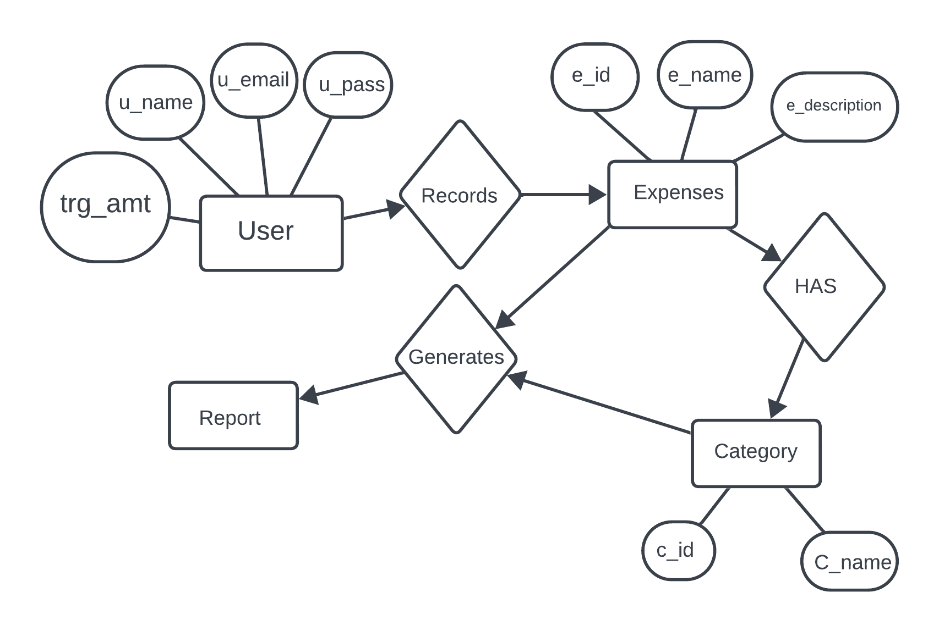

**Fig 2: ER-Diagram of Expense Tracker**

**3.1.4 Process Model (DFD)**

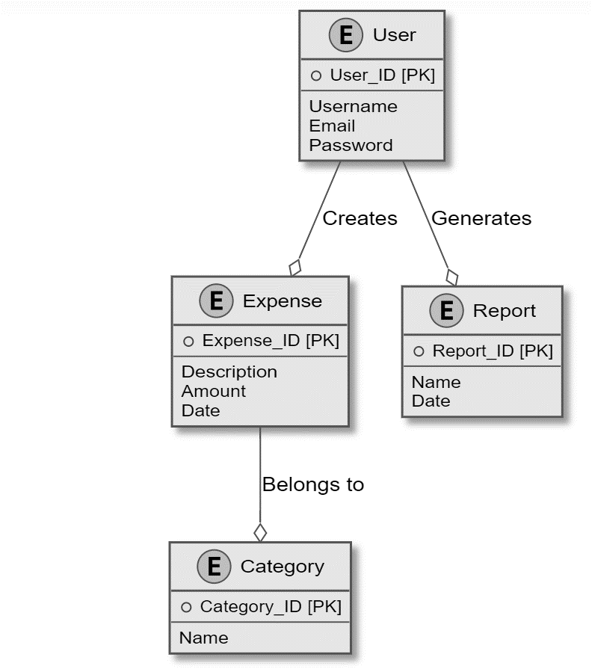

**Fig.3: DFD of Expense Tracker**

**3.2 System Design**

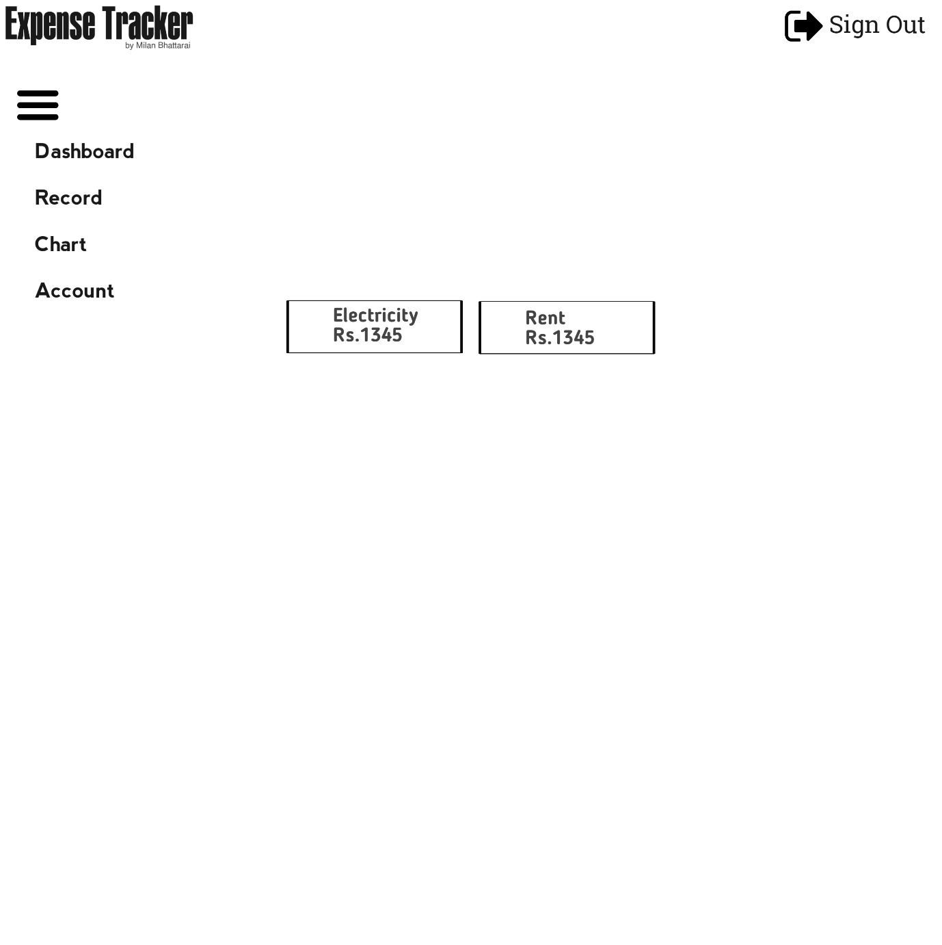

**Fig.4: UI Design of Dashboard Page of Expense Tracker**

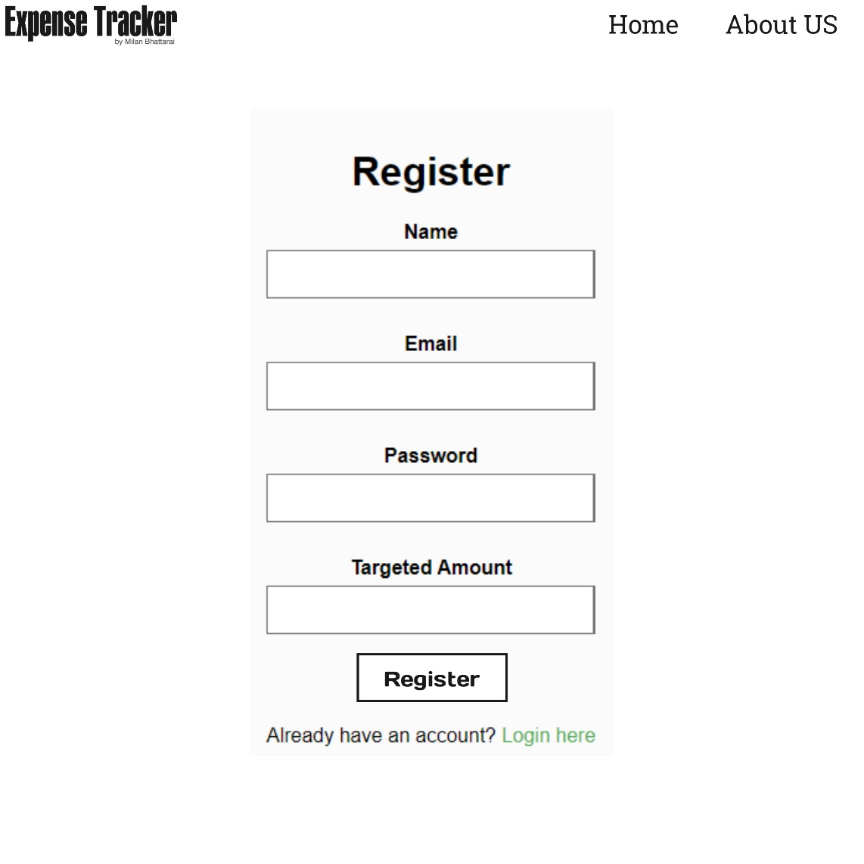

**Fig.5: UI Design of Register Page of Expense Tracker**

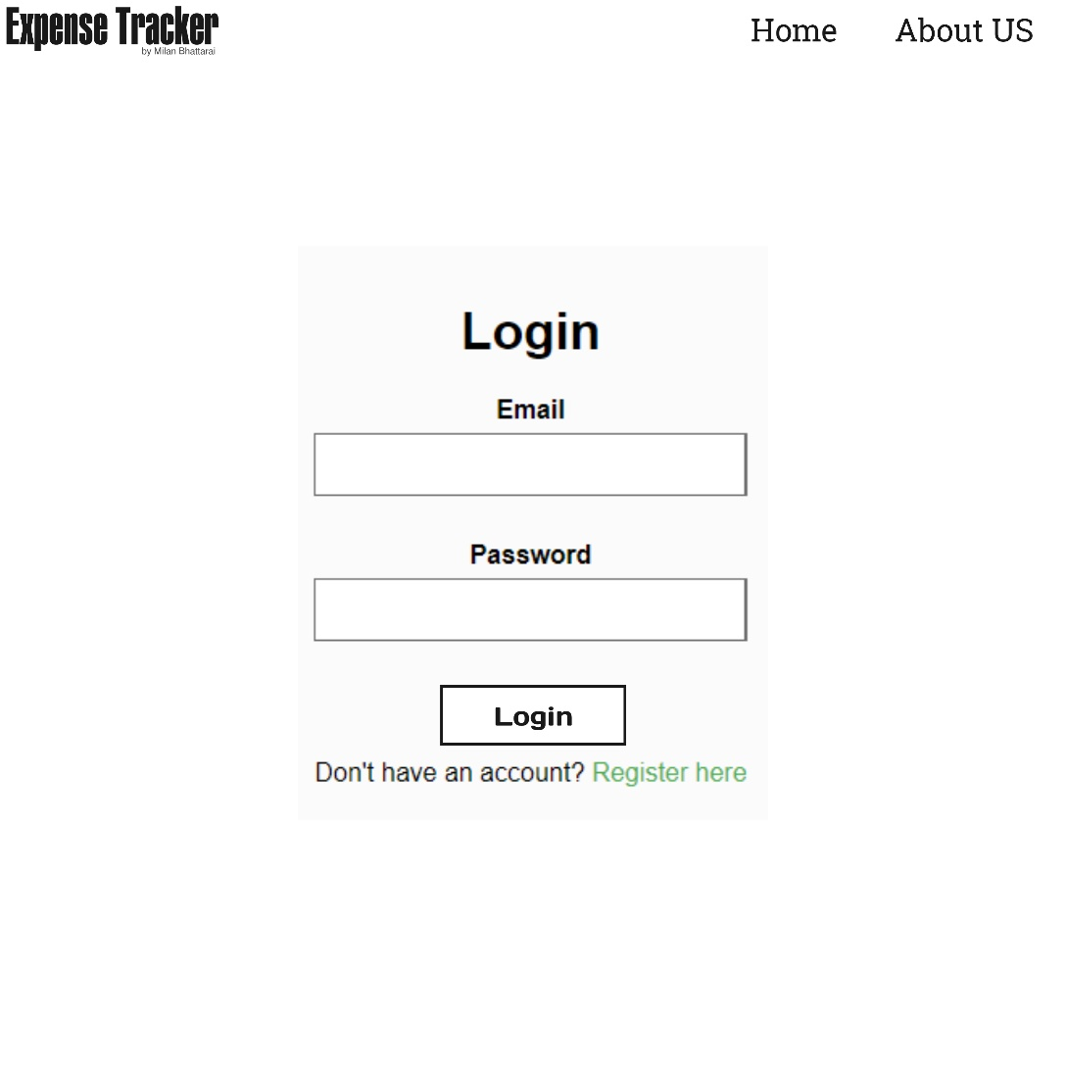

**Fig.6: UI Design of Login Page of Expense Tracker**

**3.3 Algorithm Details**

Rating Algorithm (RA) Steps:

Step 1: Initialization: Start the algorithm.

Step 2: Create the database: Create a dedicated database to store assessment information.

Step 3: Implement Package Ranking: Integrate the ranking algorithm as an integral part of the database query for each expenditure category/package.

Step 4: Calculate the classification: Schedule a background task responsible for calculating the 'ranking' for each expenditure category/package. Update the ranking field in the database with the calculated ranking.

Step 5: Obtaining the assessment details: Get detailed assessment information for each expenditure category/package from the database.

Step 6: Sort by classification: Perform a database query and sort the expense categories/packages based on their calculated rank.

Step 7: Complete the algorithm

# CHAPTER 4: IMPLEMENTATION AND TESTING

## Implementation

Implementation is the stage where physical system specifications are transformed right into an operating and dependable solution. It specifies how the system is installed, operated, and maintained. It additionally guarantees that the system meets high-satisfactory standards. System implementation is the test of a program that exercises the whole system in its real surroundings to decide its abilities and barriers which additionally demonstrates that the system is functionally operative, and is compatible with the opposite subsystems and helping factors required for its operational deployment.

**4.1.1 Tools Used**

* HTML (Hypertext Markup Language): HTML is the standard markup language used for creating the structure and content of web pages. It defines the elements and their layout on a web page, including headings, paragraphs, links, images, forms, and more.
* CSS (Cascading Style Sheets): CSS is used for styling and formatting HTML elements on web pages. It controls the presentation aspects, including layout, colors, fonts, and spacing, to enhance the visual design and user experience.
* PHP: A server-side scripting language for backend development, handling data processing and user authentication.
* MySQL: A relational database management system (RDBMS) used to store and manage user data and expenses.
* XAMPP: An open-source software package that provides an environment for running PHP, Apache, and MySQL on a local server for development and testing.
* Visual Studio Code: A code editor used for writing, editing, and debugging code in various programming languages.
* Google Chrome: Google Chrome is a widely used web browser that developers often use for testing and debugging web applications. It provides a range of developer tools and extensions that aid in web development and troubleshooting.
  1. **Testing**

Testing of the "Expense Tracker" project involved extensive quality assurance procedures. This includes unit testing for individual components, integration testing to ensure seamless interactions, and system testing for overall functionality. Rigorous testing ensured a robust, error-free application, enhancing user experience and data integrity.

**4.2.1 Test Case for Unit Testing**

|  |  |
| --- | --- |
| **Test Case ID:** | ET-TC-001 |
| **Priority:** | High |
| **Module:** | User Registration |
| **Description:** | Verify the validation of user registration inputs. |
| **Preconditions:** | * The system is operational. * The user is on the registration page. |
| **Test Steps:** | * Enter an invalid email address (e.g., "user.com") in the email field. * Enter a weak password (less than 8 characters) in the password field. * Leave the name field empty. * Enter a valid email address, a strong password, and a name in their respective fields. |
| **Expected Results:** | * An error message should display, indicating that the email address is invalid. * An error message should display, indicating that the password is weak. * An error message should display, indicating that the name is required. * The form should be submitted successfully, and the user should be registered. |

**Table 1: Test Case for Unit Testing**

**4.2.2 Test Case for Integrated Testing**

Integration testing focuses on ensuring that the various components of the system work correctly. Here is an example test case for integration testing in your expense tracker project:

|  |  |
| --- | --- |
| **Test Case Name:** | Integration Test - User Registration and Login |
| **Objective:** | To verify that the user registration and login components of the Expense Tracker system work together seamlessly. |
| **Pre-requisites:** | * An expense tracker system is installed and accessible. * The database is set up with the necessary tables including the "Users" table. |
| **Test Steps:** | * Open a web browser and access the Expense Tracker application. * Click on the "Register" link to go to the registration page. * Fill the registration form with valid user data (name, email, password, target amount). * Click on the "Register" button. * Verify that the system redirects you to the login page. * Return to the homepage and click on the "Login" link. * Enter the email and password used during registration. * Click the "Login" button. * Verify that the system redirects you to the dashboard page. * Ensure that the dashboard displays user-specific information and functionality (e.g., username, ability to add expenses). * Log out of the system. * Try logging in with wrong credentials and verify that the system displays an error message. * Try registering with an email address already in use and verify that the system displays an error message. |
| **Expected Results:** | * Registration and login processes must be completed without errors. * The system should correctly transition between registration, login, and dashboard. * User-specific data should be displayed on the dashboard. * Error messages should be displayed for incorrect login or registration attempts. |
| **Pass Criteria:** | All steps should be executed successfully without any errors or unexpected behavior. |
| **Fail Criteria:** | If any of the steps result in errors or unexpected behavior, the test case is considered to have failed. |

**Table 2: Test Case for Integrated Testing**

**CHAPTER 5: RESULT**

The Expense Tracker project has been successfully developed and operationalized, achieving its intended objectives and functionality. Throughout the development process, rigorous testing, and user feedback, the system has demonstrated its ability to effectively manage and track expenses for users. Below are the main results and outcomes of the project:

**5.1. Functionality and features**

The Expense Tracker provides the following key functionality and features:

1. User Registration and Authentication: Users can securely register and log into the system, ensuring data privacy and access control.

2. Dashboard: After logging in, users are presented with a personalized dashboard that provides an overview of their spending and progress towards their target financial goals.

3. Expense Tracking: Users can add, edit and delete individual expenses with details like expense details, amount and date.

4. Category Management: Expenses can be categorized for better organization and reporting, enabling users to gain insight into their spending habits.

5. Reports: The system generates reports that provide valuable insights into the user's financial activity, helping them make informed decisions.

**5.2. User Experience**

The project prioritized user experience, resulting in an intuitive and user-friendly interface. Extensive testing and feedback were collected to ensure that users can easily navigate the system, thereby enhancing their overall experience.

**5.3. Performance and Scalability**

The expense tracker system has demonstrated robust performance and scalability. It can handle increasing numbers of users and transactions without a significant drop in response times.

**5.4. Security**

Security measures, such as password hashing and user authentication, are implemented to protect user data and protect against unauthorized access.

**CHAPTER 6: CONCLUSION AND FUTURE ENHANCEMENTS**

**6.1. Conclusion**

In the rapidly evolving landscape of personal finance management, the **Expense Tracker** project stands as a testament to innovation and practicality. Aimed at providing users with a comprehensive tool to manage their expenses, this project has not only met its objectives but also laid the foundation for future advancements in financial tracking.

**6.1.1. Major Achievements**

During the development journey, we have achieved several key milestones:

- User-friendly Interface: The project boasts an intuitive and user-friendly interface, ensuring that users of all backgrounds can easily navigate and use the system.

- Robust Expense Tracking: Users can easily add, edit and delete expenses, making it easy to stay on top of their financial transactions.

- Goal-oriented Approach: The introduction of financial goals allows users to set goals and track their progress, providing valuable insight into their financial health.

- Data Security: Strict security measures, including password hashing and authentication, are put in place to protect user data.

**6.1.2. Positive User Experience**

The project's success is largely attributed to a relentless focus on user experience. Regular user testing and feedback gathering has played an important role in shaping the system to meet the needs and expectations of our user base.

**6.1.3. Scalability and Performance**

The Expense Tracker system has demonstrated scalability and robust performance, enabling it to grow its user base and increase transaction volumes without compromising responsiveness.

**6.2. Future Enhancements**

While the project has accomplished its primary objectives, we recognize the need for continuous improvement to stay ahead in the dynamic world of personal finance management. Some areas where improvements can be made in the future:

**6.2.1. Mobile Application**

Developing a dedicated mobile application provides more convenience and accessibility to users, enabling them to manage their expenses on the go.

**6.2.2. Notification System**

Implementing a notification system will help users stay informed about upcoming bills, deadlines and important financial events.

**6.2.3. Data Export**

Enabling users to export their financial data in various formats (e.g., CSV, PDF) enhances data portability and analysis.

**6.2.4. Advanced Analysis**

Expanding analytical capabilities to provide more detailed insights into spending patterns and financial trends will deliver even greater value to users.

**6.2.5. Continuous Security Updates**

Staying vigilant against emerging security threats and ensuring user data remains secure will be an ongoing priority.

**6.3. Final Thought**

In conclusion, the Expense Tracker project has not only met its initial objectives but has also laid a strong foundation for future growth and improvement. As technology advances and user expectations evolve, we are committed to ensuring this tool is a valuable asset for individuals and households seeking financial control and stability.

The successful completion of this project is a testament to the dedication, collaboration, and innovative spirit of our team. We look forward to the journey ahead as we continue to refine and expand Expense Tracker's capabilities to better serve our users.

**CHAPTER 7: REFERENCE**

Development of the Expense Tracker project drew on a wide range of resources, including online documentation, programming forums and educational materials. The following references played an important role in shaping the design and functionality of the project:

**7.1. Online Resources**

1. W3Schools - HTML and CSS Tutorials

URL: <https://www.w3schools.com/html/default.asp> <https://www.w3schools.com/css/default.asp>

W3Schools provided valuable tutorials and examples for HTML and CSS, forming the basis of the project's web interface.

2. Stack Overflow - Programming Q&A Community

URL: <https://stackoverflow.com/>

Stack Overflow, with its vast collection of answers and discussions, served as a valuable resource for troubleshooting coding problems.

**7.2. PHP and MySQL Documentation**

3. PHP official documentation

URL: <https://www.php.net/docs.php>

The official PHP documentation was widely referenced to understand PHP functions, syntax, and best practices.

4. MySQL official documentation

URL: <https://dev.mysql.com/doc/>

The MySQL documentation provided essential guidance on database design, queries, and optimization.

**7.3. Educational References**

5. "Web Development with HTML, CSS, and JavaScript" - Felke-Morris, Terry

ISBN: 978-0-13-480114-8

This textbook provided insight into modern web development practices and was used to enhance the project's frontend.

6. "Database Systems: Design, Implementation, and Management" - Coronel, Carlos and Morris, Steven

ISBN: 978-1-337-65093-7

Database design principles from this book were applied to the structure of the project's database.