Progress Update on RMIS and Central Records Office Requisition Information System
Date: October 13, 2026; Time: 9:09 AM – 11:11 AM

Meeting Proper
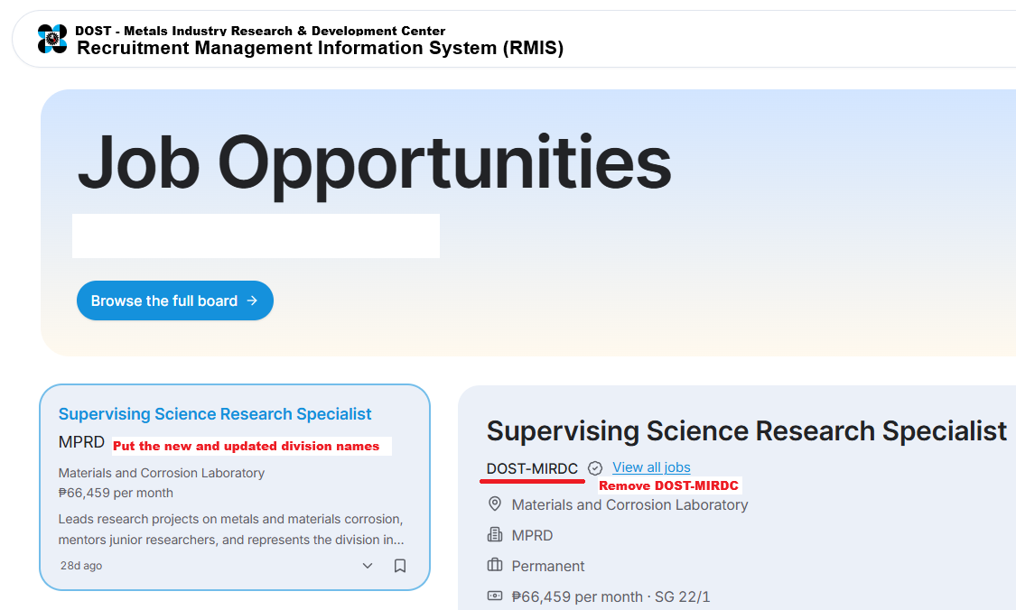
The meeting focused on the progress and updates of the Recruitment Management Information System (RMIS) and the Central Records Office Requisition Information System. For the RMIS, below are the revisions to be applied to the Homepage.
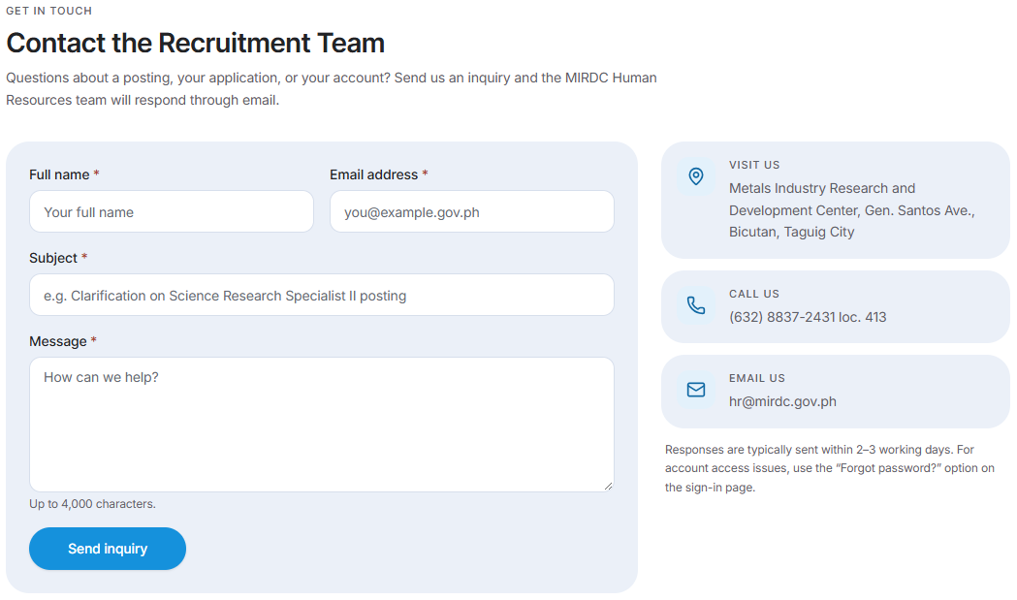
Visit Us: MIRDC Compound, Gen. Santos Ave. Bicutan 1631, City of Taguig, Metro Manila 1631, Philippines
Call Us: 8837-0431 loc. 440/441
Email Us: recruitment@mirdc.dost.gov.ph
Applicant’s Workspace > Profile
- Replicate the nodemailer on the backend side of the system’s server using the recruitment email.
- Fields such as Email Address and Phone Number should always be required to be filled.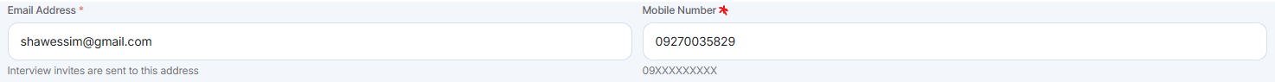
- The Character Reference section should also be marked as required to be filled before proceeding to the Education section of the Profile PDS Form.
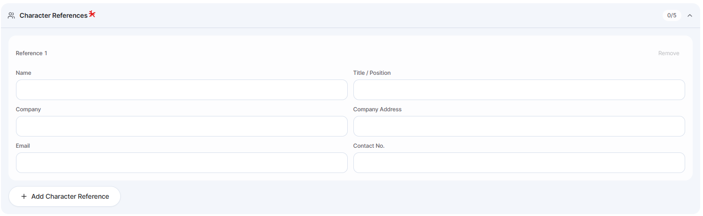
Evaluator’s Workspace > Review Queue (Applicant Not Qualified)
- It is agreed that when an applicant is rejected, the system should automatically email the applicant the result and verdict of his/her application.
- The system should also have a function for a previously rejected applicant applying on the same job listing (e.g., reposting or republication). Evaluators should still review if the applicant has already applied before and was rejected for the specific job listing.

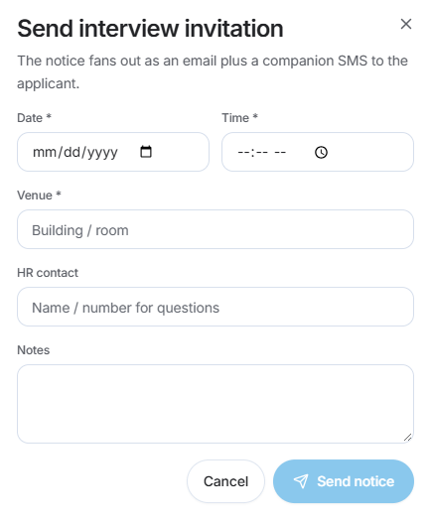
Evaluator’s Workspace > Candidates (Sending of Interview/Exam Notice to Shortlisted)
- Notes on the “Send interview invitation” shouldn’t have a character limit. Convert the data type input to long text. Change the “Notes” to “Invitation Details”.

- Also include an option for face-to-face setup or online mode for both the interview and exam. (Can be a toggle check; then a text field for the online meeting link will appear.)

- Is it possible to have a bulk-send email feature to shortlisted applicants for specific job listings?

