 QuickStream
Quick Start Guide
A simple guide to taking payments, finding transactions and accessing reports in QuickTerminal.

WHAT IS QUICKTERMINAL?
QuickTerminal is QuickStream’s secure online portal for authorised users to take payments, manage transactions and access reports. ^{VN1}

 THINGS YOU SHOULD KNOW
 | Confirm you are using the correct merchant or biller profile. |  | Check the customer reference against your internal records.
 | Review payment details carefully before submitting. |  | Only submit payments where you have the required authority.

 | Available functionality depends on your organisation’s Westpac setup, payment options and user access.
 | Screens and workflows may change as QuickTerminal is enhanced. If your organisation has a bespoke setup, also refer to your Westpac onboarding material.
SUPPORTED PAYMENT TYPES
Payment types available in QuickTerminal depend on your organisation’s configuration.
  CREDIT CARD  Take credit card payments where enabled. |  |   BANK ACCOUNT  Take direct debit payments from bank accounts where enabled. |  |   PAYTO  Create one-off PayTo payments where enabled.
Only payment options provisioned for your organisation and assigned to your user profile will be visible.

QUICK START
Use this guide to quickly find the task you need.
Make a credit card payment 3
Make a bank account payment 5
Make a PayTo payment 7
 Find transactions 9
Refund or void a transaction 11
 Export transactions 14
 View daily settlements 15
 View weekly settlements 16
 View facility reports 17

Make a credit card payment
Capture a customer credit card payment in QuickTerminal.
Payment Details → Confirm Payment Details → Transaction Details
01 ENTER PAYMENT DETAILS
Select Transactions and Reports > Make a Payment > Credit Card. ^{VN2}
Complete the required payment and card details.
Select Next.
GOOD TO KNOW
Check the customer reference and payment amount carefully before continuing.
VN21
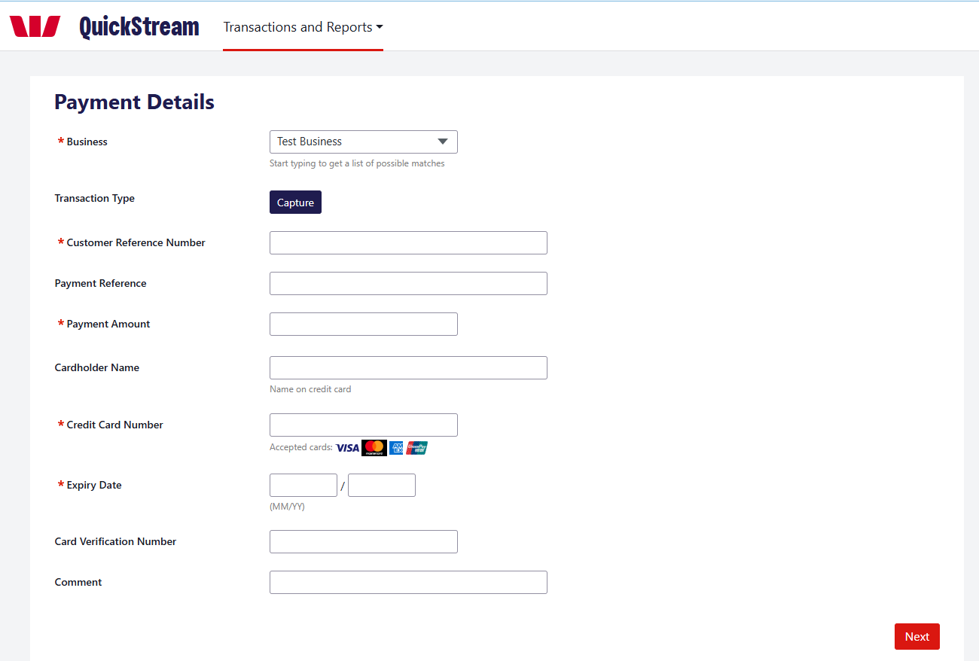
MAKE A CREDIT CARD PAYMENT — CONTINUED
02 REVIEW PAYMENT
VN21
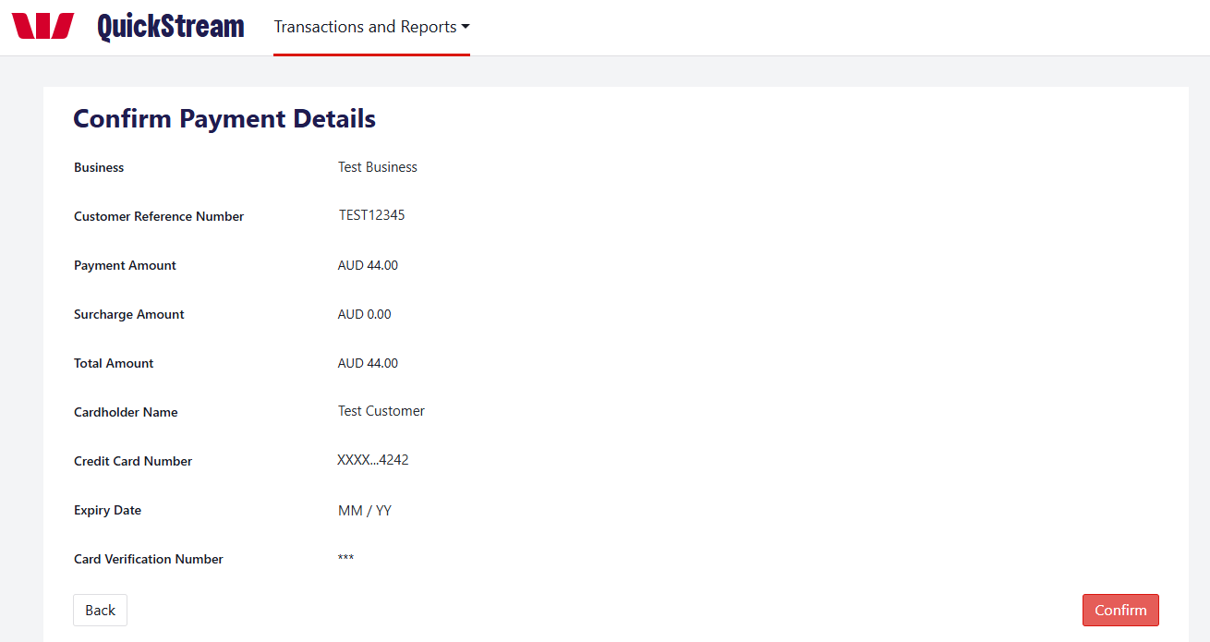
Review the business, customer reference, payment amount and card details. Select Back if anything needs changing. Select Confirm when the details are correct.
03 PAYMENT COMPLETE
VN16 VN21
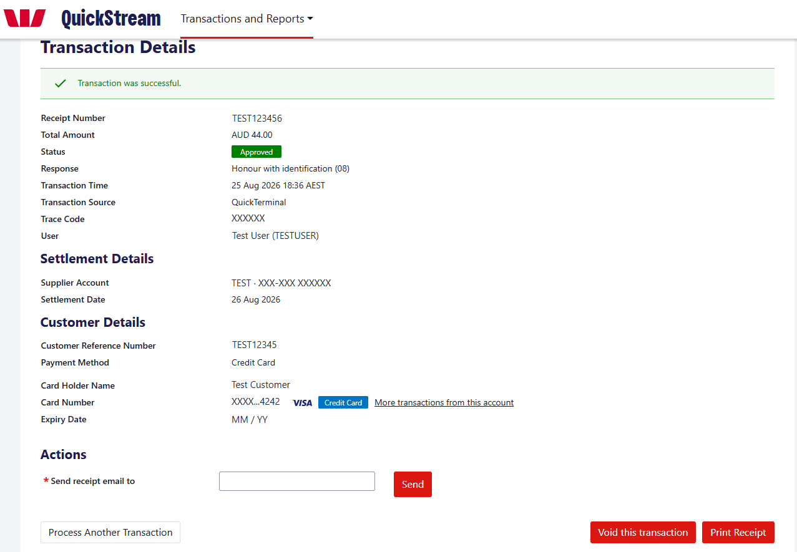
Review the transaction status, response and receipt number. Where required, email or print the receipt, or select Process Another Transaction.

Make a bank account payment
Capture a direct debit payment from a customer’s bank account.
Payment Details → Confirm Payment Details → Transaction Details
01 ENTER PAYMENT DETAILS
Select Transactions and Reports > Make a Payment > Bank Account. ^{VN2}
Enter the customer reference, payment amount, BSB, account number and account name.
Tick the Direct Debit Request confirmation when the required authority has been completed.
Select Next.
GOOD TO KNOW
Check the customer reference, BSB and account number carefully before continuing.
VN21
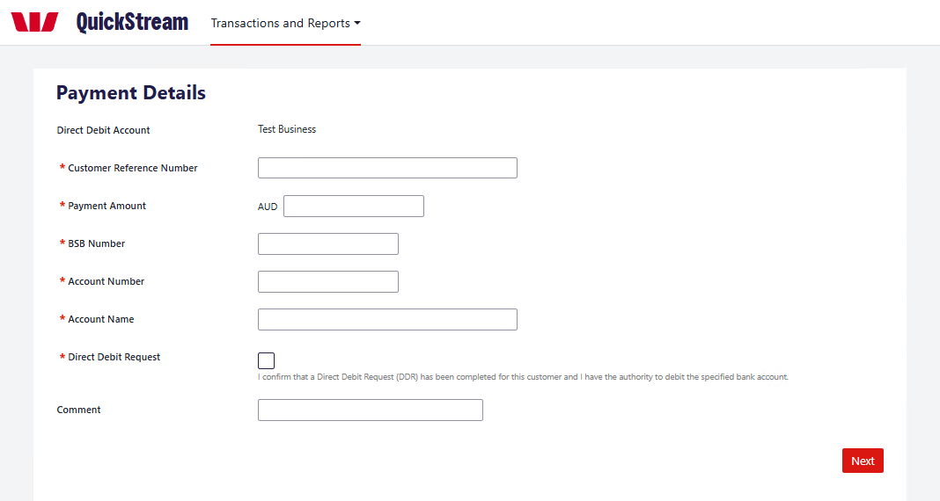
MAKE A BANK ACCOUNT PAYMENT — CONTINUED
02 REVIEW PAYMENT
VN21 VN24
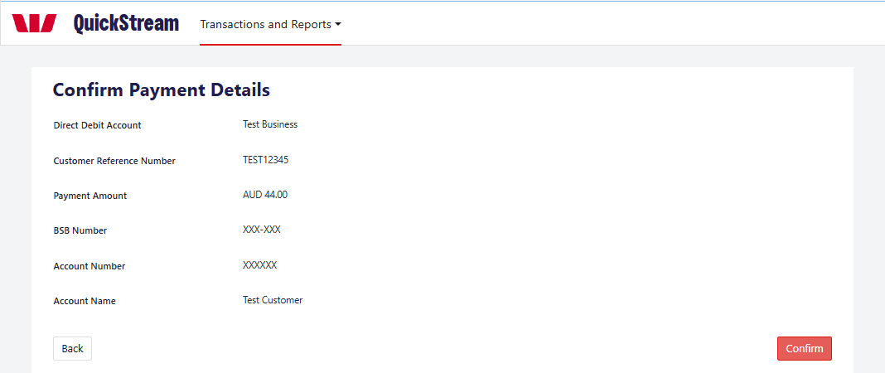
Review the direct debit account, customer reference, payment amount, BSB, account number and account name. Select Back if anything needs changing. Select Confirm when the details are correct.
03 PAYMENT COMPLETE
VN16 VN19 VN21
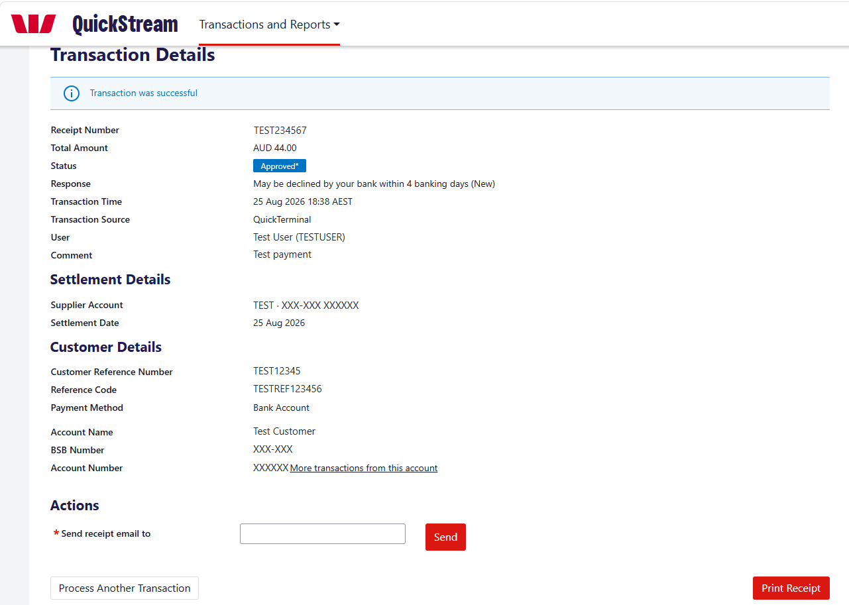
Review the transaction status, response and receipt number. Where required, email or print the receipt, or select Process Another Transaction.
Approval is only the first step. The customer’s bank can still return the payment. Follow your organisation’s reconciliation procedures to identify and handle bank returns. ^{VN12}

Make a PayTo payment
Create a one-off PayTo payment that the customer approves before it is attempted.
Available only if PayTo is enabled for your organisation and assigned to your user profile. ^{VN10}
01 ENTER PARTY DETAILS
Select Transactions and Reports > Make a Payment > PayTo.
Payer Details: enter the Payer Name and Payer ID (CRN) and choose the Payer Type.
Payer Account Details: choose PayID or BSB/Account Number. For a PayID, enter it and choose its type. ^{VN4}
Payee Details: choose the Business.
Select Next.
VN21 VN23
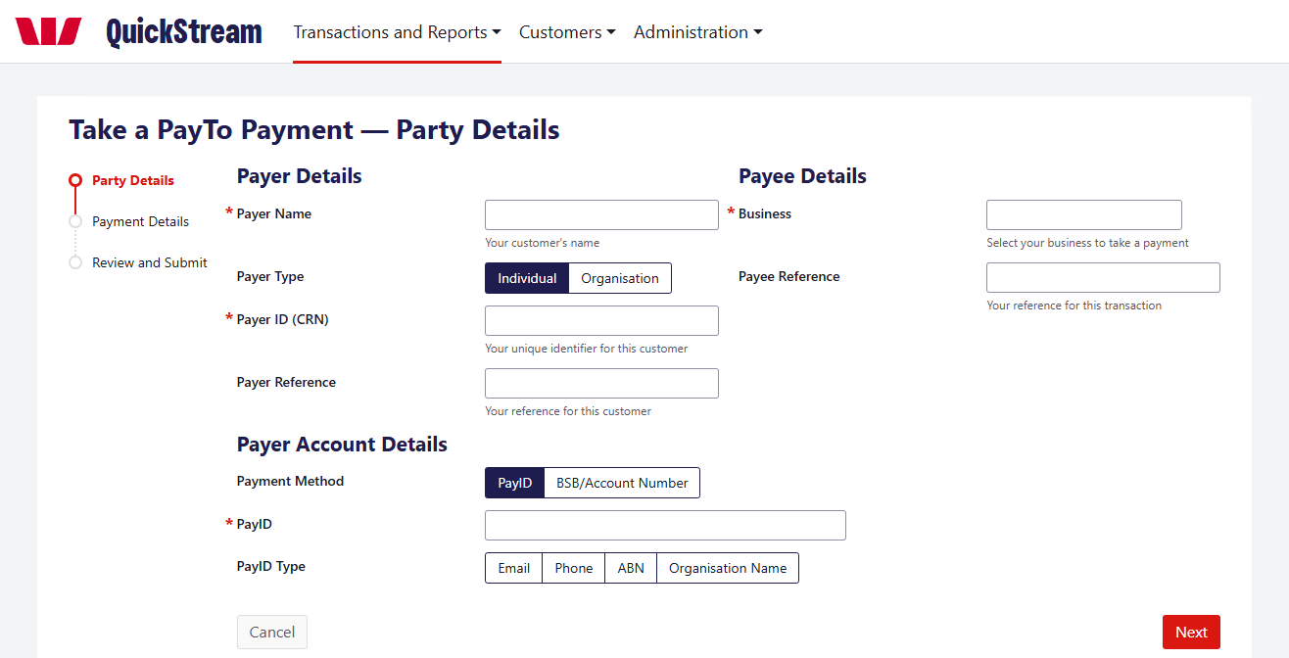
02 ENTER PAYMENT DETAILS
Enter the Payment Amount, choose the Purpose and enter a Description. The customer sees the Description on the agreement.
Select Next.
VN21 VN23
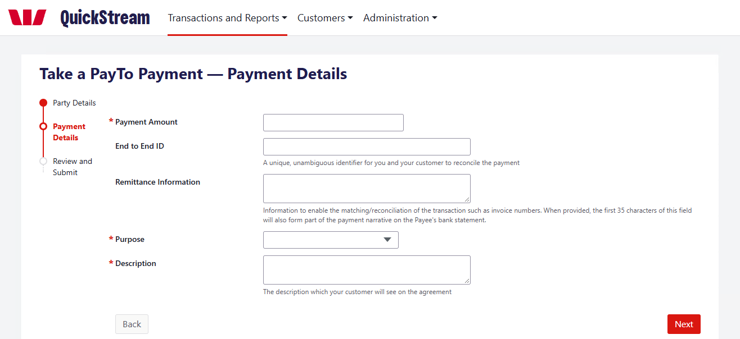
MAKE A PAYTO PAYMENT — CONTINUED
03 REVIEW AND SUBMIT
Check the details, then select Confirm. This creates a one-time PayTo agreement and sends it to the customer for approval in their banking app. ^{VN5}
VN21 VN23
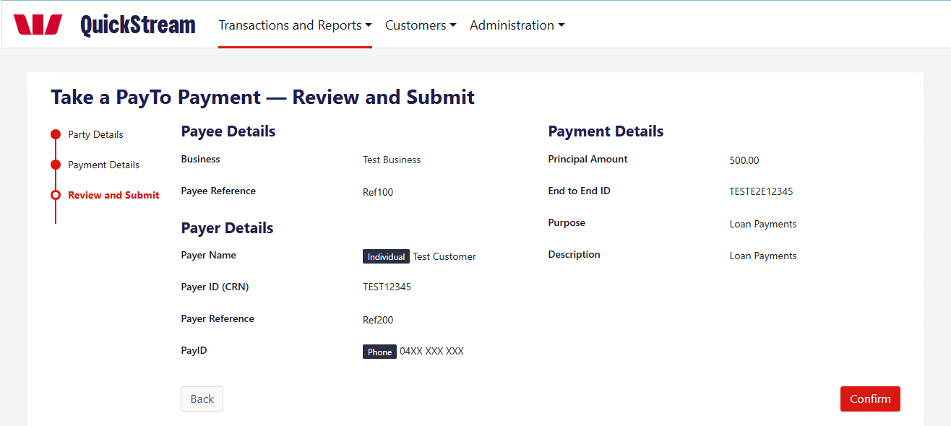
04 CHECK THE PAYMENT STATUS
VN21 VN23
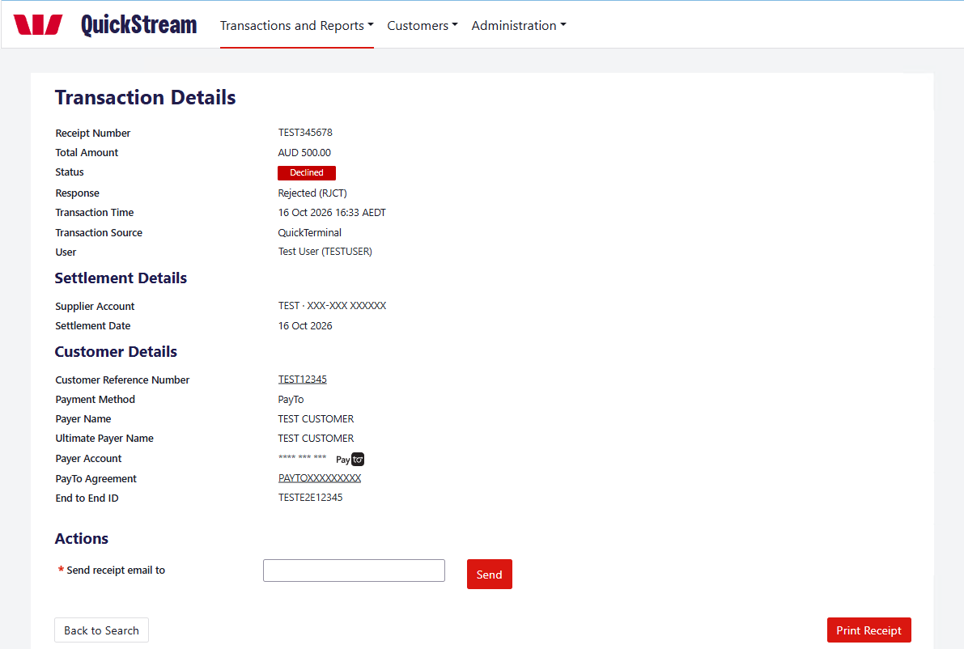
The Transaction Details screen shows the payment status and the response. The payment stays pending until the customer approves the PayTo agreement, then it is attempted. ^{VN5} This example is a declined payment.
GOOD TO KNOW
Three things are separate: the customer’s approval of the agreement, the payment status, and settlement. Approval only allows the payment to be attempted. Check the payment status before you tell the customer it is complete. Your settlement reports may show the payment once it settles. ^{VN22}

Find transactions
Look up recent activity, search for a transaction and open its details.
01 RECENT TRANSACTIONS
Select Transactions and Reports > Find Transactions > Recent Transactions.
Choose the business, then select Display.
VN21
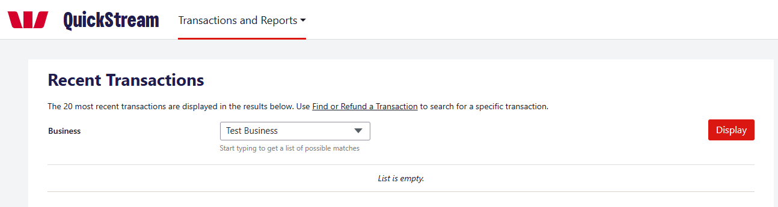
QuickTerminal shows the 20 most recent transactions.
02 SEARCH FOR A TRANSACTION
Select Transactions and Reports > Find Transactions > Find or Refund a Transaction.
Choose how to search: Settlement Date, Reference Number or Account Details. Reference Number accepts a customer reference, payment reference or receipt number. Account Details accepts a full or partial card number, or a BSB and account number. ^{VN11}
Use Advanced Search to narrow the results by business, status, transaction source, order type or amount.
Select Search.
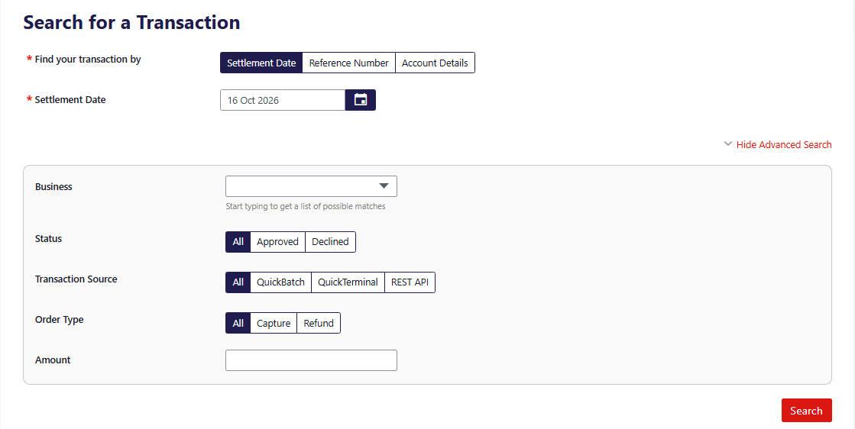
FIND TRANSACTIONS — CONTINUED
03 REVIEW THE RESULTS
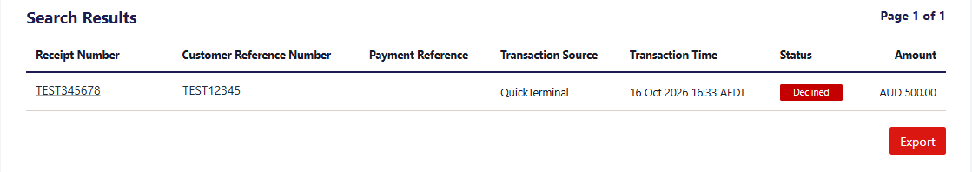
Results show the receipt number, customer reference number, payment reference, transaction source, transaction time, status and amount. Refunds appear as negative amounts. Hover over a status to see the response from the customer’s bank. ^{VN13}
04 OPEN THE TRANSACTION DETAILS
Select the receipt number.
VN21
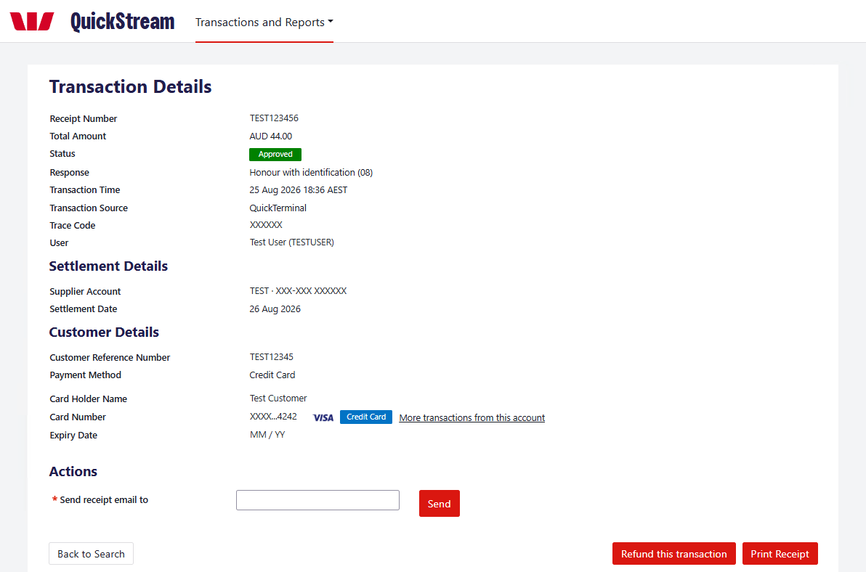
The Transaction Details screen shows the payment, settlement and customer details. Available actions depend on the transaction and your user permissions: ^{VN10}
• Send receipt email to — enter an email address and select Send.
• Print Receipt.
• Back to Search.
• Refund this transaction or Void this transaction, whichever is shown. See Refund or void a transaction.

Refund or void a transaction
Void and refund are different actions. Choose the one that applies to the transaction.
Refund and void options appear only when they are available for the transaction and allowed by your user permissions. ^{VN10}
VOID  Cancels an eligible transaction before it is included in settlement. ^{VN9}  • Card: before the bank cut-off time. ^{VN9}  • Bank account: before the payment is sent to the bank. |  | REFUND  Returns money to the payer as a separate transaction. It does not cancel the original payment. ^{VN8}  • Card: after the bank cut-off time.  • Bank account: 4 banking days after the original payment date. ^{VN9}  • PayTo: after the payment is approved. ^{VN6}
Which action is available depends on the transaction type and timing. Starting a refund does not mean the money has already reached the customer. ^{VN8}
01 FIND THE TRANSACTION
Select Transactions and Reports > Find Transactions > Find or Refund a Transaction.
Search for the transaction. See Find transactions.
02 CHOOSE REFUND OR VOID
Select the receipt number to open the Transaction Details screen.
Select Refund this transaction or Void this transaction, whichever is shown. ^{VN9}
VN21
REFUND OR VOID A TRANSACTION — CONTINUED
03 CONFIRM THE REFUND
On the Refund Payment screen, check the details and the Refund Amount, add a comment if needed, then select Confirm.
On the Confirm Refund screen, check the details and select Confirm again.
Void: follow the on-screen steps to confirm. ^{VN7}
VN21
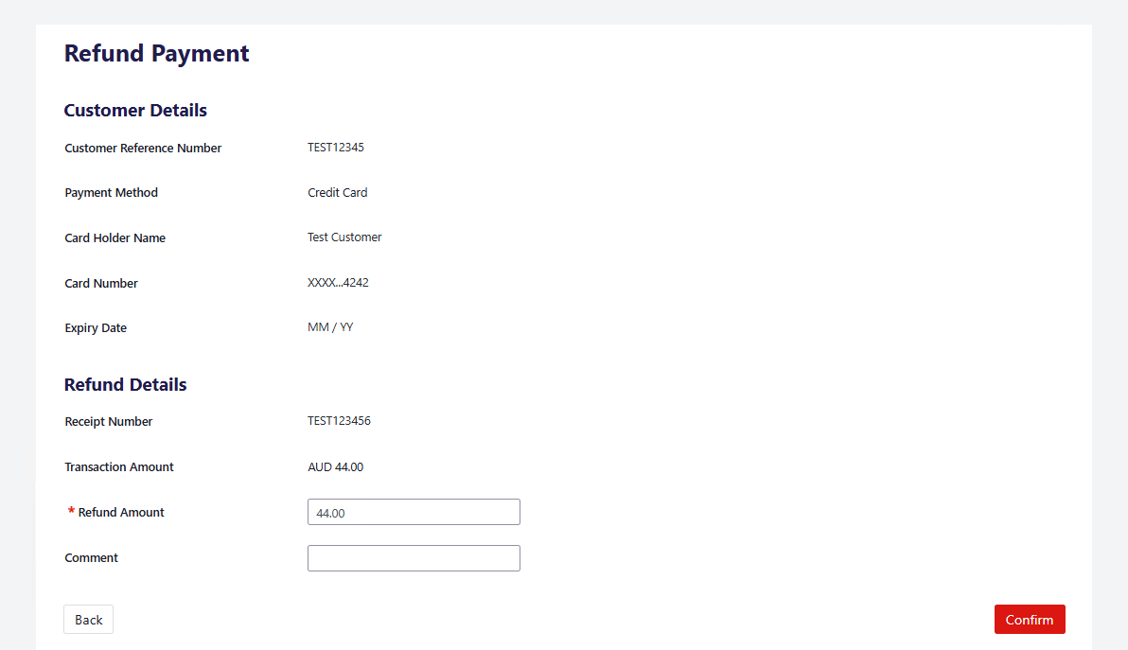
VN21
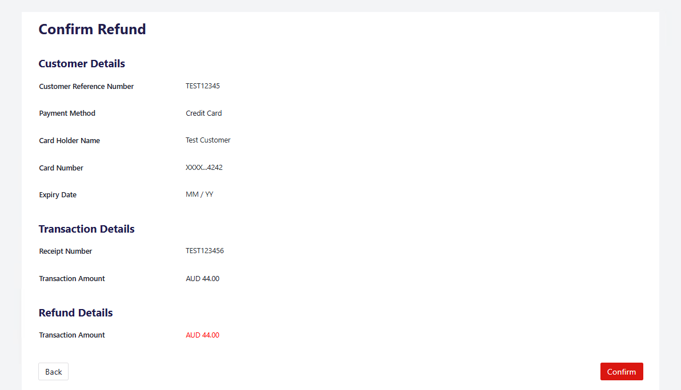
REFUND OR VOID A TRANSACTION — CONTINUED
04 CHECK THE RESULT
The Transaction Details screen shows “Refund was successful”. The refund is recorded as a separate transaction with a negative Total Amount, and the original appears under Related Transactions.
A successful refund request does not mean the funds are immediately available to the customer. ^{VN8}
After a void, find the transaction again and check its Status. ^{VN8}
VN21
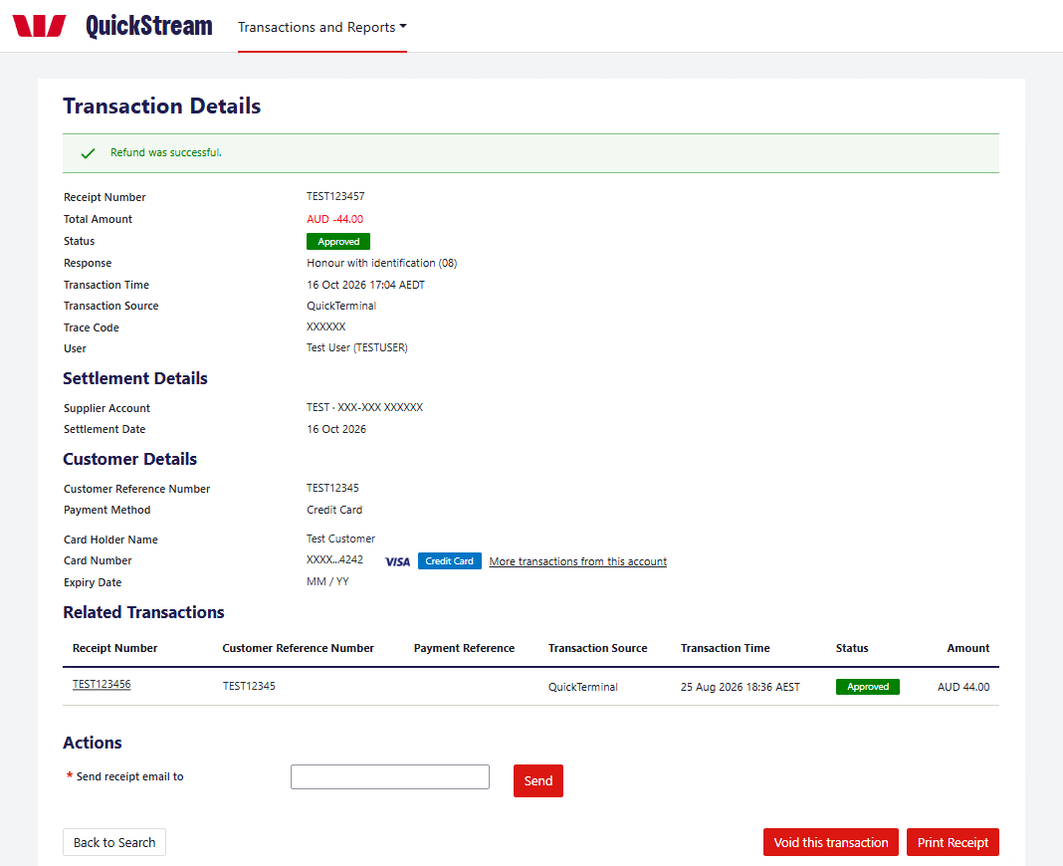
GOOD TO KNOW
Check the receipt number and amount before you confirm. If you are unsure which action applies, contact Westpac QuickStream support before you proceed.

Export transactions
Generate a transaction report using your chosen criteria.
01 OPEN EXPORT TRANSACTION REPORTS
Select Transactions and Reports > Find Transactions > Export Transaction Reports.
02 CHOOSE CRITERIA
Select the business, date, transaction status and order type.
03 GENERATE
Select Generate Report.
04 DOWNLOAD
When available, use Recent Exports to download the report.
GOOD TO KNOW
Recently exported transaction reports are available for two days from when they were generated.
VN21
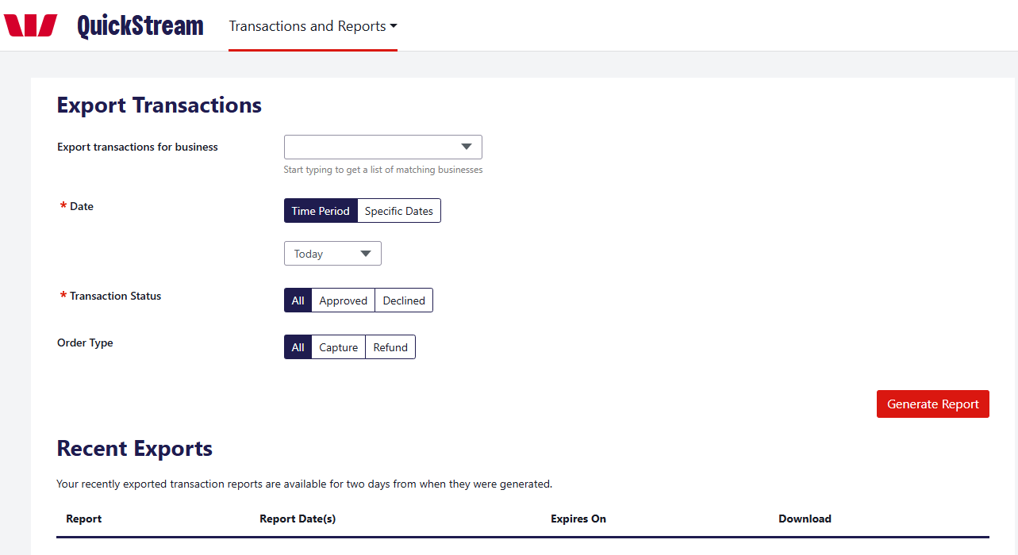

View daily settlements
View settlement information for a selected day.
01 OPEN DAILY SETTLEMENT
Select Transactions and Reports > Reports > Daily Settlement.
02 CHOOSE A DATE
Enter a settlement date and select Display, or use a Jump To date.
03 REVIEW OR DOWNLOAD
Review the settlement information and download any available report.
VN21
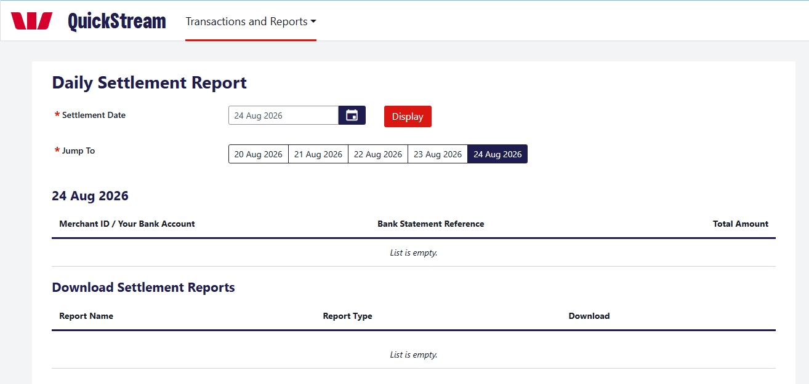

View weekly settlements
Review daily settlements across a selected week.
01 OPEN WEEKLY SETTLEMENT
Select Transactions and Reports > Reports > Weekly Settlement.
02 CHOOSE THE WEEK
Select a settlement week and select Display, or use Jump To.
03 OPEN A DAY
Select the View [date] Settlement Report button for the day you need.
VN16 VN21
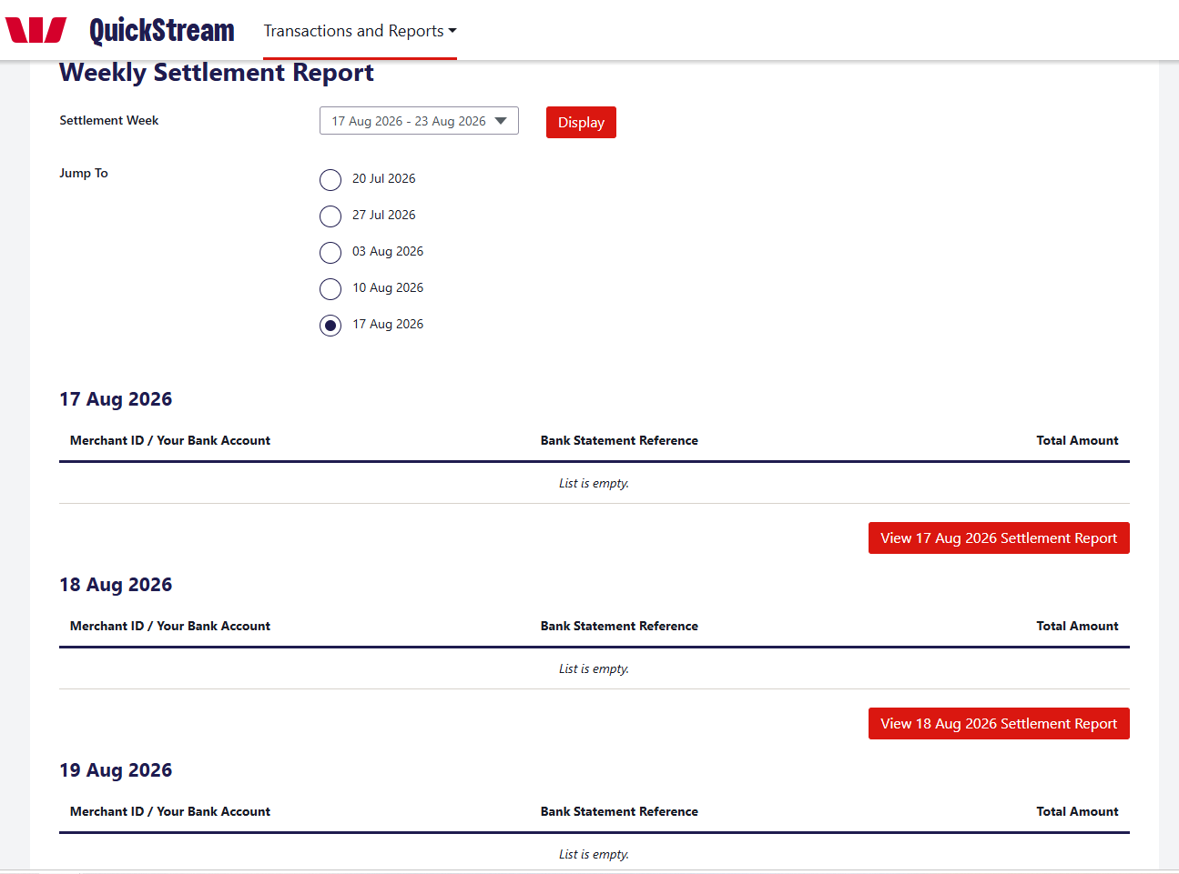

View facility reports
Find and download facility reports.
01 OPEN FACILITY REPORTS
Select Transactions and Reports > Reports > Facility Reports.
02 SET CRITERIA
Choose the report type and date. Add a business or report name if needed.
03 VIEW
Select View Reports.
04 DOWNLOAD
Use the Download column for the report you need.
VN21
