 QuickStream
Quick Start Guide
A simple guide to taking payments, managing customers and recurring payments, finding transactions and accessing reports in QuickPortal.

WHAT IS QUICKPORTAL?
QuickPortal is QuickStream’s secure online portal for authorised users to take payments, manage transactions, customers and recurring payments, and access reports.

 THINGS YOU SHOULD KNOW
 | Confirm you are using the correct merchant or biller profile. |  | Check the customer reference against your internal records.
 | Review payment details carefully before submitting. |  | Only submit payments where you have the required authority.

 | Available functionality depends on your organisation’s Westpac setup, payment options and user access.
 | Screens and workflows may change as QuickPortal is enhanced. If your organisation has a bespoke setup, also refer to your Westpac onboarding material.
SUPPORTED PAYMENT TYPES
Payment types available in QuickPortal depend on your organisation’s configuration.
  CREDIT CARD  Take credit card payments where enabled. |  |   BANK ACCOUNT  Take direct debit payments from bank accounts where enabled. |  |   PayTo  Create one-off PayTo payments where enabled.
Only payment options provisioned for your organisation and assigned to your user profile will be visible.

QUICK START
Use this guide to quickly find the task you need.
Make a credit card payment 3
Make a bank account payment 5
Make a PayTo payment 7
 Find transactions 9
Refund or void a transaction 11
 Export transactions 15
 View daily settlements 16
 View weekly settlements 17
 View facility reports 18
Customers and saved cards 19
Recurring payments 23

Make a credit card payment
Capture a customer credit card payment in QuickPortal.
Payment Details → Confirm Payment Details → Transaction Details
01 ENTER PAYMENT DETAILS
Select Transactions and Reports > Make a Payment > Credit Card.
Check the Business, or start typing to choose a different one. The payment settles to this business.
Complete the other fields marked * (Customer Reference Number, Payment Amount, Credit Card Number and Expiry Date). The remaining fields are optional.
Select Next.
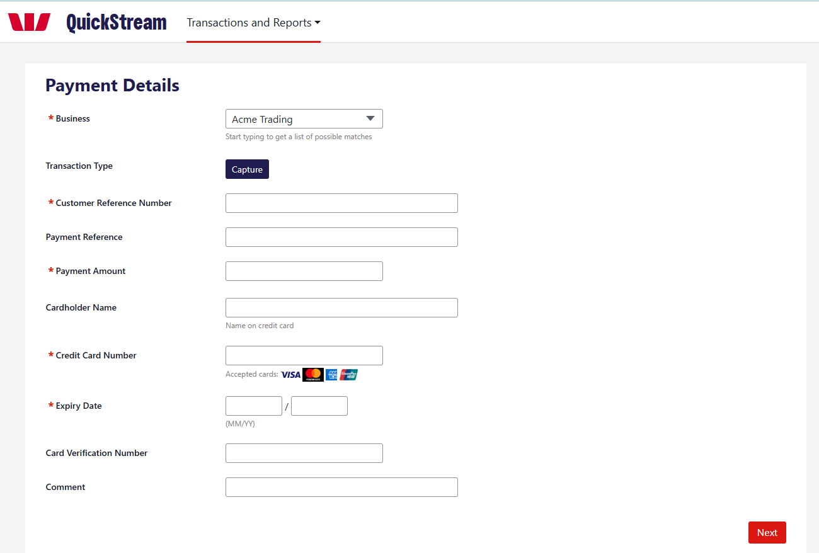
GOOD TO KNOW
Check the customer reference and payment amount carefully before continuing.
Make a credit card payment — continued
02 REVIEW PAYMENT
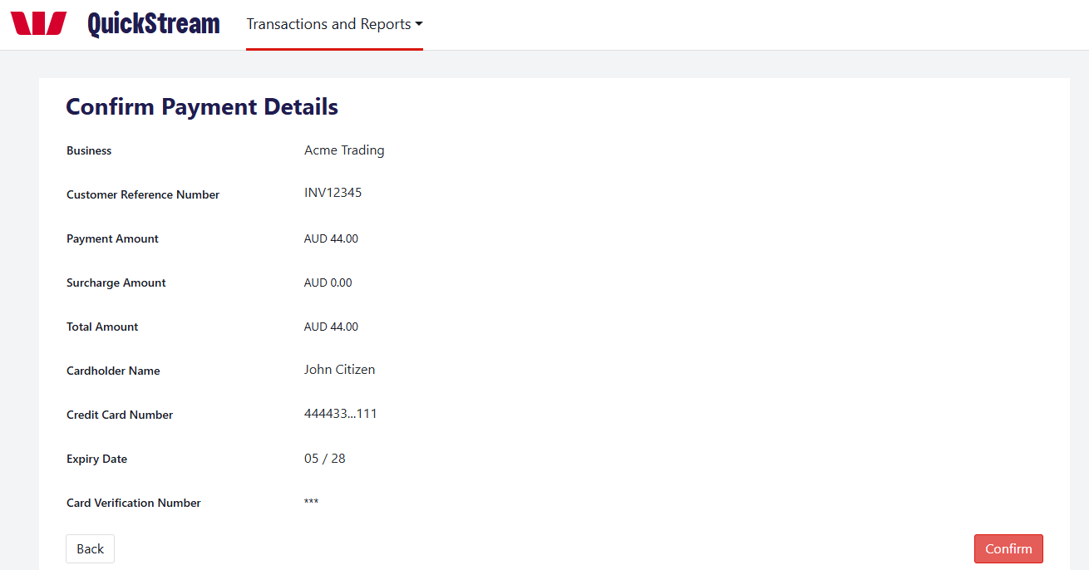
Review the business, customer reference, payment amount and card details. Select Back if anything needs changing. Select Confirm to submit the payment.
03 CHECK THE PAYMENT RESULT
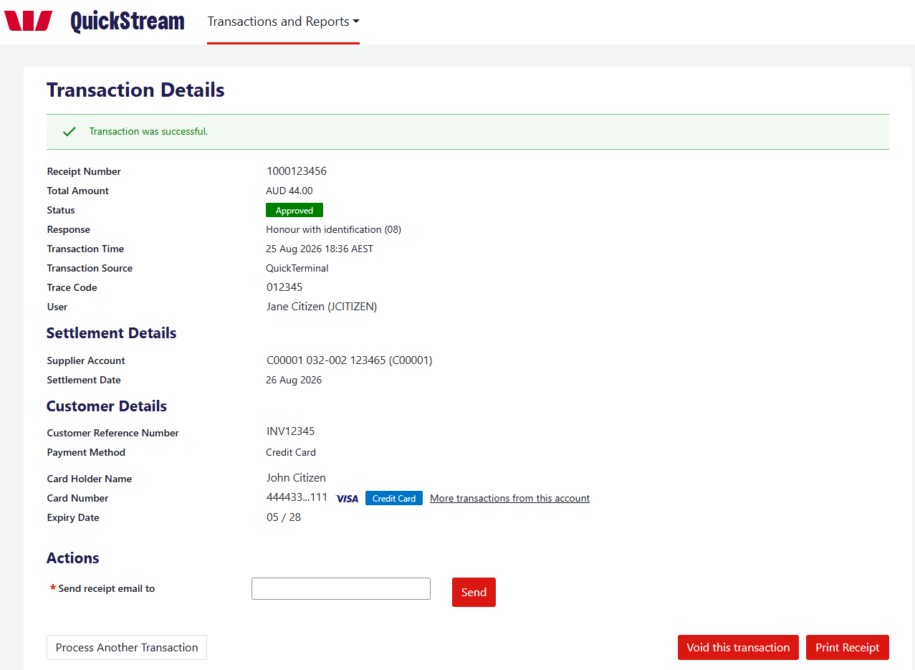
Check the Status and Response to see whether the payment was approved or declined. Email or print the receipt if required, or select Process Another Transaction.
Approved is the processing result. Settlement to your account is separate and appears in your settlement reports.

Make a bank account payment
Capture a direct debit payment from a customer’s bank account.
Payment Details → Confirm Payment Details → Transaction Details
01 ENTER PAYMENT DETAILS
Select Transactions and Reports > Make a Payment > Bank Account.
Check the Direct Debit Account shown. If you have more than one, choose the account the payment should settle to.
Complete the fields marked * (Customer Reference Number, Payment Amount, BSB Number, Account Number and Account Name). Comment is optional.
Tick the Direct Debit Request box to confirm that a Direct Debit Request has been completed for the customer and you have the authority to debit the account.
Select Next.
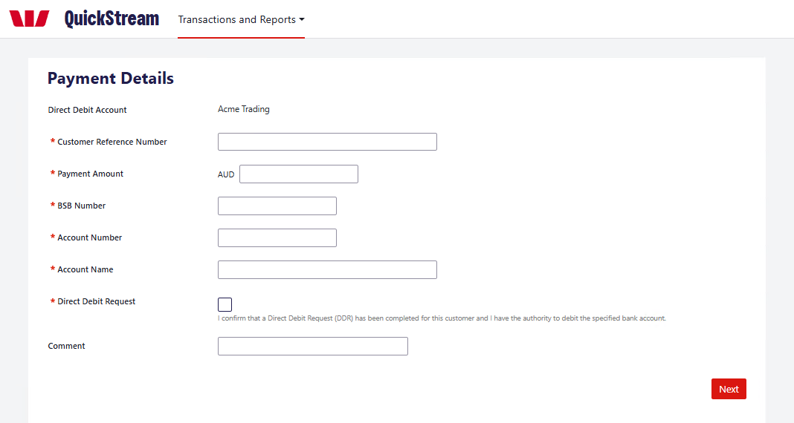
GOOD TO KNOW
Check the customer reference, BSB and account number carefully before continuing.
Make a bank account payment — continued
02 REVIEW PAYMENT
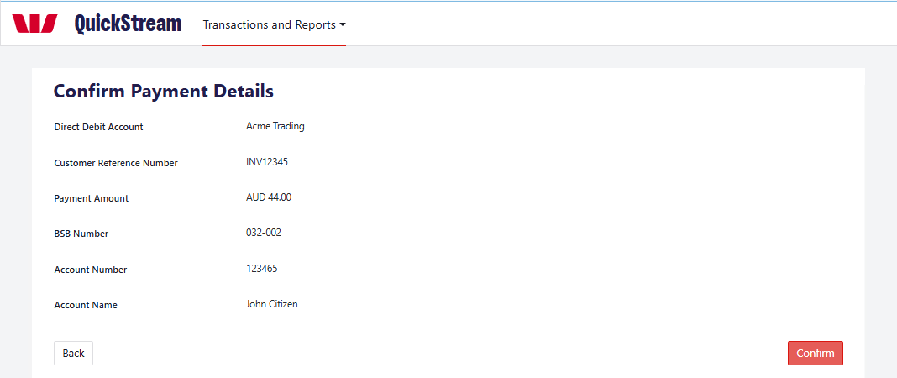
Review the direct debit account, customer reference, payment amount, BSB, account number and account name. Select Back if anything needs changing. Select Confirm to submit the payment.
03 CHECK THE PAYMENT RESULT
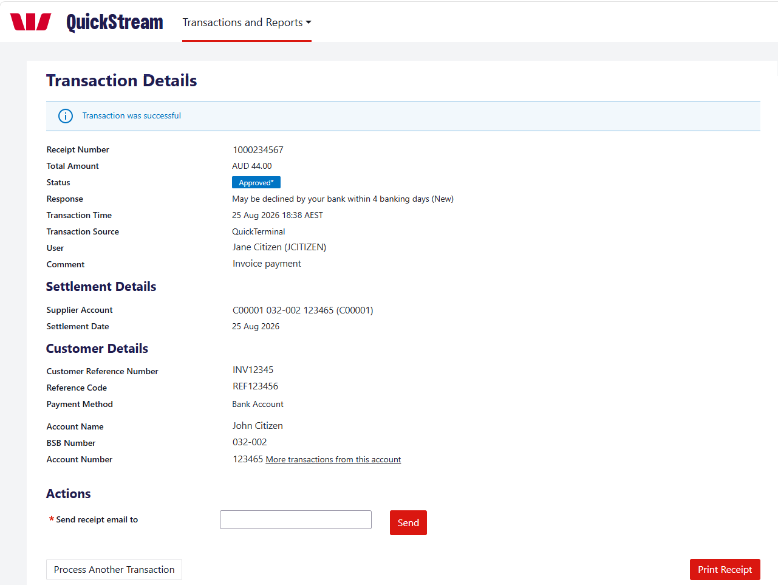
Check the Status and Response, and note the Receipt Number. Where required, email or print the receipt, or select Process Another Transaction.
Initial approval does not guarantee the payment will not be returned. A status of Approved* means the payment may still be declined or returned by the customer’s bank within 4 banking days. Follow your organisation’s reconciliation procedures to identify and handle bank returns.

Make a PayTo payment
Create a one-off PayTo payment that the customer approves before it is attempted.
Available only if PayTo is enabled for your organisation and assigned to your user profile.
01 ENTER PARTY DETAILS
Select Transactions and Reports > Make a Payment > PayTo. Fields marked * are required.
Enter the Payer Name and Payer ID (CRN). Payer Type is set to Individual; choose Organisation if needed. Payer Reference is optional.
Choose PayID or BSB/Account Number. For a PayID, enter the PayID and choose its type.
Choose the Business. Payee Reference is optional.
Select Next.
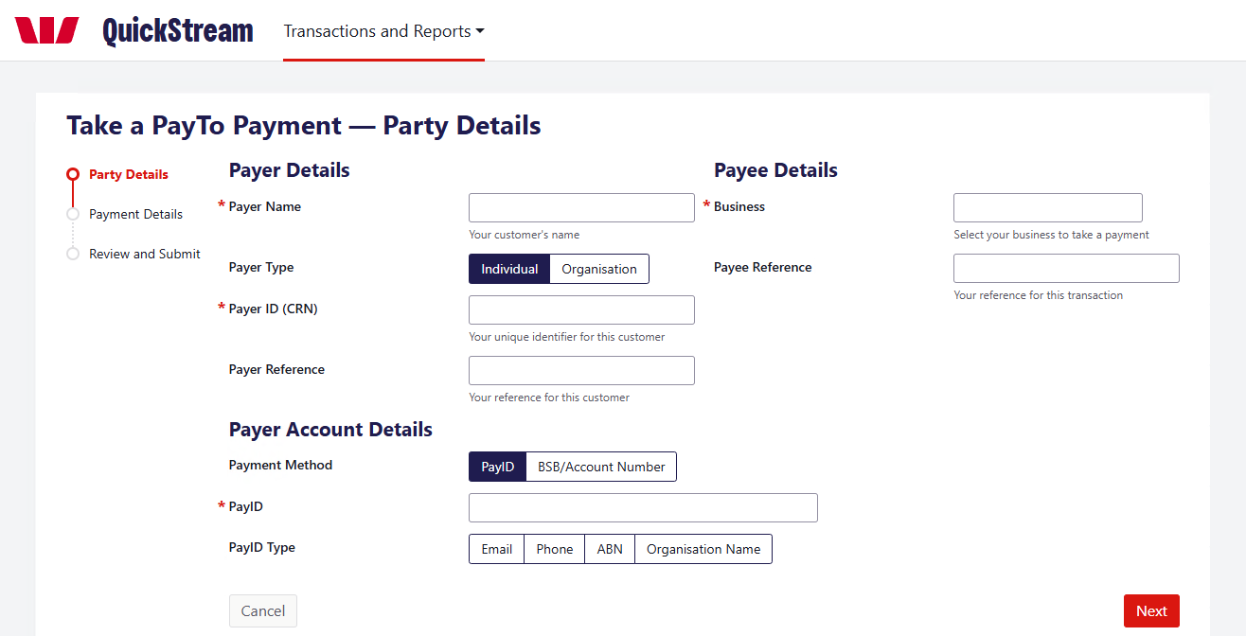
02 ENTER PAYMENT DETAILS
Enter the Payment Amount, choose the Purpose and enter a Description. The customer sees the Description on the agreement. End to End ID and Remittance Information are optional.
Select Next.
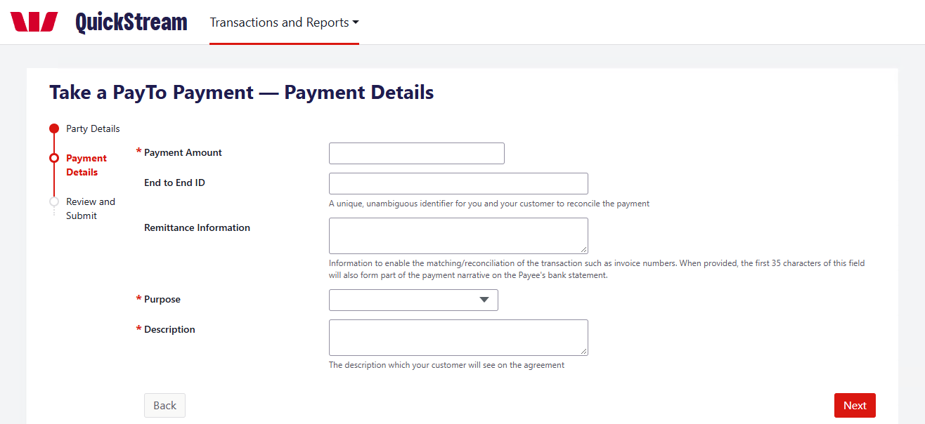
Make a PayTo payment — continued
03 REVIEW AND SUBMIT
Check the details, then select Confirm to submit the payment. This creates a one-time PayTo agreement and sends it to the customer for approval in their banking app.
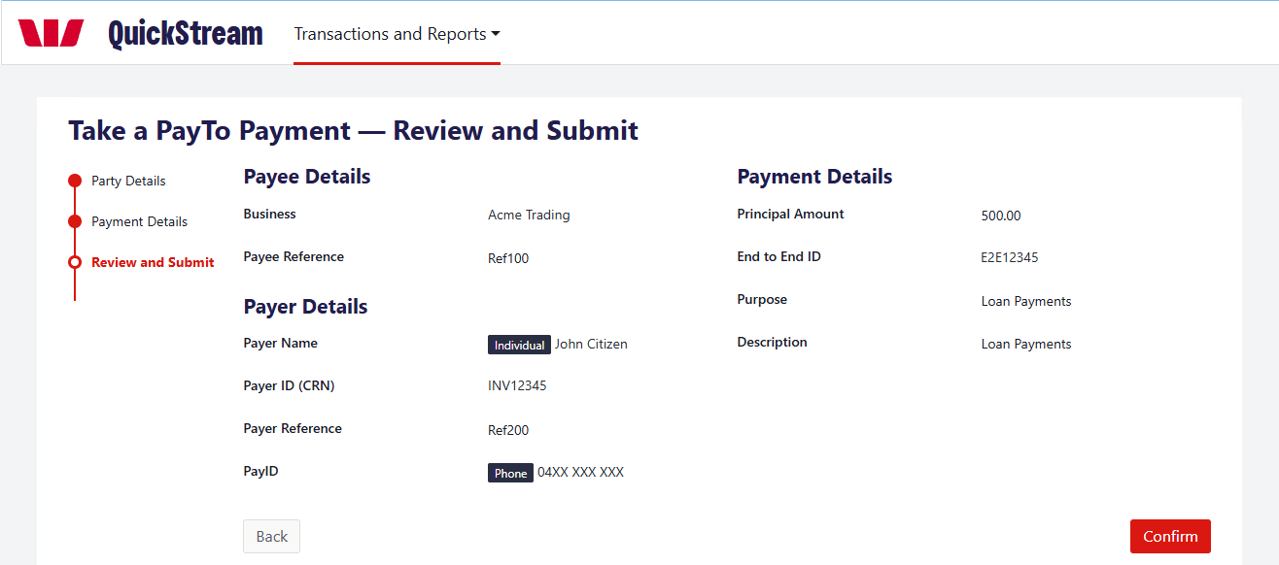
04 CHECK THE PAYMENT RESULT
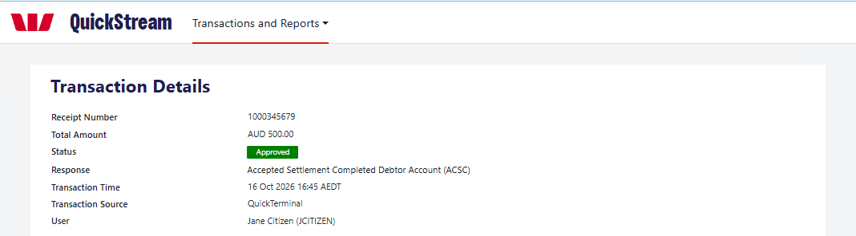
Example: an approved PayTo payment.
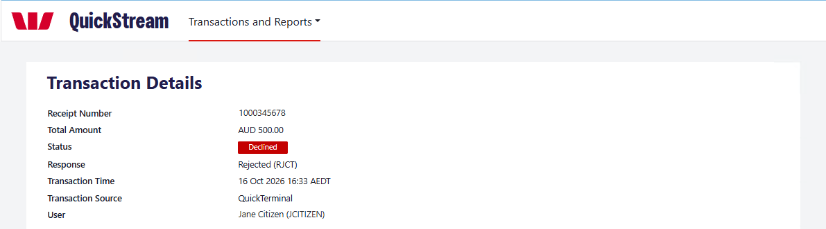
Example: a declined PayTo payment.
Check the Status and Response. The payment stays pending until the customer approves the PayTo agreement, then it is attempted and the Status shows Approved or Declined. If the customer declines or does not respond within the approval period (15 minutes or less), the agreement is cancelled and no payment is taken.
GOOD TO KNOW
Agreement approval, the payment attempt, the outcome and settlement are separate. Approval does not guarantee success. Check the Status before telling the customer it is complete. Settlement reports may show it once it settles.

Find transactions
Look up recent activity, search for a transaction and open its details.
01 VIEW RECENT TRANSACTIONS
Select Transactions and Reports > Find Transactions > Recent Transactions.
Choose the Business, then select Display to see the 20 most recent transactions.
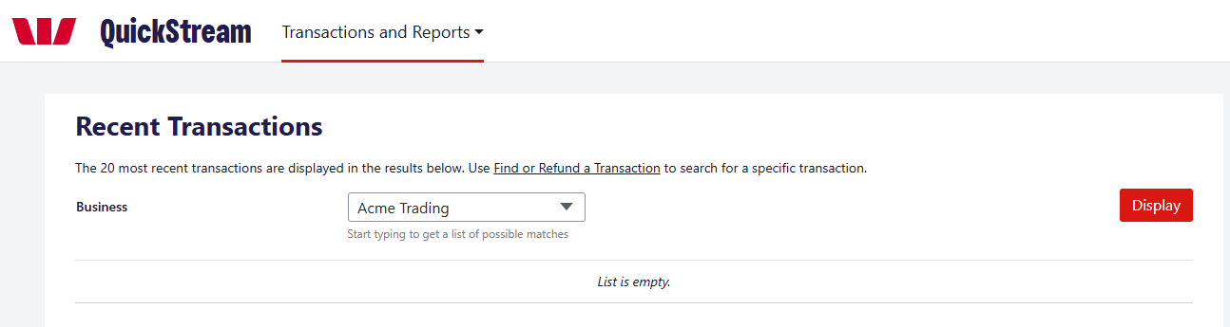
02 SEARCH FOR A TRANSACTION
Select Transactions and Reports > Find Transactions > Find or Refund a Transaction.
Under Find your transaction by, choose Settlement Date, Reference Number or Account Details, then enter the details. Reference Number accepts a customer reference, payment reference or receipt number. Account Details accepts a full or partial card number, or a BSB and account number.
Use Advanced Search to narrow the results by Business, Status, Transaction Source, Order Type or Amount.
Select Search.
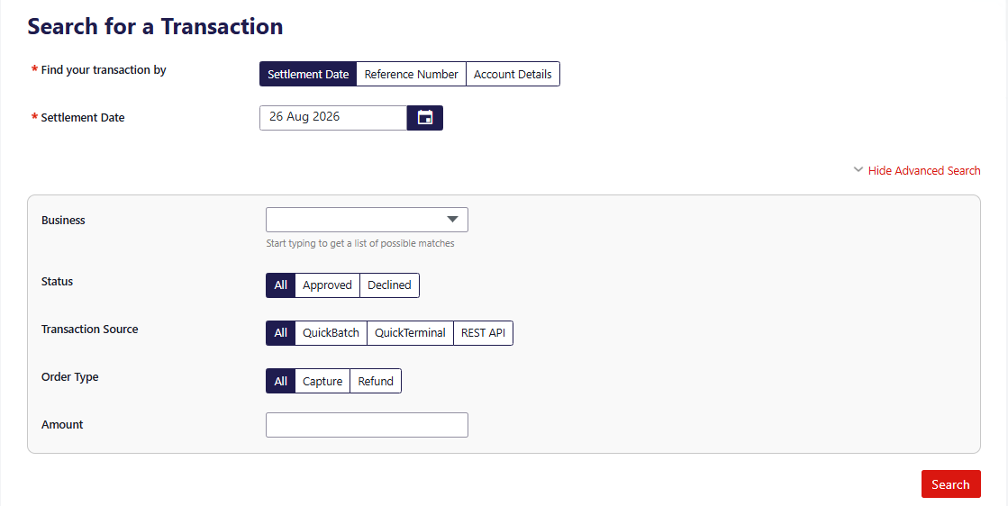
Find transactions — continued
03 REVIEW THE RESULTS
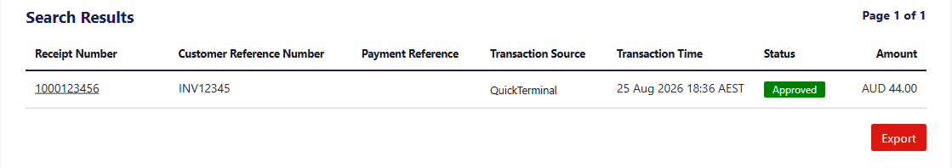
Results show the receipt number, customer reference number, payment reference, transaction source, transaction time, status and amount. Refunds appear as negative amounts.
04 OPEN THE TRANSACTION DETAILS
Select the receipt number.
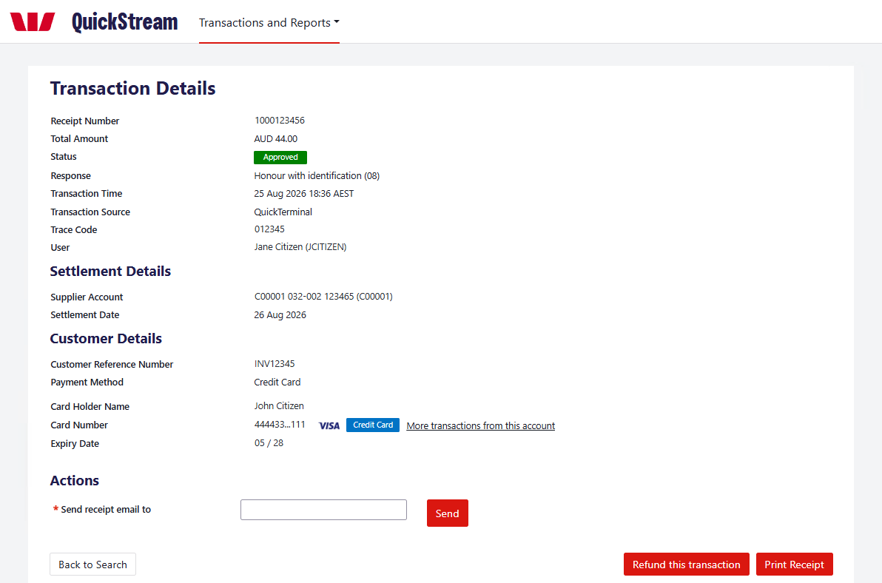
Example: a credit card transaction.
The Transaction Details screen shows the payment, settlement and customer details. Available actions depend on the transaction and your user permissions:
• Send receipt email to — enter an email address and select Send.
• Print Receipt.
• Back to Search.
• Refund this transaction or Void this transaction, whichever is shown. See Refund or void a transaction.

Refund or void a transaction
Void and refund are different actions. Choose the one that applies to the transaction.
Refund and void options appear only when they are available for the transaction and allowed by your user permissions.
VOID  Cancels an eligible transaction before it is included in settlement.  • Card: before the bank cut-off time.  • Bank account: before the payment is sent to the bank. |  | REFUND  Returns money to the payer as a separate transaction. It does not cancel the original payment.  • Card: after the bank cut-off time.  • Bank account: 4 banking days after the original payment date.  • PayTo: after the payment is approved.

01 FIND THE TRANSACTION
Select Transactions and Reports > Find Transactions > Find or Refund a Transaction.
Search for the transaction. See Find transactions.
02 CHOOSE REFUND OR VOID
Select the receipt number to open the Transaction Details screen.
Select Refund this transaction or Void this transaction, whichever is shown.
To refund, continue with step 03. To void, go to step 05.
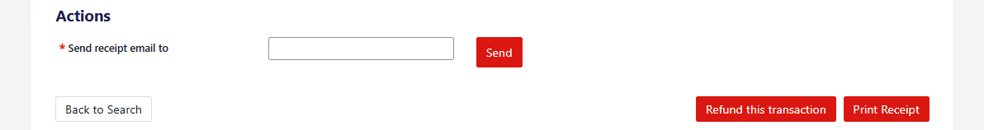
Example: the Refund this transaction button.
Refund or void a transaction — continued
03 CONFIRM THE REFUND
On the Refund Payment screen, check the Refund Amount, add a comment if needed and select Confirm. To refund part of the payment, change the Refund Amount; you cannot refund more than the original payment.
On the Confirm Refund screen, check the details and select Confirm again. A PayTo payment uses the same Refund Payment screen.
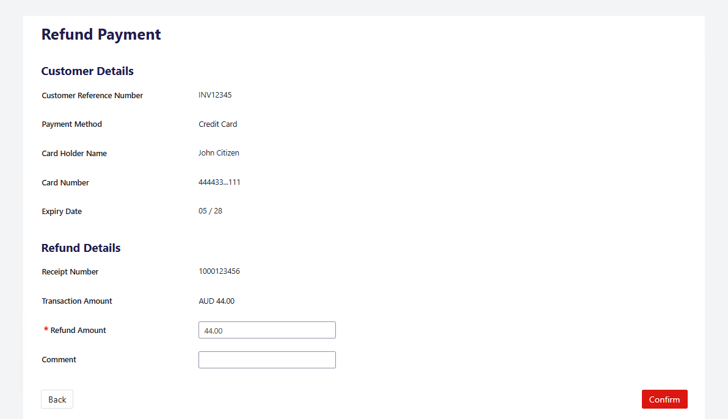
Example: refunding a credit card payment.
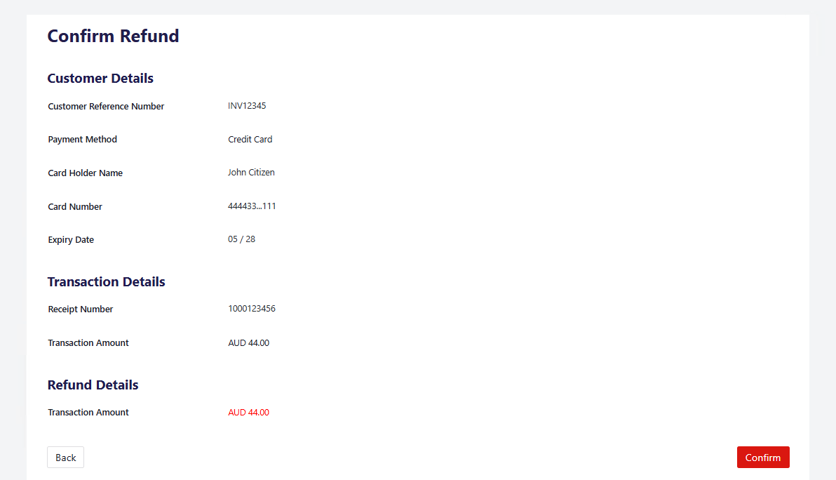
Example: the Confirm Refund screen.
GOOD TO KNOW
Check the receipt number and amount before you confirm.
Refund or void a transaction — continued
04 CHECK THE REFUND RESULT
The Transaction Details screen shows “Refund was successful”. The refund is recorded as a separate transaction with a negative Total Amount, and the original appears under Related Transactions.
A successful refund submission does not mean the customer has already received the funds.
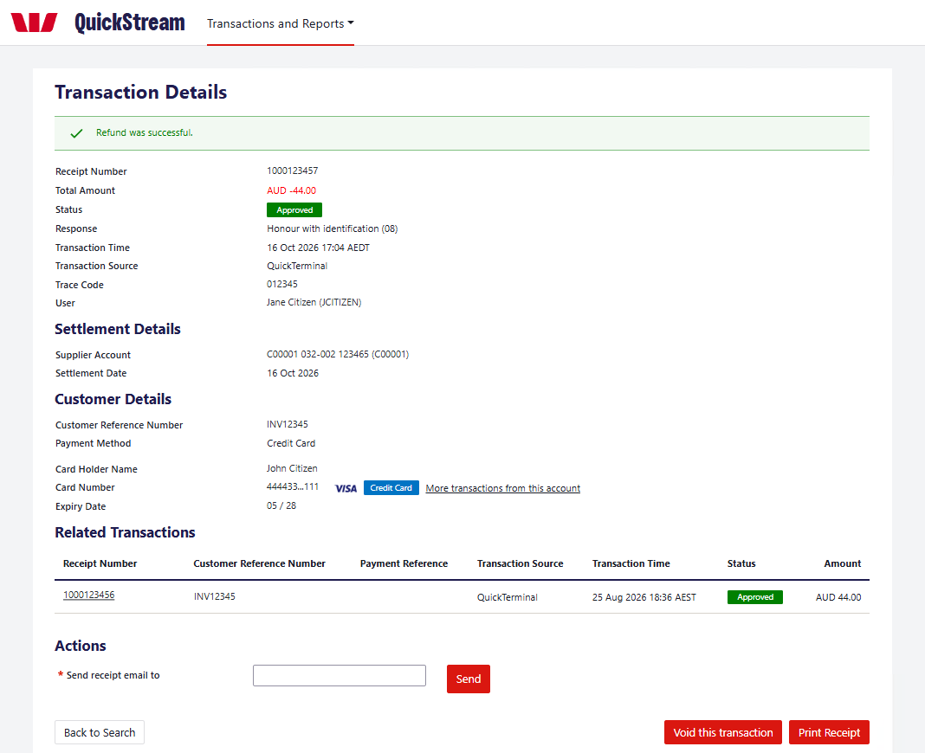
Example: a successful credit card refund.
Refund or void a transaction — continued
05 CONFIRM THE VOID
On the Transaction Details screen, select Void this transaction.
On the Confirm Void screen, check the details and select Confirm Void.
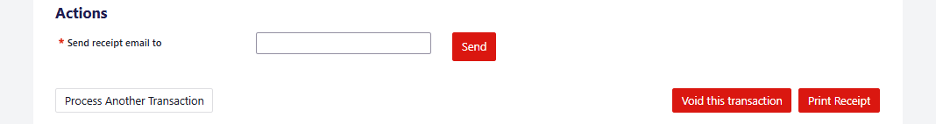
Example: the Void this transaction button.
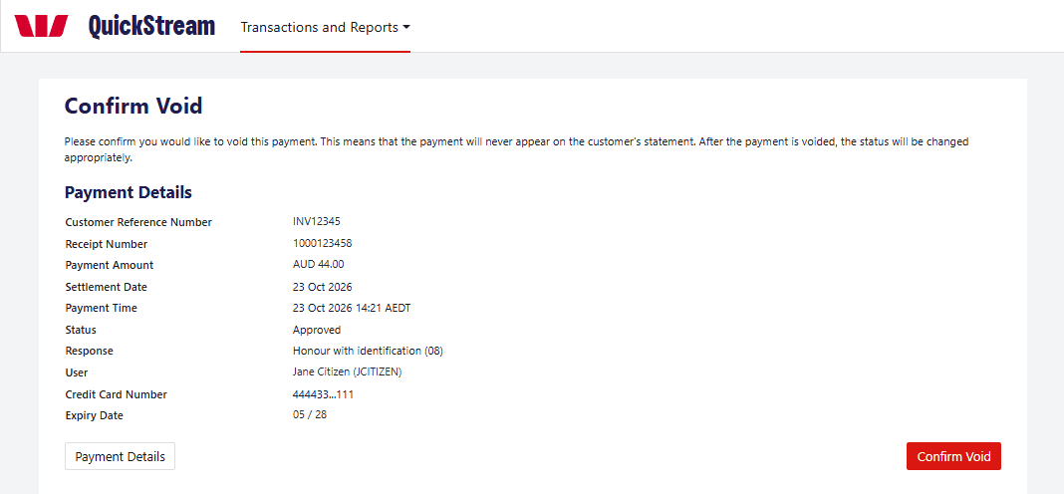
Example: the Confirm Void screen.
06 CHECK THE VOID RESULT
The Transaction Details screen shows “Transaction was successfully voided” and the Status changes to Voided. A voided transaction does not form part of your settlement total.
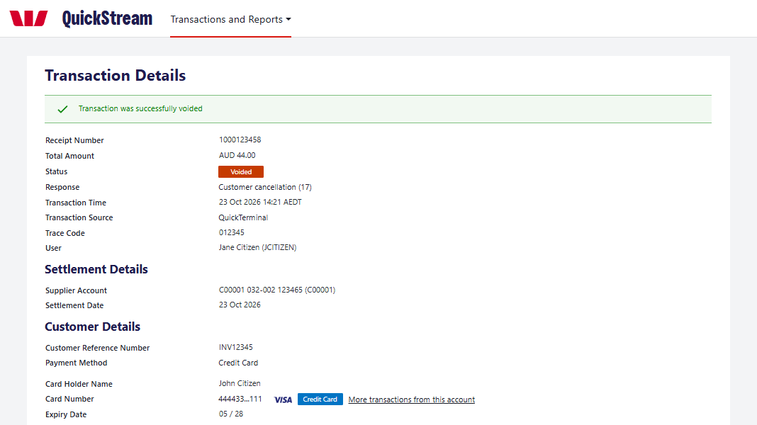
Example: a voided credit card payment.

Export transactions
Generate a transaction report using your chosen criteria.
01 OPEN EXPORT TRANSACTION REPORTS
Select Transactions and Reports > Find Transactions > Export Transaction Reports.
02 CHOOSE CRITERIA
Choose the Date (Time Period or Specific Dates) and the Transaction Status. Choose a Business and Order Type if you need to.
03 GENERATE
Select Generate Report.
04 DOWNLOAD
When the report is ready, download it. If it takes a while, come back later and download it from Recent Exports.
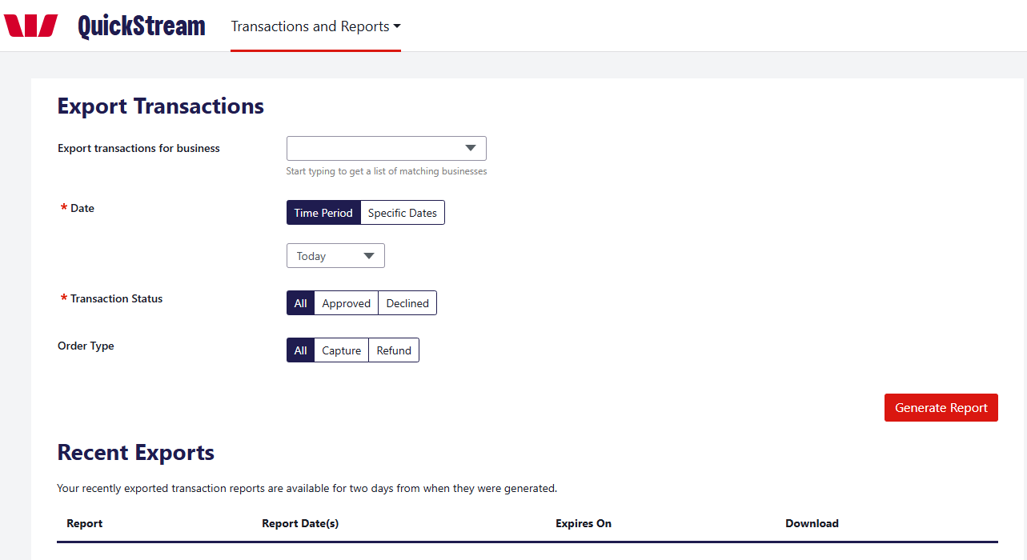
GOOD TO KNOW
Recently exported transaction reports are available for two days from when they were generated.

View daily settlements
View settlement information for a selected day.
01 OPEN DAILY SETTLEMENT
Select Transactions and Reports > Reports > Daily Settlement.
02 CHOOSE A DATE
The previous settlement date is shown by default. To see another day, enter a Settlement Date and select Display, or select a Jump To date.
03 REVIEW OR DOWNLOAD
Review the settlement information and download any available report.
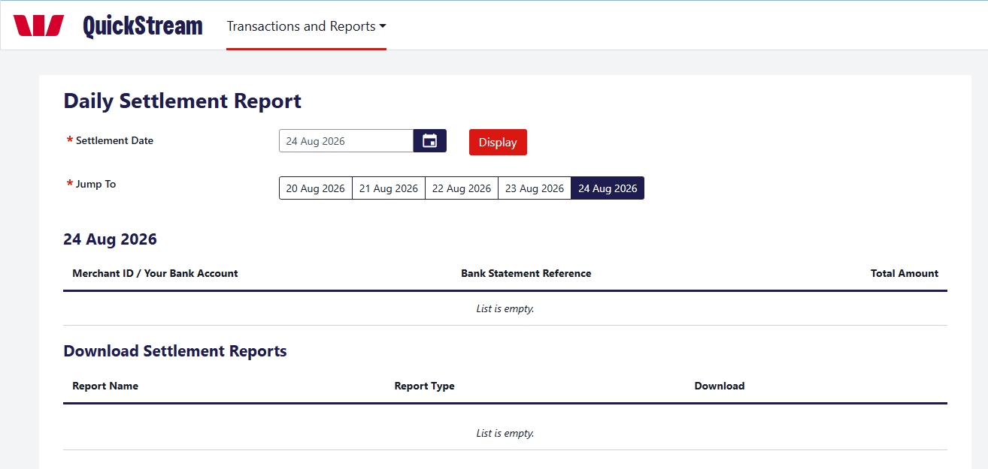
GOOD TO KNOW
Settlement amounts are indicative of how the settlement will appear on your bank statement.

View weekly settlements
Review daily settlements across a selected week.
01 OPEN WEEKLY SETTLEMENT
Select Transactions and Reports > Reports > Weekly Settlement.
02 CHOOSE THE WEEK
Select a Settlement Week and select Display, or use Jump To.
03 OPEN A DAY
Select the View [date] Settlement Report button for the day you need.
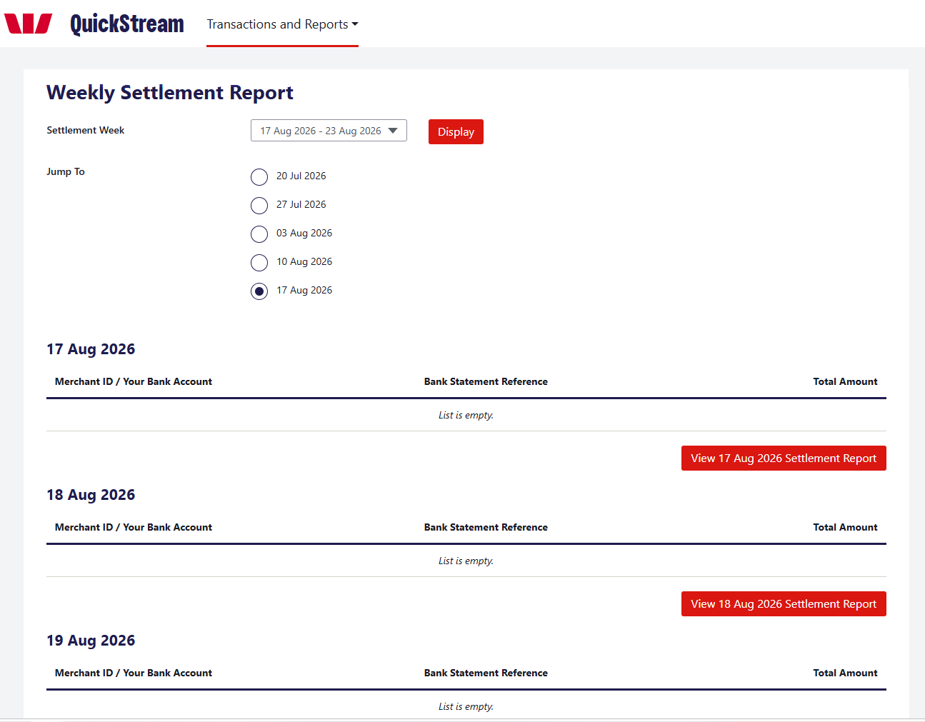
GOOD TO KNOW
Settlement amounts are indicative of how the settlement will appear on your bank statement.

View facility reports
Find and download facility reports.
01 OPEN FACILITY REPORTS
Select Transactions and Reports > Reports > Facility Reports.
02 SET CRITERIA
Choose the Date (required): Time Period or Specific Dates. To narrow the list, choose a Business or enter a Report Name (both optional).
03 VIEW
Select View Reports.
04 DOWNLOAD
Use the Download column for the report you need.
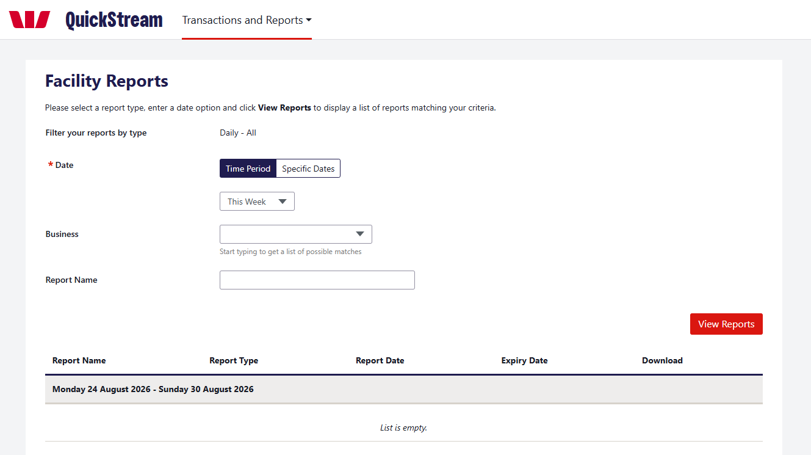

Customers and saved cards
Save a customer and their credit card so you can take payments from them later.
Available only if customers and saved cards are enabled for your organisation and assigned to your user profile.
01 SEARCH FOR CUSTOMERS
Select Customers > Search for Customers.
Choose how to find the customer: Show All, Customer Details, Account Details or Schedule ID. Tick Include Disabled Customers to include disabled customers.
Select Search. The list shows each customer’s Customer Number, Customer Name, Customer Status and a summary of their saved cards and schedules. Select Export Customers to download the list as a CSV file.
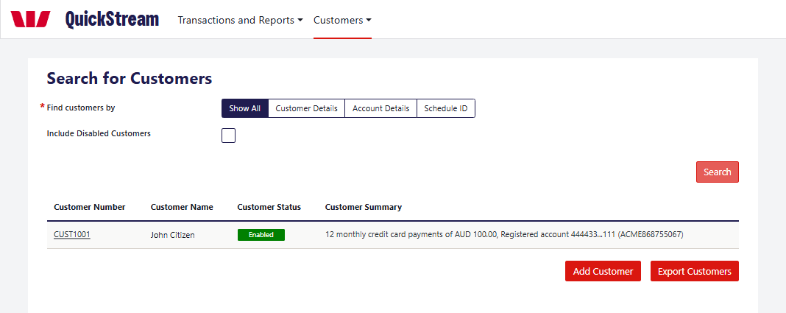
Example: the Search for Customers screen.
02 OPEN THE ADD CUSTOMER SCREEN
Select Add Customer below the list, or choose Customers > Add a Customer.
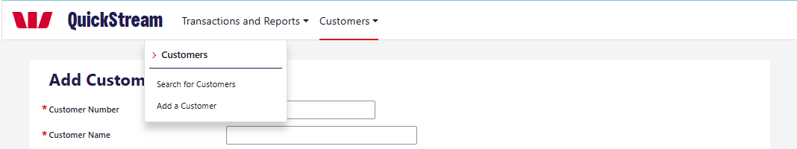
Example: the Customers menu.
Customers and saved cards — continued
03 ENTER THE CUSTOMER DETAILS
Enter the Customer Number and Customer Name. Fields marked * are required.
Email and Phone Number are optional. An Email address is required only if you switch on Email notifications, and a Phone Number only if you switch on SMS notifications. Address details are optional.
Select Save.
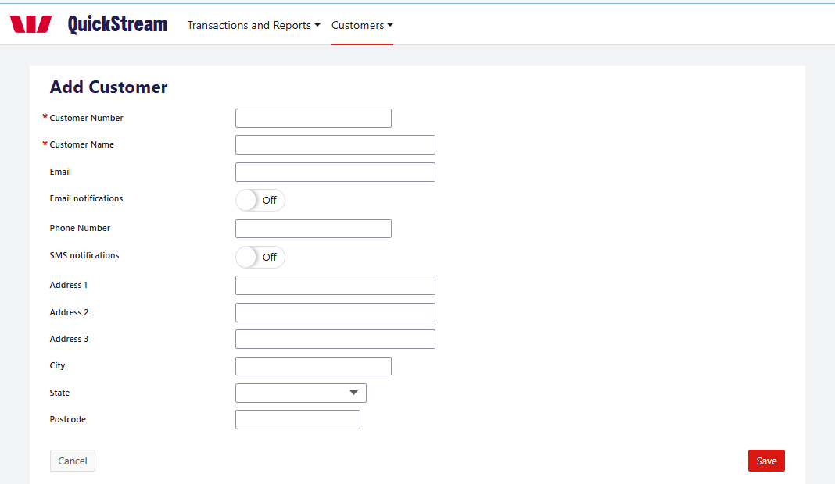
Example: the Add Customer screen.
04 CHECK THE CUSTOMER DETAILS
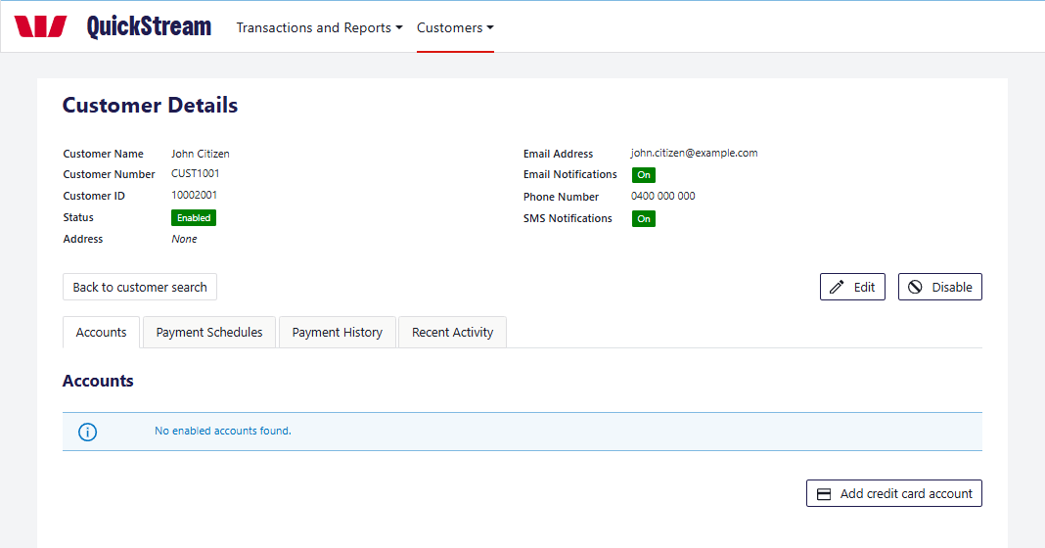
Example: a new customer with no saved cards.
The Customer Details screen shows the customer’s details, their Status and Customer ID. The tabs show their Accounts, Payment Schedules, Payment History and Recent Activity.
Customers and saved cards — continued
05 SAVE A CREDIT CARD
On the Accounts tab, select Add credit card account.
Enter the Card Number and Expiry Date. Cardholder Name is optional. Accepted cards: Visa and Mastercard.
Select Save.
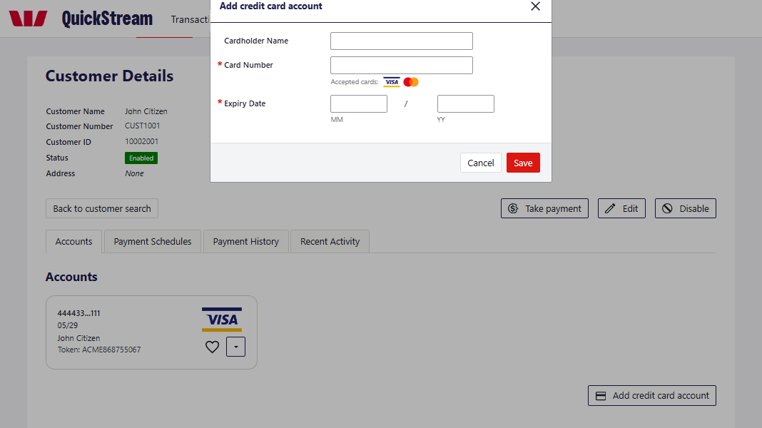
Example: the Add credit card account window.
06 CHECK THE SAVED CARD
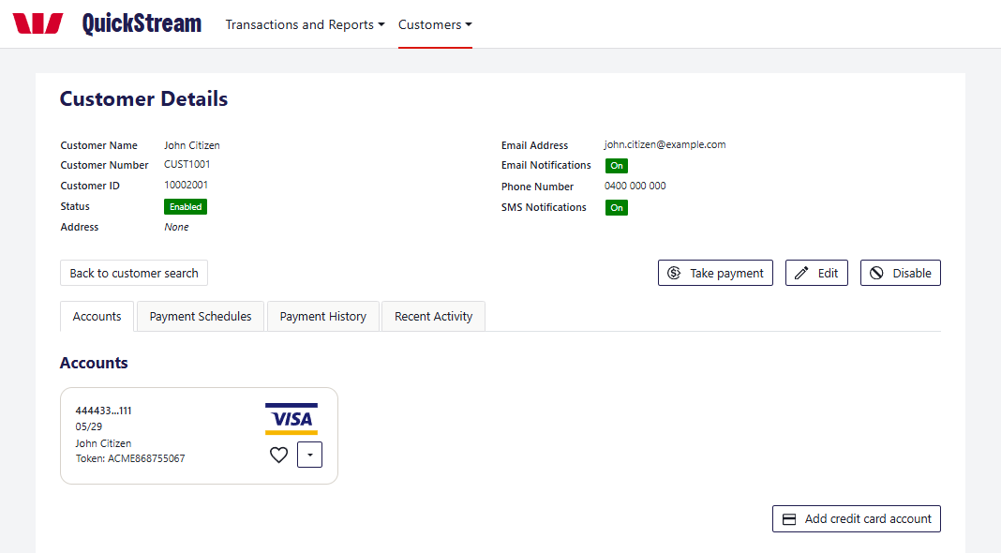
Example: a saved card on the Accounts tab.
The saved card appears as a tile with the masked card number, expiry date, cardholder name and an account token. The heart marks the default card. Use the arrow on the card to edit, disable or enable it, or to make it the default.
Customers and saved cards — continued
07 TAKE A PAYMENT FROM A SAVED CARD
On the Customer Details screen, select Take payment. If the customer has more than one card, choose the one to use.
Enter the payment details and select Next. Check the details, then select Confirm. The result appears on the Transaction Details screen.
You can also choose Transactions and Reports > Make a Payment > Existing Customer and search for the customer.
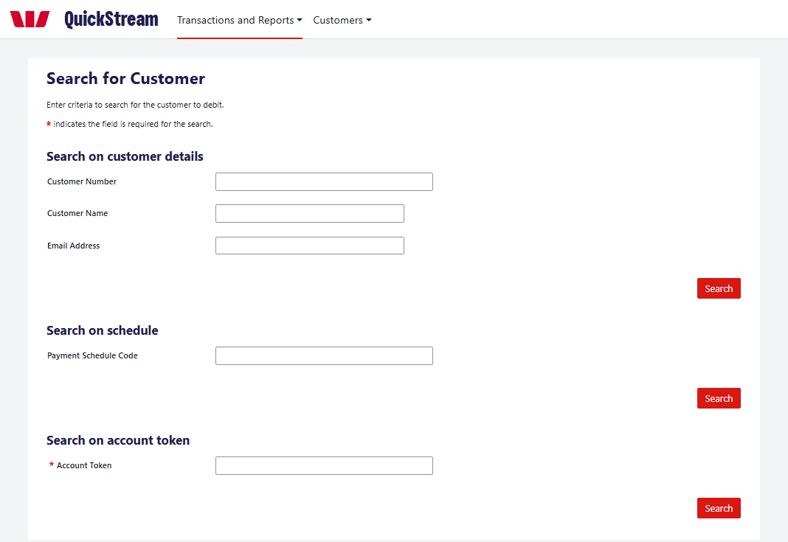
Example: Make a Payment > Existing Customer.
08 EDIT OR DISABLE A CUSTOMER
To change a customer’s details, select Edit on the Customer Details screen, update the details and select Save.
To stop taking payments from a customer, select Disable and confirm. Payments that have not yet settled are cancelled, and the customer’s saved cards and payment schedules become inactive. Select Enable to use the customer again.
GOOD TO KNOW
Only save a customer’s card and take payments from it where you have the customer’s authority.

Recurring payments
Take regular payments from a customer’s saved card on a schedule.
Available only if recurring payments are enabled for your organisation and assigned to your user profile.
01 OPEN THE CUSTOMER’S PAYMENT SCHEDULES
Select Customers > Search for Customers, then select the Customer Number.
Open the Payment Schedules tab. It lists the customer’s schedules with their Payment Schedule Code, Summary, Status and Next Payment Date.
Select Add payment schedule.
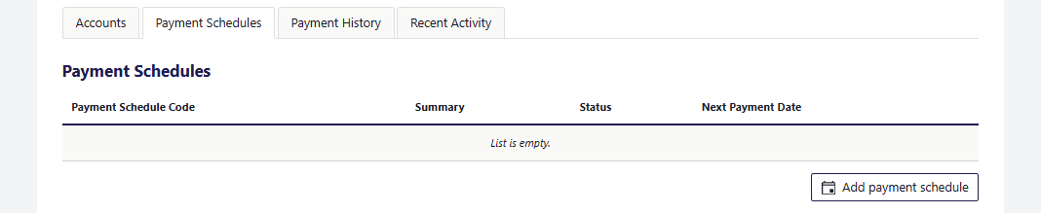
Example: the Payment Schedules tab.
02 COMPLETE THE SCHEDULE DETAILS
Choose the Supplier Business. This sets the settlement account the payments go to. Only AUD accounts can be selected.
Choose the Customer Account (a saved card), or select Add credit card account to save a new one.
Enter a Payment Schedule Code if you want your own identifier. One is generated if you leave it blank.
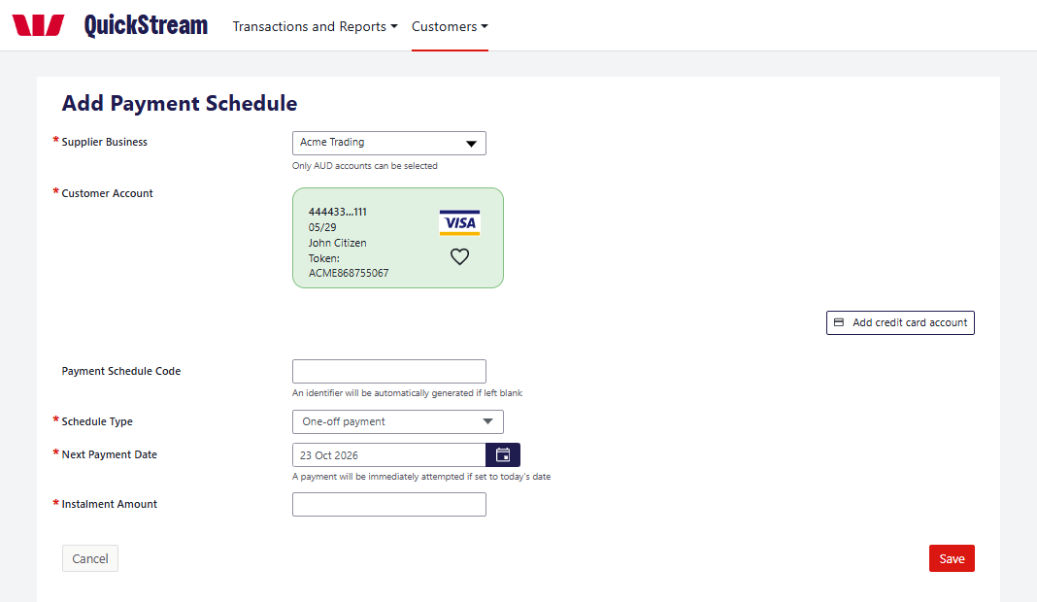
Example: the Add Payment Schedule screen.
Recurring payments — continued
03 CHOOSE THE SCHEDULE TYPE
Choose the Schedule Type, then enter the Next Payment Date and Instalment Amount. The Schedule Type decides when the payments stop:
One-off payment: a single payment on the Next Payment Date.
Continue until further notice: payments continue until you stop them.
Stop after a set number of payments: enter the number of payments (the screen shows Remaining Instalments).
Stop after total amount paid: payments stop when the total is reached. The last payment may be smaller.
Continue until set date: payments stop at the end date you enter.
For every type except One-off payment, also choose a Frequency: Weekly, Fortnightly, Monthly, Quarterly, Six-Monthly or Yearly.
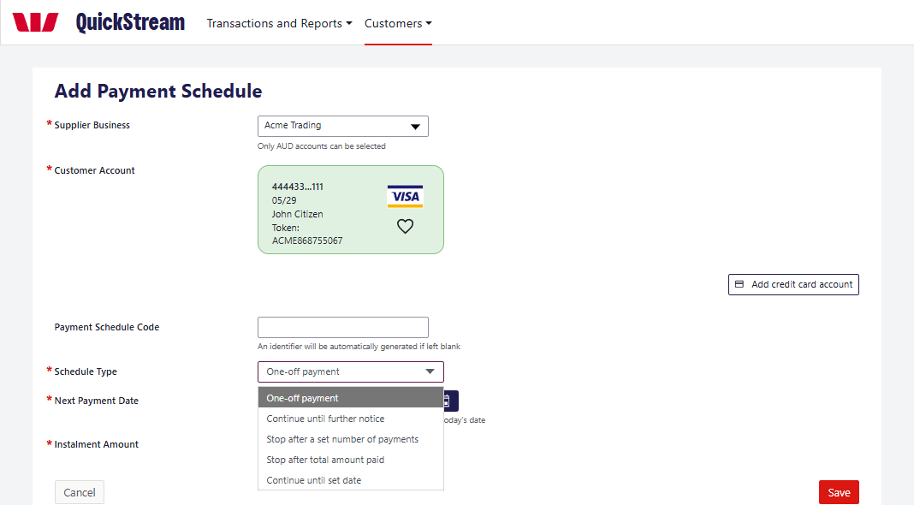
Example: the Schedule Type options.
04 SAVE THE SCHEDULE
Select Save. If the Next Payment Date is today, a payment is attempted straight away. Select Confirm to take it now, or Cancel and choose a different Next Payment Date.
Otherwise the schedule starts on the Next Payment Date and payments are attempted automatically on each payment date.
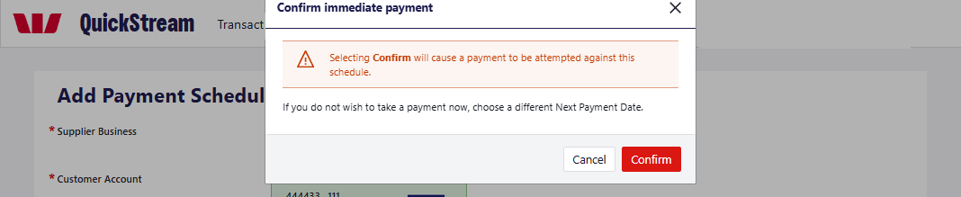
Example: confirming an immediate payment.
Recurring payments — continued
05 CHECK THE SCHEDULE
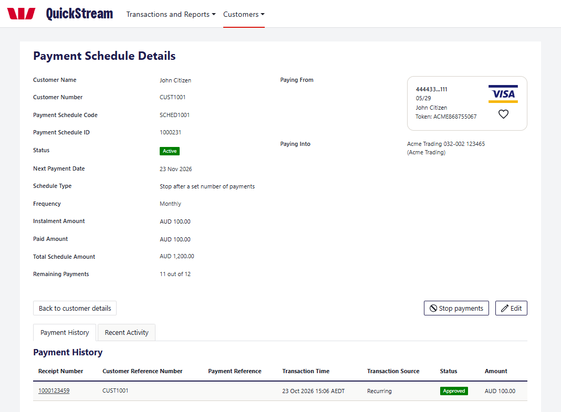
Example: the Payment Schedule Details screen.
Open the schedule from the Payment Schedules tab. The Payment Schedule Details screen shows its Status, Next Payment Date, Schedule Type, Frequency, Instalment Amount, Paid Amount, Total Schedule Amount and Remaining Payments. Paying From shows the card and Paying Into the settlement account. Payment History lists each payment taken.
06 STOP OR CHANGE A SCHEDULE
To stop a schedule, select Stop payments, then select Stop payments again to confirm. All remaining payments for the schedule are stopped.
To start it again, or to change the card, Frequency or Schedule Type, select Edit and make the changes. To restart a stopped schedule, set the Next Payment Date to today or a later date.
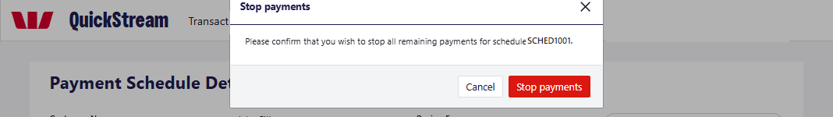
Example: confirming Stop payments.

