 QuickStream
Quick Start Guide
A simple guide to taking payments, finding transactions and accessing reports in QuickTerminal.

WHAT IS QUICKTERMINAL?
QuickTerminal is QuickStream’s secure online portal for authorised users to take payments, manage transactions and access reports. ^{VN1}

 THINGS YOU SHOULD KNOW
 | Confirm you are using the correct merchant or biller profile. |  | Check the customer reference against your internal records.
 | Review payment details carefully before submitting. |  | Only submit payments where you have the required authority.

 | Available functionality depends on your organisation’s Westpac setup, payment options and user access.
 | Screens and workflows may change as QuickTerminal is enhanced. If your organisation has a bespoke setup, also refer to your Westpac onboarding material.
SUPPORTED PAYMENT TYPES
Payment types available in QuickTerminal depend on your organisation’s configuration.
  CREDIT CARD  Take credit card payments where enabled. |  |   BANK ACCOUNT  Take direct debit payments from bank accounts where enabled. |  |   PAYTO  Create one-off PayTo payments where enabled.
Only payment options provisioned for your organisation and assigned to your user profile will be visible.

QUICK START
Use this guide to quickly find the task you need.
Make a credit card payment 3
Make a bank account payment 5
Make a PayTo payment 7
 Find transactions 9
Refund or void a transaction 11
 Export transactions 13
 View daily settlements 14
 View weekly settlements 15
 View facility reports 16

Make a credit card payment
Capture a customer credit card payment in QuickTerminal.
Payment Details → Confirm Payment Details → Transaction Details
01 ENTER PAYMENT DETAILS
Select Transactions and Reports > Make a Payment > Credit Card. ^{VN2}
Complete the required payment and card details.
Select Next.
GOOD TO KNOW
Check the customer reference and payment amount carefully before continuing.
VN21
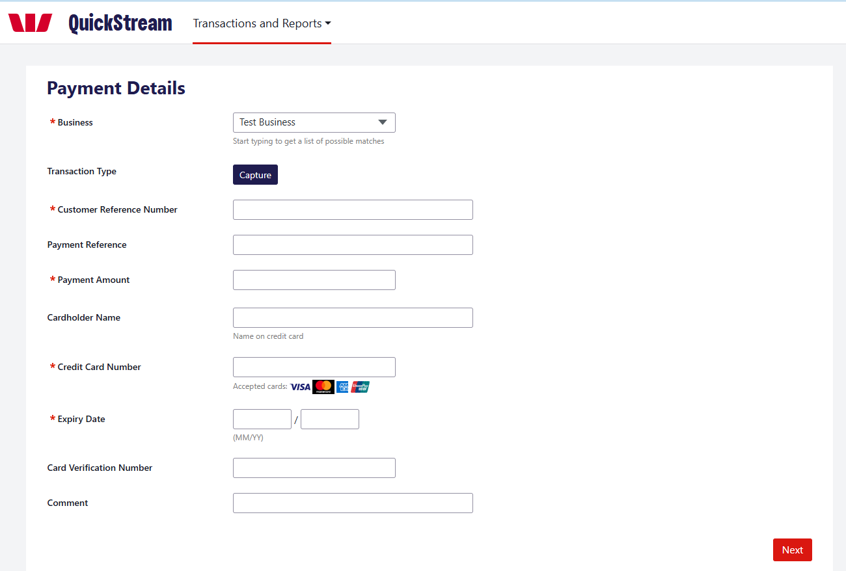
MAKE A CREDIT CARD PAYMENT — CONTINUED
02 REVIEW PAYMENT
VN21
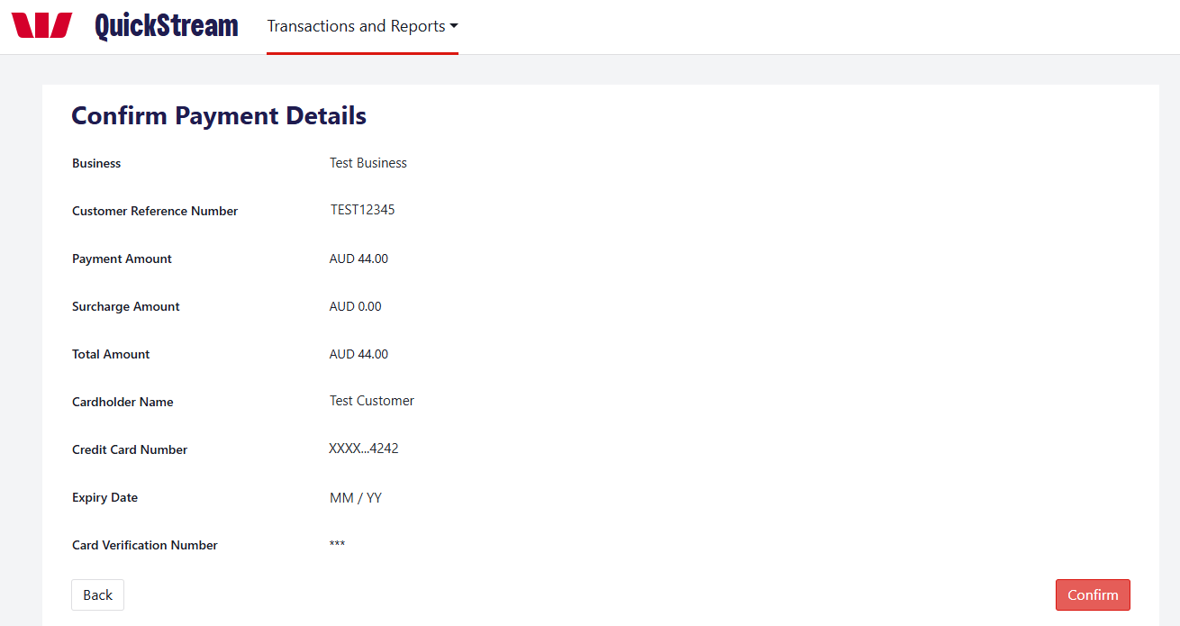
Review the business, customer reference, payment amount and card details. Select Back if anything needs changing. Select Confirm when the details are correct.
03 PAYMENT COMPLETE
VN16 VN21
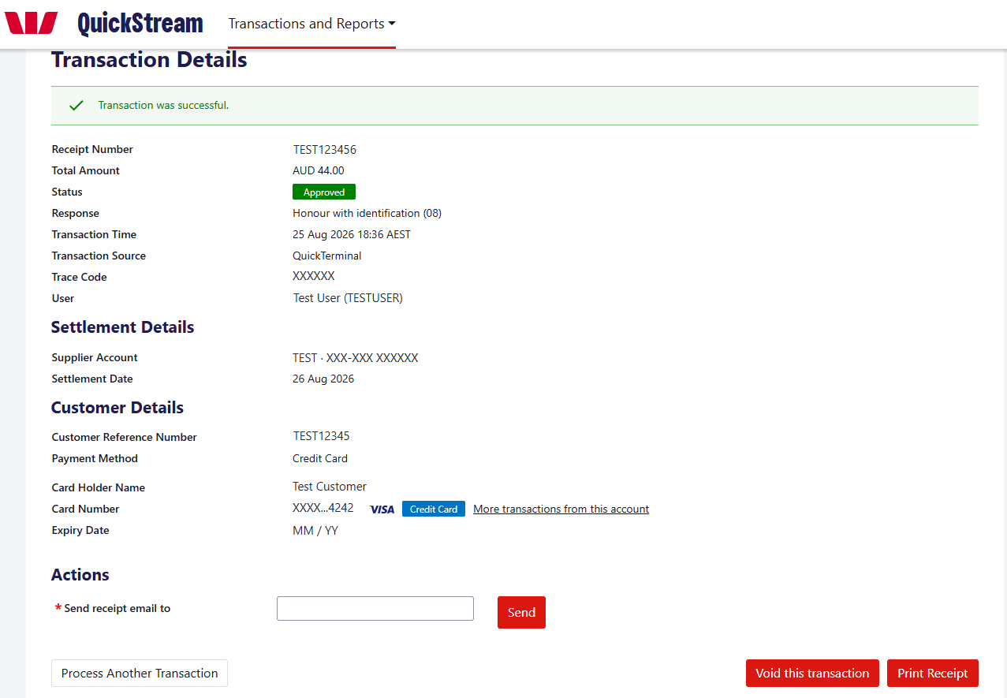
Review the transaction status, response and receipt number. Where required, email or print the receipt, or select Process Another Transaction.

Make a bank account payment
Capture a direct debit payment from a customer’s bank account.
Payment Details → Confirm Payment Details → Transaction Details
01 ENTER PAYMENT DETAILS
Select Transactions and Reports > Make a Payment > Bank Account. ^{VN2}
Enter the customer reference, payment amount, BSB, account number and account name.
Tick the Direct Debit Request confirmation when the required authority has been completed.
Select Next.
GOOD TO KNOW
Check the customer reference, BSB and account number carefully before continuing.
SCREENSHOT REQUIRED — BANK ACCOUNT PAYMENT DETAILS
Bank account Payment Details screen, title to Next, with the Direct Debit Request box ticked.
S01
MAKE A BANK ACCOUNT PAYMENT — CONTINUED
02 REVIEW PAYMENT
VN21
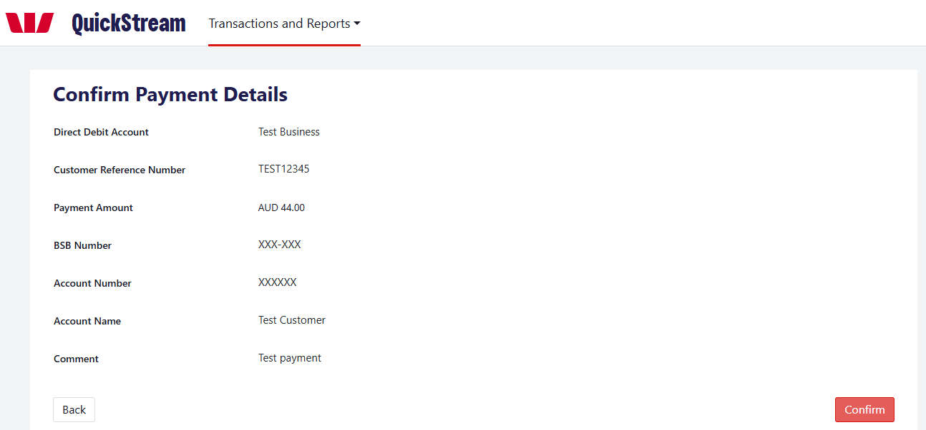
Review the direct debit account, customer reference, payment amount, BSB, account number and account name. Select Back if anything needs changing. Select Confirm when the details are correct.
03 PAYMENT COMPLETE
VN16 VN19 VN21
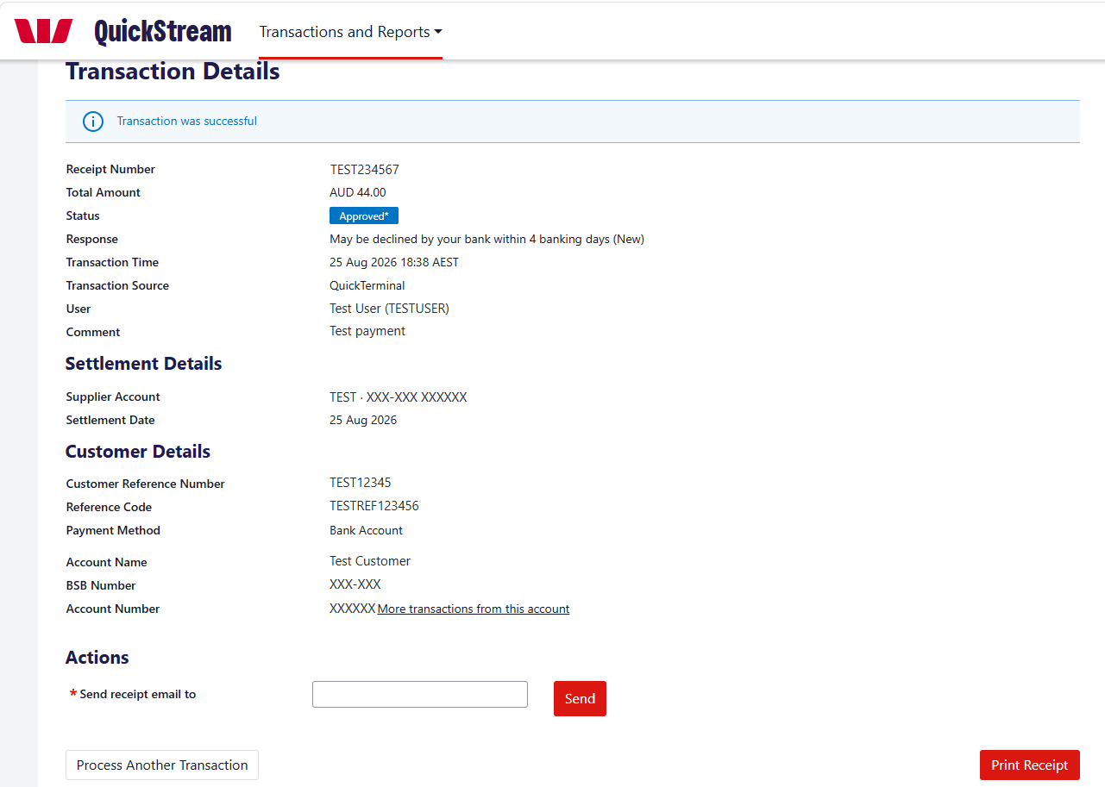
Review the transaction status, response and receipt number. Where required, email or print the receipt, or select Process Another Transaction.
Approval is only the first step. The customer’s bank can still return the payment. Follow your organisation’s reconciliation procedures to identify and handle bank returns. ^{VN12}

Make a PayTo payment
Create a one-off PayTo payment. The customer must approve a one-time PayTo agreement before the payment is attempted.
Available only if PayTo is enabled for your organisation and assigned to your user profile. ^{VN10}
Party Details → Payment Details → Review and Confirm → Transaction Details
01 ENTER PARTY DETAILS
Select Transactions and Reports > Make a Payment > PayTo. ^{VN3}
Payer Details: enter the Payer Name, Payer Type, Payer ID and Payer Reference. ^{VN4}
Payer Account Details: choose the Payment Method, then enter a PayID, or a BSB and account number. ^{VN4}
Payee Details: choose the Business and enter a Payee Reference. ^{VN4 VN18}
Select Next.
SCREENSHOT REQUIRED — PAYTO PARTY DETAILS
PayTo Party Details screen, title to Next.
S02
02 ENTER PAYMENT DETAILS
Enter the Payment Amount, then complete the End to End ID, Remittance Information, Purpose and Description as required. ^{VN4}
Select Next.
SCREENSHOT REQUIRED — PAYTO PAYMENT DETAILS
PayTo Payment Details screen, title to Next.
S03
MAKE A PAYTO PAYMENT — CONTINUED
03 REVIEW AND CONFIRM
Review the party and payment details.
Select Confirm. This creates a one-time PayTo agreement and sends it to the customer for approval in their banking app. ^{VN5}
SCREENSHOT REQUIRED — PAYTO REVIEW AND CONFIRM
PayTo review screen with the Confirm button visible.
S04
04 CHECK THE PAYMENT STATUS
SCREENSHOT REQUIRED — PAYTO TRANSACTION DETAILS (PENDING)
Transaction Details screen showing the pending PayTo payment.
S05
The Transaction Details screen shows the payment as pending until the customer approves the PayTo agreement. After the customer approves, the payment is attempted and the screen shows the result. ^{VN5} If the status has not changed, check it later using Find transactions.
GOOD TO KNOW
Three things are separate: the customer’s approval of the agreement, the payment status, and settlement. Approval only allows the payment to be attempted. Check the payment status before you tell the customer the payment is complete. Your settlement reports may show the payment once it settles. ^{VN22}

Find transactions
Look up recent activity, search for a transaction and open its details.
01 RECENT TRANSACTIONS
Select Transactions and Reports > Find Transactions > Recent Transactions. ^{VN2}
Choose the business, then select Display.
VN21
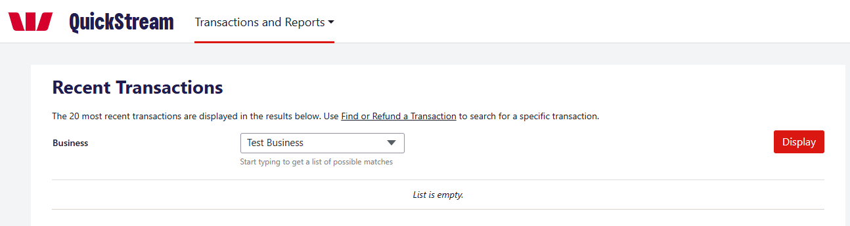
QuickTerminal shows the 20 most recent transactions.
02 SEARCH FOR A TRANSACTION
Select Find or Refund a Transaction.
Choose a search type: Settlement Date, Reference Number (customer reference, payment reference or receipt number) or Account Details (full or partial card number, or BSB and account number). ^{VN11}
Select Show Advanced Search to narrow the results by business, status, transaction source, order type, payment method or amount. ^{VN11}
Select Search.
VN21
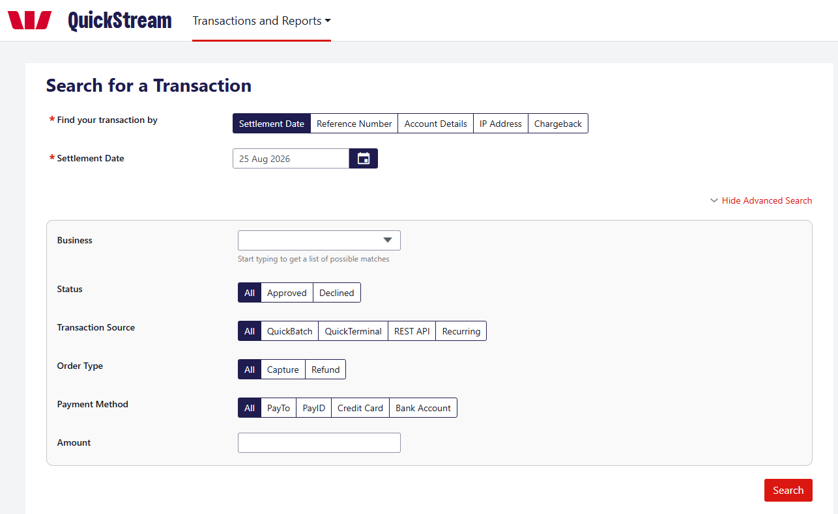
FIND TRANSACTIONS — CONTINUED
03 REVIEW THE RESULTS
SCREENSHOT REQUIRED — FIND OR REFUND A TRANSACTION — SEARCH RESULTS
Search results with at least two rows and the … button.
S06
Results show the receipt number, customer reference, payment reference, transaction time, status and amount. Refunds appear as negative amounts. Hover over a status to see the response from the customer’s bank. ^{VN13}
04 OPEN THE TRANSACTION DETAILS
Select the receipt number, or select the … button on the row.
VN16 VN21
The Transaction Details screen shows the payment, settlement and customer details. Available actions depend on the transaction status and your user permissions: ^{VN10}
• Send receipt email to — enter an email address and select Send.
• Print Receipt.
• Process Another Transaction.
• Void this transaction or Refund, where available. See Refund or void a transaction.

Refund or void a transaction
Void and refund are different actions. Choose the one that applies to the transaction.
Refund and void options appear only when they are available for the transaction and allowed by your user permissions. ^{VN10}
VOID  Cancels an eligible transaction before it is included in settlement. ^{VN9}  • Card: before the bank cut-off time. ^{VN9}  • Bank account: before the payment is sent to the bank. |  | REFUND  Returns money to the payer as a separate transaction. It does not cancel the original payment. ^{VN8}  • Card: after the bank cut-off time.  • Bank account: 4 banking days after the original payment date. ^{VN9}  • PayTo: after the payment is approved. ^{VN6}
Which action is available depends on the transaction type and timing. Starting a refund does not mean the money has already reached the customer. ^{VN8}
01 FIND THE TRANSACTION
Select Transactions and Reports > Find Transactions > Find or Refund a Transaction. ^{VN2}
Search for the transaction. See Find transactions.
02 CHOOSE VOID OR REFUND
Select the receipt number, or select the … button on the transaction row.
Choose Void to cancel the transaction before it settles, or Refund to return money to the payer. ^{VN7}
SCREENSHOT REQUIRED — TRANSACTION ACTIONS MENU (REFUND AND VOID)
Results with the … menu open, showing the Refund and Void options.
S07
REFUND OR VOID A TRANSACTION — CONTINUED
03 REVIEW AND CONFIRM
Check the receipt number, amount and action shown.
Follow the on-screen steps to confirm the action. ^{VN7}
SCREENSHOT REQUIRED — REFUND OR VOID CONFIRMATION
The screen shown after choosing Refund, and after choosing Void.
S08
04 CHECK THE RESULT
Find the transaction again and check its Status and Amount.
A void changes the original transaction. A refund is recorded as a separate transaction with a negative amount. ^{VN8}
A successful refund request does not mean the funds are immediately available to the customer. ^{VN8}
SCREENSHOT REQUIRED — SEARCH RESULTS AFTER REFUND OR VOID
Search results after a refund or void, showing the resulting status.
S09
GOOD TO KNOW
Check the receipt number and amount before you confirm. If you are unsure which action applies, contact Westpac QuickStream support before you proceed.

Export transactions
Generate a transaction report using your chosen criteria.
01 OPEN EXPORT TRANSACTION REPORTS
Select Transactions and Reports > Find Transactions > Export Transaction Reports. ^{VN15}
02 CHOOSE CRITERIA
Select the business, date, transaction status and order type.
03 GENERATE
Select Generate Report.
04 DOWNLOAD
When available, use Recent Exports to download the report.
GOOD TO KNOW
Recently exported transaction reports are available for two days from when they were generated.
VN21
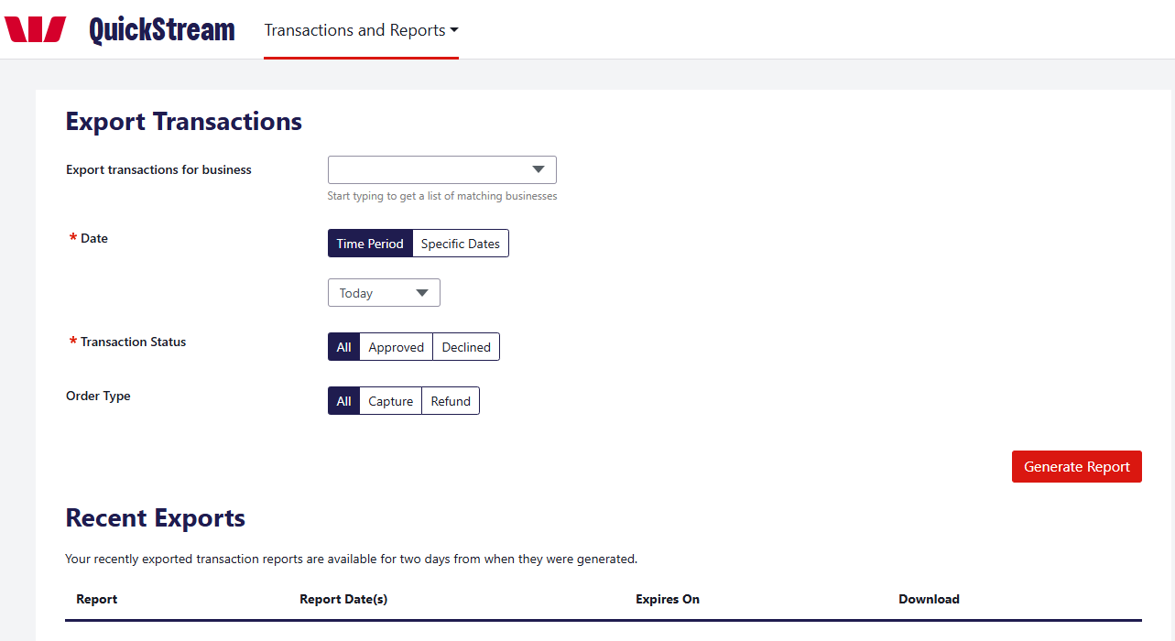

View daily settlements
View settlement information for a selected day.
01 OPEN DAILY SETTLEMENT
Select Transactions and Reports > Reports > Daily Settlement. ^{VN14}
02 CHOOSE A DATE
Enter a settlement date and select Display, or use a Jump To date.
03 REVIEW OR DOWNLOAD
Review the settlement information and download any available report.
VN21
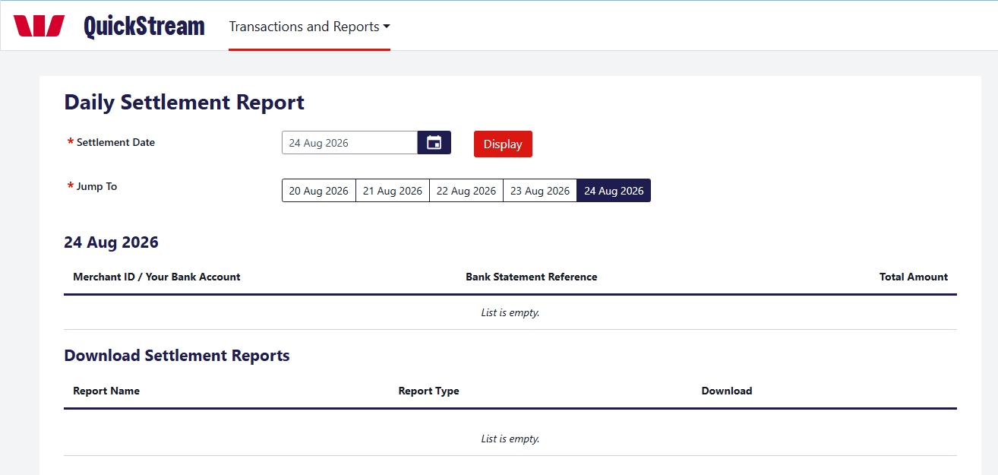

View weekly settlements
Review daily settlements across a selected week.
01 OPEN WEEKLY SETTLEMENT
Select Transactions and Reports > Reports > Weekly Settlement. ^{VN14}
02 CHOOSE THE WEEK
Select a settlement week and select Display, or use Jump To.
03 OPEN A DAY
Select the View [date] Settlement Report button for the day you need.
VN16 VN21
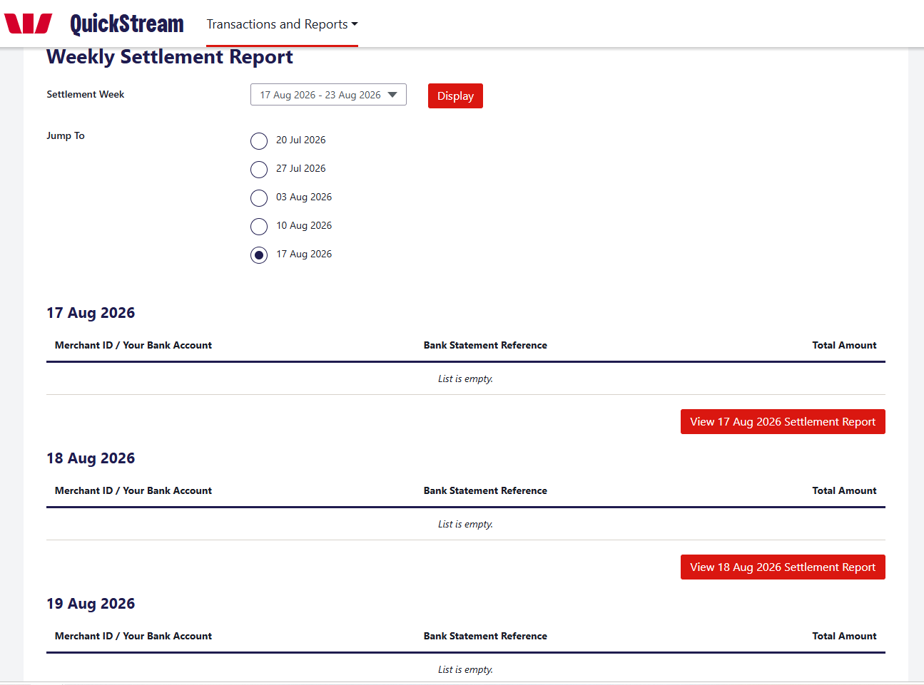

View facility reports
Find and download facility reports.
01 OPEN FACILITY REPORTS
Select Transactions and Reports > Reports > Facility Reports. ^{VN14}
02 SET CRITERIA
Choose the report type and date. Add a business or report name if needed.
03 VIEW
Select View Reports.
04 DOWNLOAD
Use the Download column for the report you need.
VN21
