 QuickStream
Quick Start Guide
A simple guide to taking payments, managing customers and recurring payments, finding transactions and accessing reports in QuickPortal.

WHAT IS QUICKPORTAL?
QuickPortal is QuickStream’s secure online portal for taking payments, managing customers and transactions, and accessing reports.

 THINGS YOU SHOULD KNOW
 | Confirm you are using the correct merchant or biller profile. |  | Check the customer reference against your internal records.
 | Review payment details carefully before submitting. |  | Only submit payments where you have the required authority.

 | Available functionality depends on your organisation’s Westpac setup, payment options and user access.
 | Screens and workflows may change as QuickPortal is enhanced. If your organisation has a bespoke setup, also refer to your Westpac onboarding material.
SUPPORTED PAYMENT TYPES
Payment types available in QuickPortal depend on your organisation’s configuration.
  CREDIT CARD  Take credit card payments where enabled. |  |   BANK ACCOUNT  Take direct debit payments from bank accounts where enabled. |  |   PayTo  Create one-off PayTo payments where enabled.
Only payment options provisioned for your organisation and assigned to your user profile will be visible.

QUICK START
Use this guide to quickly find the task you need.
Make a credit card payment 3
Make a bank account payment 5
Make a PayTo payment 7
 Find transactions 9
Refund or void a transaction 11
 Export transactions 15
 View daily settlements 16
 View weekly settlements 17
 View facility reports 18
Customers and accounts 19
Recurring payments 21

Make a credit card payment
Capture a customer credit card payment in QuickPortal.
Payment Details → Confirm Payment Details → Transaction Details
01 ENTER PAYMENT DETAILS
Select Transactions and Reports > Make a Payment > Credit Card.
Check the Business, or start typing to choose a different one. The payment settles to this business.
Complete the other fields marked * (Customer Reference Number, Payment Amount, Credit Card Number and Expiry Date). The remaining fields are optional.
Select Next.
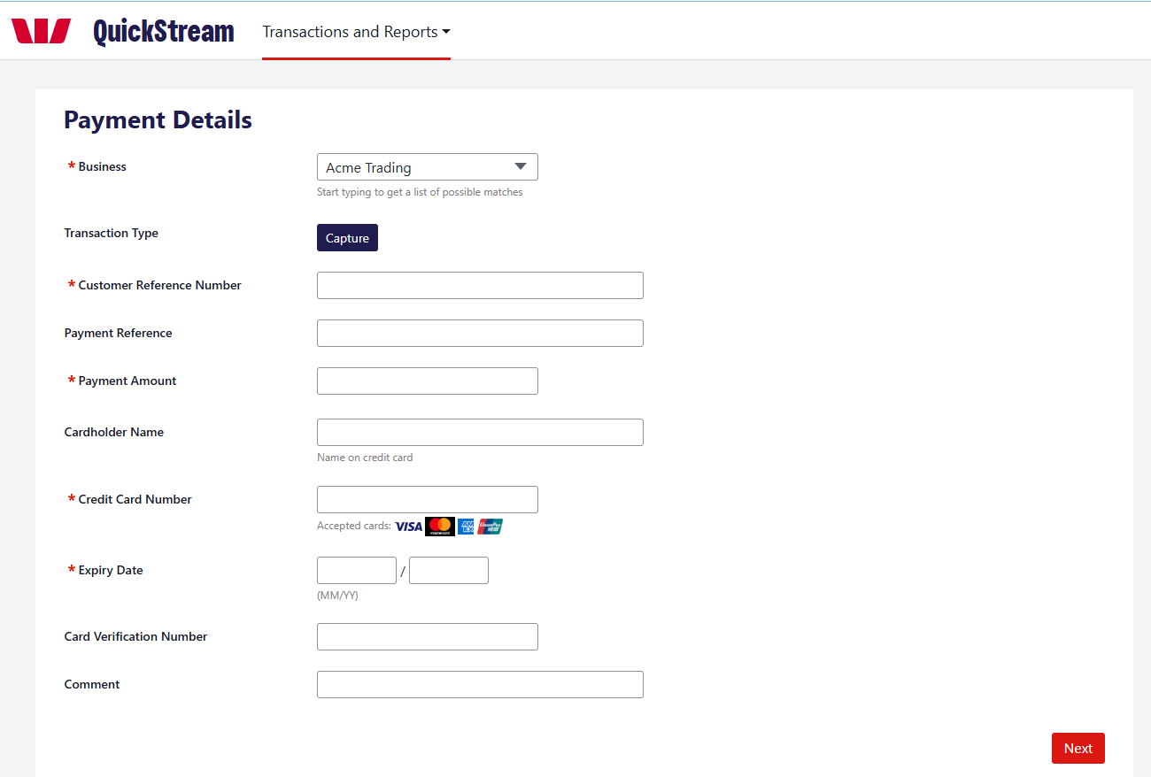
GOOD TO KNOW
Check the customer reference and payment amount carefully before continuing.
Make a credit card payment — continued
02 REVIEW PAYMENT
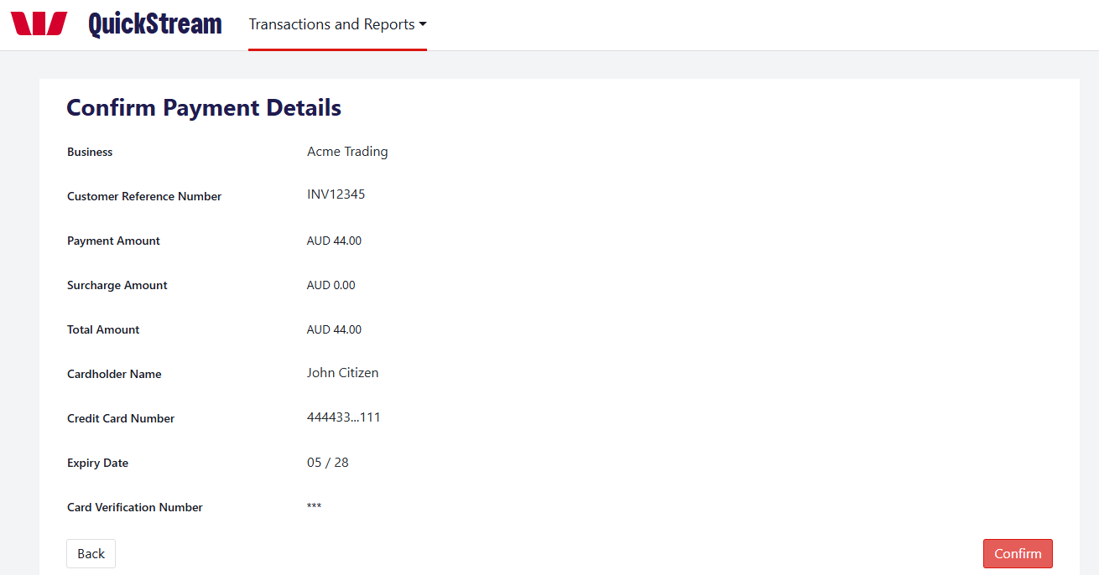
Review the business, customer reference, payment amount and card details. Select Back if anything needs changing. Select Confirm to submit the payment.
03 CHECK THE PAYMENT RESULT
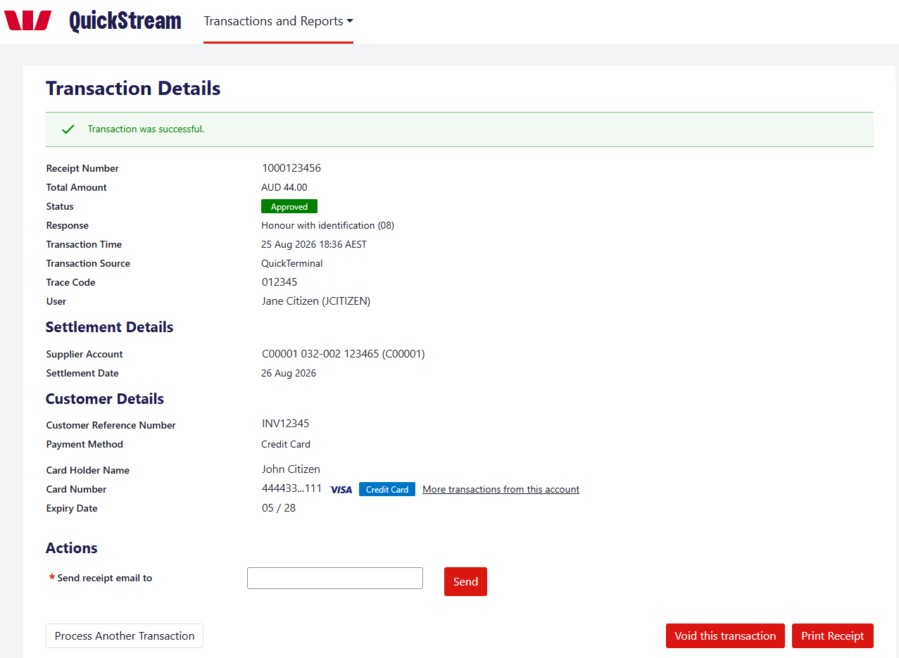
Check the Status and Response to see whether the payment was approved or declined. Email or print the receipt if required, or select Process Another Transaction.
Approved is the processing result. Settlement to your account is separate and appears in your settlement reports.

Make a bank account payment
Capture a direct debit payment from a customer’s bank account.
Payment Details → Confirm Payment Details → Transaction Details
01 ENTER PAYMENT DETAILS
Select Transactions and Reports > Make a Payment > Bank Account.
Check the Direct Debit Account shown. If you have more than one, choose the account the payment should settle to.
Complete the fields marked * (Customer Reference Number, Payment Amount, BSB Number, Account Number and Account Name). Comment is optional.
Tick the Direct Debit Request box to confirm that a Direct Debit Request has been completed for the customer and you have the authority to debit the account.
Select Next.
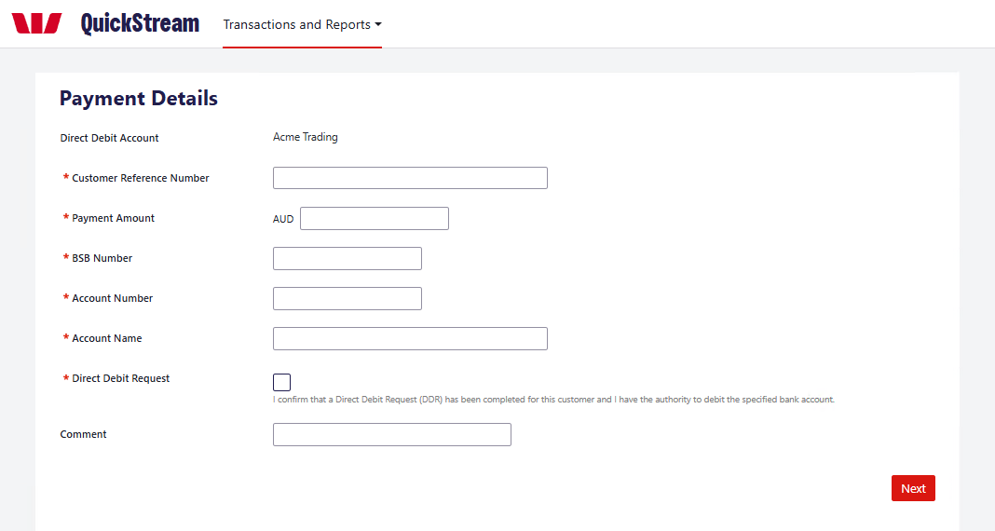
GOOD TO KNOW
Check the customer reference, BSB and account number carefully before continuing.
Make a bank account payment — continued
02 REVIEW PAYMENT
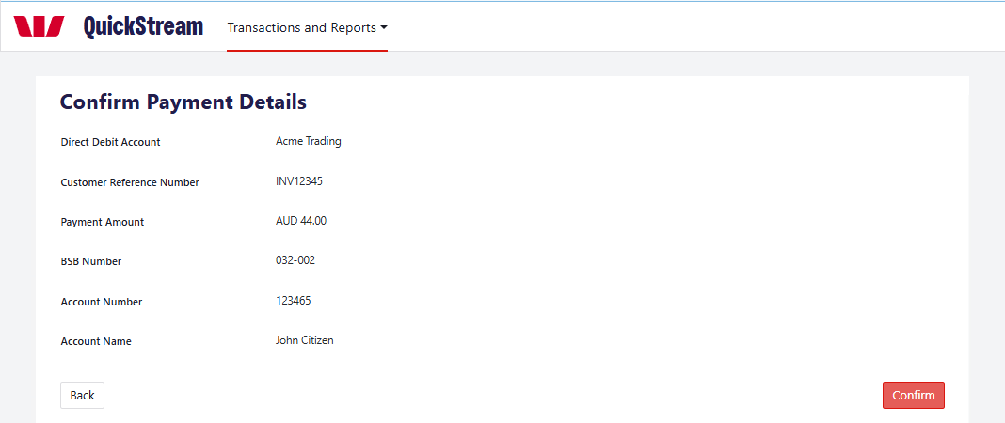
Review the direct debit account, customer reference, payment amount, BSB, account number and account name. Select Back if anything needs changing. Select Confirm to submit the payment.
03 CHECK THE PAYMENT RESULT
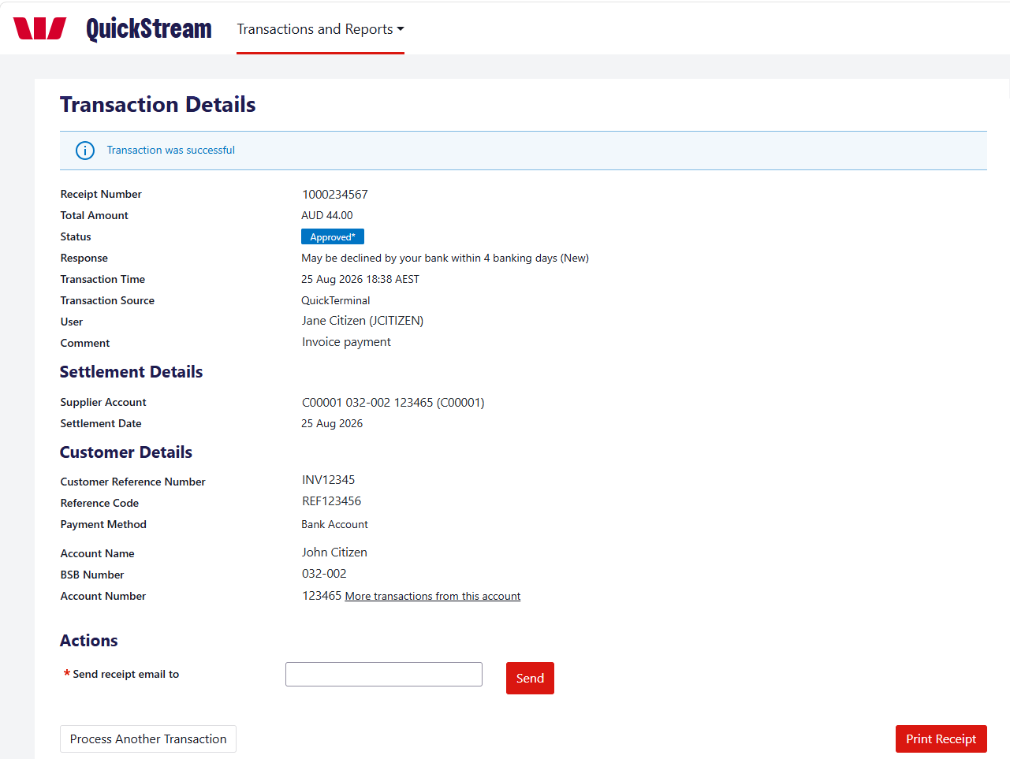
Check the Status and Response, and note the Receipt Number. Where required, email or print the receipt, or select Process Another Transaction.
Approval is not final for bank account payments. Approved* means the customer’s bank can still decline or return the payment within 4 banking days. Follow your organisation’s reconciliation procedures to identify and handle returns.

Make a PayTo payment
Create a one-off PayTo payment that the customer approves before it is attempted.
Available only if PayTo is enabled for your organisation and assigned to your user profile.
01 ENTER PARTY DETAILS
Select Transactions and Reports > Make a Payment > PayTo. Fields marked * are required.
Enter the Payer Name and Payer ID (CRN). Payer Type is Individual unless you choose Organisation. Payer Reference is optional.
Choose PayID or BSB/Account Number and enter the details. For a PayID, also choose its type.
Choose the Business. Payee Reference is optional.
Select Next.
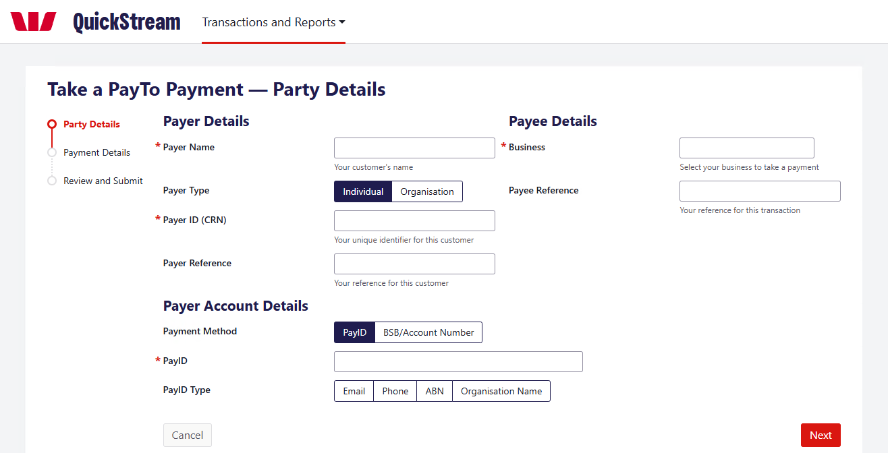
02 ENTER PAYMENT DETAILS
Enter the Payment Amount, choose the Purpose and enter a Description. The customer sees the Description on the agreement. End to End ID and Remittance Information are optional.
Select Next.
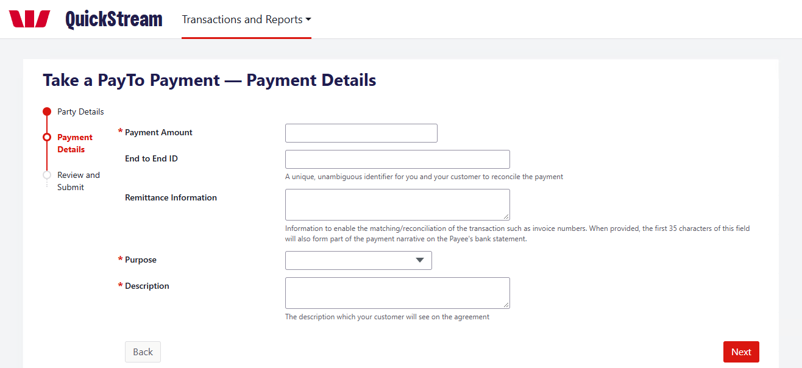
Make a PayTo payment — continued
03 REVIEW AND SUBMIT
Check the details, then select Confirm. This creates a one-time PayTo agreement and sends it to the customer to approve in their banking app.
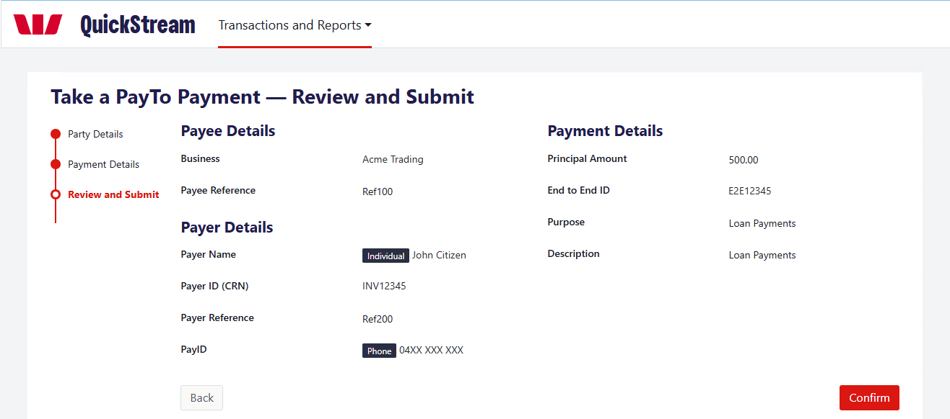
04 CHECK THE PAYMENT RESULT
The payment stays pending until the customer approves the agreement. If they decline, or do not respond within the approval period (15 minutes or less), the agreement is cancelled and no payment is taken.
Once approved, the payment is attempted. Approval does not guarantee it succeeds.
Check the Status and Response before telling the customer the payment is complete. It can stay pending before the final result.
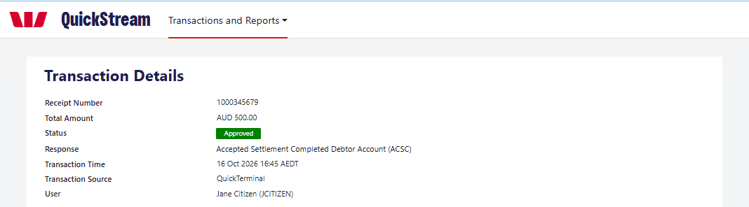
Example: an approved PayTo payment.
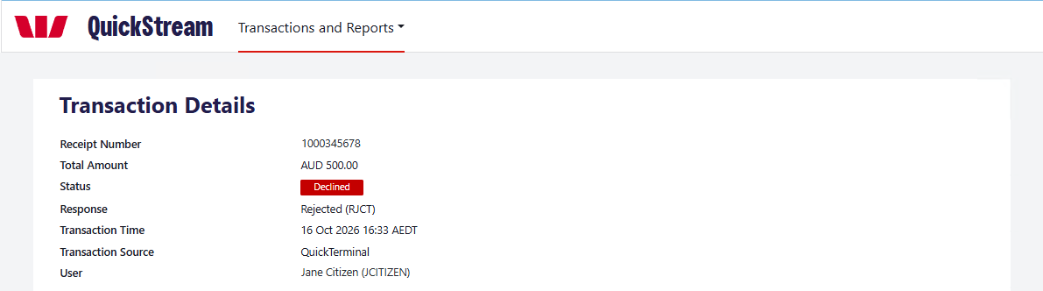
Example: a declined PayTo payment.
GOOD TO KNOW
Settlement is separate. An approved payment may appear in your settlement reports once it settles.

Find transactions
Look up recent activity, search for a transaction and open its details.
01 VIEW RECENT TRANSACTIONS
Select Transactions and Reports > Find Transactions > Recent Transactions.
Choose the Business, then select Display to see the 20 most recent transactions.
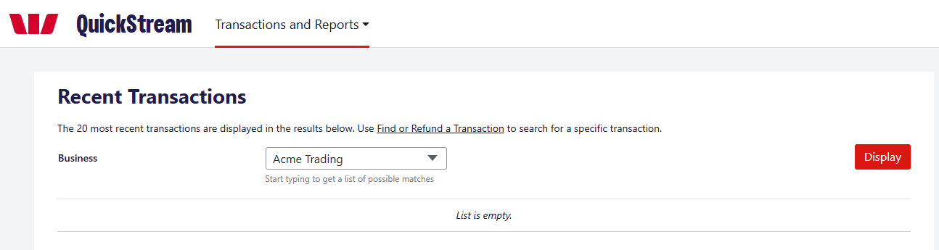
02 SEARCH FOR A TRANSACTION
Select Transactions and Reports > Find Transactions > Find or Refund a Transaction.
Under Find your transaction by, choose an option and enter the details:
• Settlement Date
• Reference Number: a customer reference, payment reference or receipt number
• Account Details: a full or partial card number, or a BSB and account number
To narrow the results, use Advanced Search (Business, Status, Transaction Source, Order Type or Amount).
Select Search.
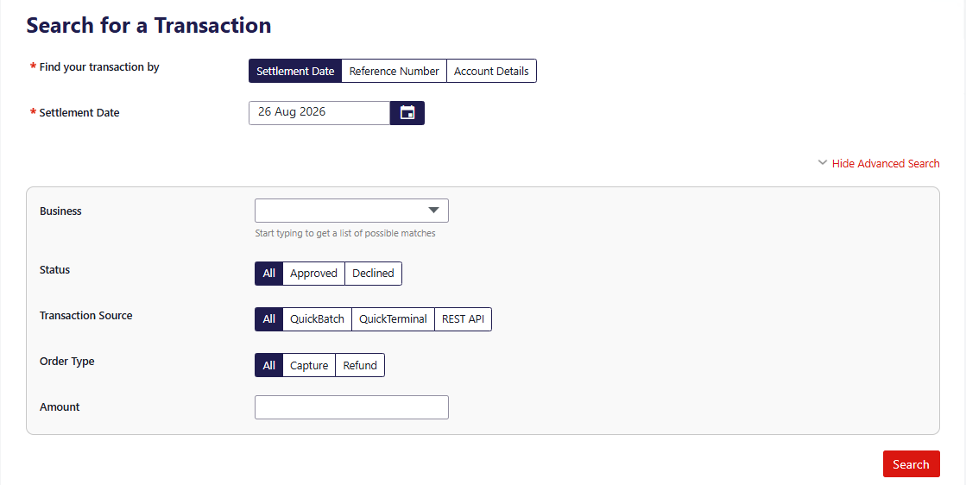
Find transactions — continued
03 REVIEW THE RESULTS
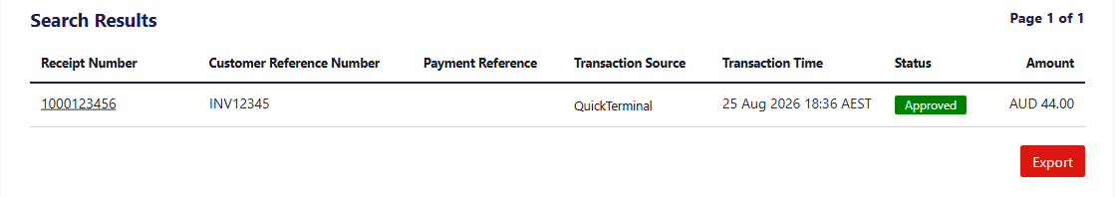
Results show the receipt number, customer reference number, payment reference, transaction source, transaction time, status and amount. Refunds appear as negative amounts.
04 OPEN THE TRANSACTION DETAILS
Select the receipt number.
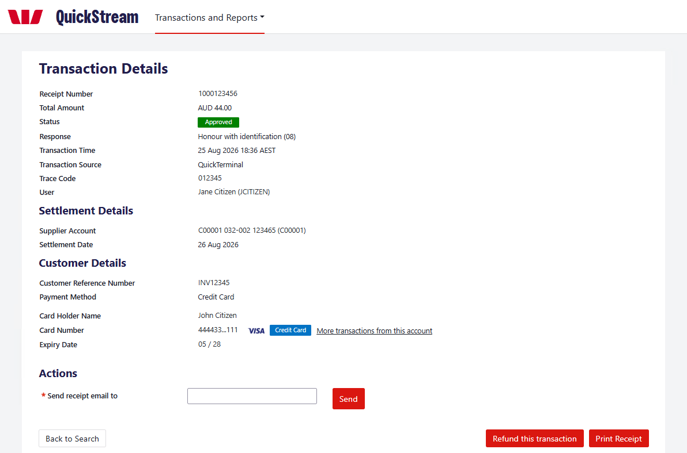
Example: a credit card transaction.
The Transaction Details screen shows the payment, settlement and customer details. Available actions depend on the transaction and your user permissions:
• Send receipt email to — enter an email address and select Send.
• Print Receipt.
• Back to Search.
• Refund this transaction or Void this transaction, whichever is shown. See Refund or void a transaction.

Refund or void a transaction
Void and refund are different actions. Choose the one that applies to the transaction.
Refund and void options appear only when they are available for the transaction and allowed by your user permissions.
VOID  Cancels an eligible transaction before it is included in settlement.  • Card: before the bank cut-off time.  • Bank account: before the payment is sent to the bank. |  | REFUND  Returns money to the payer as a new, separate transaction. The original payment is not cancelled.  • Card: after the bank cut-off time.  • Bank account: from 4 banking days after the original payment date.  • PayTo: after the payment is approved.

01 FIND THE TRANSACTION
Select Transactions and Reports > Find Transactions > Find or Refund a Transaction.
Search for the transaction. See Find transactions.
02 CHOOSE REFUND OR VOID
Select the receipt number to open the Transaction Details screen.
Select Refund this transaction or Void this transaction, whichever is shown.
To refund, continue with step 03. To void, go to step 05.
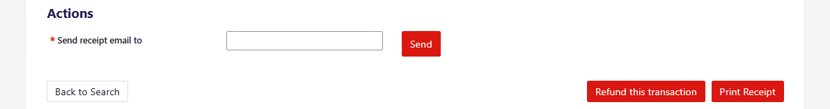
Example: the Refund this transaction button.
Refund or void a transaction — continued
03 CONFIRM THE REFUND
On the Refund Payment screen, check the Refund Amount, add a comment if needed and select Confirm. To refund part of the payment, change the Refund Amount; you cannot refund more than the original payment.
On the Confirm Refund screen, check the details and select Confirm again. A PayTo payment uses the same Refund Payment screen.
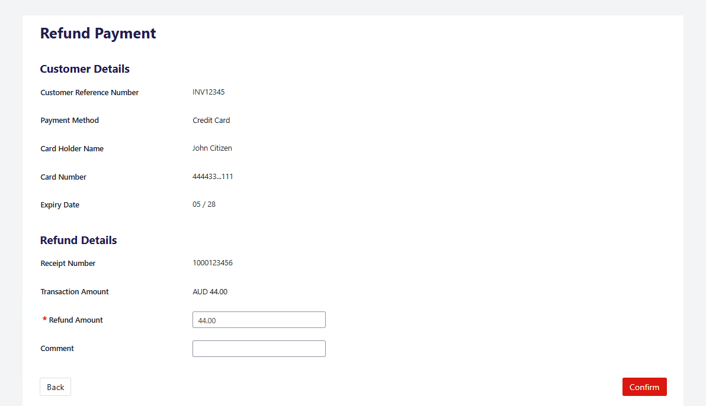
Example: refunding a credit card payment.
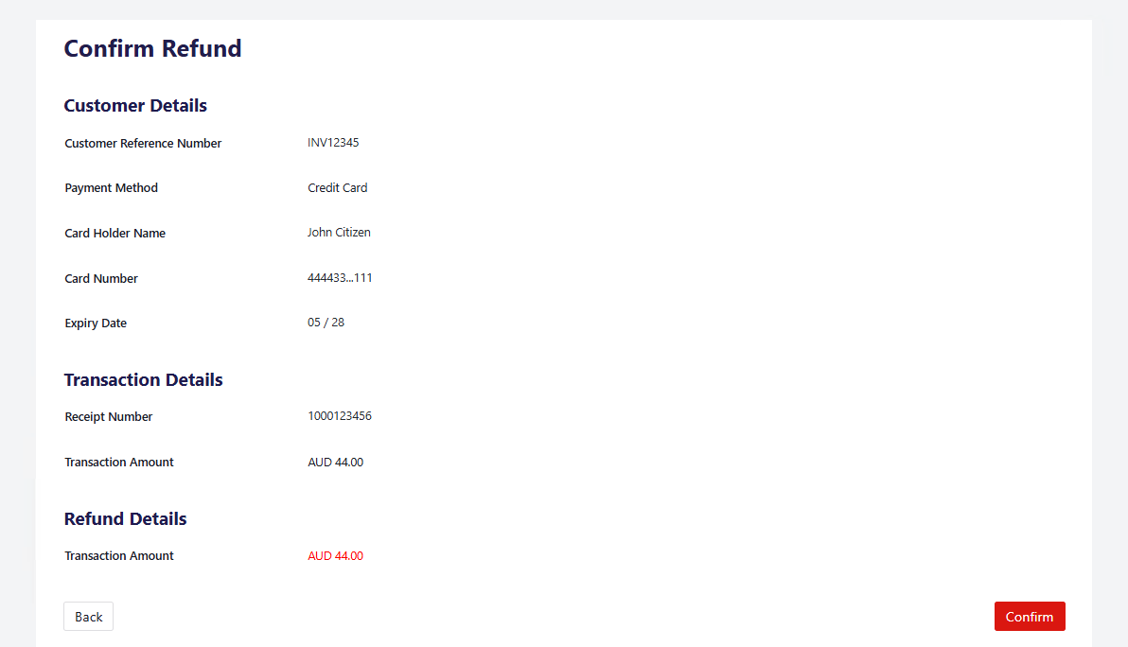
Example: the Confirm Refund screen.
GOOD TO KNOW
Check the receipt number and amount before you confirm.
Refund or void a transaction — continued
04 CHECK THE REFUND RESULT
The Transaction Details screen shows “Refund was successful”. The refund is recorded as a separate transaction with a negative Total Amount, and the original appears under Related Transactions.
A successful refund submission does not mean the customer has already received the funds.
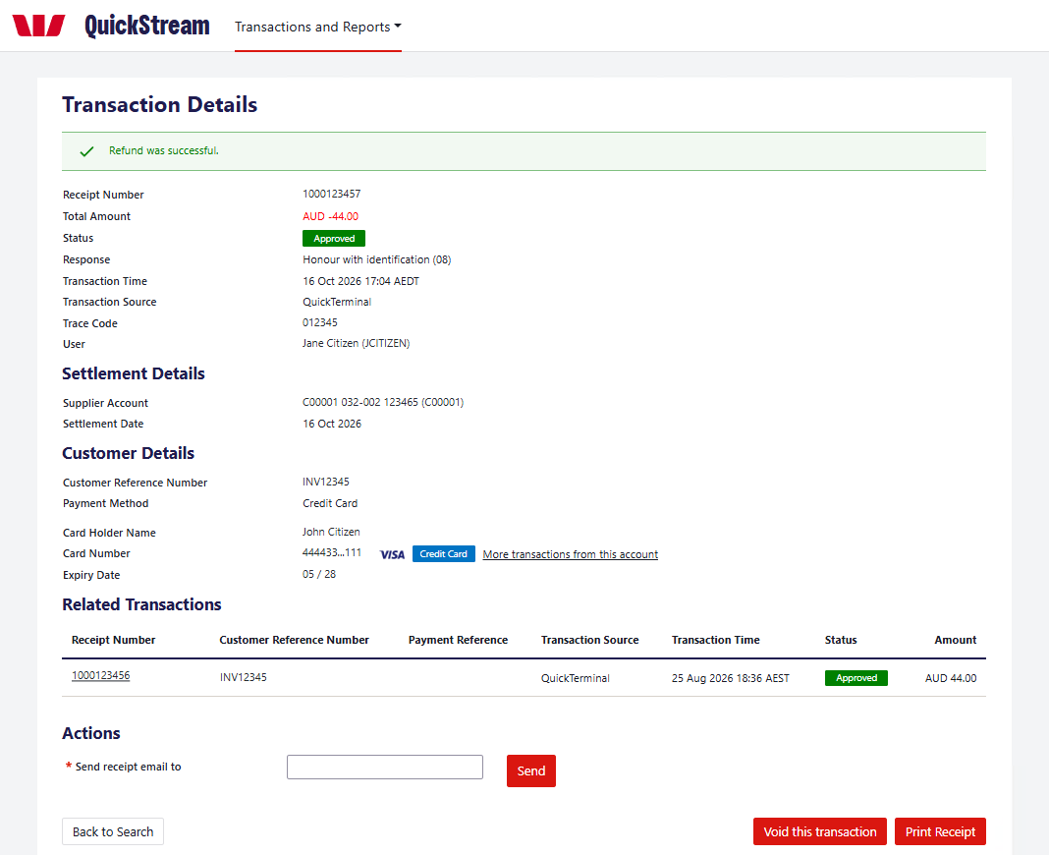
Example: a successful credit card refund.
Refund or void a transaction — continued
05 CONFIRM THE VOID
On the Transaction Details screen, select Void this transaction.
On the Confirm Void screen, check the details and select Confirm Void.
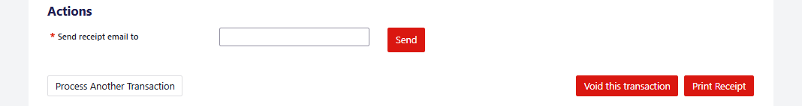
Example: the Void this transaction button.
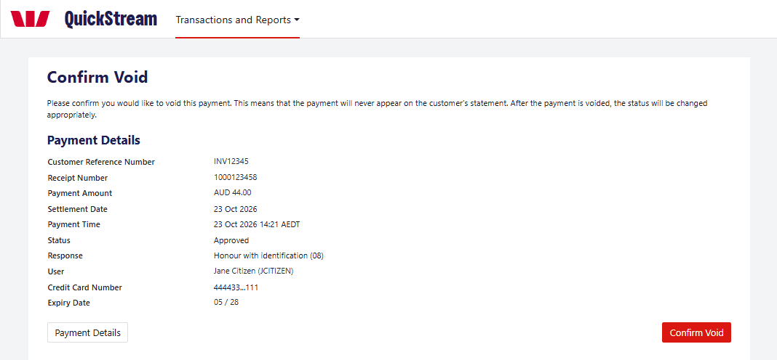
Example: the Confirm Void screen.
06 CHECK THE VOID RESULT
The Transaction Details screen shows “Transaction was successfully voided” and the Status changes to Voided. A voided transaction does not form part of your settlement total.
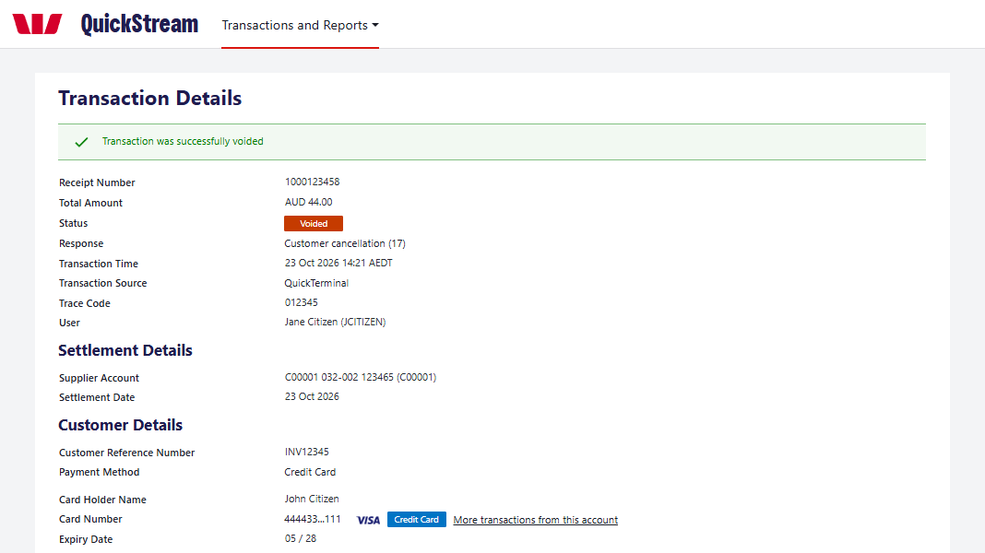
Example: a voided credit card payment.

Export transactions
Generate a transaction report using your chosen criteria.
01 OPEN EXPORT TRANSACTION REPORTS
Select Transactions and Reports > Find Transactions > Export Transaction Reports.
02 CHOOSE CRITERIA
Choose the Date (Time Period or Specific Dates) and the Transaction Status. Choose a Business and Order Type if you need to.
03 GENERATE
Select Generate Report.
04 DOWNLOAD
When the report is ready, download it. If it takes a while, come back later and download it from Recent Exports.
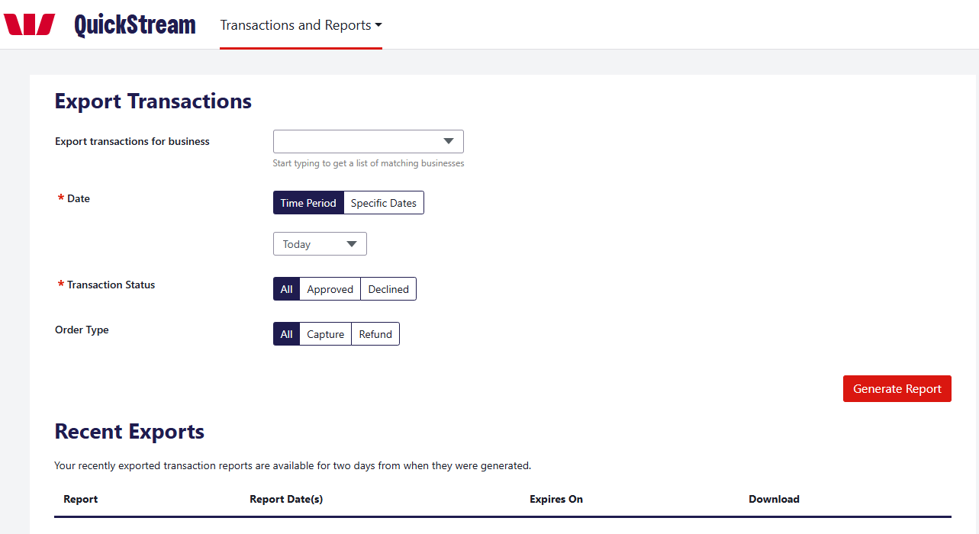
GOOD TO KNOW
Recently exported transaction reports are available for two days from when they were generated.

View daily settlements
View settlement information for a selected day.
01 OPEN DAILY SETTLEMENT
Select Transactions and Reports > Reports > Daily Settlement.
02 CHOOSE A DATE
The previous settlement date is shown by default. To see another day, enter a Settlement Date and select Display, or select a Jump To date.
03 REVIEW OR DOWNLOAD
Review the settlement information and download any available report.
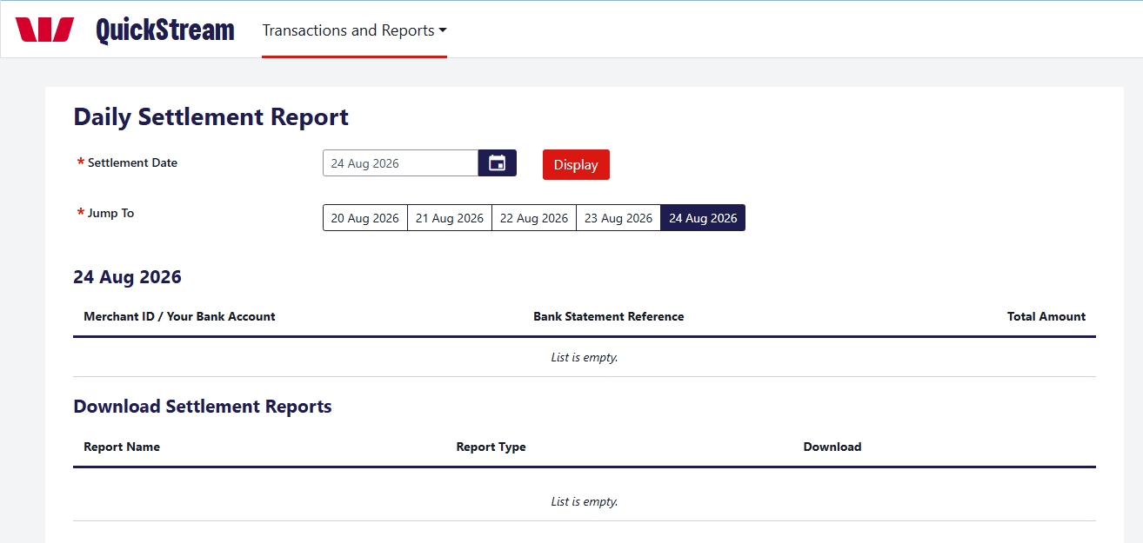
GOOD TO KNOW
Settlement amounts are indicative of how the settlement will appear on your bank statement.

View weekly settlements
Review daily settlements across a selected week.
01 OPEN WEEKLY SETTLEMENT
Select Transactions and Reports > Reports > Weekly Settlement.
02 CHOOSE THE WEEK
Select a Settlement Week and select Display, or use Jump To.
03 OPEN A DAY
Select the View [date] Settlement Report button for the day you need.
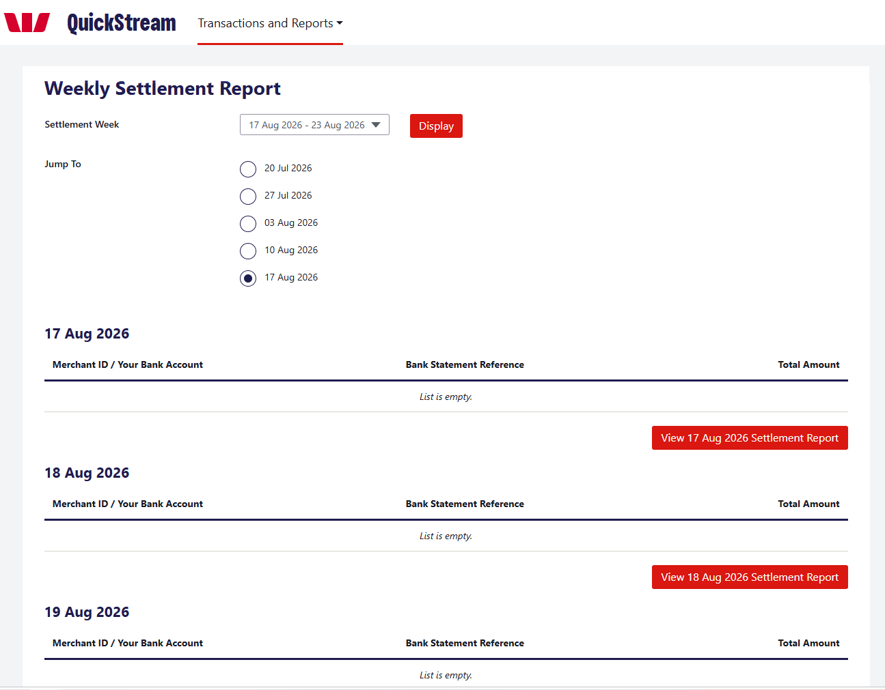
GOOD TO KNOW
Settlement amounts are indicative of how the settlement will appear on your bank statement.

View facility reports
Find and download facility reports.
01 OPEN FACILITY REPORTS
Select Transactions and Reports > Reports > Facility Reports.
02 SET CRITERIA
Choose the Date (required): Time Period or Specific Dates. To narrow the list, choose a Business or enter a Report Name (both optional).
03 VIEW
Select View Reports.
04 DOWNLOAD
Use the Download column for the report you need.
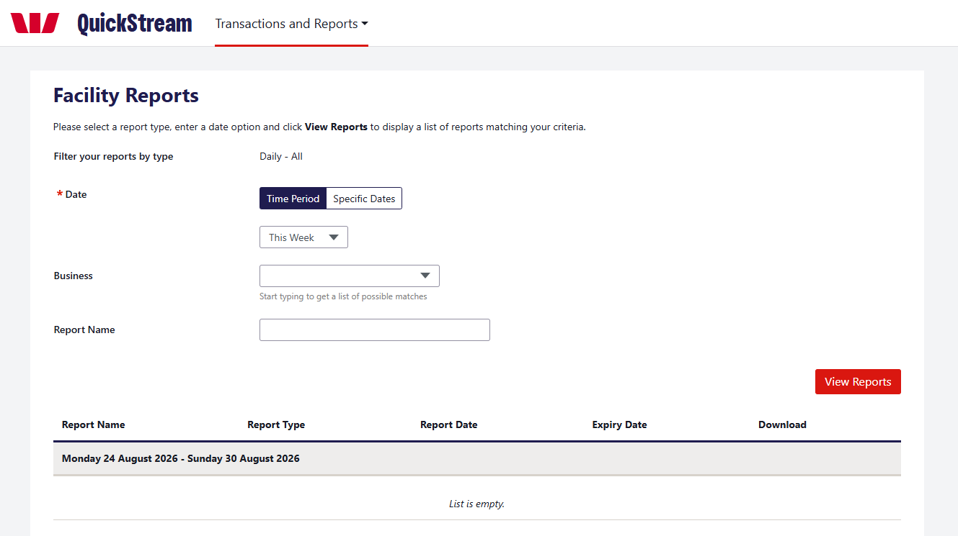

Customers and accounts
Add a customer, then add the account you will take payments from.
Available only if customers and customer accounts are enabled for your organisation and assigned to your user profile.
01 ADD A CUSTOMER
Select Customers > Add a Customer. To find an existing customer, select Customers > Search for Customers.
Enter the Customer Number and Customer Name. Fields marked * are required.
Email and Phone Number are optional. You need an Email only if you switch on Email notifications, and a Phone Number only if you switch on SMS notifications.
Select Save.
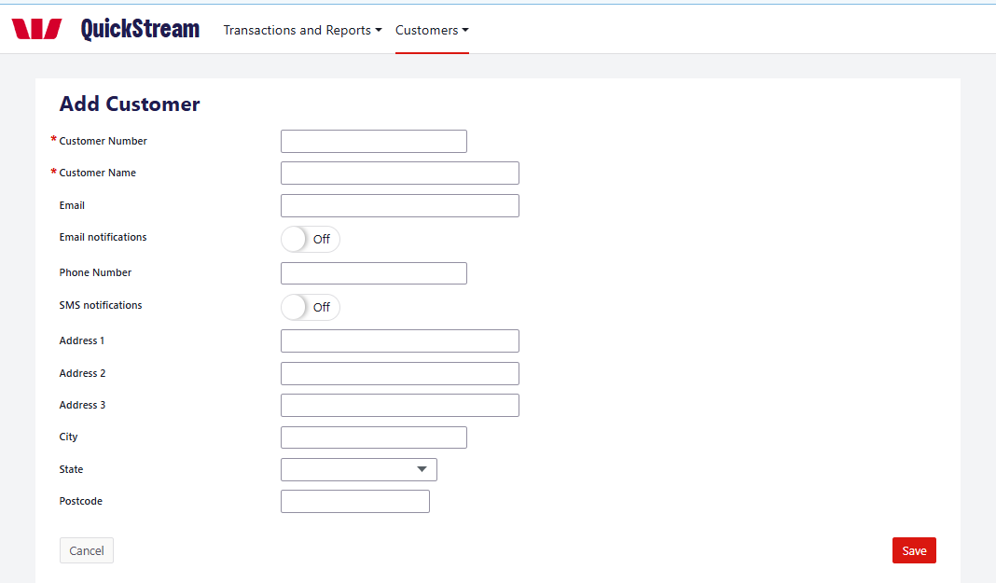
Example: the Add Customer screen.
Customers and accounts — continued
02 ADD A CUSTOMER ACCOUNT
An account is the payment method saved against a customer, such as a credit card. A customer can have more than one.
To add a card account, open the customer, select Add credit card account on the Accounts tab, enter the Card Number and Expiry Date, then select Save.
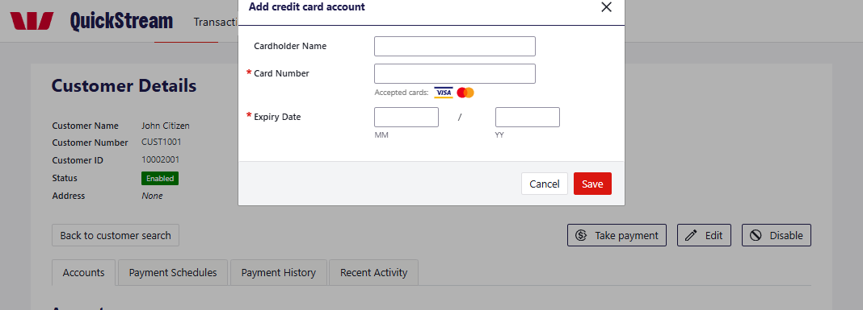
Example: adding a card account.
03 TAKE A PAYMENT FROM AN ACCOUNT
Open the customer and select Take payment. Enter the payment details, then select Next and Confirm.
You can also use the arrow on an account and choose Take payment.
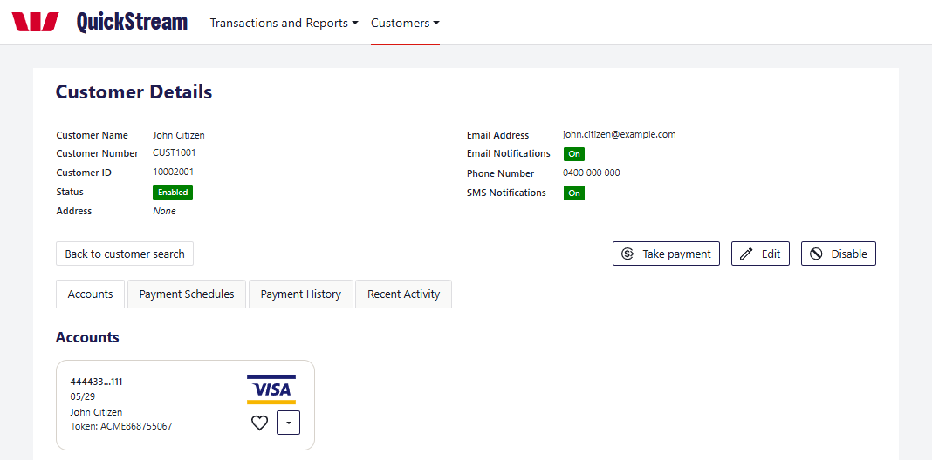
04 EDIT OR DISABLE AN ACCOUNT OR CUSTOMER
Account: use the arrow on the account to choose Edit account details or Disable account. You can change only the cardholder name and expiry date. A disabled account can no longer be used for payments or recurring schedules.
Customer: select Edit to change the customer’s details, or Disable to stop taking payments from them. Read the notice before you confirm, because disabling a customer also affects their payments, accounts and payment schedules.
GOOD TO KNOW
Only add a customer’s account and take payments from it where you have the customer’s authority.

Recurring payments
Take regular payments from a customer’s account on a schedule.
Available only if recurring payments are enabled for your organisation and assigned to your user profile.
01 START A PAYMENT SCHEDULE
Open the customer, select the Payment Schedules tab, then select Add payment schedule.
Choose the Supplier Business and the Customer Account.
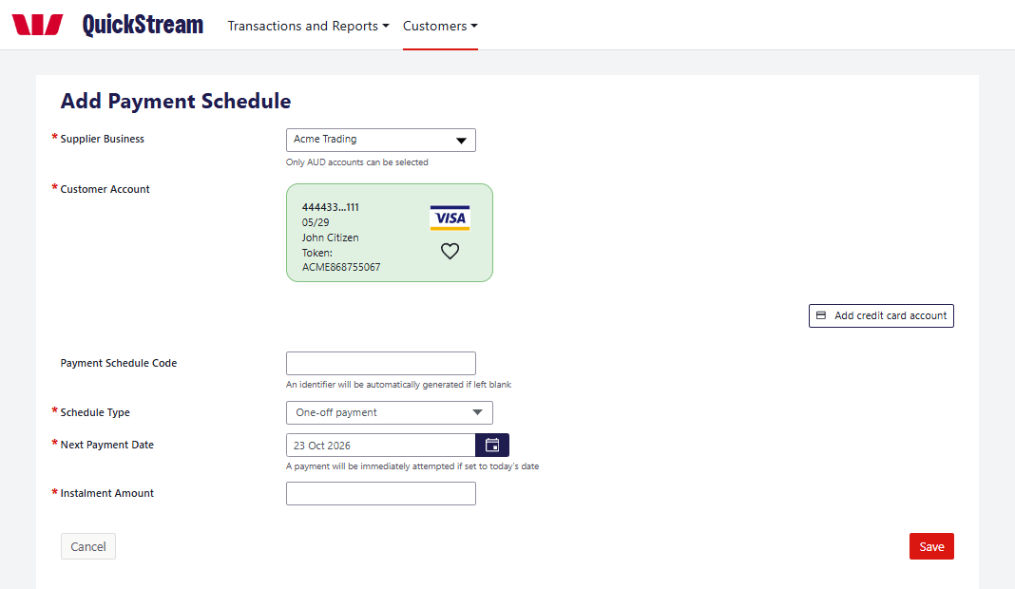
Example: the Add Payment Schedule screen.
02 CHOOSE WHEN PAYMENTS STOP AND HOW OFTEN
Schedule Type decides when payments stop:
• One-off payment: one payment only
• Continue until further notice: payments continue until you stop them
• Stop after a set number of payments: stops after the number you enter
• Stop after total amount paid: stops once the total you enter is reached
• Continue until set date: stops on the date you enter
Frequency decides how often payments are taken: Weekly, Fortnightly, Monthly, Quarterly, Six-Monthly or Yearly. It is not needed for a One-off payment.
03 SET THE FIRST PAYMENT AND SAVE
Enter the Next Payment Date and Instalment Amount, then select Save.
If the Next Payment Date is today, you are asked to confirm, and a payment is attempted straight away.
Recurring payments — continued
04 REVIEW A SCHEDULE
On the Payment Schedules tab, select the schedule to see its Status, Next Payment Date and the payments taken so far.
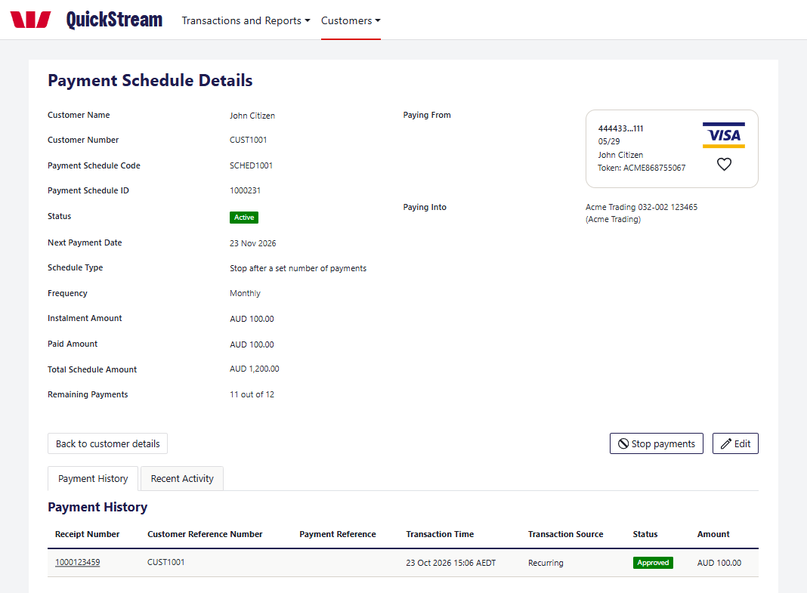
Example: the Payment Schedule Details screen.
05 EDIT OR STOP A SCHEDULE
Select Edit to change the schedule.
Select Stop payments to stop the remaining payments. The Status changes to Stopped.

