Fossil skulls reveal that blood flow rate to the brain increased faster than brain volume during human evolution
Roger S. Seymour,, Vanya Bosiocic and Edward P. Snelling
Supplementary Material
Sources of data for individual specimens
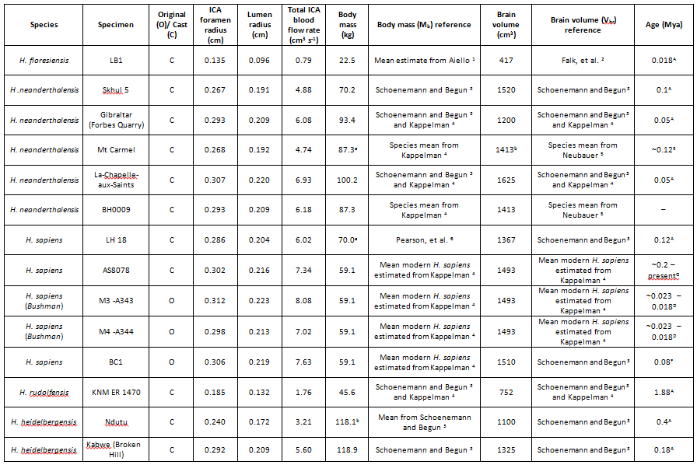
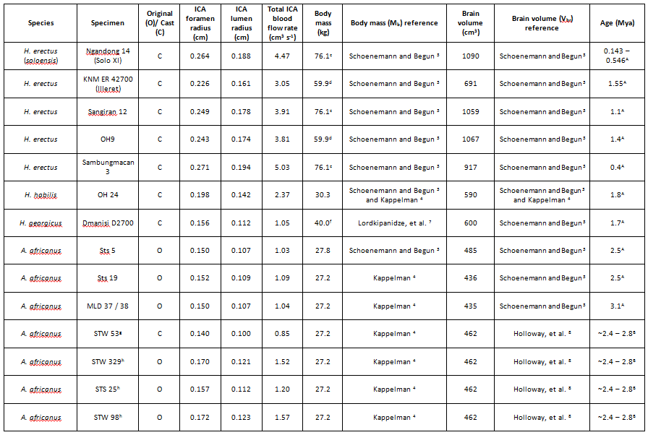
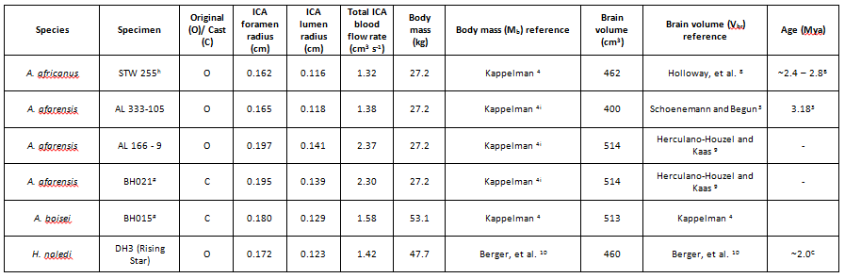

ª body mass of LH 18 derived from Omo 1 due to its physiological resemblance as noted by Magori and Day ¹¹.
^{b} Ndutu individual was based in Tanzania, and so allocated body mass was estimated by averaging the known body masses of two African H. heidelbergensis individuals (Kebwe and Bodo).
^{c} body mass of H. erectus soloensis estimated from Sangiran 17 (due to lack of published data), which shares a common endocrinal volume, geographical habitation and age.
^{d} body mass estimated from known body mass of KNM – WT 15000, which shared common age and geographical habitation, although it is noted that KNM ER 42700 (IIIeret) does have significantly smaller endocrinal volume in comparison to mean endocrinal volume for H. erectus.
^{f} lower estimated endocrinal volume used owing to subadult developmental stage of Dmanisi D2700 as recommended by Lordkipanidze et al. (2007).
^{g} speciation determined from Kuman and Clarke ¹² and Clarke ¹³.
^{h} temporal bone specimen speciated from Braga, et al. ¹⁴.
^{I} body mass of A. afarensis derived from body mass estimate of A. africanus, as Jungers ¹⁵ states mininal differences in body size between Australopithecus taxa.
^{A} specimen age determined from Schoenemann and Begun ³ .
^{B} specimen collection from Sterkfontein Member 4 ¹⁶, and age of specimens identified from McKee, et al. ¹⁷.
^{C} specimen age approximated from Berger et al ¹⁰.
^{D “}Bushman – oids” specimens of Mumbwa strata IV aged according to Protsch ¹⁸.
^{E} specimen age according to Mercier et al. (1993).
^{F} specimen age according to Lahr ¹⁹.
^{G} mean species age according to Trinkaus ²⁰.
# cast number from the South Australian Museum.

Supplementary References
1 Aiello, L. C. Five years of Homo floresiensis. Am. J. Phys. Anthropol. 142, 167-179 (2010).
2 Falk, D. et al. Brain shape in human microcephalics and Homo floresiensis. Proc. Natl. Acad. Sci. U. S. A. 104, 2513-2518 (2007).
3 Schoenemann, P. T. & Begun, D. in A Companion to Paleoanthropology 136-164 (Blackwell Publishing Ltd., 2013).
4 Kappelman, J. The evolution of body mass and relative brain size in fossil hominids. J. Hum. Evol. 30, 243-276 (1996).
5 Neubauer, F. A brief overview of the last 10 years of major late pleistocene discoveries in the Old World: Homo floresiensis, neanderthal, and denisovan. Journal of Anthropology 2014, 7 (2014).
6 Pearson, O. M., Royer, D. F., Grine, F. E. & Fleagle, J. G. A description of the Omo I postcranial skeleton, including newly discovered fossils. J. Hum. Evol. 55, 421-437 (2008).
7 Lordkipanidze, D. et al. Postcranial evidence from early Homo from Dmanisi, Georgia. Nature 449, 305-310 (2007).
8 Holloway, R. L., Broadfield, D. C. & Yuan, M. S. in The Human Fossil Record 295-301 (John Wiley & Sons, Inc., 2005).
9 Herculano-Houzel, S. & Kaas, J. H. Gorilla and orangutan brains conform to the primate cellular scaling rules: implications for human evolution. Brain, behavior and evolution 77, 33-44 (2011).
10 Berger, L. R. et al. Homo naledi, a new species of the genus Homo from the Dinaledi Chamber, South Africa. Elife 4, e09560 (2015).
11 Magori, C. C. & Day, M. H. Laetoli Hominid 18: an early Homo sapiens skull. J. Hum. Evol. 12, 747-753, doi:http://dx.doi.org/10.1016/S0047-2484(83)80130-4 (1983).
12 Kuman, K. & Clarke, R. J. Stratigraphy, artefact industries and hominid associations for Sterkfontein, Member 5. J. Hum. Evol. 38, 827-847 (2000).
13 Clarke, R. Latest information on Sterkfontein's Australopithecus skeleton and a new look at Australopithecus. South African Journal of Science 104, 443-449 (2008).
14 Braga, J. et al. A new partial temporal bone of a juvenile hominin from the site of Kromdraai B (South Africa). J. Hum. Evol. 65, 447-456 (2013).
15 Jungers, W. L. New estimates of body size in australopithecines. Evolutionary history of the “robust” australopithecines, 115-125 (1988).
16 Pickering, T. R., Clarke, R. J. & Moggi-Cecchi, J. Role of carnivores in the accumulation of the Sterkfontein Member 4 hominid assemblage: A taphonomic reassessment of the complete hominid fossil sample (1936–1999). Am. J. Phys. Anthropol. 125, 1-15, doi:10.1002/ajpa.10278 (2004).
17 McKee, J. K., Thackeray, J. F. & Berger, L. R. Faunal assemblage seriation of southern African Pliocene and Pleistocene fossil deposits. Am. J. Phys. Anthropol. 96, 235-250 (1995).
18 Protsch, R. Mumbwa: Its absolute chronology and archaeology. Z. Morphol. Anthropol. 68, 1-7 (1977).
19 Lahr, M. M. Genetics and fossil evidence from modern human origins. (Oxford University Press, 2013).
20 Trinkaus, E. Early modern humans. Annu. Rev. Anthropol. 34, 207-230, doi:10.1146/annurev.anthro.34.030905.154913 (2005).

