1) What is the channel shown in the image?
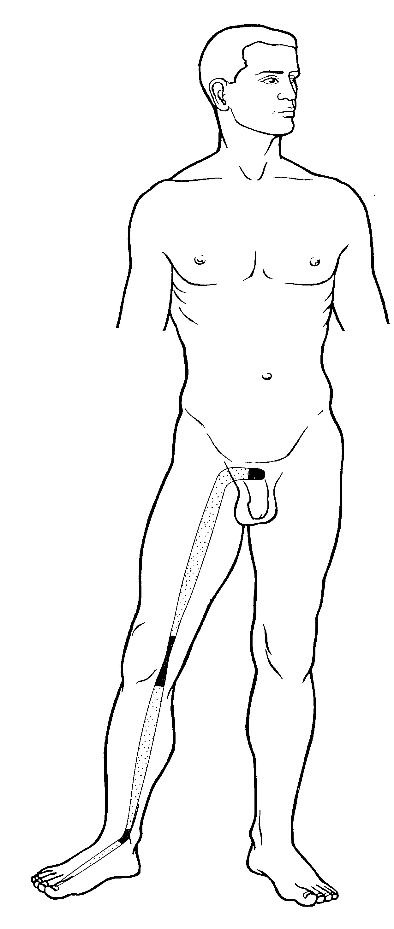
- Liver sinew channel +++++
- Liver divergent channel
- Spleen divergent channel
- Bladder luo-connecting channel
Feedback: The broad superficial pathway follows the Liver sinew channel. Its musculotendinous course and binding pattern distinguish it from a deep divergent route or a luo-connecting branch.
2) What is the channel shown in the image?
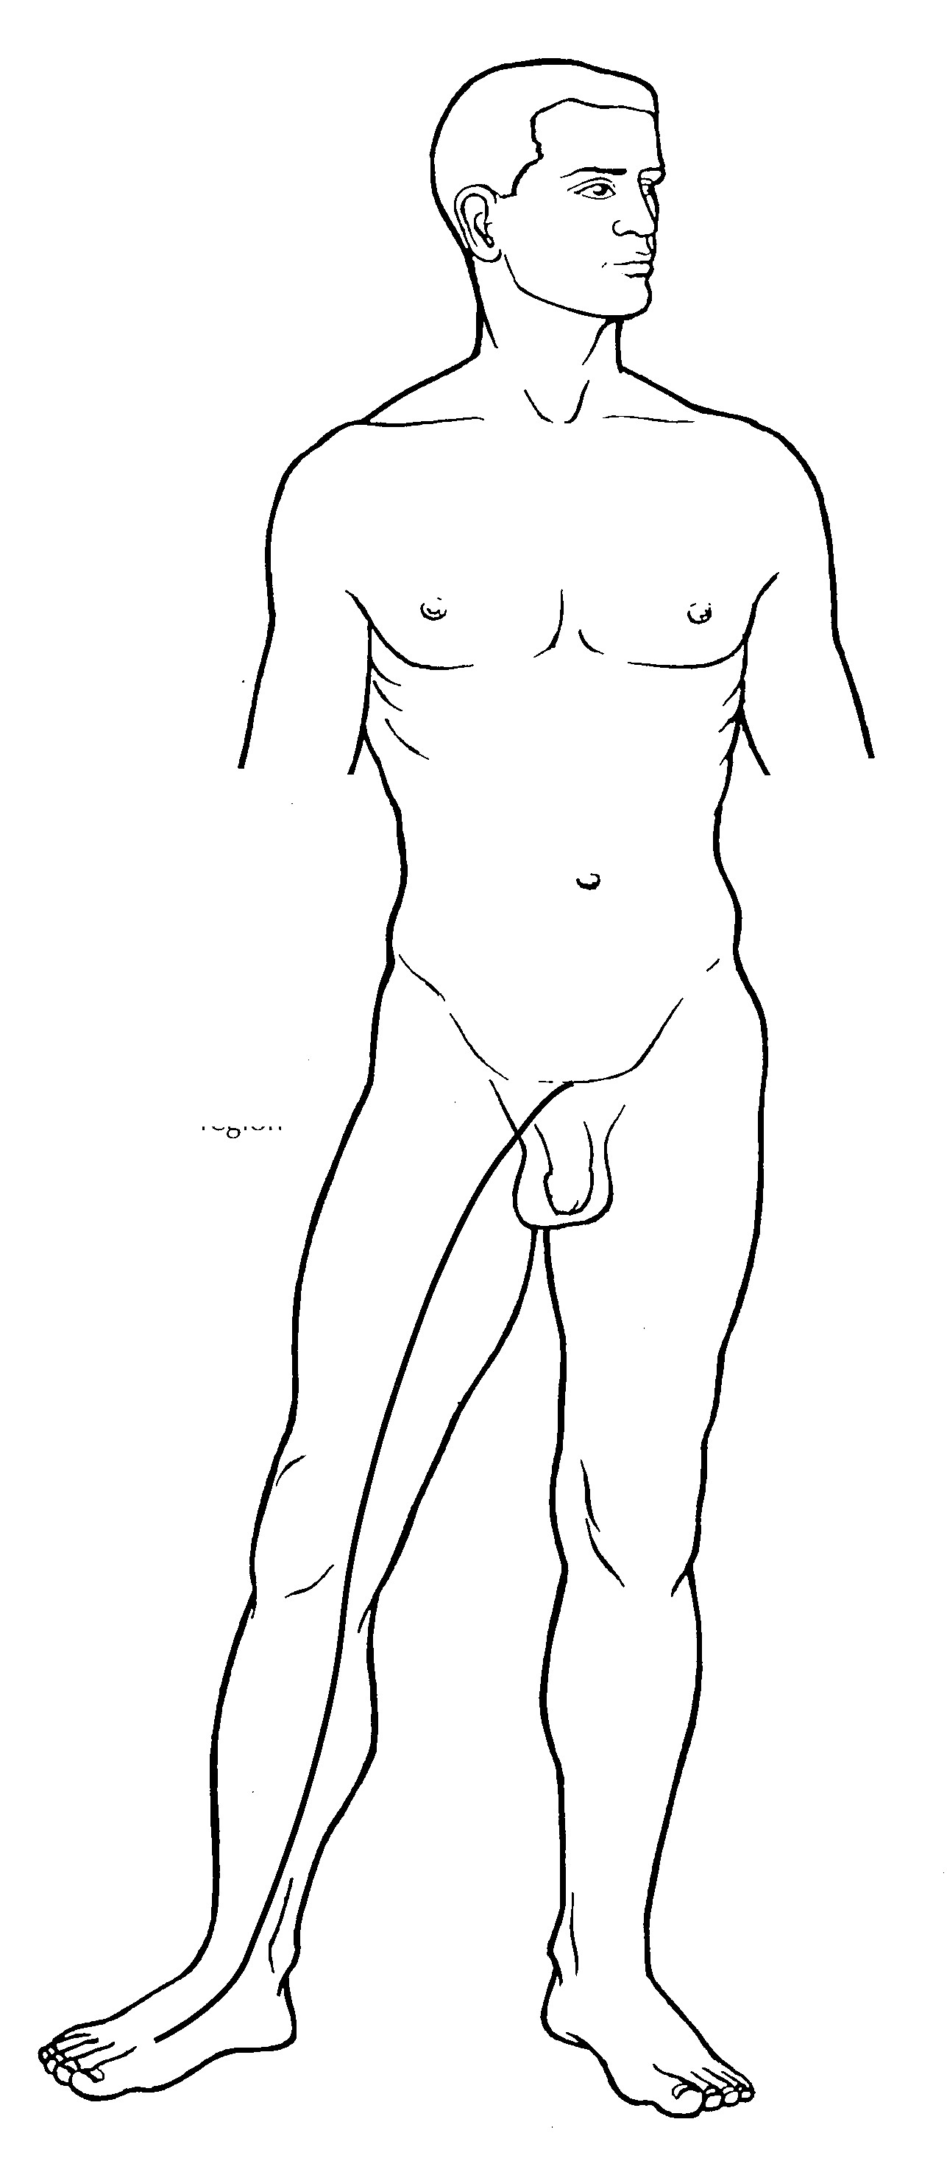
- Liver sinew channel
- Liver divergent channel +++++
- Kidney divergent channel
- Liver luo-connecting channel
Feedback: The pathway represents the Liver divergent channel. Its deep internal course and relationship with the paired Gall Bladder divergent pathway separate it from the superficial sinew and luo-connecting systems.
3) What is the channel shown in the image?
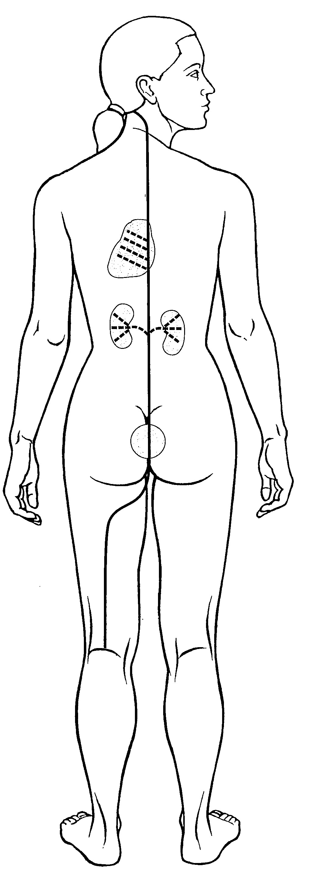
- Liver sinew channel
- Gall Bladder divergent channel
- Bladder divergent channel +++++
- Bladder luo-connecting channel
Feedback: The illustrated deep pathway is the Bladder divergent channel. Its separation from the primary pathway and internal connection with the Kidney system distinguish it from a short luo branch or a superficial sinew channel.
4) What is the channel shown in the image?
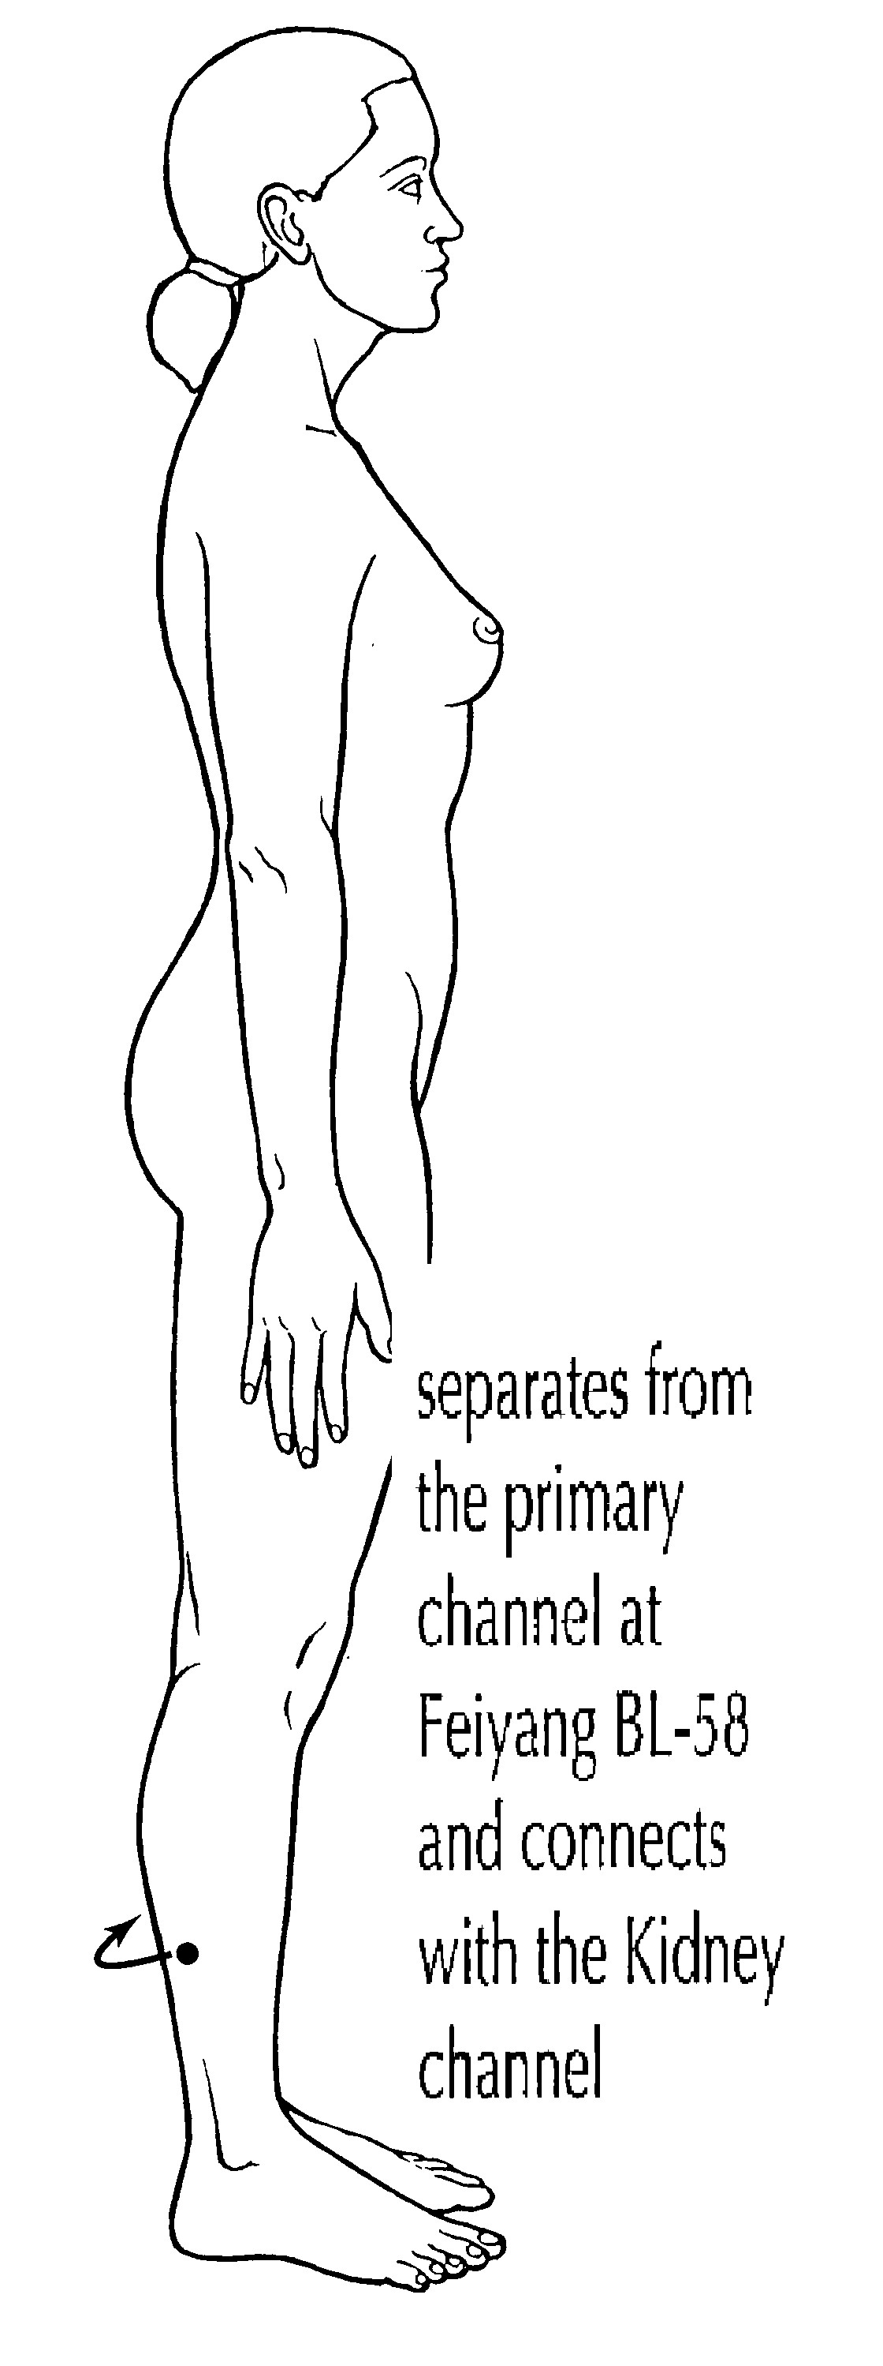
- Liver sinew channel
- Liver divergent channel
- Bladder divergent channel
- Bladder luo-connecting channel +++++
Feedback: The branch represents the Bladder luo-connecting channel. Its origin at the Bladder luo point and connection with the paired Kidney channel identify the luo-connecting system.
5) What is the channel shown in the image?
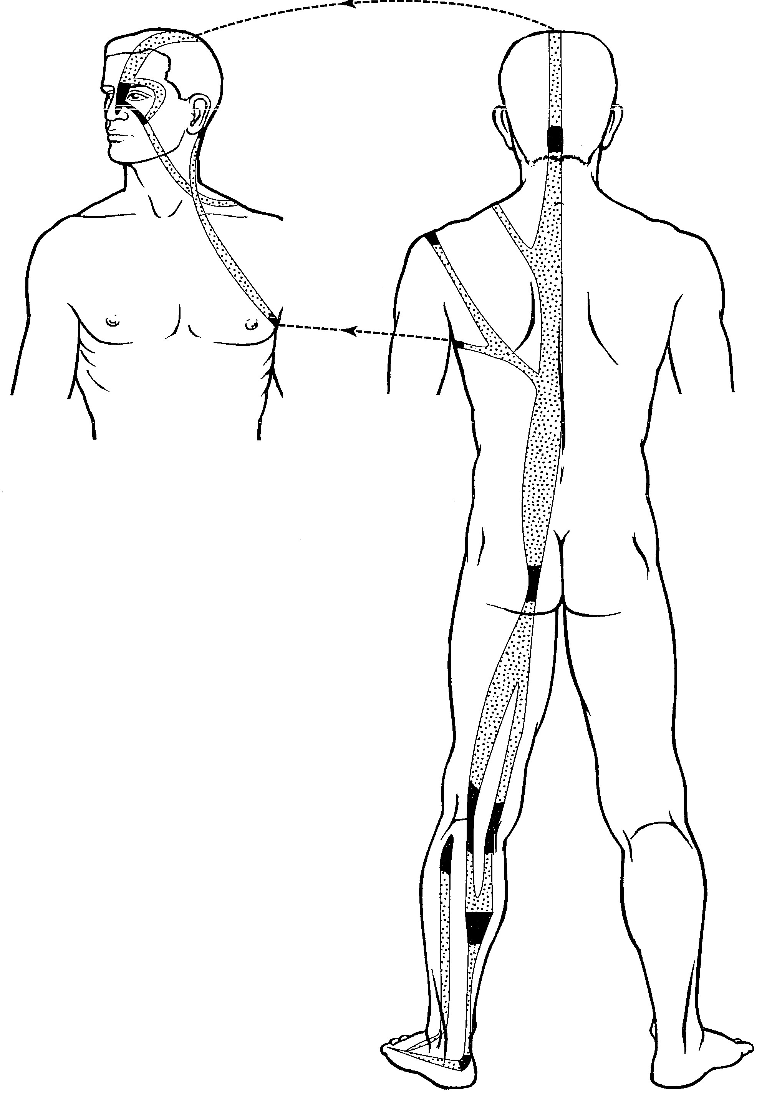
- Bladder sinew channel +++++
- Liver divergent channel
- Bladder divergent channel
- Bladder luo-connecting channel
Feedback: The broad posterior musculotendinous pathway is the Bladder sinew channel. Multiple binding regions and a superficial route distinguish it from the deeper Bladder divergent channel and the more limited luo branch.
6) What is the channel shown in the image?
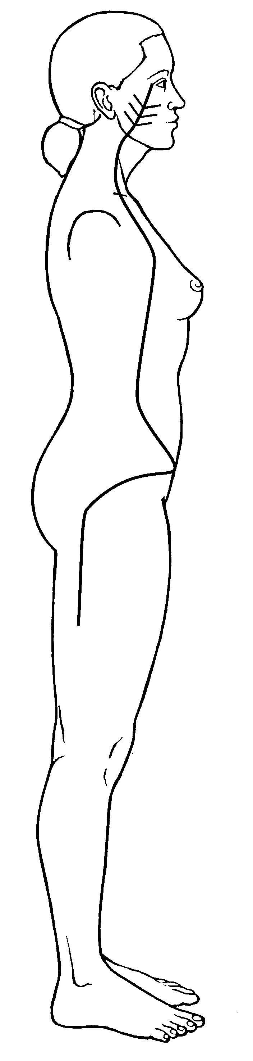
- Bladder sinew channel
- Bladder divergent channel
- Bladder luo-connecting channel
- Gall Bladder divergent channel +++++
Feedback: The pathway is the Gall Bladder divergent channel. Its deep route and convergence pattern with the paired Liver divergent channel distinguish it from the Bladder pathways.
7) What is the channel shown in the image?
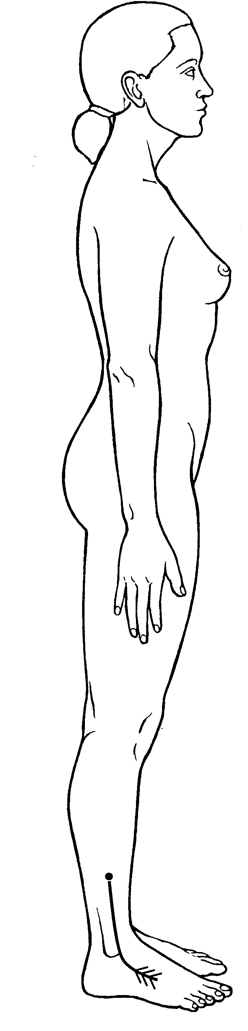
- Gall Bladder luo-connecting channel +++++
- Bladder divergent channel
- Bladder luo-connecting channel
- Gall Bladder divergent channel
Feedback: The image shows the Gall Bladder luo-connecting channel. Its localized connecting branch from the Gall Bladder luo point distinguishes it from the deeper divergent pathways.
8) What is the channel shown in the image?
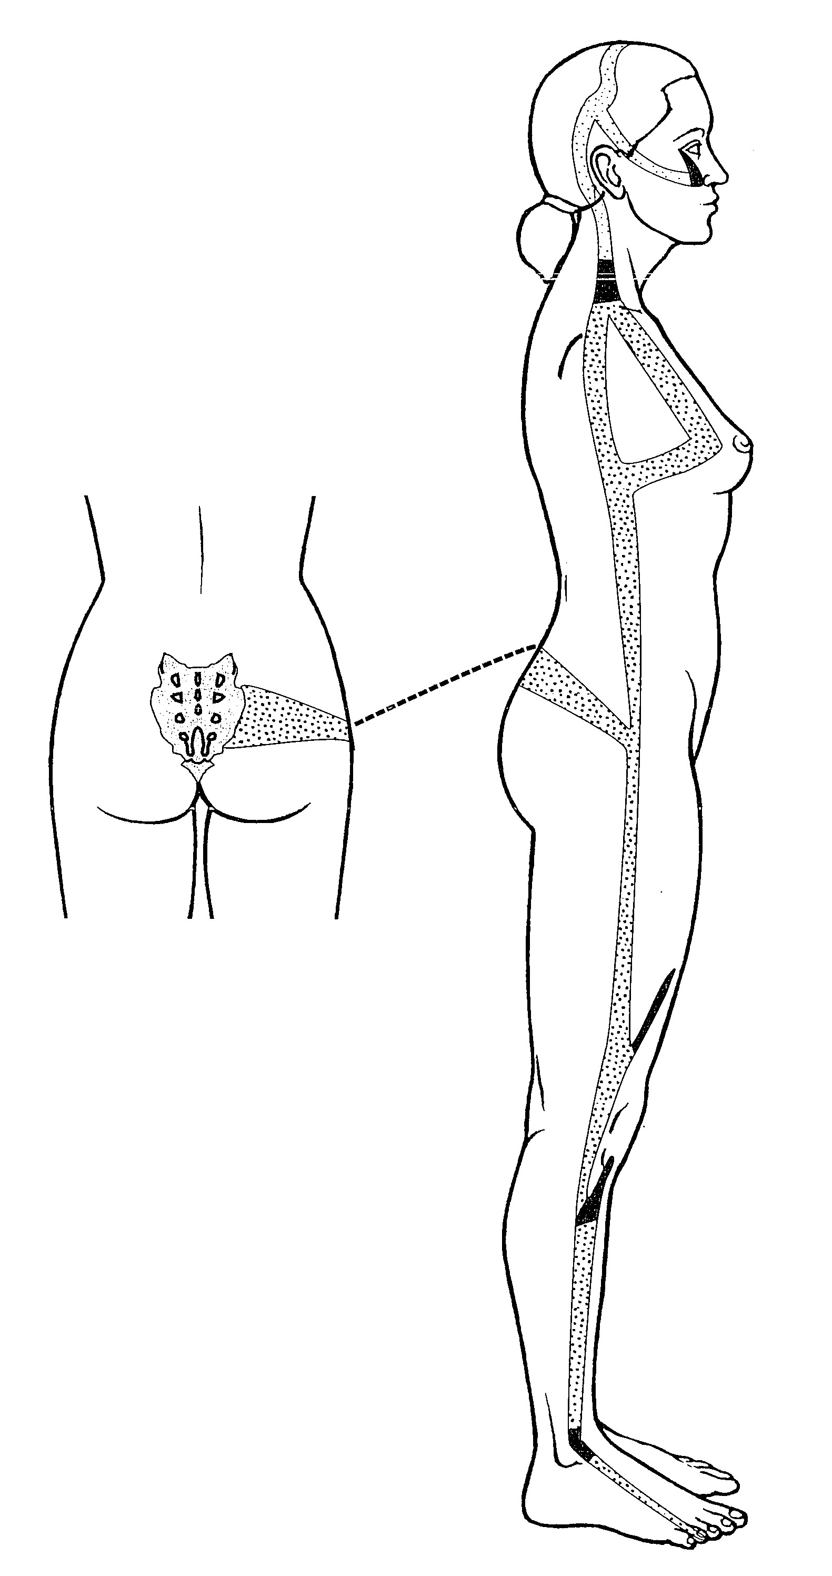
- Gall Bladder luo-connecting channel
- Gall Bladder sinew channel +++++
- Bladder luo-connecting channel
- Gall Bladder divergent channel
Feedback: The superficial lateral musculotendinous route is the Gall Bladder sinew channel. Its broad binding pattern differentiates it from the narrow luo branch and the deep divergent pathway.
9) What is the channel shown in the image?
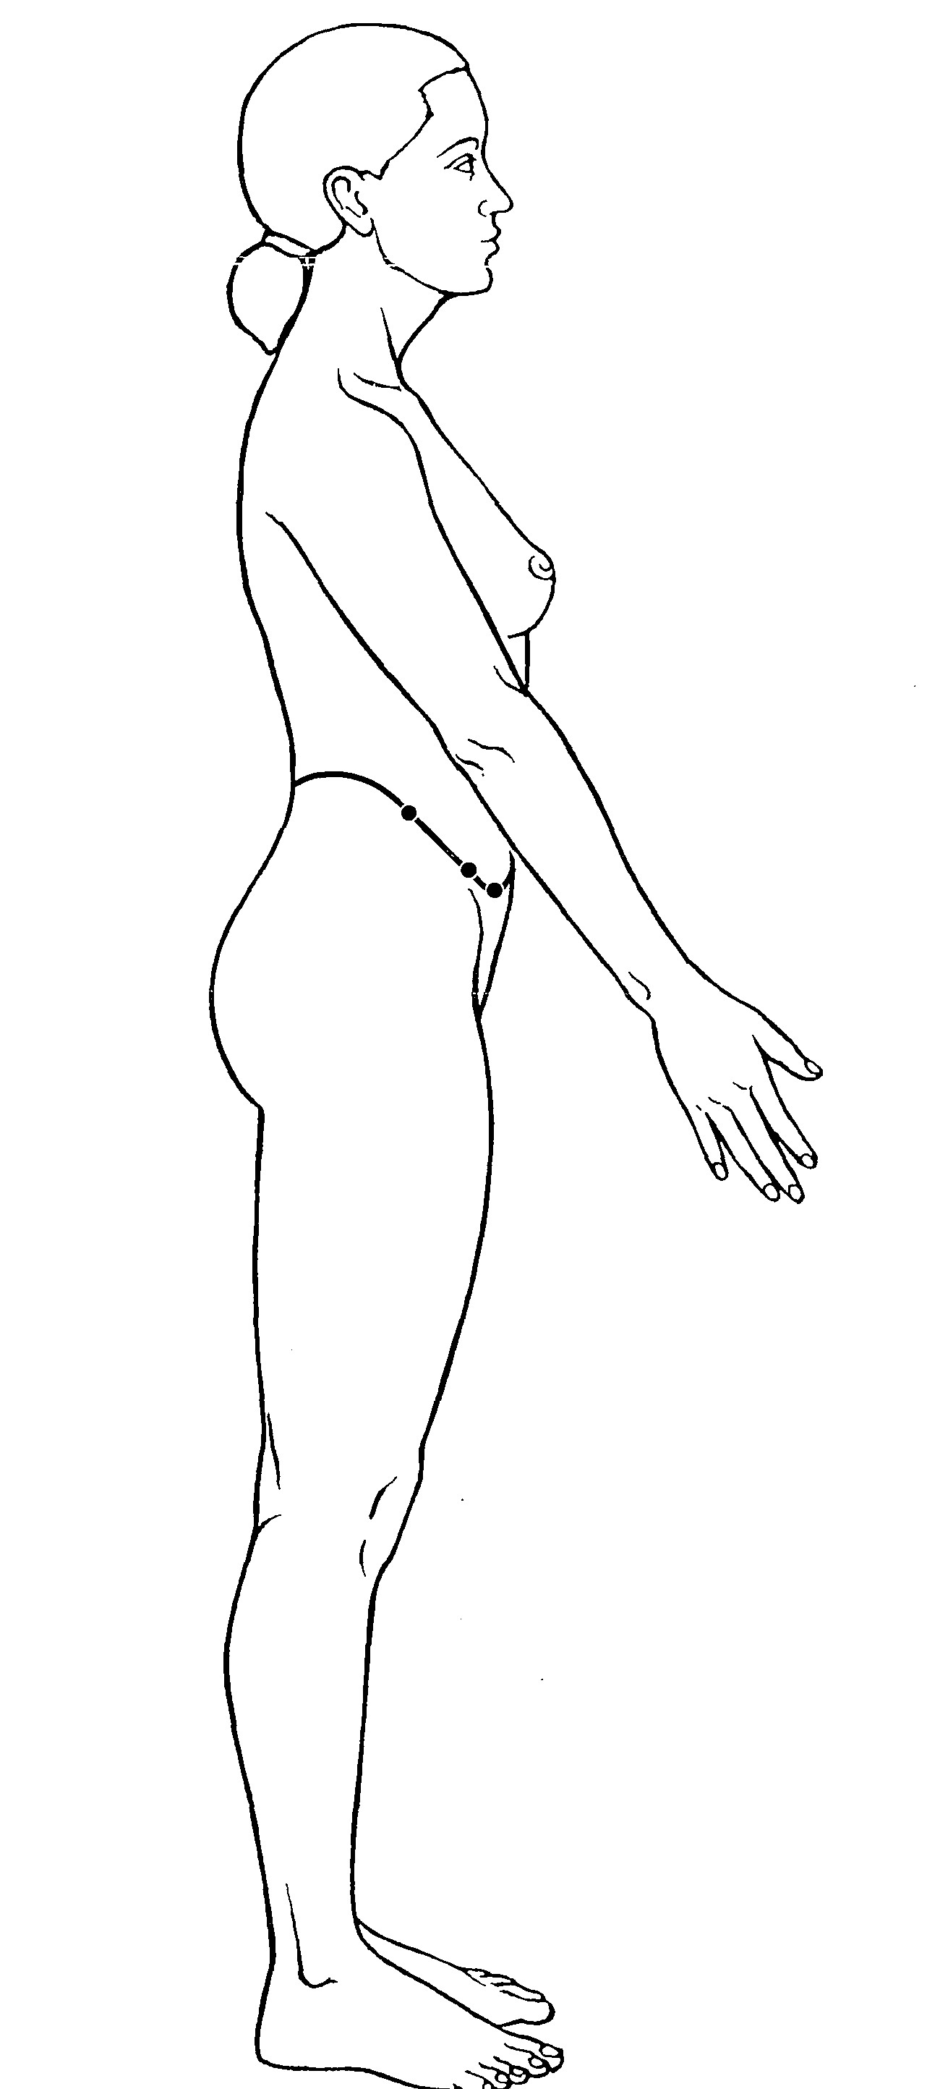
- Gall Bladder luo-connecting channel
- Gall Bladder sinew channel
- Girdling Vessel +++++
- Gall Bladder divergent channel
Feedback: The transverse pathway encircling the waist identifies the Girdling Vessel. This horizontal course is unlike the primarily longitudinal trajectories of the Gall Bladder systems.
10) What is the channel shown in the image?
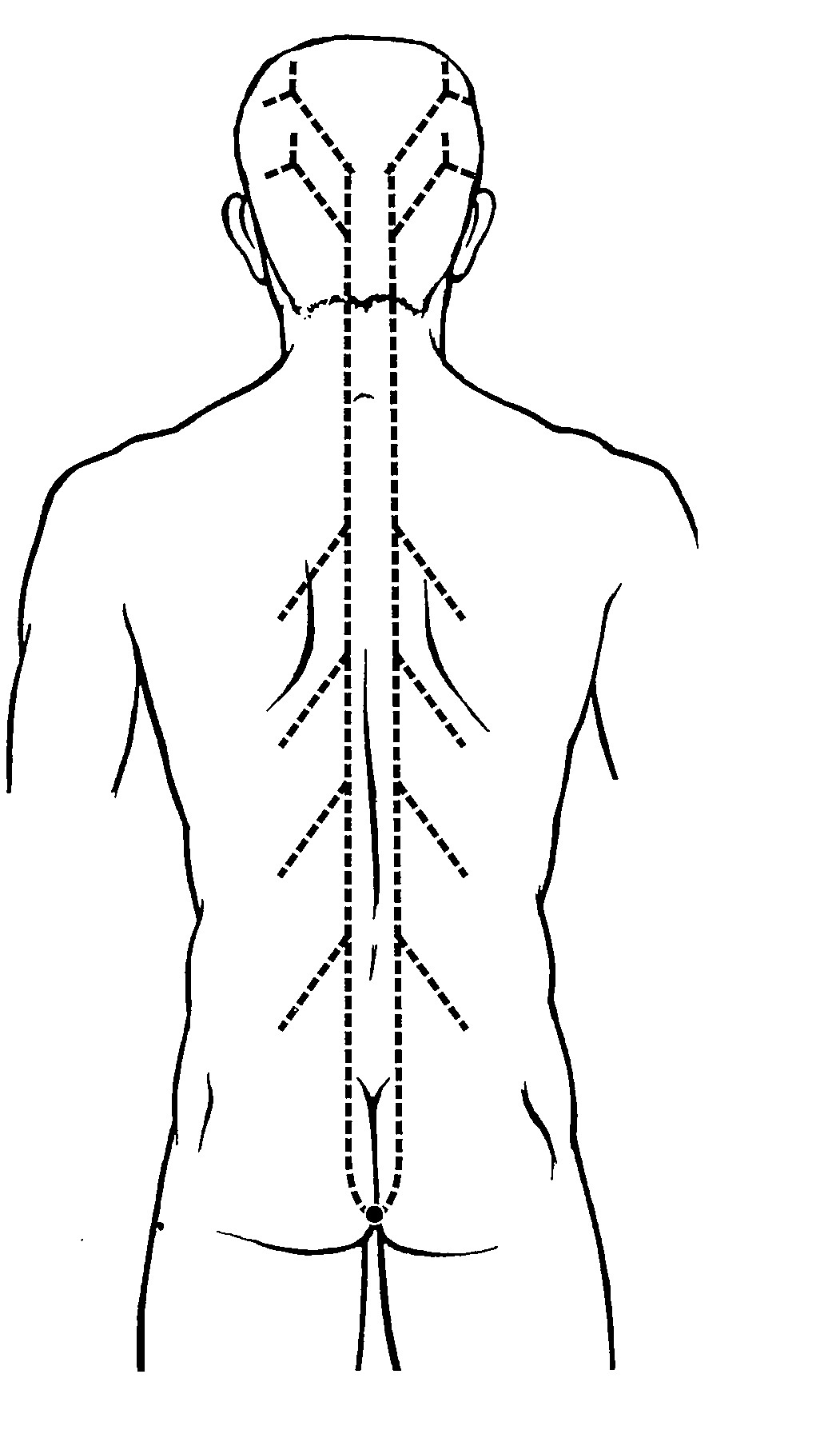
- Gall Bladder luo-connecting channel
- Gall Bladder sinew channel
- Girdling Vessel
- Governing luo-connecting vessel +++++
Feedback: The posterior midline connecting pathway identifies the Governing luo-connecting vessel. Its relationship to the Governing Vessel separates it from the transverse Girdling Vessel and the lateral Gall Bladder routes.

