Channel Pathways — Part 4: Continuing Education Learning Plan
Table of Contents

Channel Pathways — Part 4: Continuing Education Learning Plan
Acupuncture & Point Location — Channel Pathway Identification
Continuing Education Learning Plan — Channel Pathway Identification
This structured plan organizes the Continuing Education learning path. The certificate is issued only after the mandatory module examination is completed; recognition of Continuing Education credit remains subject to applicable approval requirements.
DOWNLOADABLE COURSE DOCUMENT

Complete Continuing Education Course Summary
Download the editable Word document with the course overview, objectives, instructional plan, mnemonics, assessment requirements, references and the complete Anatomical Region Atlas appendix.
Download Word Summary ↓
CONTINUING EDUCATION · COURSE OVERVIEW

Channel Pathway Identification and Comparison
This self-paced learning plan develops a repeatable method for distinguishing Primary, Divergent, Luo-Connecting and Sinew pathways, together with selected Extraordinary Vessels. The emphasis is visual identification supported by anatomical landmarks, channel-system characteristics and source-based comparison.
DeliveryOnline · asynchronous · self-paced
Planning time3 hours · mandatory exam time to be added
CE credits3 credits · whole credits only
CertificateIssued after the mandatory module exam
CE ESSENTIALS · VISUAL SUMMARY

The evidence that matters most
Use this overview to connect the twelve objectives before completing the mandatory Continuing Education examination.
3 CE
credits
12learning objectives
5channel systems
53anatomical regions
1mandatory final exam
1OrientIdentify the body region.
→
2ClassifyName the channel system.
→
3TraceFollow origin to destination.
→
4ConfirmUse two landmarks.
→
5DefendReject the closest alternative.
Primary reference map. Learn the four directional groups first; use them as the positional framework for comparing every other channel system.
SAME FAMILY · DIFFERENT SYSTEM

Bladder pathways demonstrate why the system must be identified first
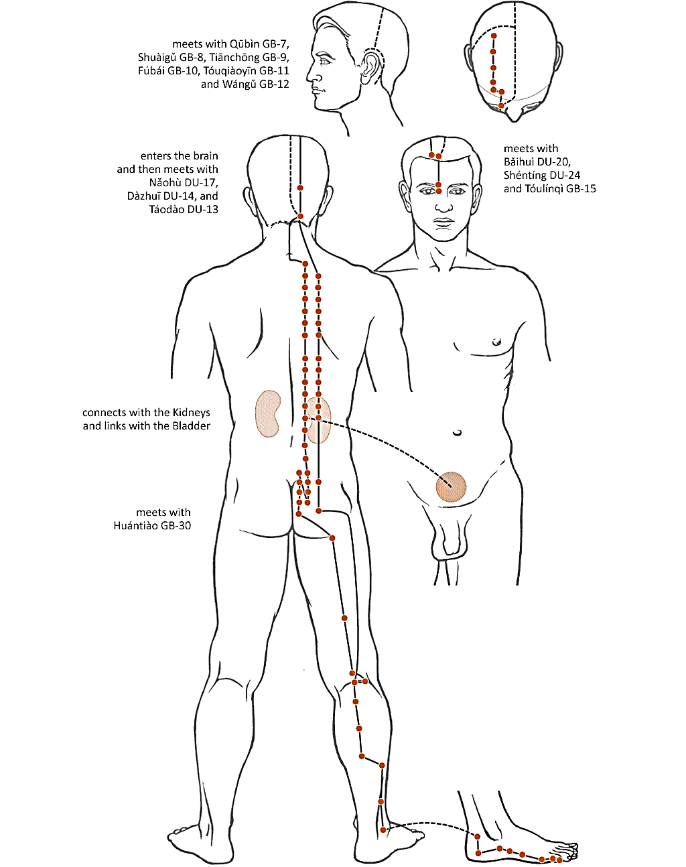
PrimaryComplete point-bearing route with brain, Kidney and Bladder relationships.
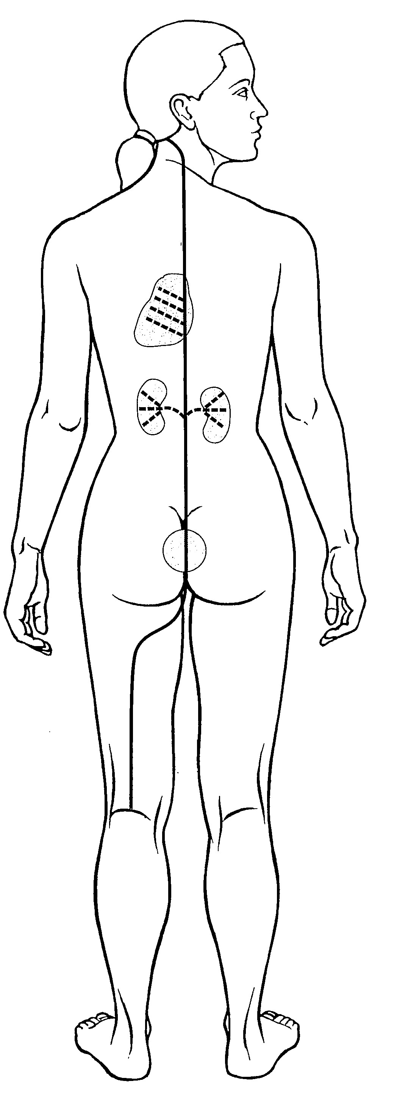
DivergentDeep paired zangfu course that separates, enters and converges.
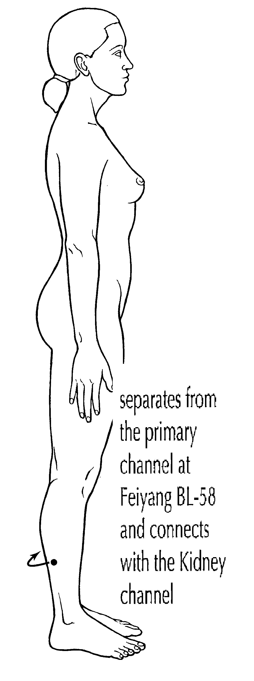
Luo-ConnectingCollateral from BL-58 toward the paired Kidney channel.
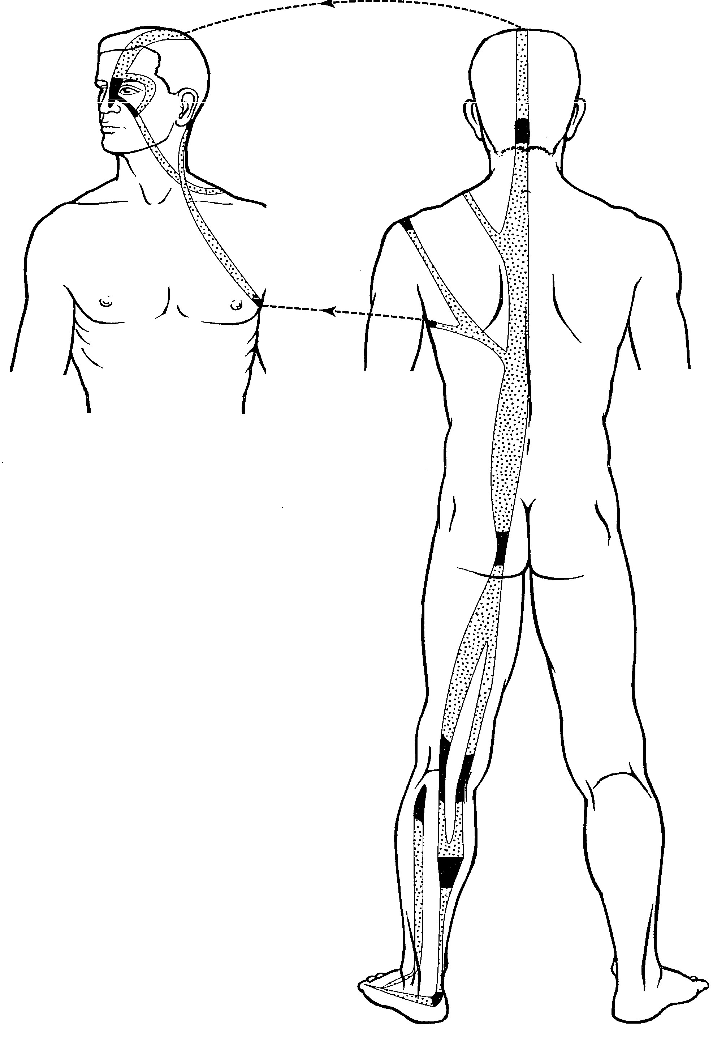
SinewBroad posterior chain with superficial binding regions.
Channel system | Organizing pattern | High-yield action words | Best confirming evidence
Primary | Complete external route with internal branches | Begins · ascends · descends · enters | Direction, limb position and two characteristic landmarks
Divergent | Deep Yin–Yang paired pathway | Separates · enters · emerges · converges | Paired zangfu relationship and region of re-emergence
Luo-Connecting | Branch from a named Luo point | Connects · disperses · reaches | Luo origin, paired channel and distinctive destination
Sinew | Superficial musculotendinous chain | Binds · spreads · converges | Distal origin, joint bindings and absence of zangfu penetration
Extraordinary | Distinctive central, transverse, medial or lateral geometry | Girdles · links · ascends · encircles | Overall shape confirmed by named landmarks
Completion ruleThe certificate and 3 CE credits are awarded only after completion of the mandatory module examination. Practice exams, flashcards and self-tests remain optional study resources.
CERTIFICATE PREVIEW

Your Continuing Education Certificate
Issued after the mandatory module exam
ATACUPUNCTURETESTS.COM
Certificate of Completion
This certifies that
Student Name
has successfully completed the Continuing Education course

Channel Pathway Identification and Comparison
3 CE CreditsCredits earned
Completion DateDate completed
Certificate IDVerification number
Course Instructor
3CE
Credits
Program Director
Preview: the final personalized certificate is issued only after the mandatory Continuing Education module examination is completed. All other exams are optional.

Learner Objectives and Learning Plan
The current 180-minute learning plan equals 3 Continuing Education credits. Partial hours are always rounded down to the next lower whole credit. The mandatory examination time will be added when its final duration is established.
Learner Objectives | Subject Matter | Teaching Method | Estimated Time
1. Identify the pathway and relative position of the Twelve Primary Channels. | Hand/Foot, Yin/Yang, anterior–middle–posterior position, external course and selected internal landmarks. | Labeled pathway atlas, positional map, comparative reading and guided recall. | 15 minutes
2. Identify the pathways and connections of the Twelve Divergent Channels. | Separation, deep entry, zangfu relationship, Yin–Yang pairing, convergence and re-emergence. | Pattern comparison, paired-channel reasoning and visual identification. | 15 minutes
3. Identify the origin, connection and destination of the Luo-Connecting Channels. | Luo point of origin, paired-channel connection and characteristic continuation. | Origin-to-destination method, route clues and image comparison. | 15 minutes
4. Identify the pathways and binding regions of the Twelve Sinew Channels. | Distal origin, limb surface, binding regions and terminal distribution. | Four-group organization, body-chain tracing and visual recognition. | 15 minutes
5. Recognize selected Extraordinary Vessels by their pathway pattern. | Transverse, central, lateral, medial, motility and linking patterns represented in this chapter. | Defining-shape comparison, pathway landmarks and mixed visual practice. | 15 minutes
6. Differentiate pathways from the same organ family across channel systems. | Primary, Divergent, Luo and Sinew organization compared within shared anatomical areas such as heel, spine and genitals. | Same-family matrices, action-word contrasts, anatomical atlas lookup and reverse-recall flashcards. | 15 minutes
7. Distinguish visually similar pathways across different channel systems. | Look-alike routes separated by exact area, surface, depth, direction, binding, origin, destination and geometry. | Regional comparison of eye, knee, mouth and other high-overlap areas; distractor elimination and landmark verification. | 15 minutes
8. Justify a mixed pathway identification using system evidence and two landmarks. | Integrated interpretation using anatomical area, action word, channel-system evidence and two independent landmarks. | Locate–Classify–Confirm–Justify method, region flashcards, evidence statements and error review. | 15 minutes
9. Organize channel relationships by anatomical region and body surface. | Head and neck, upper limb, thorax and back, abdomen and pelvis, lower limb and internal-organ zones. | Searchable anatomical atlas, zone filters, region-first sorting and reverse retrieval. | 15 minutes
10. Analyze internal-organ, cavity and diaphragm relationships. | Routes that enter, connect, traverse, disperse, originate or pass through internal structures. | Action-verb comparison, internal-route mapping and exception analysis. | 15 minutes
11. Compare major convergence and transition landmarks. | DU-14, BL-1, LI-15, GB-30, the supraclavicular fossa and other shared pathway hubs. | Landmark matrices, paired comparisons, route reconstruction and flashcard retrieval. | 15 minutes
12. Construct and defend an integrated pathway map for an unfamiliar region. | System, family, depth, direction, regional action and two independent landmark confirmations. | Regional case mapping, evidence statements, closest-alternative rejection and self-correction. | 15 minutes
Current total and CE credits |  |  | 180 minutes · 3 credits

Recommended Learning Sequence
- OrientReview the twelve objectives and classify each channel system before memorizing individual routes.
- StudyRead each objective and trace the pathway from its distal origin through its major landmarks.
- CompareUse the Anatomical Region Atlas to compare pathways sharing the same organ name or body area.
- PracticeUse image flashcards and reverse-recall region cards without relying on color alone.
- ReviewExplain missed images with an action word and two landmarks, then revisit the relevant area and objective.
Certificate requirement: the Continuing Education certificate is received only after completing the mandatory module examination. All other chapter exams, practice exams, flashcards and self-tests are optional resources and are not required for the certificate.
How Channel Pathway Identification Aligns with Continuing Education
This continuous reading extends comparison and clinical reasoning across the chapter and supports the twelve objectives in the Continuing Education Learning Plan.

From memorizing lines to recognizing systems
Visual pathway questions become difficult when several systems share the same organ name. “Liver” may refer to a Primary, Divergent, Luo-Connecting or Sinew route, yet each image organizes the body differently. The most reliable approach is to identify the system before naming the organ. This prevents a familiar body region from becoming the only reason for an answer.

The Primary Channels as the reference network
The Twelve Primary Channels provide the principal positional map. Hand Yin, Hand Yang, Foot Yang and Foot Yin establish direction and limb surface. The anterior–middle–posterior relationships further distinguish the three channels in each group. Other systems can then be compared with this reference rather than learned as unrelated diagrams.

Divergent Channels: depth, pairing and convergence
Divergent Channels are deeper branches associated with the Twelve Primary Channels. A Yang Divergent route enters both paired zangfu and rejoins its Yang Primary Channel after re-emerging. A Yin Divergent route enters its Yin organ, connects with the paired Yang Divergent pathway and joins the Yang Primary Channel. Their organization into paired convergences explains why an image may show relationships that are not visible on the ordinary point-bearing pathway.

Luo-Connecting Channels: a branch with a destination
A Luo-Connecting point and a Luo-Connecting Channel are not interchangeable terms. The point is the named origin; the channel is the pathway that leaves it. Visual recognition improves when each route is studied as origin, paired connection and characteristic continuation. LI-6 toward the jaw, teeth and ear; ST-40 toward the nape, head and throat; and LIV-5 toward the genital region are examples of distinctive continuations.

Sinew Channels: broad superficial body chains
Sinew Channels begin at the extremities and ascend through muscles, tendons and binding regions. They tend to appear wider and more regional than a single point-to-point Primary Channel line. Joint bindings, muscular spread and terminal distribution are stronger clues than internal-organ connections, because the Sinew Channels do not penetrate the zangfu.

Extraordinary Vessels: recognize the organizing shape
Selected Extraordinary Vessels can be recognized by their overall geometry. Dai Mai is transverse and girdles the waist. Chong Mai has a deep central relationship with the lower abdomen and trunk. Yang Qiao rises from the lateral heel toward the eye, while Yang Wei links lateral Yang regions. Yin Wei ascends medially through the trunk toward the throat. These shapes should be confirmed against their pathway landmarks rather than used as decorative silhouettes.

Anatomical region reasoning: work backward from the area
The Anatomical Region Atlas adds a second direction of study. Instead of starting with a named channel and tracing its course, the learner begins with an area—such as the eye, heel, knee, diaphragm or spine—and retrieves every pathway that reaches it. The next step is to separate those pathways by action word, system, direction and landmark. This reverse reasoning directly strengthens Objectives 6, 7 and 8.
- Same family: at the heel, Kidney Primary enters, Kidney Luo encircles, and Kidney Divergent and Sinew bind.
- Look-alike systems: around the eye, Bladder Sinew forms the upper net while Stomach Sinew forms the lower net.
- Regional exception: eleven Primary Channels traverse the diaphragm; Bladder Primary is the exception in the supplied list.
- Landmark convergence: the six Yang Channels meet Governing Vessel at Dazhui DU-14.

From regional recall to an integrated pathway map
Objectives 9 through 12 extend the atlas from memorization into structured analysis. Learners organize routes by anatomical zone, distinguish internal relationships by action verb, identify convergence hubs and finally construct a complete map for an unfamiliar region. A strong map does not merely list channels: it separates system, family, direction, depth, regional action and next destination.
- Regional organization: group the 53 areas into head and neck, upper limb, thorax and back, abdomen and pelvis, lower limb and internal organs.
- Internal relationships: distinguish “enters,” “connects,” “traverses,” “disperses” and “originates” rather than treating all internal courses as identical.
- Convergence hubs: reconstruct what meets at DU-14, BL-1, LI-15 and GB-30, then trace where each route came from and where it goes next.
- Integrated defense: justify the best identification with two landmarks and reject the closest alternative using a precise anatomical difference.

Clinical reasoning boundary
A symptom located along a pathway can guide further examination, but location alone does not establish a zangfu pattern or determine treatment. Pattern differentiation, anatomy, safety, the complete presentation and the individual actions of points remain necessary. These pathway images are learning models; they should not be interpreted as modern anatomical structures or fixed tissue planes.

How to study this material efficiently
First reconstruct the four Primary Channel groups without an image. Next compare one organ family across systems—for example, Liver Primary, Divergent, Luo and Sinew. Then practice mixed images and explain aloud which two features establish the answer. When an error occurs, return to the relevant objective and identify whether the mistake involved system, body surface, direction or a missing landmark.
Sources and image attributionThe complete bibliography, course-material list and image-source note appear in the final block of this chapter.Open the course bibliography →

