Introduction to EDA
Programming Assignment #1
Technology Mapping (DAGON)
Due date see class website

1. Problem statement
In this assignment, you are required to build the core of the DAGON technology mapping algorithm. Although the DAGON algorithm is pretty old, it is still in use in many logic synthesis tools. Our program accepts a single logic expression using basic Boolean operations: AND, NAND, OR, and NOT. This Boolean expression is a tree structure (no fanout) so you do not have to worry about partition. Your job is to use the DAGON algorithm and map this Boolean expression to a given library of cells (INV, NAND2, NAND3, AOI21, AOI22). Your program produced the total area of the mapped circuit.
You can download the PA1_c.tgz or PA1_cpp.tgz file from Ceiba website. PA1_c.tgz is the source code written in the C language and PA1_cpp.tgz is source code written in C⁺⁺. PA1 is available for both C and C⁺⁺. Uncompress the tgz file using linux command,
tar -zxvf PA1.tgz
You can see the following directories after uncompressing it.
Name | Description
bin/ | Directory of reference binary file
doc/ | Directory of document
source/ | Directory of source code
test/ | Directory of test data

2. Have a try!
The syntax of executing the binary file is
./map <input testcase>
The binary file is bin/map and the input test cases are in test/. Please log in to an EDA union machine. You can type the following command in bin/ directory to run DAGON algorithm for test1.
cd PA1_c/bin (or cd PA1_cpp/bin)
./map ../test/test1

3. I/O Formats
3.1. Input Format
The syntax of the input Boolean expression is defined as follows. The input consists of a single logic expression terminated with a semicolon. White-space (blank, tab, newline) has no semantic meaning and may be used in any quantity to enhance the readability. The same holds for comments that start with the hash character '#' and extend to the end of the line. The Sheffer stroke '|' is the NAND operator. It binds just as strong as the AND-operator. Binding among equal precedence operators proceeds from left to right, so e.g. a | b & c is parsed as (a | b) & c. The AND-operator '&' binds stronger than the OR- operator '+'. All three are commutative and associative. Note that the AND-operator is optional and may thus also be denoted by juxtaposition of Factors. The NOT-operator '!' has the highest precedence. Variables are denoted by single letters; they act merely as place-holders and will not appear in the parse tree; in a negative literal, however, the implied NOT-operator is preserved. The input format is defined by the following Backus Naur Form syntax:
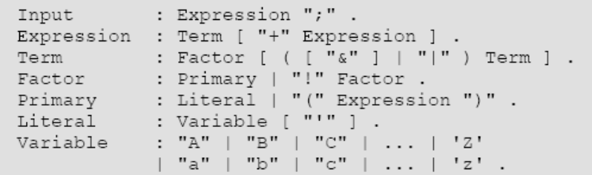
For example, the following input files represents the circuit in the Figure 5 of the DAGON paper.
# example circuit
!(a’ | ((b | c) d));
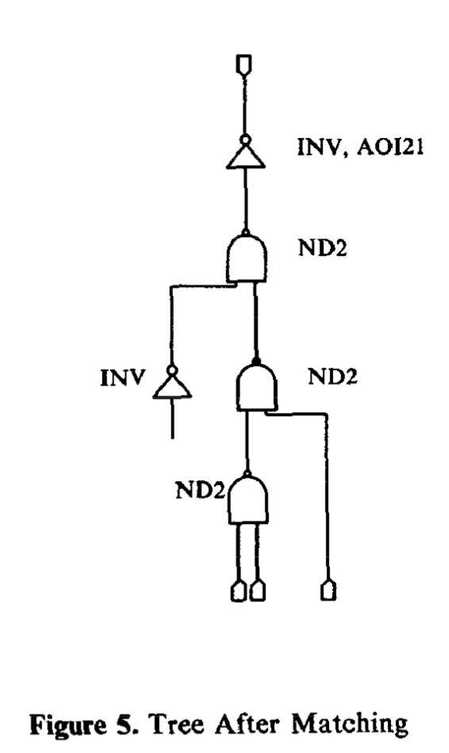

3.2. Library Cells
You are given the technology library which contains 6 cells. The name and the area and the function are shown in the first three columns. For cells NAND3, NAND4, and AOI21, we have different implementations (For example, there are 2 ways to implement AOI21 and 5 ways to implement NAND4), which are shown in the last column.
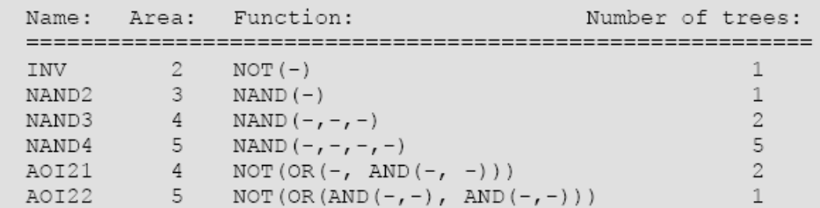

3.3. Output Format
After running test1, you will see the following output. Normalized tree is the NAND/INV representation of the circuit. The format of each line is like this.
Tree node: <The current node>, area: <current area>, cell: <mapping cell >
The last line (number 26 ) is the total optimal area.

Normalized tree : NAND2(INV(-),INV(NAND2(NAND2(INV(-),INV(NAND2(-,-))),INV(NAND2(NAND2(-,INV(NAND2(INV(-),-))),INV(NAND2(NAND2(-,-),NAND2(INV(-),-))))))))
Tree node: INV, area: 2, cell: INV
Tree node: INV, area: 2, cell: INV
Tree node: NAND2, area: 3, cell: NAND2
Tree node: INV, area: 5, cell: INV
Tree node: NAND2, area: 6, cell: NAND3
Tree node: INV, area: 2, cell: INV
Tree node: NAND2, area: 5, cell: NAND2
Tree node: INV, area: 7, cell: INV
Tree node: NAND2, area: 6, cell: NAND3
Tree node: NAND2, area: 3, cell: NAND2
Tree node: INV, area: 2, cell: INV
Tree node: NAND2, area: 5, cell: NAND2
Tree node: NAND2, area: 11, cell: NAND2
Tree node: INV, area: 7, cell: AOI22
Tree node: NAND2, area: 16, cell: NAND2
Tree node: INV, area: 18, cell: INV
Tree node: NAND2, area: 23, cell: NAND3
Tree node: INV, area: 25, cell: INV
Tree node: NAND2, area: 26, cell: NAND4
26
Figure. A Output of test1
4. Source Code
Now please go to the source code directory and view the source codes.
cd ../source
vim main.c (or parser.c …)

We provide the input Boolean expression parser in parser.c that translates G_{i} to G_{d},, according to the DAGON paper. We also provide a function to normalize the tree to a canonical expression of 2-input NAND and INV (i.e. translate from G_{d} to G_{c}). You only need to implement two functions in main.c or main.cpp file.
tree_match()
tree_mapper()
To implement the above two functions, there are some important functions that you need to know before getting started.
- All the cells that can be used are defined in libcells in main.c or main.cpp.
- The circuit is only composed by NAND and INV gate after doing tree_normalize. You can see the code in main.c (main.cpp).
- tree_libcells_init in main.c can decompose all the cells in libcells to NAND gate and INV gate.
- The DAGON algorithm is implemented in tree_mapper(). In this function, you need to follow the algorithm that we teach in class and calculate the area bottom-up from input to output.
- tree_match() is used to check whether the cell in libcells can be used to replace the cell in the circuit. This function is called by tree_mapper().
- In tree.h, you can see following #define,
#define T_TYPE(t) ((t)->type)
#define T_AREA(t) ((t)->area)
#define T_CELL(t) ((t)->cell)
#define T_LEFT(t) ((t)->left)
#define T_RIGHT(t) ((t)->right)
You can get the type of a given cell by using T_TYPE(t). The definition of type, area, cell, left, right are showing below.
Type type; /* logic gate type */
Area area; /* total area of this subtree when mapped */
int cell; /* mapped to cell at this index in libcells table */
Tree left; /* left subtree */
Tree right; /* right subtree, NULL for INV/NOT */

- It’s ok to design your own function, but please explain the function in your report and make sure your code can be executed correctly.

We also provide a few test cases in the ‘test’ directory.
5. Requirements
1. You can implement the code in either C or C⁺⁺.
2. The output message should be printed to the screen by using cout (C⁺⁺) or printf in C.
3. Please print the process of your tree_mapper() while doing DAGON. The syntax is the same as the output format that we show above in Figure A.
4. The optimal area should be printed in the last line. Since the order of DAGON algorithm might be different in your program, you can get all the score if your final optimal area is correct.
5. After you finish both of the above functions, type make in source/ directory and you can get your own binary file. (If you are interested in how the binary file is generated, you can open Makefile in source directory to see how it is written. )

6. Submission
1. Submit the main.c or main.cpp file.
2. Submit a report to explain your code and named <student_id>_pa1_report.doc. Please also submit a printed report in class.
The submission filename should be compressed in a single file <student_id>_pa1.tgz. (e.g. b90901000_pa1.tgz). You can use the following command to compress a whole directory:
tar -zcvf <filename>.tgz <dir>

7.Grading:
80% correctness (including submission correctness)
20% report

COPYING RESULTS in ZERO GRADES FOR BOTH STUDENTS!

