Fault Simulator
(Due: 10/11 9AM)
Introduction:
We provide the C source codes of an ATPG (automatic test pattern generation) program for single stuck-at faults. This ATPG system has two major functions: test pattern generation and fault simulation. For test pattern generation, it implements the PODEM algorithm [Goel 1981]. For fault simulation, it implements the parallel fault simulation algorithm. In this PA, we first show you how to run fault simulation mode. Then, you are asked to fill in the holes in the fault simulator code.

Tutorial:
First, please enter the bin directory, and run the golden binary to see results of fault simulation mode. Notice that you should run these commands on eda union platforms. Otherwise, it may not work. Simply type the following commands.
cd bin
./golden_atpg –fsim ../sample_circuits/c17.input ../sample_circuits/c17.ckt
Then you will see results generated by fault simulation.
Second, leave the bin directory, enter the podem directory, and compile the source code by typing.
cd ..
cd podem
make
This code should be compiled correctly on Linux machines. In case you see any compilation error, please fix it before you proceed. If you succeed, an executable file ‘atpg’ is generated. Then, in the same directory, run this software in fault simulation mode by typing the following command.
./atpg -fsim ../sample_circuits/c17.input ../sample_circuits/c17.ckt
The number of total faults, detected faults, and fault coverage should be showed. Notice that the fault coverage is not correct now because there are some holes in the source code. Your job is to fill in the holes so that your outputs are the same as those generated by the golden binary.
I/O Files:
We explain the results using the following circuit, c17.
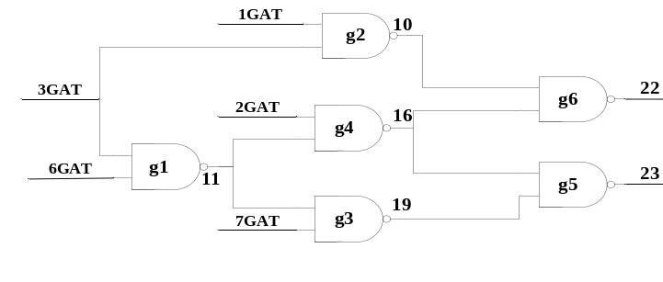
Figure 1. c17 circuit
The following file is our circuit file (c17.ckt). At the beginning, the circuit name is shown after the keyword “name”. Second, circuit primary inputs (PIs) go after the keyword “i”. Third, the circuit primary outputs (POs) go after the keyword “o”. Last, the rest of gates go after the keyword “g” and its gate index. Take “g1 nand 6GAT(3) 3GAT(2) ; 11GAT(5)” for example, it means g1 is a NAND gate, and inputs of this NAND gate are signal 6 and signal 3, and output of this NAND gate is signal 11. The numbers in the parentheses are total gates index, which can be ignored here.
name C17.iscas
i 1GAT(0)
i 2GAT(1)
i 3GAT(2)
i 6GAT(3)
i 7GAT(4)

o 22GAT(10)
o 23GAT(9)

g1 nand 6GAT(3) 3GAT(2) ; 11GAT(5)
g2 nand 3GAT(2) 1GAT(0) ; 10GAT(6)
g3 nand 7GAT(4) 11GAT(5) ; 19GAT(7)
g4 nand 11GAT(5) 2GAT(1) ; 16GAT(8)
g5 nand 19GAT(7) 16GAT(8) ; 23GAT(9)
g6 nand 16GAT(8) 10GAT(6) ; 22GAT(10)
Figure 2. c17 circuit file

The following file is our test pattern (c17.input), which is generated by our ATPG tool. The circuit data is shown at the beginning. Then, all test vectors are shown after the keyword “T”. The other ATPG results are shown after test vectors: fault coverage, number of backtracks, etc. The statements which come after ‘#’ are all comments that are not used by our tool.
#Circuit Summary:
#---------------
#number of inputs = 5
#number of outputs = 2
#number of gates = 6
#number of wires = 11
#atpg: cputime for reading in circuit ../sample_circuits/c17.sim: 0.0s 0.0s
#atpg: cputime for levelling circuit ../sample_circuits/c17.sim: 0.0s 0.0s
#atpg: cputime for rearranging gate inputs ../sample_circuits/c17.sim: 0.0s 0.0s
#atpg: cputime for creating dummy nodes ../sample_circuits/c17.sim: 0.0s 0.0s
#number of equivalent faults = 28
#atpg: cputime for generating fault list ../sample_circuits/c17.sim: 0.0s 0.0s
T'00110'
T'10111'
T'10001'
T'01000'
T'11011'
T'01100'
T'10000'
T'01111'
#number of aborted faults = 0
#number of redundant faults = 0
#number of calling podem1 = 8
#total number of backtracks = 0
#FAULT COVERAGE RESULTS :
#number of test vectors = 8
#total number of gate faults = 34
#total number of detected faults = 34
#total gate fault coverage = 100.00%
#number of equivalent gate faults = 28
#number of equivalent detected faults = 28
#equivalent gate fault coverage = 100.00%

#atpg: cputime for test pattern generation ../sample_circuits/c17.sim: 0.0s 0.0s
Figure 3. c17 input file (generated by ATPG)

Assignment:
Before you start, you should read the readme file that explains important data structure of this PODEM code. Please fill in the holes in the fault simulation code. Enter podem directory and find the file faultsim.c, there are two holes in this file. You can simply type the keyword “TODO” to find out the holes. After you fill in the holes, your result should be same as our golden results.
1) Please fill in the following table in your report.

circuit number | number of test vector pairs | number of gates | number of total faults | number of detected faults | number of undetected faults | fault coverage
C499
C1355
C6288
C7552
2) Please print out the critical parts of your code and explain it.
3) 10% bonus for any speed up technique that you implement. Please show it very clearly in the report.

Grading:
80% correctness
20% report
10% bonus for speed up technique.

Submission:
Make a directory <student_id>_pa1
Please copy 4 items /podem, report, makefile, readme into directory. Then submit a single *.tgz file to CEIBA system. Please submit your code on ceiba. Include everything so that your code can be easily compiled using ‘make’. Also submit a hardcopy of your report on class or to BL-427 by the deadline. You can use the following command to compress a whole directory: tar -zcvf <filename>.tgz <dir>

Reference:
[Goel 1981] P. Goel, “An Implicit Enumeration Algorithm to Generate Tests for Combinational Logic Circuits,” IEEE Trans. on Computers, Vol. 30, No.3, pp215-222, 1981.

---
Copying source code results in zero grade for both students!

---
COPYRIGHT ANNOUNCEMENT
The copyright of this PODEM program belongs to the original authors. This program is only for our education purpose.

