TDF Simulator
(Due: 11/29 9AM)
Introduction:
We provide the C source codes of an ATPG (automatic test pattern generation) program for single stuck-at faults. This ATPG system has two major functions: test pattern generation and fault simulation. However, our customer wants us to make our tool packaged in order to sell to people. So we need to chain our primary inputs and primary outputs so that we can do the transition delay faults (TDF) simulation by using launch-on-shift (LOS) technique. In this PA, we first show you how to run tdfsim mode. Then, you are asked to build the whole TDF simulator.

Tutorial:
First, please enter the podem directory,
cd podem
then compile the source code by typing
make
This code should be compiled correctly on Linux machines. In case you see any compilation error, please fix it before you proceed. If you succeed, an executable file ‘atpg’ is generated. Then, in the same directory, run this software in tdfsim mode by typing the following command.
./atpg –tdfsim ../tdf_patterns/c17.pat ../sample_circuits/c17.ckt
Notice that you will see nothing happened because we are not build the simulator yet. Your job is to use what you have learned in the testing class to build the whole TDF simulator.
I/O Files:
We explain the I/O information using the following circuit, c17. We chain the PIs and POs up, the head of the chain is the first PI (e.g. PI₁), and the tail of the chain is the last PO (e.g. PO₂).
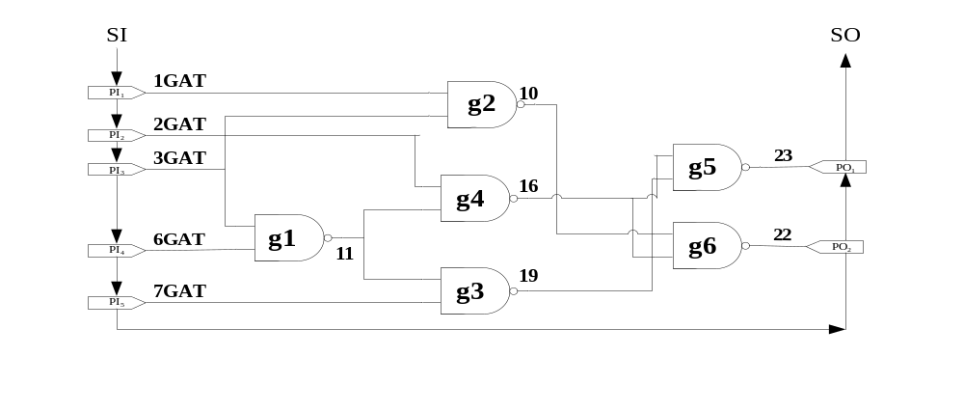
Figure 1. c17 circuit
The following file is our circuit file (c17.ckt). At the beginning, the circuit name is shown after the keyword “name”. Second, circuit primary inputs (PIs) go after the keyword “i”. Third, the circuit primary outputs (POs) go after the keyword “o”. Last, the rest of gates go after the keyword “g” and its gate index. Take “g1 nand 6GAT(3) 3GAT(2) ; 11GAT(5)” for example, it means g1 is a NAND gate, and inputs of this NAND gate are signal 6 and signal 3, and output of this NAND gate is signal 11. The numbers in the parentheses are total gates index, which can be ignored here. Notice that we chain the PIs and POs according to the order they appear in the file. In this case, we chain the PIs and POs from 1GAT(0) to 23GAT(9).
name C17.iscas
i 1GAT(0)
i 2GAT(1)
i 3GAT(2)
i 6GAT(3)
i 7GAT(4)

o 22GAT(10)
o 23GAT(9)

g1 nand 6GAT(3) 3GAT(2) ; 11GAT(5)
g2 nand 3GAT(2) 1GAT(0) ; 10GAT(6)
g3 nand 7GAT(4) 11GAT(5) ; 19GAT(7)
g4 nand 11GAT(5) 2GAT(1) ; 16GAT(8)
g5 nand 19GAT(7) 16GAT(8) ; 23GAT(9)
g6 nand 16GAT(8) 10GAT(6) ; 22GAT(10)
Figure 2. c17 circuit file

The following file is our test pattern (c17.pat). The circuit data is shown at the beginning. Then, all test vectors are shown after the keyword “T”, which composed of two parts. The two parts are separated by a blank, first part is for our primary inputs, and the second part is for our shifting bit in launch on shift technique.
#Circuit Summary:
#---------------
#number of inputs = 5
#number of outputs = 2
#number of gates = 6
#number of wires = 11
T'00110 1'
T'10111 0'
T'10001 1'
T'01000 0'
T'11011 1'
T'01100 0'
T'10000 1'
T'01111 0'

Figure 3. c17 pattern file

Assignment:
Before you start, you should read the readme file that explains important data structure of this PODEM code. Enter podem directory and find the file tdfsim.c, coding here and it is free for you to modify other files, but you should clearly write down it in the report.
We now simply introduce how we do the simulation using LOS in this PA. For all the circuits, we chain the PIs and POs, then we use the LOS technique to do the TDF simulation by the following steps:
Step 1: Assign input pattern and run the good simulation and check which faults are activated.
Step 2: Shift in a bit from the chain in the beginning of PI.
Step 3: Do another simulation to check if there is a fault happened and the effect propagate to the POs.
Step 4: Push POs out to see if there are different value from good value.

1) Please fill in the following table in your report.

circuit number | number of gates | number of total TDFs | number of detected faults | number of undetected faults | Total fault coverage
C432
C499
C880
C1355
C2670
C3540
C6288
C7552
2) Please print out the critical parts of your code and explain it.
3) 10% bonus for any speed up technique that you implement. Please show it very clearly in the report.

Grading:
80% correctness
20% report
10% bonus for speed up technique.

Submission:
Make a directory <student_id>_pa3
Please copy 3 items /podem, report, readme into directory. Then submit a single *.tgz file to CEIBA system. Please submit your code on ceiba. Include everything so that your code can be easily compiled using ‘make’. Also submit a hardcopy of your report on class or to BL-427 by the deadline. You can use the following command to compress a whole directory: tar -zcvf <filename>.tgz <dir>

---
Copying source code results in zero grade for both students!

---
COPYRIGHT ANNOUNCEMENT
The copyright of this PODEM program belongs to the original authors. This program is only for our education purpose.

