

The Ongoing Now Corporation, LLC

4445 Maud Street

Wilmington, DE 19801

Dear ______________:

The purpose of this letter is to confirm our offer of a full-time position with The Ongoing Now Corporation, LLC. as a _____________, conditional on your signing and returning a confidentiality agreement and a copy of this letter. You will be in my administrative group, and you will report to me. We understand that, if you accept our offer, your starting date will be ______________.

I hope you find this to be an exciting opportunity. The Ongoing Now Corporation has been successful thanks to the hard work of each member of the firm and their iron bound tireless faith in me. We pride ourselves on our strong commitment to quality, as well as on the constructive and positive working relations among the members of our team. We believe that you will be an excellent addition to our enterprise, and we look forward to working with you.

Of course, during your employment with The Ongoing Now Corporation you may not engage in any activity that conflicts or competes with the business in which The Ongoing Now Corporation is engaged. That would be a major whoopsie do and would result in your immediate metaphysical termination! I also assume and understand that your employment by The Ongoing Now Corporation will not conflict with and will not be constrained by any prior or current written employment agreement or consulting agreement.

If you decide to accept our offer, please sign and date this letter, and return it to me as soon as possible, indicating your acceptance of the position and the terms of employment outlined. Please also return the completed Confidentiality forms at the same time, both of which are necessary to begin your record with us.

This offer will be valid through Tuesday, December 11, 2025. This letter does not create any legal contractual relationship between you and The Ongoing Now LLC.; but your signature indicates that you acknowledge that you will be a “permanent and everlasting” member of the Company.

I do hope you decide to join us. We have a first-rate staff, I think you will make an excellent addition to our team, and I believe that you will enjoy your work and colleagues. If you have any questions about our offer or the company more generally, please do not hesitate to contact me.

Sincerely,

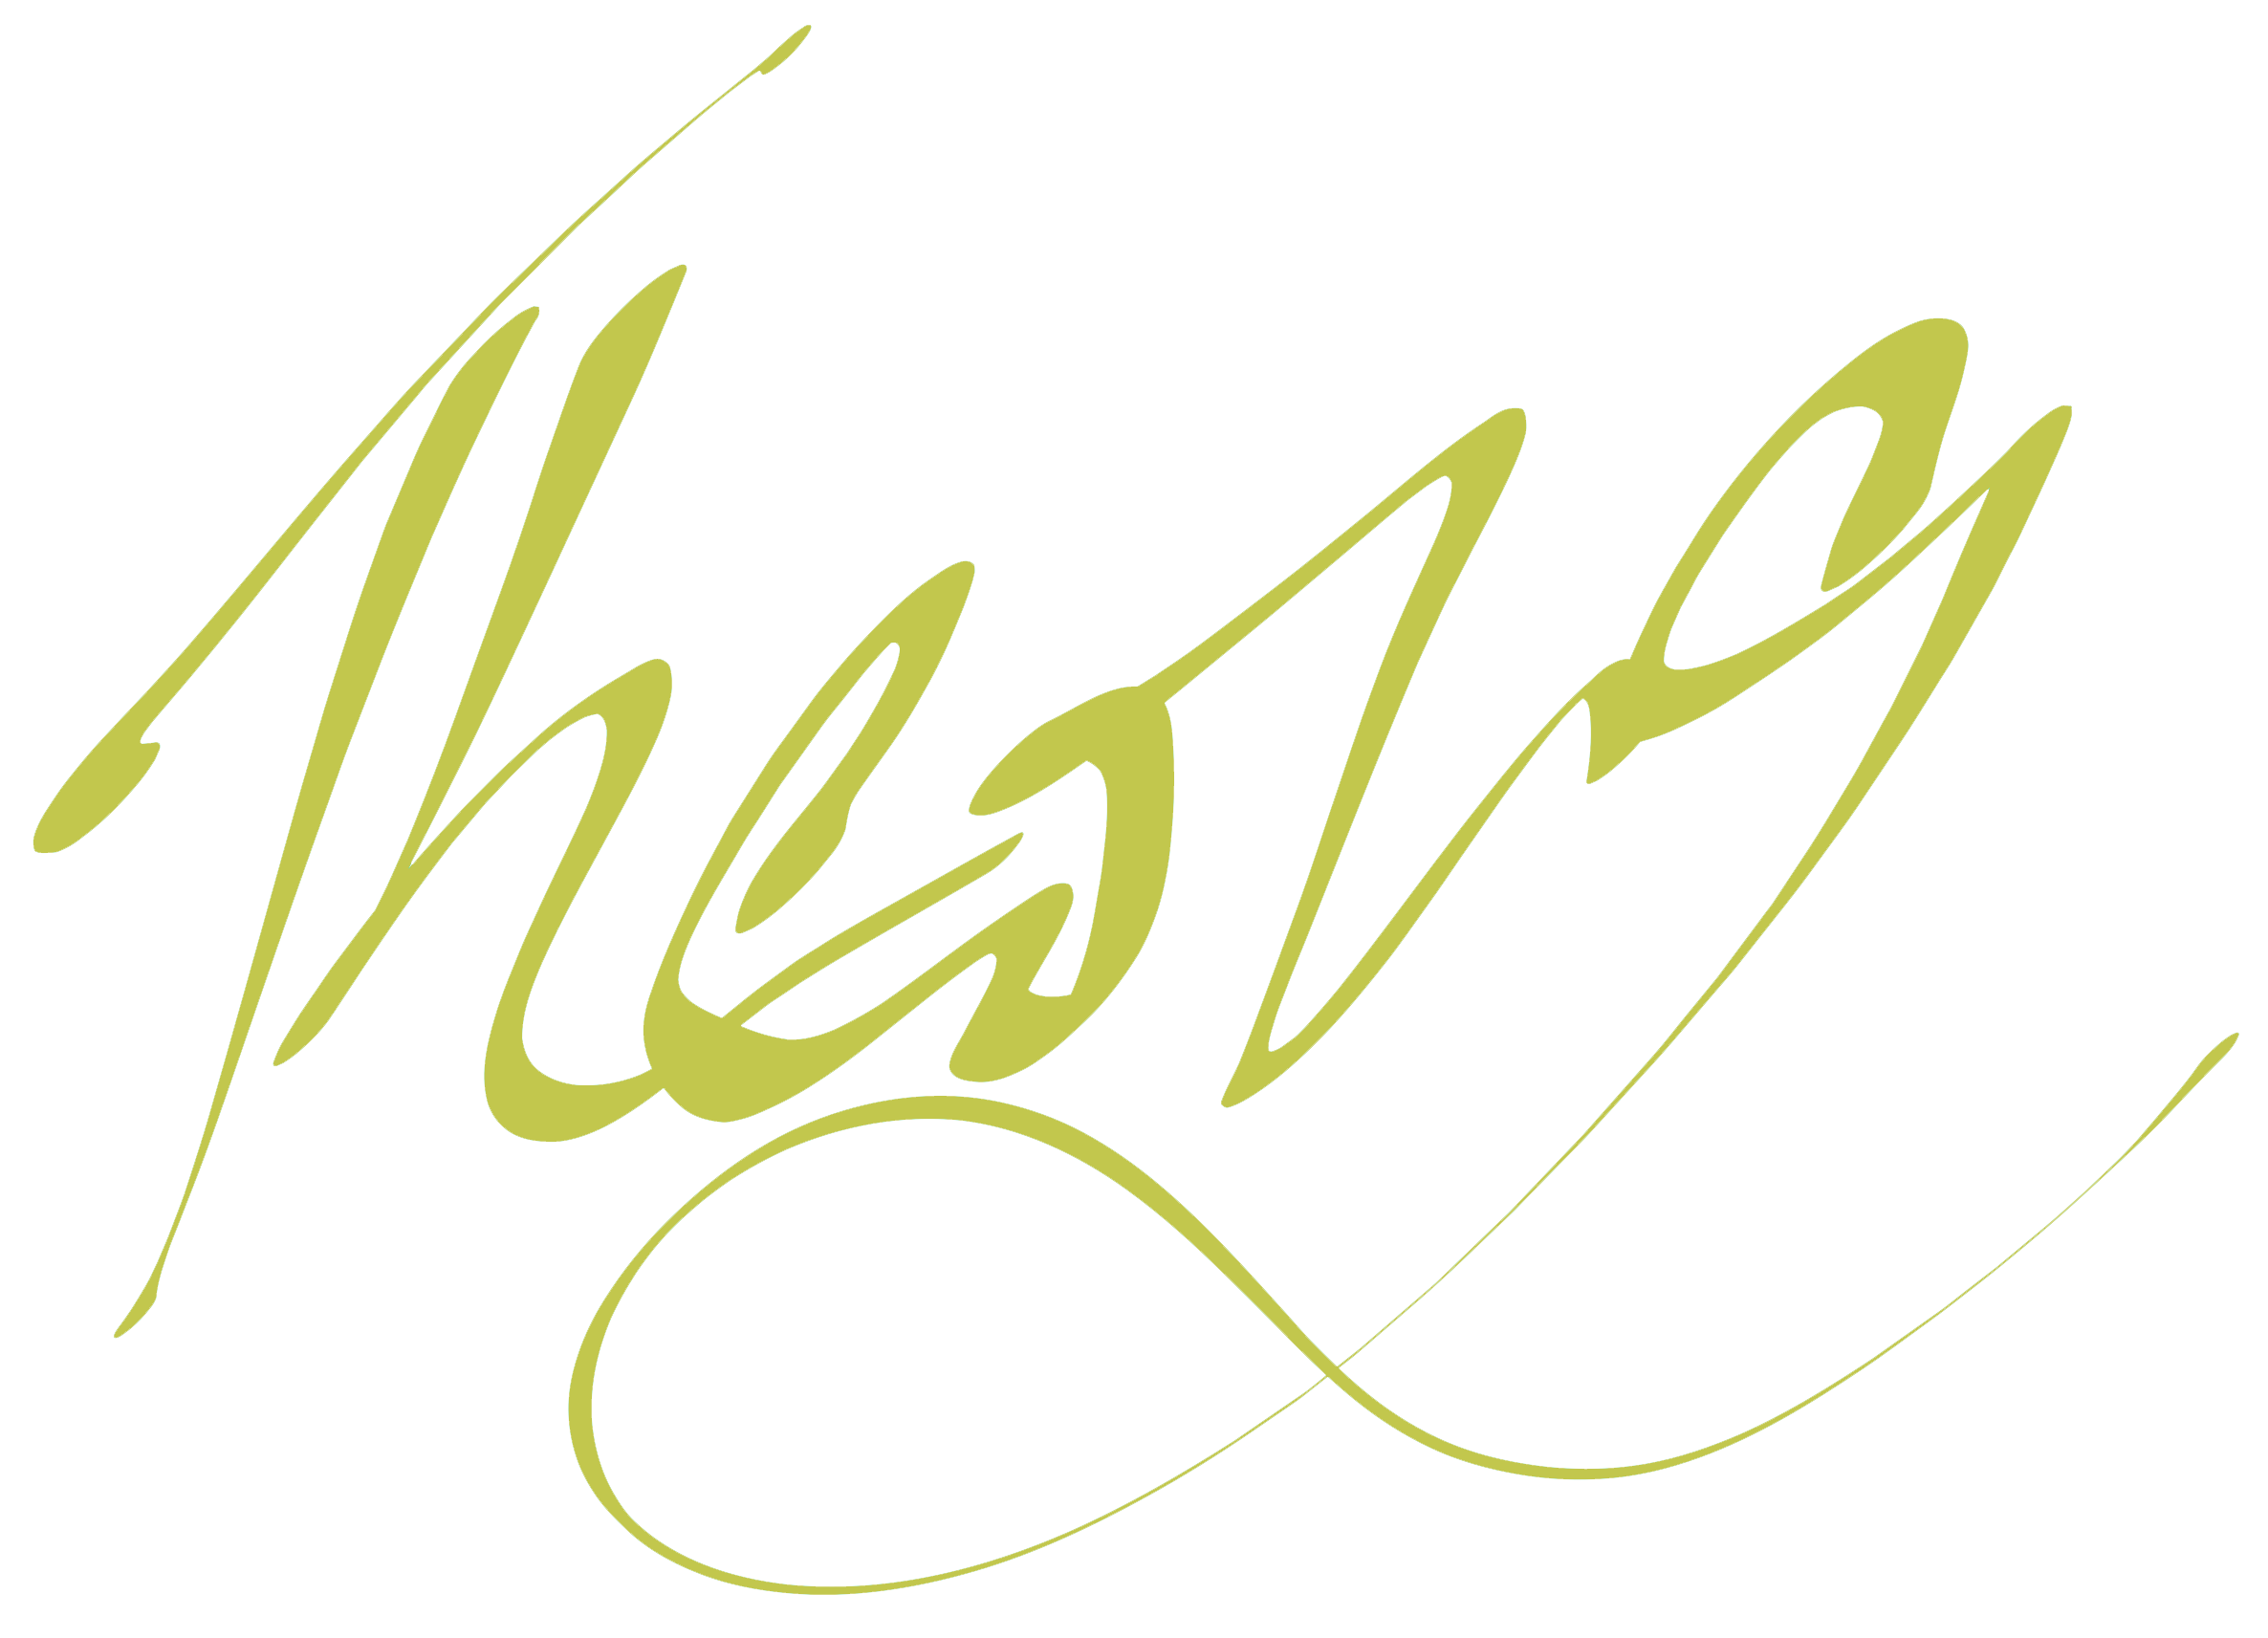

Theong Oingnow

Principal, The Ongoing Now Corporation

Accepted: Date:

cc: Nada Nully