Practical Task 6 – Interactive Data Visualization Dashboard

Objective:
To create interactive charts and dashboards using Plotly.

Tools Used:
Anaconda
Jupyter Notebook
Python (Plotly, Pandas)

Dataset:
Global Population / Economic Indicators (Gapminder Dataset)

Visualizations:
1. Interactive Line Chart
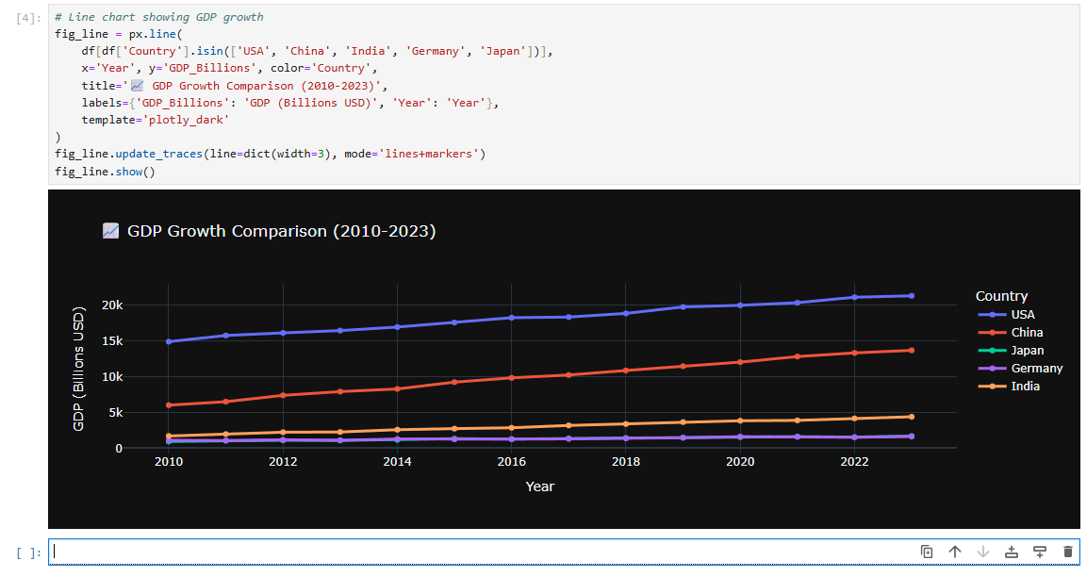2. Interactive Bar Chart
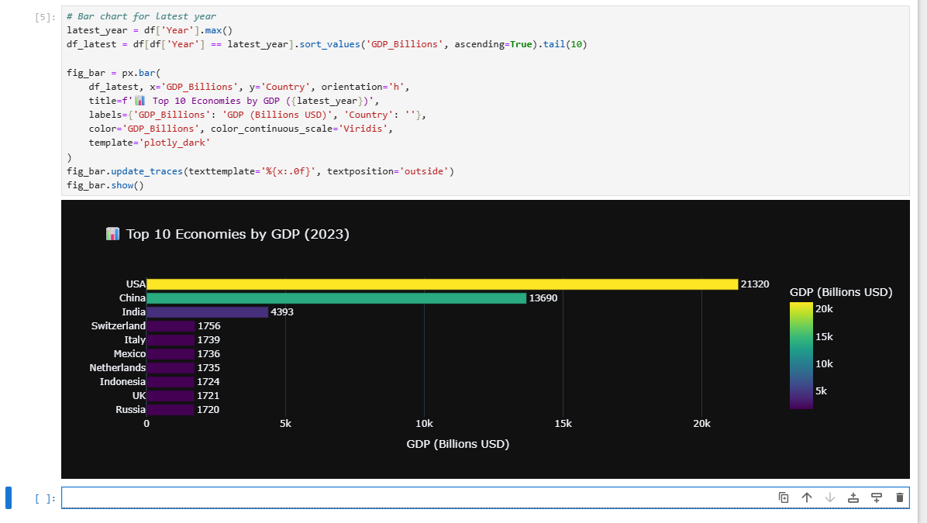3. Scatter Plot with Hover
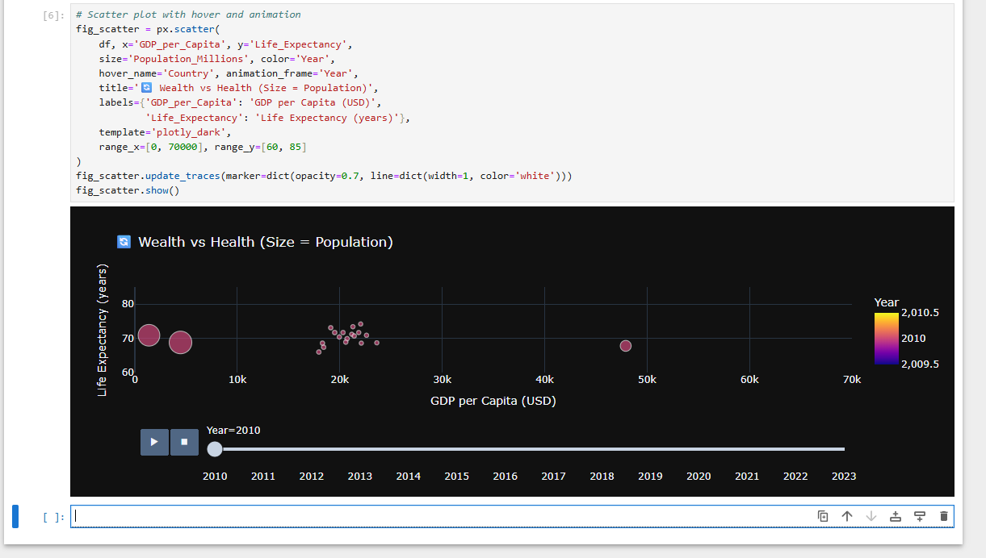4. Choropleth Map
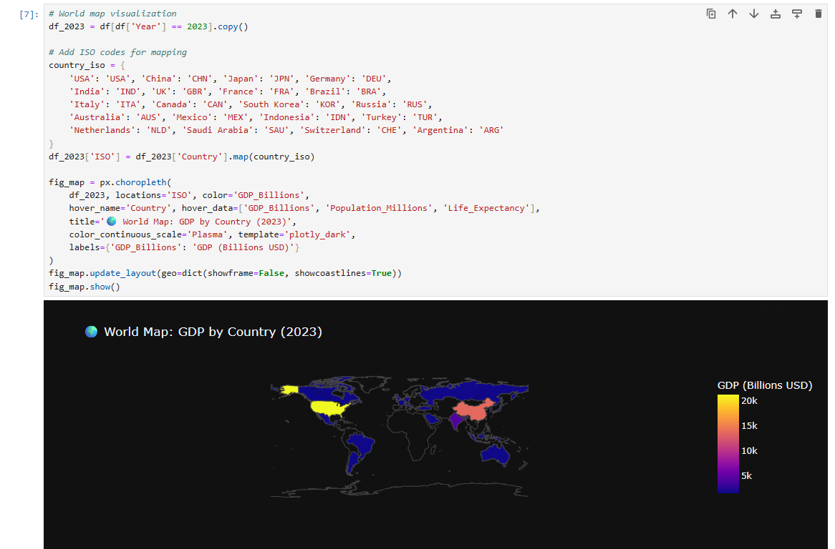
5. 3D Scatter Plot
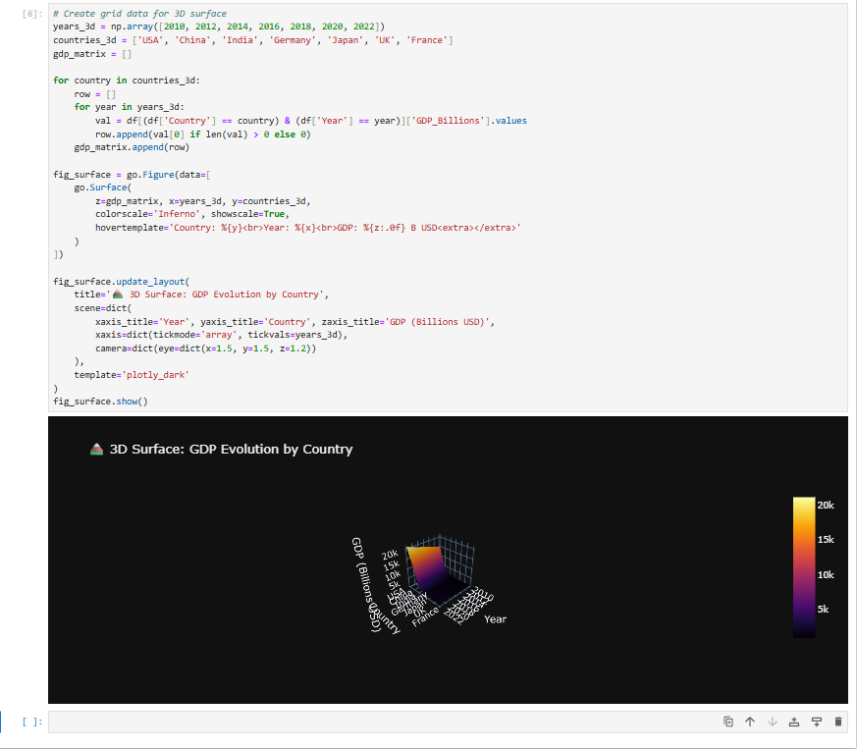6. 3D Surface Plot
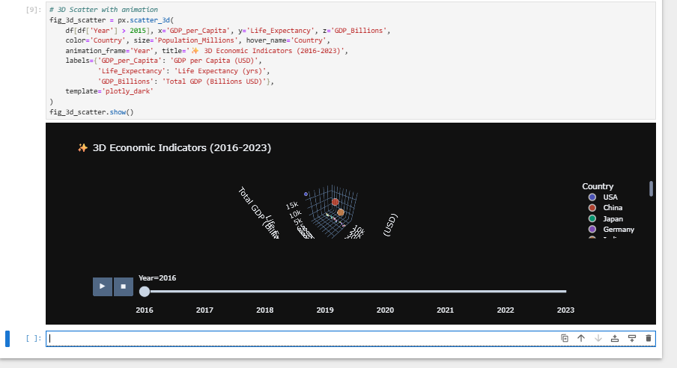
7. Time Series Animation
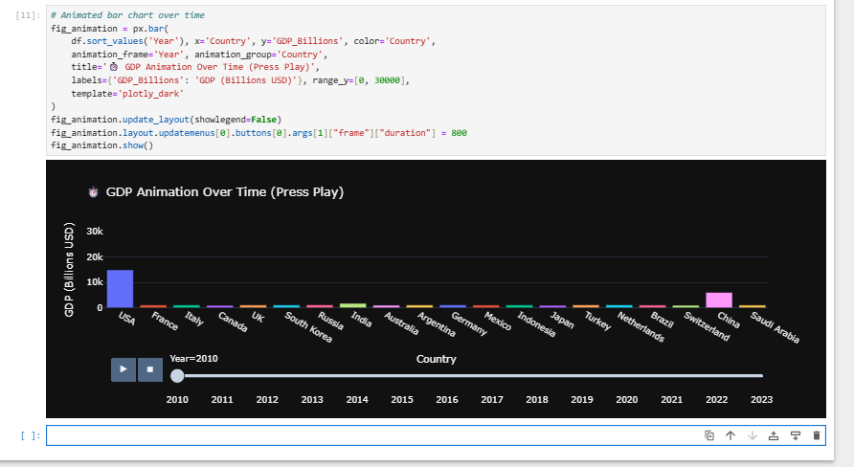

Conclusion:
This task helped in understanding how to create interactive visualizations and dashboards using Plotly.

