Practical Task 5 – Data Visualization using Python

Objective
To visualize data using different types of charts and graphs in Python.

Tools Used
Anaconda
Jupyter Notebook
Python (Matplotlib, Seaborn)

Dataset
COVID-19 Dataset / Weather Dataset

Screenshots to Include (IMPORTANT)
1. Line Plot (Time Series)
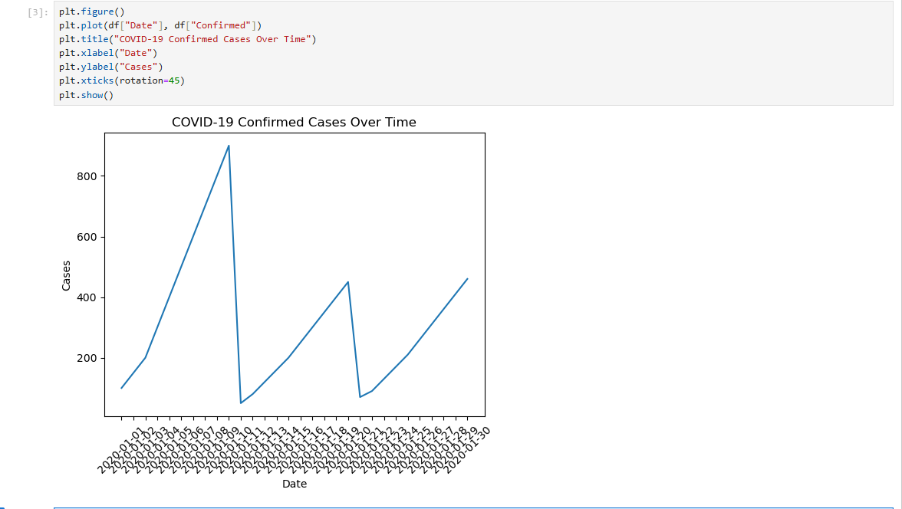
2. Bar Chart
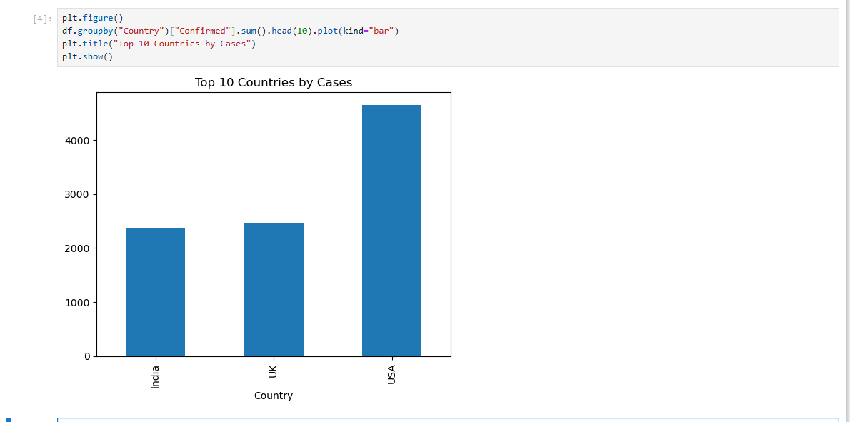3. Histogram
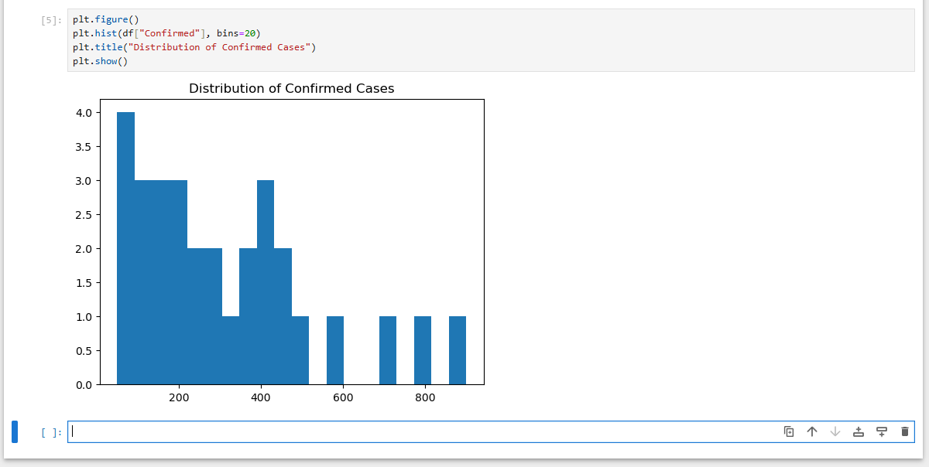4. Scatter Plot
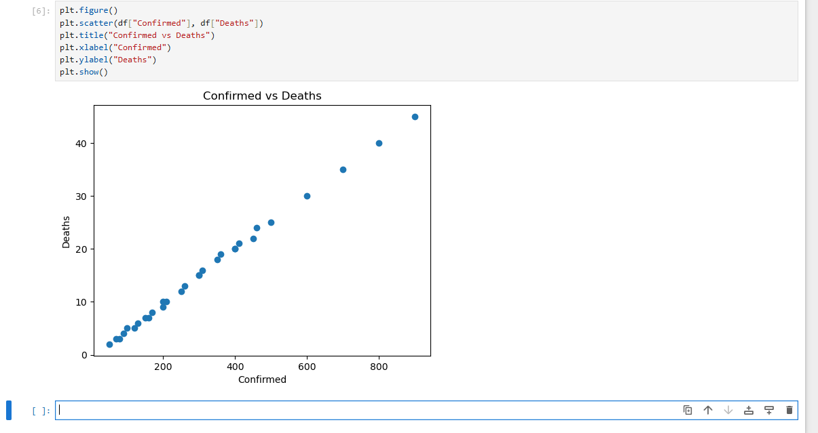5. Box Plot
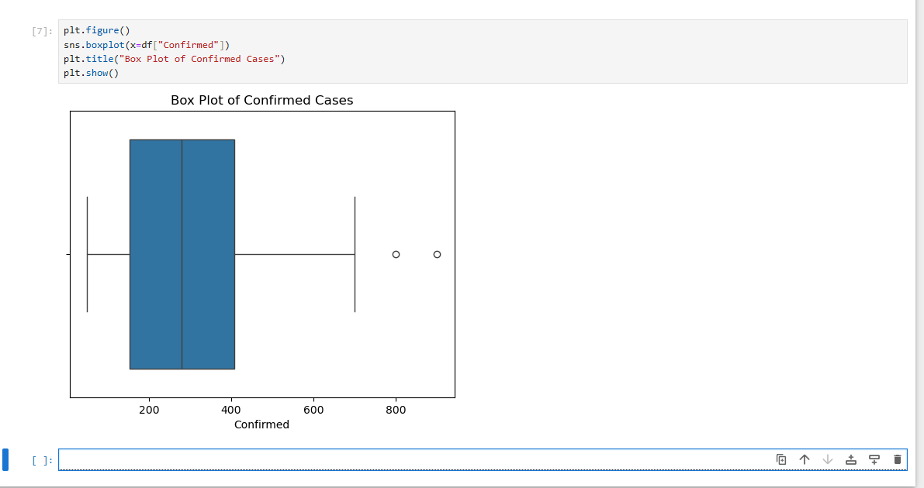
6. Violin Plot
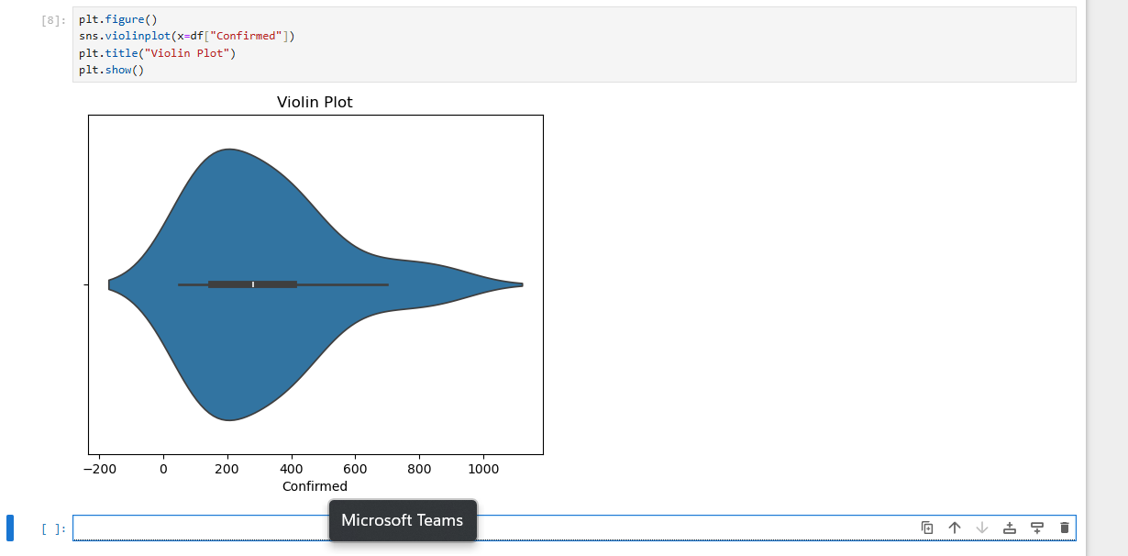7. Heatmap (Correlation Matrix)
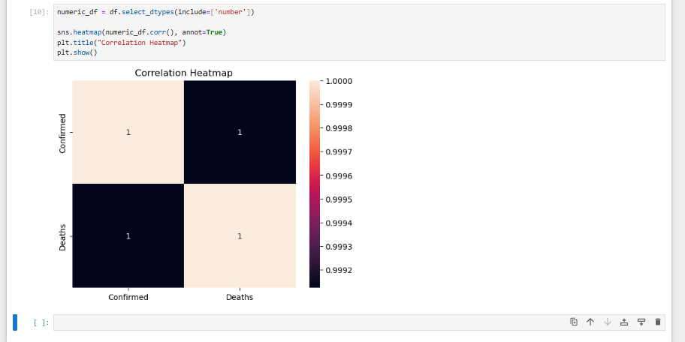
8. Customized Plot (Color, Labels, Title, Legend)
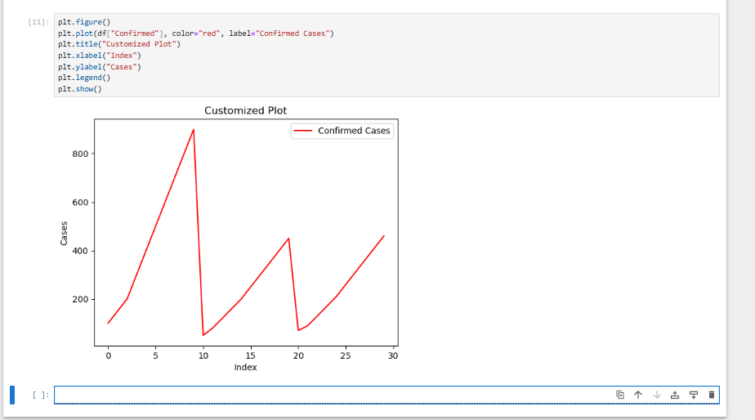9. Subplots / Multi-panel Figure
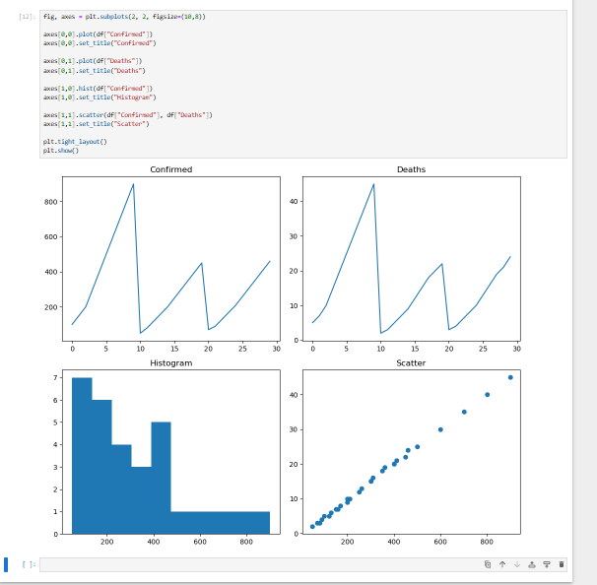

Conclusion
This task helped in understanding different visualization techniques and how to represent data effectively using Python.

