**Hand-in 5**

In this assignment we’ve extended our TaskManager application with an authentication facility.

**Task modifications**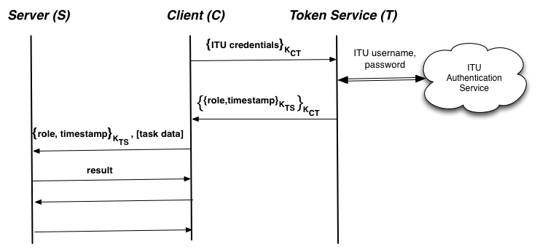We have added the role-element to our class Task in order to use JAXB with the new XML format.

**Token Service:**We have made a Token service according to the above picture, which checks ITU usernames and password using SSH.

**Client**:  
Our client class initially authenticates itself through the Token Service. As seen in the picture, this communication is encrypted. Upon authentication the client will receive a token encrypted with a shared key only possessed by the Server and Token Service – thus unreadable by the Client.  
The client then connects to the server with its access token.

**Server:**The servers role is to decrypt any tokens and check their validity before executing tasks. If 2 minutes has passed since the token was granted access is denied.

**How to test:**  
In order to test our program you will have to start the Server and then the Client.  
Then enter username and password as prompted, followed by the name of the task you wish to execute.

**Security**  
The system is not secure. First of all in our implementation the shared keys are hardcoded in the code, and so they can’t be changed later unless the code is rewritten. If an evil person somehow gets these keys he will have access forever with nothing to do about it.

We also find it to be a bad idea that the communication between client and server is not encrypted. An eavesdropper can resend any communication with different task data.

**A test run can be seen in the following pictures:**

Server startup: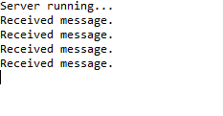

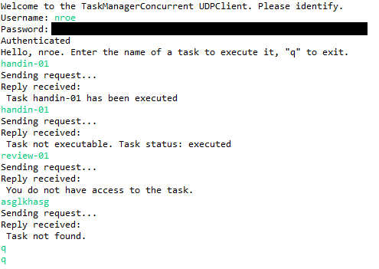Client execution: