Project Documents

1- Screen-Shots of the outputs:

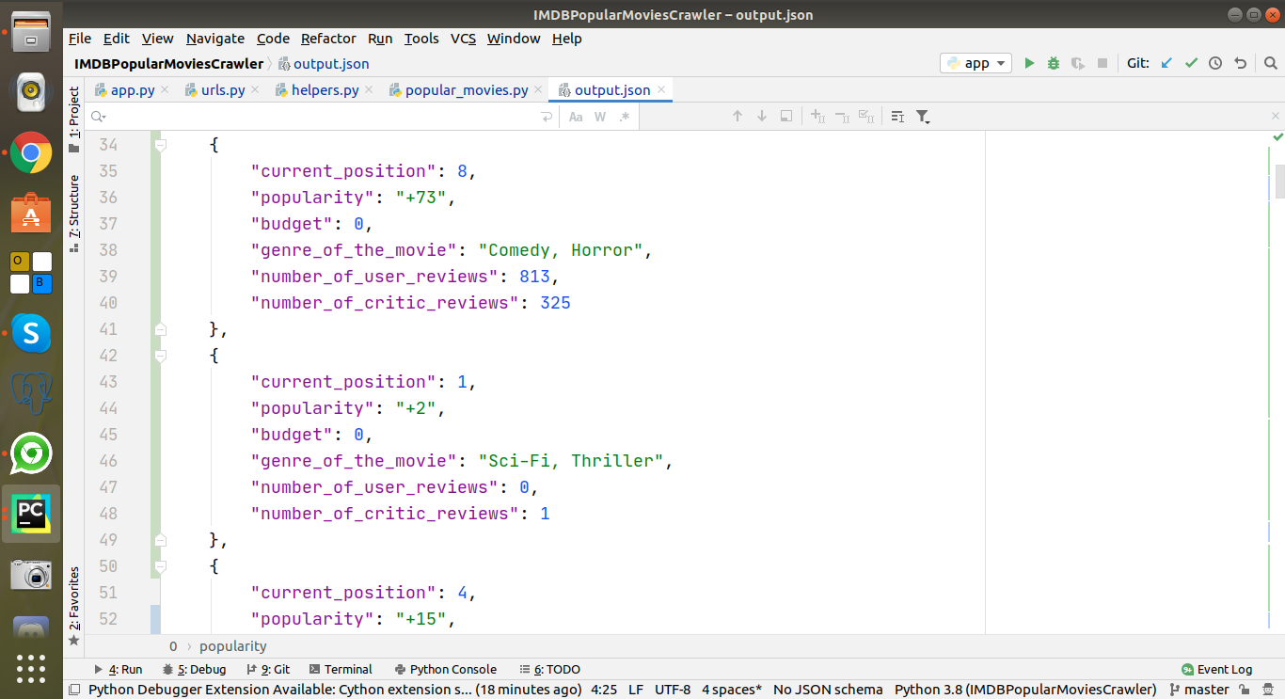
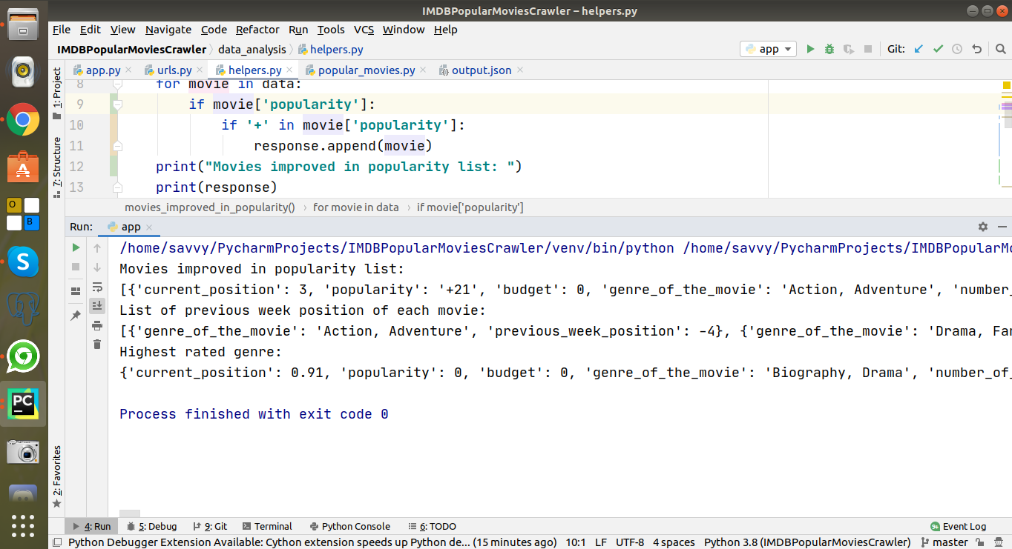
2- The technology stack and why you chose it:
I have used following technology stack and tools:

Programming Language: Python
Package: Requests, Beautifulsoup
IDE: PyCharm
I have used these packages for current assignment to scrape the data but there there is also a other framework Scrapy. Due to assignment time deadlines I have submitted it and I am also converting it into Scrapy and will send you soon.

3- Hours it took to complete the task
I have done this on weekend almost 20 Hours.

4- Any other improvements you would make if you had more time:
Although, I have used all best practices of PEP8 for quality code but If I will have more time then will do code refactoring to further optimize it regarding time and space.

