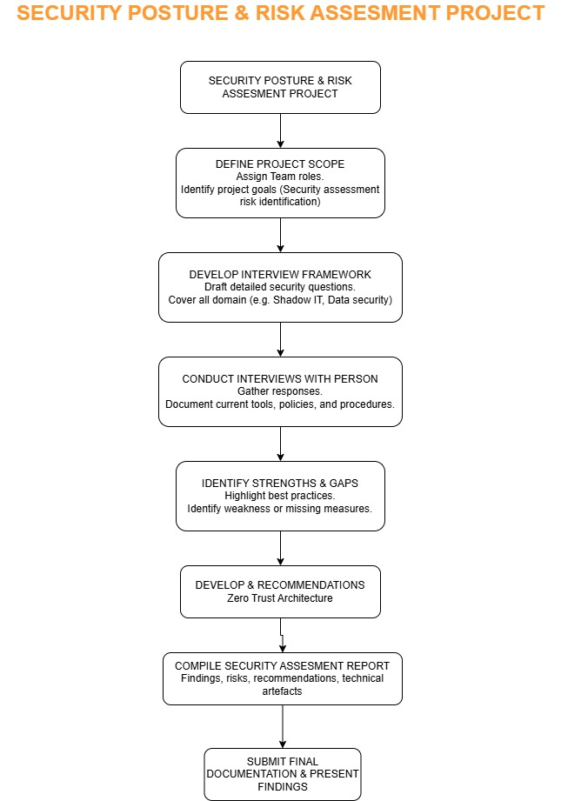

**1. Security Posture & Risk Assessment Project**

This step represents the overall objective of the project — to assess the security practices of Premier Technology Solutions, identify potential risks, and recommend improvements to strengthen their cybersecurity posture.

**2. Define Project Scope**

The team began by defining the project’s scope, assigning roles, and setting goals. This included identifying areas of focus such as third-party vendor risks, Shadow IT usage, data security, and endpoint protection.

**3. Develop Interview Framework**

A detailed interview framework was created, consisting of structured questions designed to explore the company’s current security systems. The questions covered various topics, including internal security policies, tool usage, and access control methods.

**4. Conduct Interviews with Person**

The team conducted an interview with a representative from Premier Technology Solutions. This step helped collect insights about real practices in the company, including what tools and processes are in use, and any challenges they face.

**5. Identify Strengths & Gaps**

The interview responses were analyzed to identify both strengths (such as fast patch management or basic controls) and weaknesses (such as lack of vendor oversight or endpoint monitoring). These findings helped pinpoint where the biggest security improvements were needed.

**6. Develop Recommendations**

Based on the identified gaps, we proposed security recommendations using Zero Trust Architecture (ZTA). These included using role-based access, micro-segmentation, DNS filtering, WARP client deployment, and posture checks for devices.

**7. Compile Security Assessment Report**

All findings, risks, and solutions were documented in a formal report. We also included technical artefacts such as policy templates, tool comparison tables, and a staff training plan to help implement the proposed solutions.

**8. Submit Final Documentation & Present Findings**

The project concluded with the submission of the final documentation and a formal presentation of the findings. This allowed the client and stakeholders to clearly understand the risks and see the practical solutions we proposed.