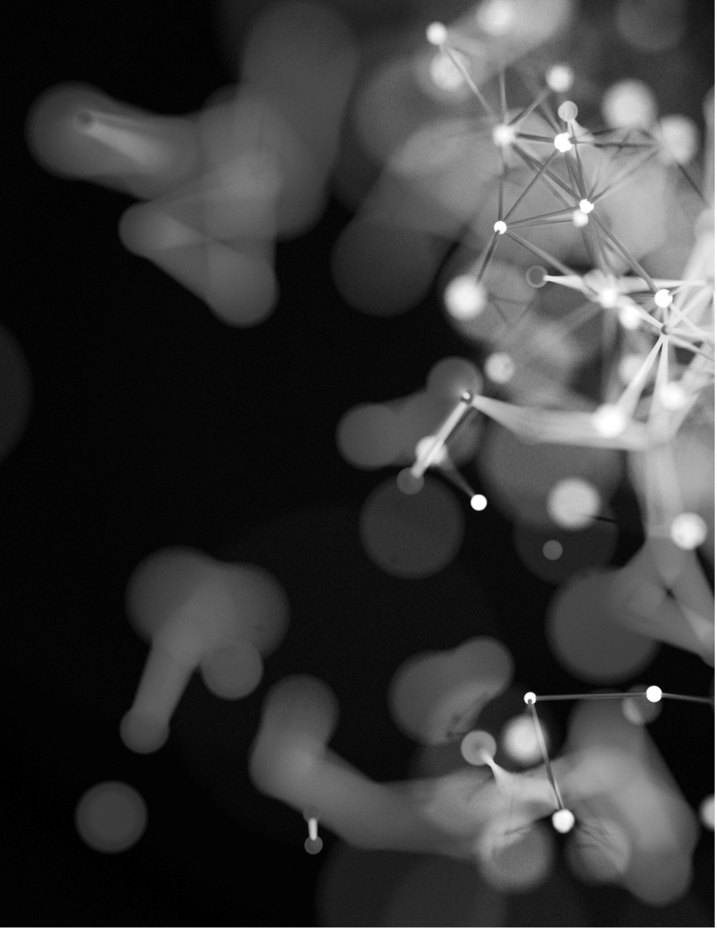

PROJECT REPORT

DIGITAL IMAGE PROCESSING

Mian Afzaal Zahoor | 01-134182-094

Suleman | 01-134182-059

**IMAGE CHARACTER RECOGNITION**

**Problem Description:**

In modern times, we have a lot of data in written form that we must transfer to computer and as the data is too much it will require a lot of labor and uncountable hours of time to transfer. So, to reduce the men hours we must propose the solution that can help us achieve this milestone with very few resources and work force.

**Benefits of Image Character Recognition:**

* Information of Image Character Recognition can be readable with high degree of accuracy. Flatbed scanners are very accurate and may produce reasonably top-quality images.
* Processing of Image Character Recognition information is fast. Large quantities of text are often input quickly.
* A paper-based form is often becoming an electronic form which is straightforward to store or send by mail.
* It is cheaper than paying someone amount to manually enter great deal of text data. Moreover, it takes less time to convert within the electronic form.
* The latest software can re-create tables also as original layout.
* This process is much faster as compared to the manual typing the information into the system.
* Advanced version can even Recreate tables, columns and even produce sites.

**Solution To the Problem:**

So, to solve this problem we have designed a code which recognizes the characters from images and converts it in the written digital format which can be further used for any purpose like storing in a database, sending etc.

**CODE**

#<<-------------------------LIST OF ALL THE IMPORTED MODULES------------------------->>

from tkinter import*

import tkinter as tk

from tkinter import filedialog

from PIL import ImageTk,Image

import os

import pytesseract

import cv2

#<<-------------------------PROVIDING THE PATH TO COMMAND OF TESSERACT FOR OCR------------------------->>

pytesseract.pytesseract.tesseract_cmd = r'C:\Users\sulem\AppData\Local\Programs\Tesseract-OCR\tesseract.exe'

#<<-------------------------MAIN CODE WITH GUI USED FOR USER FRIENDLY ENVIRONMENT------------------------->>

def showImage():

#LABEL BEING DISPLAYED ON THE POP-UP WINDOW

label = tk.Label(root, text = "ORIGINAL IMAGE")

label.place(x = 610, y = 10)

#SELECTING THE IMAGE FOR CONVERSION

path = filedialog.askopenfilename(initialdir = os.getcwd(), title = "SELECT IMAGE TO CONVERT", filetypes = (("PNG Files", "*.png"), ("JPG Files", "*.jpg"), ("ALL Files", "*.*")))

img = Image.open(path)

basewidth = 300

wpercent = (basewidth / float(img.size[0]))

hsize = int((float(img.size[1]) * float(wpercent)))

img = img.resize((basewidth, hsize), Image.ANTIALIAS)

img.save('G:/images/resized_image.png')

im = ImageTk.PhotoImage(Image.open('G:/images/resized_image.png'))

#OPENING THE FILE FOR DISPLAYING

lbl.configure(image = im)

lbl.image = im

#<<-------------------------EXTRACTING TEXT FROM THE IMAGE------------------------->>

#READING IMAGE

img = cv2.imread(path)

#USING GOOGLE PYTESSERACT TO CONVERT TEXT FROM IMAGE TO STRING

text = pytesseract.image_to_string(img, config = '')

#PRINTING THE TEXT RETRIVED FROM IMAGE

text = text.split('\n')

Output.insert(END, text)

root = tk.Tk()

frme = tk.Frame(root)

frme.pack(side = tk.BOTTOM, padx = 15, pady = 15)

lbl = tk.Label(root)

lbl.pack()

btn1 = tk.Button(frme, text = "Browse Image", bg = "#856ff8", fg = "#2F2F0F", padx = 10, pady = 10, command = showImage)

btn1.pack(side = tk.LEFT)

btn2 = tk.Button(frme, text = "Exit", bg = "#856ff8", fg = "#2F2F0F", padx = 20, pady = 10, command = root.destroy)

btn2.pack( )

Output = Text(root, height = 30, width = 180, bg = "white")

Output.pack()

root.config(bg = "light cyan")

root.title("IMAGE TEXT CONVERSION TO STRING")

root.geometry("1200x800")

root.mainloop()

**INTERFACE**

