Rules for Calculating Time Complexity and Big-Oh

Rule 00
Normally these formulas are very handy:

If 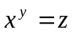 then 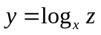
Also,
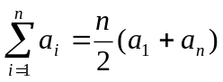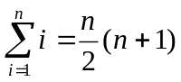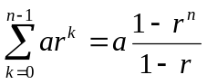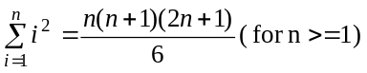

Rule 0
The condition that stops a loop executes ONE MORE time than the loop itself (the last time is when it is evaluated false)

Rule 1
for (i=0;i<n;i=i+k) Anything inside the loop will run approximately n/k times

Rule 2
for (i=n;i>0;i=i-k) Anything inside the loop will run approximately n/k times

Rule 3
for (i=1;i<n;i=i*k) Anything inside the loop will run approximately log_{k}n times

Rule 4
for(i=1;i<=n;++i)
for (j=1;j<=i;++j)
The above nested loop approximately runs (1/2)n(n+1) times.
The variable j depends upon the value of i

Rule 5
for(i=1;i<=n;i=i*2)
for (j=1;j<=i;++j)
The statements in the above nested loop approximately run 2n-1 times.
The variable j depends upon the value of i

Rule 6
If the loop variables are independent then the total times a statement inside a nested loop is executed is equal to the product of the times the individual loops run
e.g. for (i=0;i<n;++i)
for (j=0;j<m;++j)
A statement inside the above nested loop will run n*m times

FORMULA 1

Arithmetic Series:
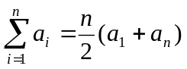 [ Also: n/2(2a+(n-1)d ]

Example#1
1 4 7 10 13

a₁=1
d=3 (common difference)
n=5
5(1+13)/2 = 70/2 = 35 (As 1+4+7+10+13 = 35)

Example#2
3 8 13 18 23

a₁=3
d=5
n=5
5(3+23)/2 = 5*26/2 = 65 (As 3+8+13+18+23 = 65)

FORMULA 2

Geometric Series:

Example#1
1 2 4 8 (As 1+2+4+8 = 15)
a = 1
r = 2 (“common ratio” between term is doubling)
n = 4
1 (1-2⁴)/1-2 = 1 (1-16)/1-2 = -15/-1 = 15

Example#2
10 30 90 270 (As 10+30+90+270 = 400)
a = 10
r = 3 (“common ratio”)
n = 4
10 (1-3⁴)/1-3 = 10 (1-81)/1-3 = 10 * -80/-2 = 400

FORMULA 3

for (i=1; i <= n; i++)
for (j=1; j<= i; j++)
cout<<“ Hi”;

1+2+3+4+5+6+7+8+9 (As 1+2+3+4+5+6+7+8+9 = 45)

n = 9 = 9/2(9+1) = 9/2(10) = 45

FORMULA 4

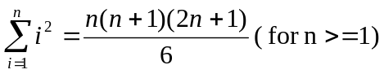

for (i=1; i <= n; i++)
for (j=1; j<= i²; j++)
cout<<“ Hi”;

1+4+9+16+25 (As 1+4+9+16+25 = 55)

n = 5 = (5(5+1)(2*5+1))/6 = 9/2(10) = (5*6*11)/6 = 330/6 = 55

