To Access Multiple Users Dropbox:

1. <https://auth0.com/docs/connections/social/dropbox>
2. <https://temboo.com/csharp/upload-to-dropbox>

To Access Your Own Dropbox:

Step 1.

You’ll need a free Dropbox Account. If you don’t already have one, sign up at <https://dropbox.com>

Step 2.

If you haven’t already, create a Dropbox app in the Dropbox app console. <https://dropbox.com/developers/apps>

When you asked to choose an API, select Dropbox API. Choose the type of access your application need: App Folder or Full Dropbox. The App name can be whatever you like. When you are done. Click Create App.

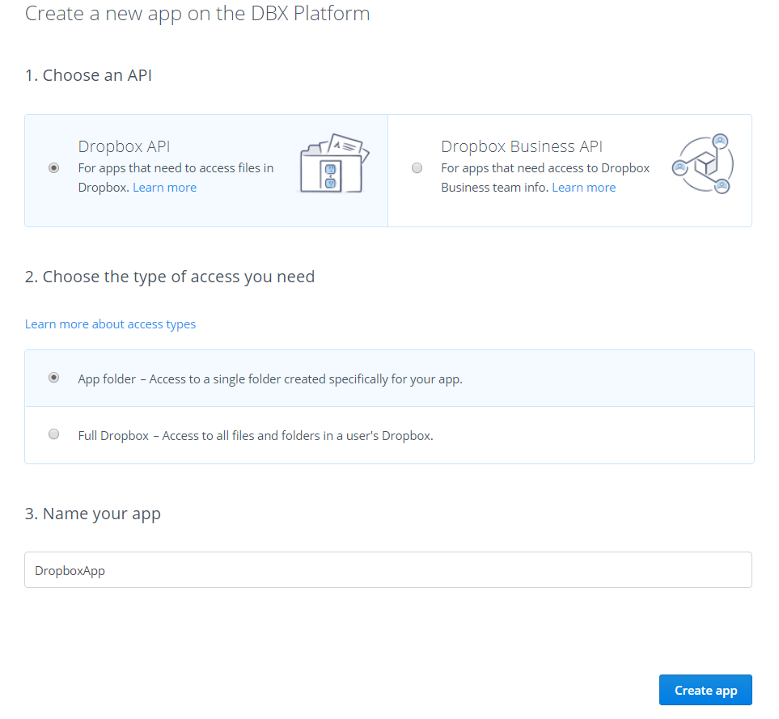

Step 3:

Click the Generate button in the OAuth 2 section. Save the generated key to use within your app to access your Dropbox account. That’s it.