Project Documentation: Night Life RP Prototype
Milestone 1: Planning & Technical Setup

1. Project Scope
This document outlines the finalized project scope, technical architecture, network flow, asset selection, and detailed development roadmap for the Night Life RP Prototype. The prototype is designed to validate core mechanics—movement, camera controls, driving physics, and multiplayer synchronization—following the gameplay style of OneState and the visual style of Gangstar Vegas.
In-Scope Features:
- Compact Test Map: A compact testing environment based on the Race Track asset from the Unity Asset Store.
- One Playable Character: A third-person playable character utilizing the Gangster Boss 3D model, with mobile-optimized virtual joystick controls and camera orbit.
- Basic Animations: Idle, walking, running, jumping, and vehicle entry/exit animations.
- One Drivable Vehicle: Full driving physics (Realistic Car Controller) with trigger-based entry and exit mechanics.
- Basic Multiplayer (Photon PUN2): Support for 10–20 concurrent test players.
- User Management: Guest login, player spawning, reconnection support, and local storage of basic player data.
- Roleplay (RP) Feature: The Identity (ID Card) System. Player names above heads are hidden by default. Players can interact and introduce themselves to make their names temporarily visible to nearby players.
- German UI/Localization: User interface, labels, buttons, and interaction prompts are fully translated into German (e.g., 'Einsteigen', 'Aussteigen', 'Ausweis zeigen').
- Android Test Build: Delivery of an installable APK for mobile playtesting.
Client Feedback & Architectural Adjustments:
- Restricted Room Creation: Regular players cannot create rooms (game servers). The 'Create Room' UI button is hidden/disabled for normal clients. Only founders and administrators are authorized to create rooms on the server. Regular players fetch the server list and join existing rooms directly.
- No Dedicated Server Deployment Needed: A new dedicated server infrastructure is not required. The prototype will integrate directly with the client's existing Photon/server environment using their App ID.
Out-of-Scope (Excluded from Prototype):
- Full combat system (weapons, shooting, hit registers)
- In-game economy (cash, dirty money, banks, taxes)
- Proximity voice chat
- Interactive mobile phone system
- The complete large map (Los Angeles/Vice City hybrid)
- Other state/illegal factions (police tablets, medical reviving systems, mechanic shops, etc. will only be simulated via UI mockups if needed)

2. Game Development Principles & Project Structure
The project code is built using the Single Responsibility Principle (SRP). Every component is designed to handle a single dedicated function (e.g., separating input detection from movement physics and network sync).
Directory Structure (Assets/Prototype/):
Assets/
└── Prototype/
├── Prefabs/ # Networked player, vehicle, and UI canvas prefabs
├── Scenes/ # Compact test map scene (using the Race Track asset)
├── Scripts/ # C# Scripts organized by SRP
│ ├── Core/ # Boot management and persistent settings
│ ├── Player/ # Mobile touch input and movement controllers
│ ├── UI/ # German localization and screen overlay managers
│ ├── Vehicle/ # Car controller wrappers and entry/exit syncer
│ └── RP/ # Identity (ID card) logic
├── UI/ # Fonts, sprites, and localization text sheets
└── architecture_flow_chart.png # Visual architecture diagram

3. Network & Gameplay Flow
The diagram below illustrates the corrected workflow for character loading, mobile configurations, and restricted lobby joining (with no room creation for normal players):
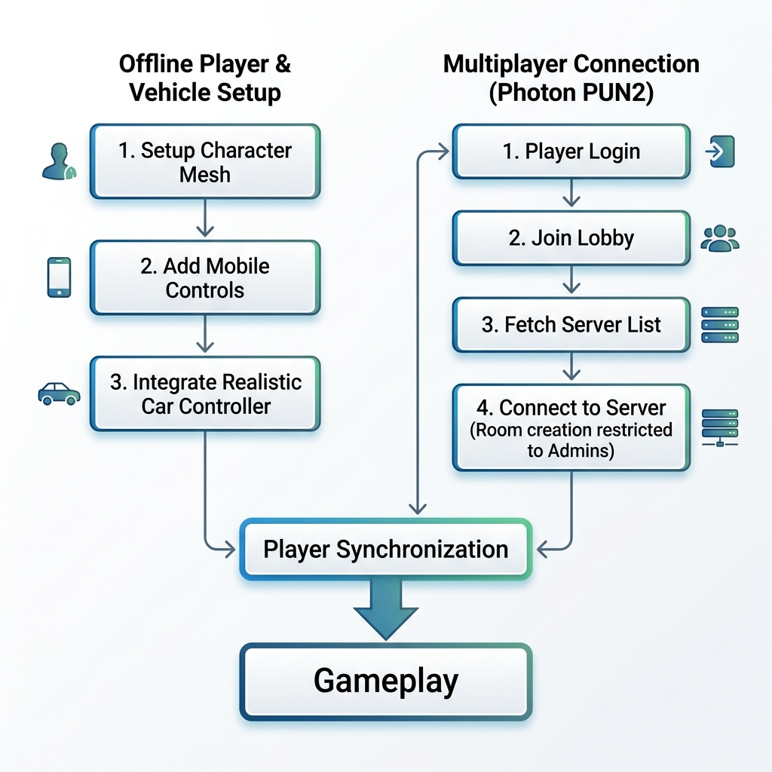

4. Required Assets and Plugins
- Humanoid Character Model: Gangster Boss (Sketchfab) (https://sketchfab.com/3d-models/gangster-boss-e97810fa7398473aaf3465e11581fe7b)
- Environment (Map): Race Track (Unity Asset Store)
- HUD & Navigation: HUD-Navigation-System (Unity Asset Store) (https://assetstore.unity.com/packages/tools/gui/hud-navigation-system-103056)
- Character Controller: Ju TPS 3 (Unity Asset Store) (https://assetstore.unity.com/packages/templates/systems/ju-tps-3-third-person-shooter-gamekit-vehicle-physics-251334)
- Vehicle Physics: Realistic Car Controller (Unity Asset Store) (https://assetstore.unity.com/packages/tools/physics/realistic-car-controller-16296)
- Multiplayer System: Photon PUN2 - Free (Unity Asset Store) (https://assetstore.unity.com/packages/tools/network/pun-2-free-119922)
- VFX/Particles: Epic Toon FX (Unity Asset Store) (https://assetstore.unity.com/packages/vfx/particles/epic-toon-fx-57772)

5. Detailed Development Plan (Milestones 1–4)
Part 1 – Planning & Technical Setup (2 Days) - Completed
- Finalized the prototype scope and incorporated client's restricted joining rules.
- Configured the base project structure in Unity (Version 2022.3.0f1 LTS).
- Established custom directories and compiled base scripts.
- Generated technical diagrams and completed documentation.
Part 2 – Basic Gameplay (1–2 Weeks)
- Import the Race Track asset to serve as the compact test map.
- Rig the Gangster Boss 3D model onto the Ju TPS 3 controller.
- Configure touch controls for movement (joystick) and camera rotation (orbit swipe).
- Create the player spawn system.
- Set up the trigger mechanism using Realistic Car Controller to handle entry/exit transitions (prompting German UI text 'Einsteigen').
Part 3 – Multiplayer & Backend (1–2 Weeks)
- Integrate Photon PUN2 to synchronize player positions, rotations, and animation triggers.
- Implement a guest login screen.
- Disable room-creation inputs for normal players, allowing joining only.
- Connect clients directly to the client's existing test server infrastructure.
- Write a session manager to handle connection dropouts and automatic reconnection.
Part 4 – RP Feature, Testing & Handover (2 Weeks)
- Implement the custom Identity System (name display visibility toggled via proximity and 'Sich vorstellen' button).
- Apply German translation across all HUD overlays, menus, and system status logs.
- Optimize rendering for Android (batching static geometry, limiting lighting).
- Package and build the final Android APK file.
- Compile and deliver the documented source code to the client.

6. Verification & Test Plan
- Compilation Check: Test Android platform compilation target inside Unity build settings.
- Access Control Verification: Assert that a non-admin client cannot successfully send room-creation requests to Photon.
- Sync Verifications: Verify that 10–20 players can coordinate and view animations, character positions, and driving physics accurately.
- UI Validation: Audit German translations on mobile viewports for formatting and clipping.

