The Dataset is collected from <https://www.kaggle.com/datasets/kumarajarshi/life-expectancy-who>

The dataset is prepared from WHO website and the basic purpose of it to estimate life expectancy by several factors. We have also explored the dataset and made some visualizations.

# Visualization

## Scatter Plot

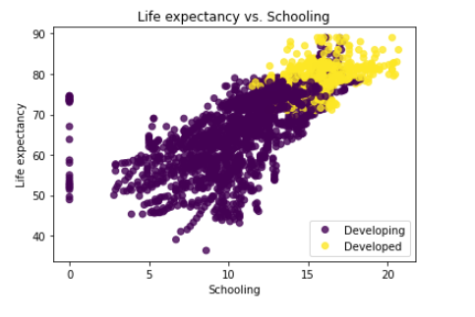

We have created a scatter chart to demonstrate the relationship between two variables. In this example, we are exploring the relationship between Life expectancy and Schooling. The above diagram shows that there is positive relationship between both of these variables. We also included third variable that shows the difference of this relation among developed and under-developed countries. The above plot shows a strong positive relationship and also we can conclude that developed countries progressed more than developing countries in schooling.

## Line Plot

We have used Multi line plot to compare the average life expectancy of both developing countries and developed countries. It shows that developed countries have high life exp as compared to developing countries. It also shows that both types have increase in average life expectancy with respect to their scales. This plot uses for comparison between two categories upon certain scales.

## Coorelation Matrix

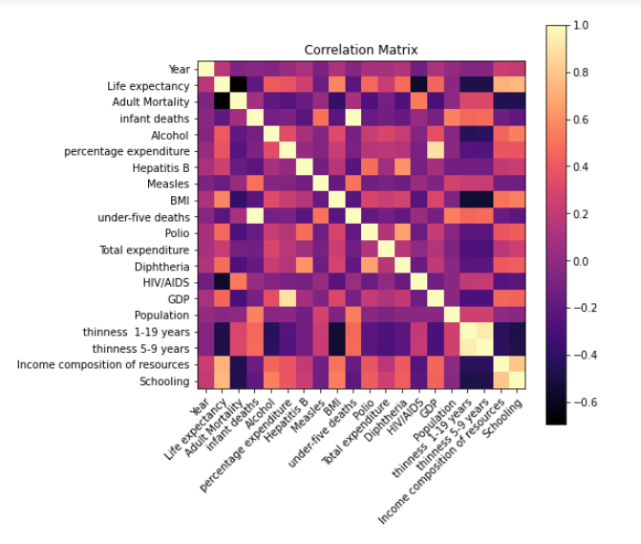

Based on above correlation matrix below are the insight

Adult Mortality: There is a strong negative correlation between adult mortality and life expectancy, indicating that countries with higher adult mortality rates tend to have lower life expectancies.

BMI: There is a moderately strong positive correlation between BMI and life expectancy, indicating that countries with higher average BMI tend to have higher life expectancies.

Income composition of resources: There is a moderately strong positive correlation between income composition of resources and life expectancy, indicating that countries with higher levels of income tend to have higher life expectancies.

Schooling: There is a moderately strong positive correlation between schooling and life expectancy, indicating that countries with higher levels of education tend to have higher life expectancies.

Other variables that have moderate correlations with life expectancy include Alcohol, percentage expenditure, Polio, Diphtheria, and GDP.

On the other hand, there are several variables that have weak or no correlation with life expectancy, including infant deaths, Hepatitis B, Measles, under-five deaths, Total expenditure, HIV/AIDS, Population, thinness 1-19 years, and thinness 5-9 years.

## Bar Plot

We have used bar plot to compare countries over different variables. In this example we check top 20 countries in average infant death.

## Pie Chart

In previous example, we have used bar plot and it shows that india has high infant deaths score. So we create pie chart for checking the weightage of infant deaths over the course of 15 years. We concluded that infant deaths were high from 2000 to 2004.

