Macro Risk Driver Model

Model ID:

Version: 2017Q4

**Whitepaper Version: 1.0**

Primary Model Owner: **Todd Peterson**

Author(s): **Yigao Liang, Todd Peterson, Dajing Shang**

Modeling and Analytics Department: **Enterprise Models**

Approving Officer: **Mark An**

Application/EUC Version & ID:

Disclaimers

Confidential Commercial Information – Confidential Treatment and FOIA Exemption Requested.

Unless otherwise specified in this document, do not use this information as an input to or in support of other reporting processes, production application, pr EUC (End-User Computing), regardless of financial reporting designation. Contact the provider of the information listed in this document if you need to use the information for such purposes.

Version Log

|  |  |  |  |
| --- | --- | --- | --- |
| Version No. | Date | Changes | Author(s) |
| V1.0 | November 28, 2017 | Initial document | Dajing Shang |
|  |  |  |  |
|  |  |  |  |

Table of Contents

Executive Summary 4

1. Introduction 5

1.1. Motivation for Model Update 5

1.2. White paper outline 12

2. Model Uses / Purpose 12

2.1. Business Units 12

2.2. Model Dependencies 12

2.3. Model Scope / Applicability 12

3. Model Output 13

3.1. Definition 13

4. Theoretical Background 13

5. Alternative Structures / Methodologies 14

6. Estimation Data 14

7. Key Drivers 18

8. Final Model Structure 19

9. Model Assumptions 22

10. Model Testing / Validation 22

11. Model Limitations 36

12. Model Performance 36

13. Simulation Process 40

14. Conclusion 40

References 41

Appendices 42

Appendix 1. Multi-horizon forecast uncertainty Sampling 42

Appendix 2. Conditional normality …………………………………………………………..44

Executive Summary

The macro risk driver model systematically studies how a set of macroeconomic variables, deemed as key risk factors underlying Fannie Mae’s book of business, jointly evolve over time. The model quantifies the dynamic interrelationships between key risk drivers so that downstream loan performance models can consume a more realistic economic environment and produce accurate risk metrics, resulting in improved risk management. The modelled macroeconomic variables include national home price, consumer price index (CPI), employment, personal income, unemployment rate, multifamily housing starts, federal fund rate, nominal and real 10-year treasury rate and mortgage rate. These ten variables paint an integrated picture of housing market landscape at any point in time. The model provides a unified view of how these risk drivers interact with each other through time. The strengthened modelling of the interaction between risk drives betters risk management by generating point as well as distributional forecasts, providing theoretically sound simulation cones, facilitating consistent and realistic scenario-generations, and improving model risk management.

The model adopts a vector auto-regressive (VAR) functional form. The VAR structure exploits the interdependence between included variables, and the serial dependence in each variable’s time dimension. Thus, the model is self-sustainable in that it can be used to predict included macroeconomic variables for any given horizon without relying on external models. Because all macroeconomic variables are endogenous in the model, the forecast uncertainty can be quantified in an internally consistent way and distributional forecasts can be generated.

*Reviewed by:*

*Date:*

1. Introduction

Over the life of a mortgage, many housing related macroeconomic variables influence the home owner/renter’s decision on the underlying loan. Typical examples are people choose to default on their mortgages when home prices drop to certain level and tend to refinance on falling interest rates. The value of mortgages is thus fundamentally driven by lots of macroeconomic variables. All these housing related risk factors do not act in isolation. Instead, they move together over time. In order to effectively quantify and manage the risks in our mortgage portfolio, it is useful for us to gain a unified view on how these risk factors jointly evolve in the future.

The macro risk driver model specifies how housing risk drivers interact and evolve through time and provide multi-horizon and multi-path forecasts for these variables. The modelled macroeconomic variables include national home price, consumer price index (CPI), employment, personal income, unemployment rate, multifamily housing starts, federal fund rate, nominal and real 10-year treasury rate and mortgage rate.

The model adopts a vector auto-regressive (VAR) functional form. Without resorting to a particular economic theory, the parsimonious VAR model structure exploits the interdependence among macroeconomic variables, and their own serial dependence in time dimension. Thus, the model is self-sustainable in that it can be used to predict included macroeconomic variables for any horizon without any dependence on outside models.

We show that the model closely imitates the historical scenarios and at the same time achieves good forecasting performance out of sample. Additionally, the forecasts uncertainties are quantified in an internally consistent way so that distributional forecasts and consistent random paths are readily available.

Currently, many risk drivers are modelled separately so ad-hoc adjustment is often required for the purpose of generating multiple paths. For example, due to the reliance on external model for its input variables, local HPI model has to employ a separate and rather ad-hoc model to generate multi-path simulations. The simulated home price and interest rates are not paired to preserve the observed dynamics. For another example, multifamily credit works has its own model for a smaller group of macroeconomic variables that are related to rental business. However, the correlation between this group and single family home prices are not quantified in the existing framework. This might lead to inferior risk analysis for cross-business products like single family rental deals.

The newly proposed model is aimed to model the dynamic relationship among all important risk drivers, being it single family related or multifamily related. And because we model them jointly, we can quantify the uncertainty surrounding the point forecasts and make it easier for joint and multi-path generation.

1.1. Motivation for new Model

The new model makes the following major enhancements over the existing one: firstly, the new modelling approach replaces the old model infrastructure that only incorporates limited interaction between risk drives with a new one that directly models their interdependence over time. The pervasive dependence between risk drivers are so evident in the data that overlooking them will lead to ineffective modelling and risk management. And the interdependence captured in the new model can potentially improve the point forecasts for important drivers like HPI and IR.

Secondly, the new model can provide theoretically sound simulation cones that the old model cannot produce. On every path inside the cones generated by the new model, risk drivers are not randomly paired like the old model does. Instead, their internal correlation as well as time persistence seen in the historical data are preserved in simulation. The capability of generating mutually consistent risk factors is key to effective risk management for mortgages as the loans are loaded with prepayment and default options.

Thirdly, the new model provides an effective tool for scenario generation. Due to lack of direct modelling of the interdependence among key risk drivers, the current scenario generation practice is rather ad-hoc and inconsistent model usage is inevitable. In contrast, the new model naturally generate scenarios in a consistent way. Additionally, it is easy to prescribe certain scenarios (for example, management stress scenarios) or extend the conditional scenarios (for example, Dodd-Frank tests) in the proposed model.

Fourthly, the new model improves model risk management as it removes the dependence of external models.

We will expand the discussion on these motivations one by one in the rest of this section.

1.1.1 Improved model infrastructure emphasizing interdependence

The figure below shows how two of Fannie Mae’s business sectors are related to their respective risk drivers.

Figure 1.1: Business sectors and example risk drivers

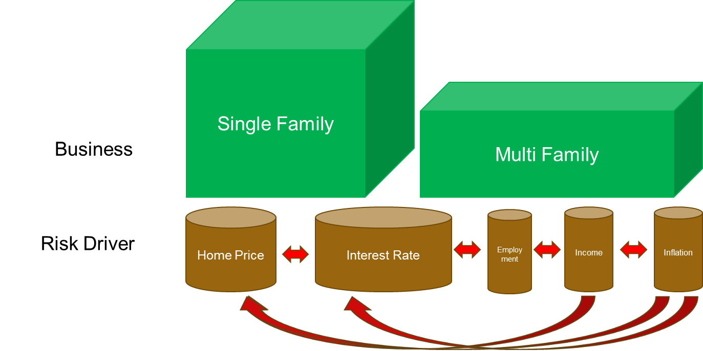

In order to capture the dependence shown above, Fannie Mae’s loan performance models take some of the drivers as input variables. The complete dependence structure of macro risk drivers on behavior models is summarized in the following table:

Table 1.1: Behavior model dependence on input risk drivers



As the read arrows in the Figure 1.1 above indicates, the risk drivers also depend on each other when influencing the business. The aim of the newly proposed model is to directly model this inter-driver dependence.

We surveyed the inputs to Fannie Mae’s in-house Single family models as well as Multi-family models and conclude that at a minimum, we need to model the following risk drivers: national home price, consumer price index (CPI), employment, personal income, unemployment rate, multifamily housing starts, federal fund rate (FFR), nominal and real 10-year treasury rate and 30-year mortgage rate.

This list of macroeconomic variables encompasses labor market variables (employment and unemployment rate) as well as financial variables like interest rates. And this list includes many important housing variables in order to picture the housing landscape in any time point. It’s also customary to include central bank’s policy rate (FFR), inflation and unemployment rate in the system as a specification of Taylor Rule.

Currently these key risk drivers are either being analyzed in separate models, or provided by outside vendors. The existing modelling framework for risk drivers can be summarized in the following figure:

Figure 1.2: Existing model infrastructure: limited interaction

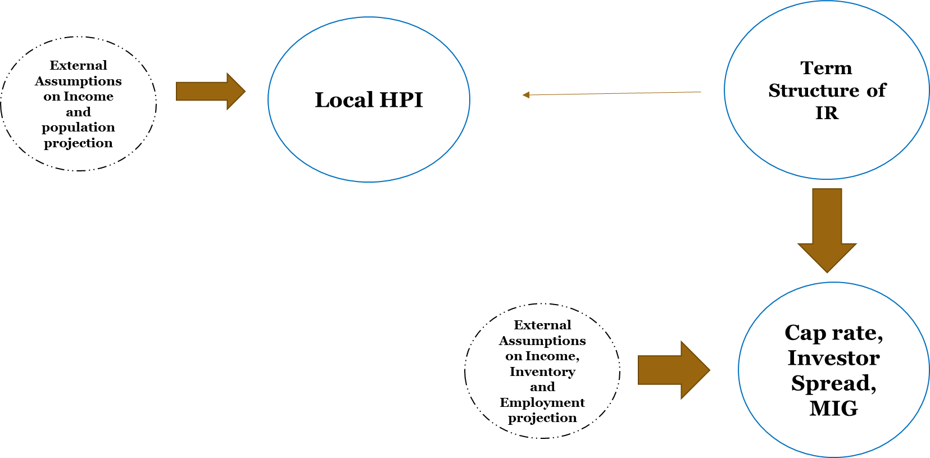

As Figure 1.2 shows, because local HPI model and Cap rates/Investor Spreads/MIG model use different vender models as inputs, subsequent SF and MF behavior models that take these two risk driver models as inputs, do not take into consideration the interactions between risk drivers.

There are two undesired consequences from modeling risk drivers separately: first, the risk driver forecast partially relies on the forecast accuracy of other input models, potentially from outside; second, the dependence between risk drivers is not quantified; third, the uncertainty around forecasts from a chain of models is difficult to quantify in simulation, leading to over- or under- estimated risks.

Designed to overcome the above deficiencies, the Macroeconomic model provides a unified view of how various risk drivers (in particular home price and interest rates) interact with each other.

This new model treats all the macroeconomic factors endogenous so that we don’t need to rely on the forecasts of external models. At the same time, the forecast uncertainty can be quantified in a consistent way.

The following figure shows how the proposed new model improves the quantifications of the inter-dependence among risk drivers.

Figure 1.3: Proposed model infrastructure: strong interdependence

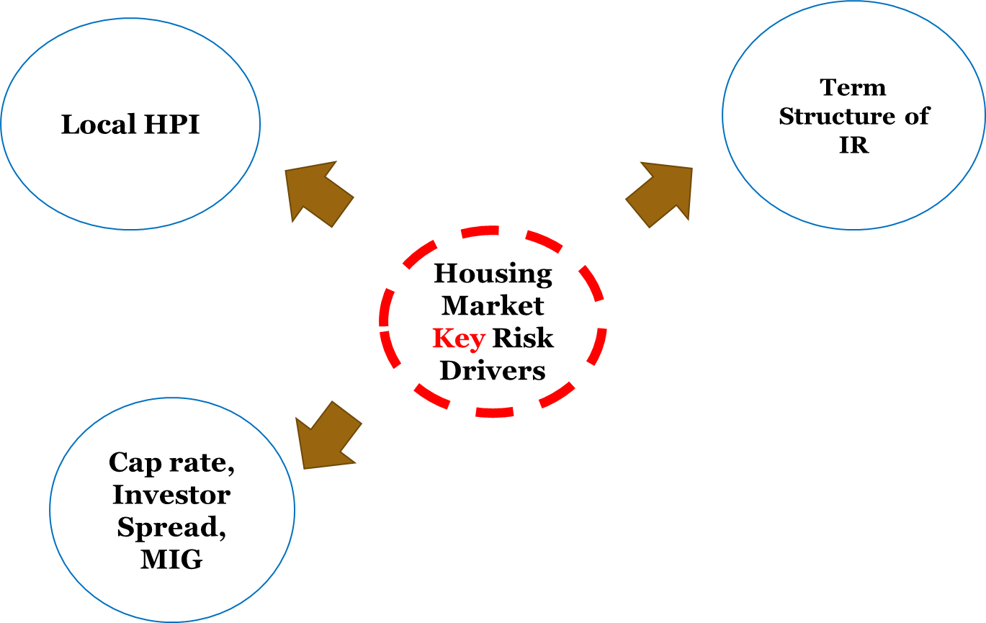

As Figure 1.3 indicates, we group a small numbers of the key risk drivers in a core model and then model all other drivers as derived from this core model. This way, all the risk drivers are connected in a parsimonious modeling framework.

The old model infrastructure only incorporates limited interaction between risk drives while the new one that directly models their interdependence over time. Overlooking the pervasive dependence between risk drivers in the data results in ineffective risk management. And the interdependence captured in the new model can potentially improve the point forecasts for all included drivers.

1.1.2 Improved distributional forecasts/simulation

In mortgage risk management and valuation, accurate distributional simulation/forecasts are critical. This because mortgages are loaded with borrower’s options: for example, the mortgagor may exercise the option of default on falling home price or opt to refinance in response to low interest rates. In order to effectively manage these option-related risks in mortgages, we need not only a point forecast for the key risk drivers but also their other possible realizations with associated likelihood.

Currently, many risk drivers are modelled separately so ad-hoc adjustment is often required in regards to multi-variate simulation. For example, due to the reliance on external model for its input variables, local HPI model has to employ a separate and rather ad-hoc model to generate simulations. The simulated home price and interest rates are then paired randomly, instead of being paired to preserve the history pattern. As another example, multifamily credit works has its own model for a smaller group of macroeconomic variables that are related to rental business. However, the correlation between this group and single family home prices are not quantified in the existing framework. This separation might lead to inferior risk analysis for cross-business products like single family rental deals.

In contrast, the new model provides transparent and consistent ways of simulating/forecasting multiple risk drivers. As the new model specifies how the risk drivers jointly evolve, the multi-variate simulation/forecast is straightforward. Figure 1.4 below shows that the new model can not only make point forecasts but also distributional forecasts (graphically shown as cones).

Figure 1.4: Example distributional forecasts by proposed model

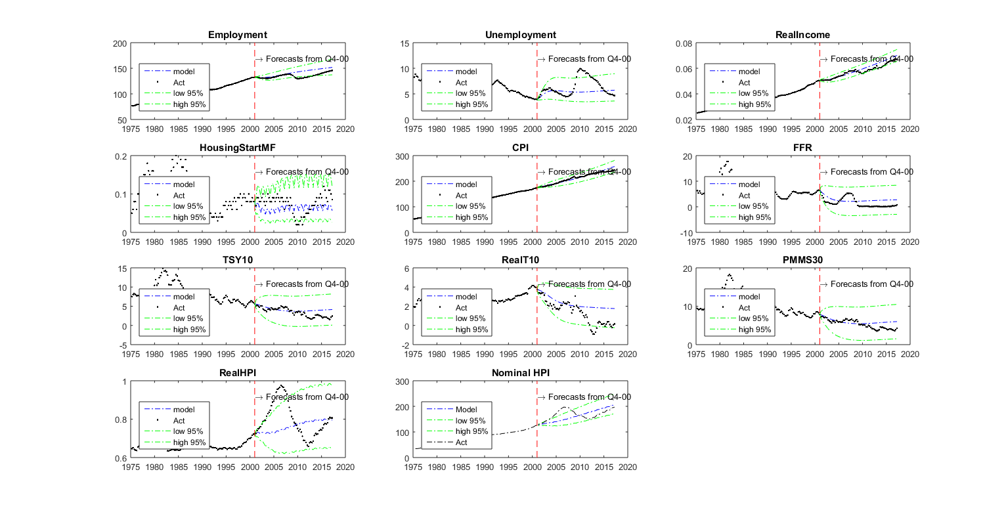

On every path inside the cones generated by the new model, risk drivers are not randomly paired. Instead, their internal correlations are preserved.

The model take all risk drivers as endogenous so it removes all conditional dependences from outside models. This benefits the generation of simulation paths in a non–ad-hoc way.

Figure 1.5: A multivariate simulation path by proposed model

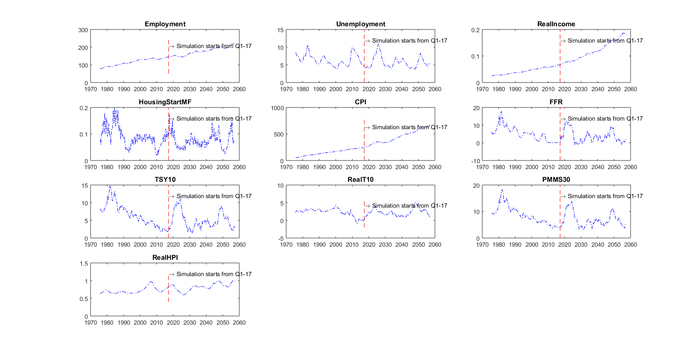

Figure 1.5 shows one path for each of the ten included risk drivers. The simulation is constructed in such a way that the interaction between risk drivers is built in. This capability of generating mutually consistent random paths is key to effective risk management for mortgages as the loans are loaded with prepayment and default options.

1.1.3 Improved scenario generation

Due to lack of direct modelling of the interdependence between key risk drivers, the current scenario generation practice is rather ad-hoc and inconsistent model usage is inevitable. For example, in order to expand a series of prescribed economic time series to input variables to our internal loan behavior models, we built a few bridge models, which are different from production ones.

In contrast, the new model naturally generate scenarios in a consistent way. Additionally, it is easy to prescribe certain scenarios (for example, management stress scenarios) or extend the conditional scenarios (for example, Dodd-Frank tests). As we only need to specify the paths for a few key risk drivers and we can then extend to all other risk drivers according to the dependence structure shown in Figure 1.3.

1.1.4 Improved model risk management

Existing models often rely on other vender’s projection at different stages. This convoluted model dependence structure complicates model performance tracking and management.

The new model infrastructure also improves model risk management as we can now conduct more meaningful model performance tracking and attribution. Without the dependence on outside models, it is easy to identify and correct the weak part of the models.

1.2. Whitepaper Outline

The rest of the whitepaper is organized as follows. Section 2 describes some of the model’s use cases at Fannie Mae. Section 3 describes the model output. Section 4 reviews theoretical researches on macroeconomic forecast. Section 5 reviews alternative forecast models. Section 6 and 7 describe the data and key variables used in the proposed model. Section 8 describes details of the proposed model. Section 9 lists model assumptions. Section 10 provides results from back-testing, scenario analysis and impact testing. Section 11 discusses model limitations. Section 12 reviews model performance and vetting results. Sections 13 describes the simulation process. Section 14 concludes. Technical details are put in the appendices.

*Reviewed by:*

*Date:*

2. Model Uses / Purpose

2.1. Business Units

We expect multiple business units at Fannie Mae could benefit from the model output. For example, the first application of this model is to provide a reasonably constructed home price simulation for credit risk transfer (CRT) purpose. The major business units that can benefit from the model outputs are:

* Single Family Underwriting and Pricing

2.2. Model Dependencies

The Macroeconomic model in general can remove any model dependence.

2.3. Model Scope / Applicability

*Reviewed by:*

*Date:*

3. Model Output

**3.1. Definition**

The Macroeconomic model currently provides the forecasts of the following risk factors:

* National home price index,
* Employment,
* CPI level(Inflation),
* Personal income,
* Unemployment rate,
* Multifamily housing starts,
* Federal fund rate(FFR),
* Nominal 10-year treasury rate,
* Real 10-year treasury rate,
* 30Y mortgage rate.

In addition to the point (median) forecasts, the model also provide distributional forecasts for the variables in above list.

*Reviewed by:*

*Date:*

4. Theoretical Background

The basic framework of the Macroeconomic model is a VAR time series model, which is widely used in business sectors and government agencies. The time series model utilize the interdependence among selected variables and the serial correlation inherent in the variables.

The model uses a ten-dimensional vector of macroeconomic variables to picture the economy at each point in time. The included variables are national home price, consumer price index (CPI), employment, personal income, unemployment rate, multifamily housing starts, federal fund rate(FFR), nominal and real 10-year treasury rate and 30-year mortgage rate. This list includes many important housing variables in order to picture the housing landscape in any time point. The macroeconomic model combines all these risk drivers into one model and investigates their interaction. The time-varying risk drivers can be regarded as state variables, where a term structure model can be built upon.

The VAR model structure is flexible to allow for more variables to be modelled. We choose VAR structure because of its simplicity and extendibility.

*Reviewed by:*

*Date:*

5. Alternative Structures / Methodologies

This section begins with a survey of various macroeconomic forecasting models in the financial industry.

There are many other time series models for forecasting. For example, one could consider vector error correction model, or Markov-switching time series model to account for some complicated dynamics in the data. We choose not to pursuit these and other nonlinear time series model because the relative simplicity of our VAR model and its good forecast performance. We leave these other models as future improvements.

*Reviewed by:*

*Date:*

6. Estimation Data

The estimation data used for the model source from Moody’s DATABUFFET, Fannie Mae’s historical home price index (HPI), and Freddie Mac’s Primary Mortgage Market Survey. The sample spans from 1975Q1 to 2015Q4 and is of quarterly frequency.

Specifically, the data includes: historical Fannie Mae’s national HPI; Employment from Moody’s DATABUFFET with Mnemonic “FET.US”; consumer price index (CPI) from Moody’s DATABUFFET with Mnemonic “FCPIU.US”; unemployment rate from Moody’s DATABUFFET with Mnemonic “FLBR.US”; Personal Income from Moody’s DATABUFFET with Mnemonic “FYPQ.US”; Multifamily housing starts from Moody’s DATABUFFET with Mnemonic “FXHSTMF.US”; Fed funds rate (FFR) from Moody’s DATABUFFET with Mnemonic “FRFED.US”; 10-year Treasury rate from Moody’s DATABUFFET with Mnemonic “FRGT10Y.US”; 10-year real Treasury rate from IRDB with collection name “Derived_real_Treasury_rate”; zero-point 30-year mortgage rate (PMMS30) from IRDB with collection name “PMMS30”. Table 6.1 presents a snapshot summary of the variables that are included in the proposed model.

**Table 6.1: Variables Used in the Macroeconomic Model**



In order to get a sense of how these selected variables move together, we plot them in the following figure:

**Figure 6.1: Trends, Seasonality, Cycles and Co-movements**

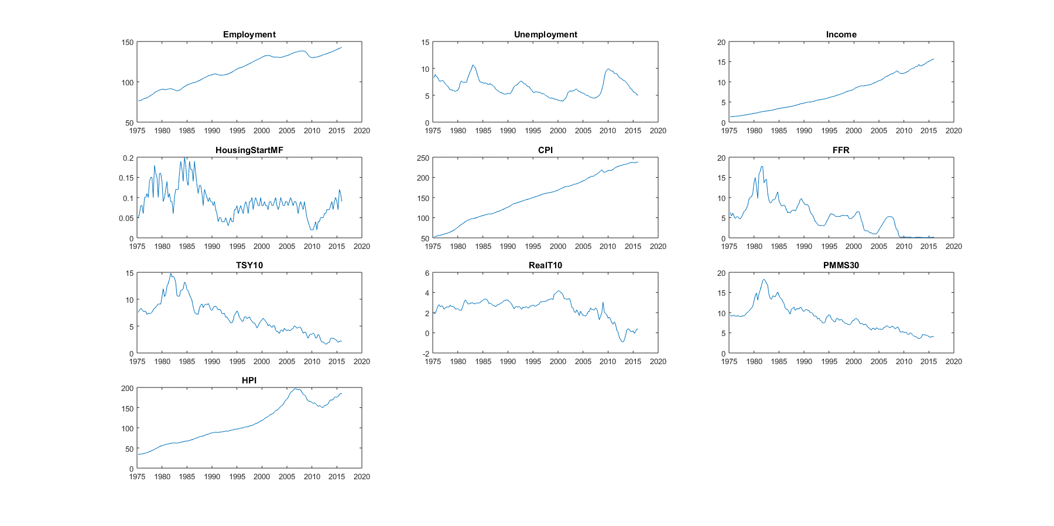

It’s evident from figure 6.1 that Income, CPI and HPI have clear trend with large swing in HPI due to recent housing market turmoil. FFR, PMMS30 and TSY10Y are drifting to historical lows recently, reflecting central bank’s effort to stabilize the economy. Unemployment clearly varies with business cycles in the sample period. Multifamily housing starts display strong seasonal patterns.

In order to group these selected variables in the VAR model, we need to remove the trend inherent in Income, CPI and HPI. Therefore, we introduce the data transformation in table 6.1 above. The data flow can be shown in the following figure:

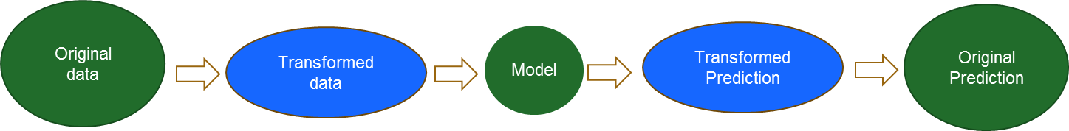

Specifically, we transform the employment variable into employment growth as the latter being the difference in logarithm of the former. Since unemployment rates are in the range of [0,100], we used a logistic function to transform this variable into a variable with unbounded range:

.

As or the trending variables like income, CPI and HPI, we remove the trend of the logarithm and further remove the seasonality in HPI. For example, we remove the trend and seasonality from HPI as follows:

.

We assume the average annualized growth rate of real HPI being 20 bps. Another example is real income:

.

We also assume CPI is trend-stationary:

.

For the above three trending variables, the annual growth rate is . The following figure displays these three trending variables and their fitted trends:

**Figure 6.2: Trend fitting for risk drivers**

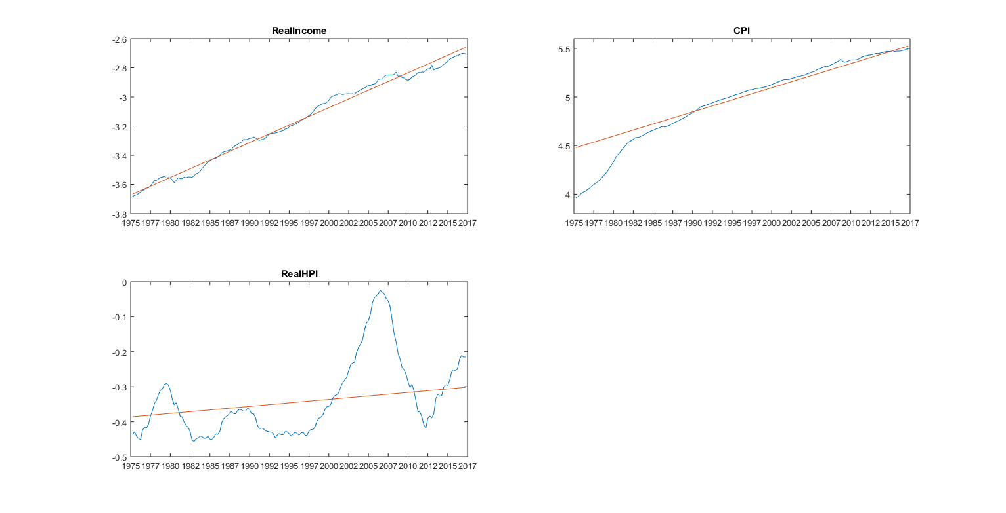

It can be seen from Figure 6.2 that the trend clearly separates the housing bubble period with recent crisis period.

We use the following transformation for the employment data:

.

We assume interest rates can be negative and are mean-reverting so there is no transformation for the included four interest rates.

The final transformed data is shown in the figure 6.3. We use this data for subsequent VAR model calibration.

**Figure 6.3: Transformed Data**

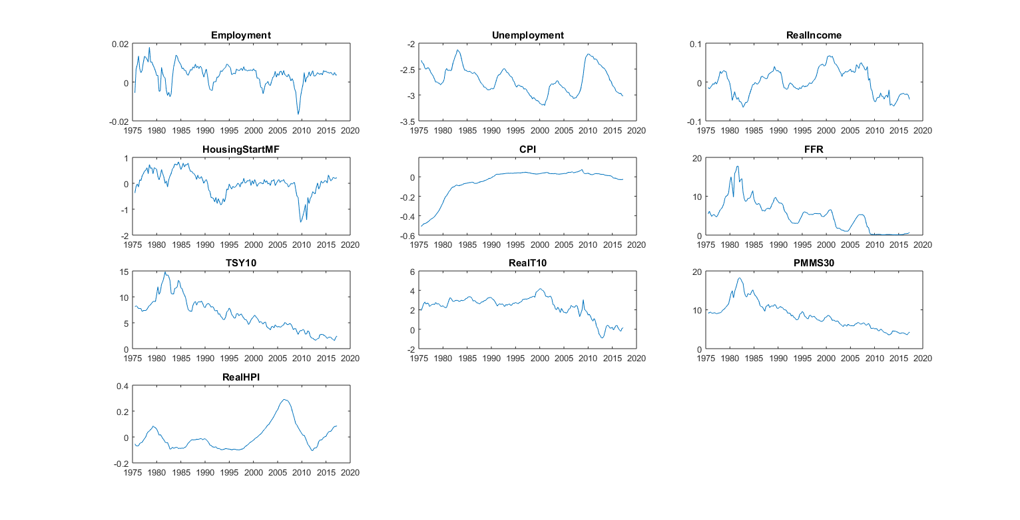

*Reviewed By:*

*Date:*

7. Key Drivers

The key drivers of the model are: national home price, consumer price index (CPI), employment, personal income, unemployment rate, multifamily housing starts, federal fund rate(FFR), nominal and real 10-year treasury rate and 30-year mortgage rate.

The inclusion of home price and interest rates is obvious as these are deemed as two major sources of risk to Fannie Mae’s book of business. In addition, inflation and unemployment are included in the model. This is because the two are the determinants of short term interest rate (such as the three-month treasury rate), which is a policy rate employed by central bank to guide the economy. The determination is often referred as Taylor rule, which quantifies central bank’s dual mandate: control inflation and achieve full employment. Furthermore, inflation and unemployment can also impact home prices.

It is well documented that yield curve slope and level are among the dominating factors that can explain most of the yield curve dynamics. The macroeconomic model pools these two interest rate factors with macroeconomic variables to model the interaction among them.

*Reviewed by:*

*Date:*

8. Final Model Structure

To fix notation, the ten included macroeconomic variables is grouped into a vector *Y* and ten transformed variables into :

*Y = {Employment, CPI,RealHPI, UnemploymentRate, RealIncome, MFHS,FFR,RealT10,NominalT10,PMMS30}*

And

*X = {Employment_Growth, Detrend_log_CPI, Deseason_Detrend_log_RealHPI, Transformed_UnemploymentRate, Detrend_log_RealIncome, Deseason_log_MFHS,FFR,RealT10,NominalT10,PMMS30 }.*

The model’s functional form is of vector autoregressive structure with trends and seasonal dummies

,

,

where *p* indicates the maximum lag in the model, is a 10x1 vector, is a 10x10 matrix and is also a 10x10 matrix.

We first estimate the trends and seasonality and the resulting parameters are given in table 8.1 and 8.2 below:

**Table 8.1: Trend Parameters**

|  |  |  |
| --- | --- | --- |
| **RealIncome** | **CPI** | **RealHPI** |
| -3.6722 | 4.4729 | -0.3864 |
| 0.0060 | 0.0062 | 0.0005 |

**Table 8.2: Seasonality Parameters**

|  |  |  |
| --- | --- | --- |
|  | **HousingStartMF** | **RealHPI** |
| Q1 | -2.672 | 0.000 |
| Q2 | -2.438 | 0.010 |
| Q3 | -2.406 | 0.011 |
| Q4 | -2.498 | 0.005 |

It can be seen that the annual growth rate is 2.4% for real income and 2% for real HPI index. The annual inflation is 2.48%. From the seasonality table, one can see that the better season for housing market are Q2 and Q3 while it cools down in Q3 and Q4.

We choose the system lag to be 1, i.e. *p=1*. There are two major reasons for this lag choice. Firstly, for a VAR model with ten variables, the number of parameters will go exponentially with the number of lags, which quickly drain the degree of freedom in data and lead to over-parameterization and inferior forecast result. Secondly, the BIC criteria also suggests that p=1 is the best choice.

The model parameters in the VAR(1) are summarized in the following Table 8.3:

**Table 8.3: VAR Parameters**



The Eigen values of are:

(0.36,0.81+0.15i,0.81-0.15i,0.74,0.93+0.08i,0.93-0.08i,0.89,0.97,0.96+0.03i,0.96-0.03i).

They are all less than 1 in module, which indicates the system is stationary and some oscillation behavior may appear in the long-run forecasts.

The long-run variance of *X* can be expressed as, and the long-run mean can be. As the interest rates are not transformed, we can see the model implied long run average as

**Table 8.3: Long-run mean of interest rates**

|  |  |  |  |
| --- | --- | --- | --- |
| **FFR** | **TSY10** | **RealT10** | **PMMS30** |
| 2.92 | 4.37 | 1.73 | 6.28 |

The long-run equilibrium level of PMMS30 is 6.28%, smaller than the historical average of 8.71%. The long-run equilibrium levels of other interest rate variables also look reasonable.

As shown in Figure 8.1, the model residuals do not have significant persistency. However, some residuals show volatility clustering, which indicates that an additional GARCH/ARCH model for the residuals might help improve the overall performance.

**Figure 8.1: Model residuals**

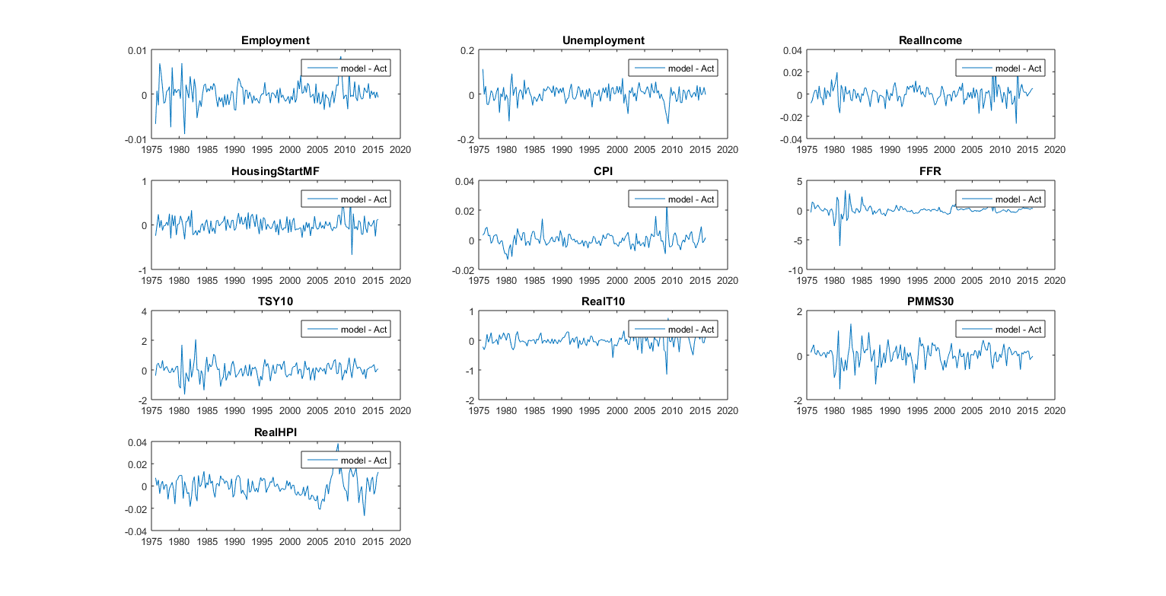

By adding back the trend and seasonality, we can evaluate the total model fits with actual data. This is shown in Figure 8.2 below. Again, the model seems to replicates the past very well.

**Figure 8.2: The model fit**

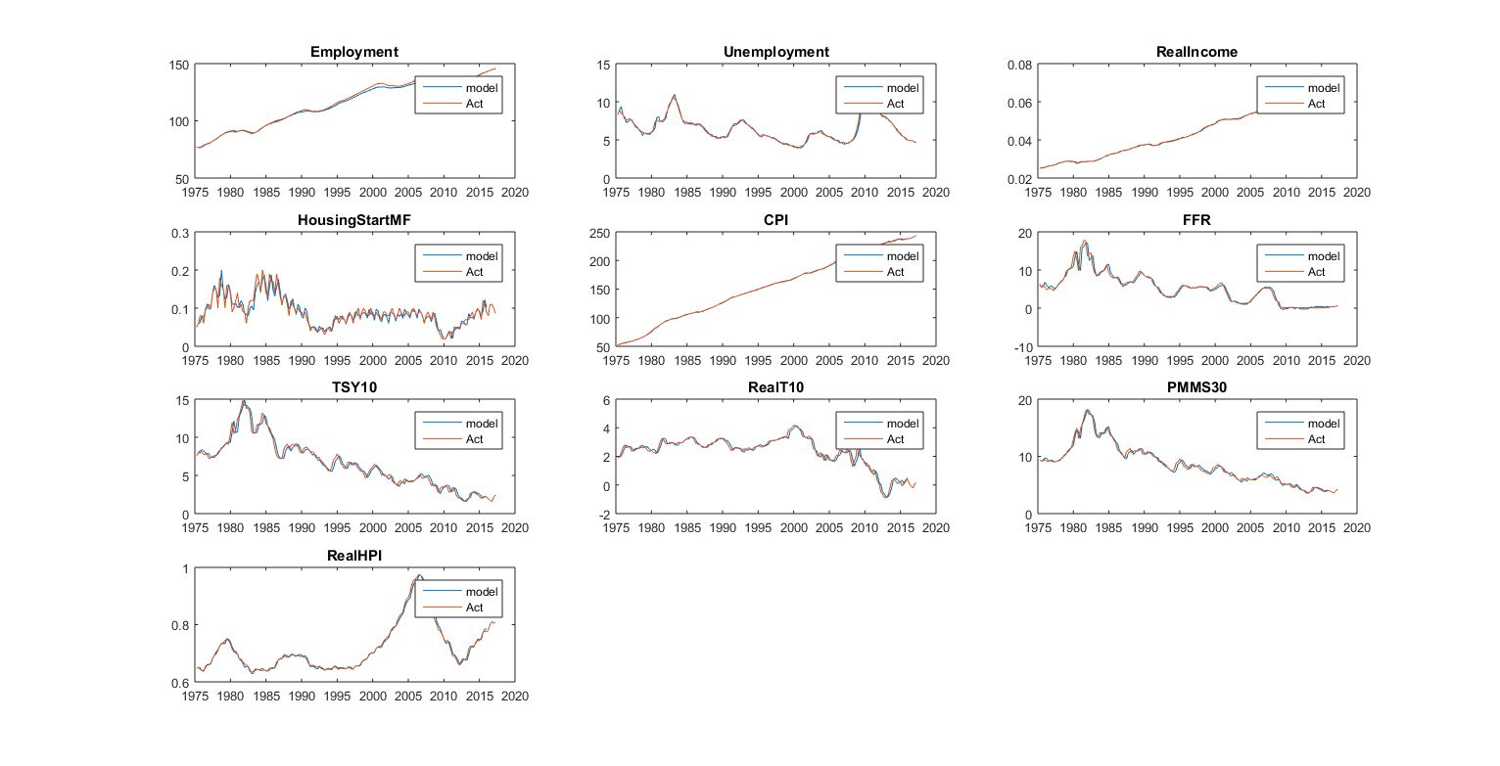

*Reviewed by:*

*Date:*

9. Model Assumptions

There are a few implicit model assumptions:

* The CPI, Real income and Real HPI are trend-stationary;
* The annual growth rate of real home price index is 20 bps;
* Transformed variables are jointly normally distributed;
* Model structure and parameters do not change with time.

*Reviewed by:*

*Date:*

10. Model Testing / Validation

## 

This section examines the model from different perspective. First we show the model back-test result for the included variables. It illustrates how well the model repeats history. Second, we look at the transformed variables. Third, we conduct sensitivity analysis for the joint model.

## 10.1. Back Testing

As the first step to assess the appropriateness of the proposed model, we look at the back-test results. A typical back-test makes forecast starting from a past time point and see how closely the forecasts match the realized time series.

Currently production HPI forecast model uses a conservative approach which assumes that the forecasts from HPI model is not useful in determining the uncertainties surrounding forecasts. In case the model is correct or even approximately so, the resulting cone size is inevitably too wide.

In contrast, the new approach used by the proposed model quantifies the uncertainties in HPI forcasts as well as other macro variables. Consequently, the cone size is narrower than that in the production model.

We select a few historical dates as starting point in our best tests: 1995Q4, 2000Q4, 2006Q3, 2009Q3 and 2012Q3. These dates represent test points for long-run(20-year), medium-run(15-year), housing-bubble, housing-crisis and housing recovery, respectively.

Figure 10.1 to 10.5 shows the test results for the ten included macroeconomic risk drivers. We can see that the point forecasts seem to track realized values very well and the coverages of 95% distributional forecasts(the cones) are reasonablly well.

**Figure 10.1: Back Test 1995**

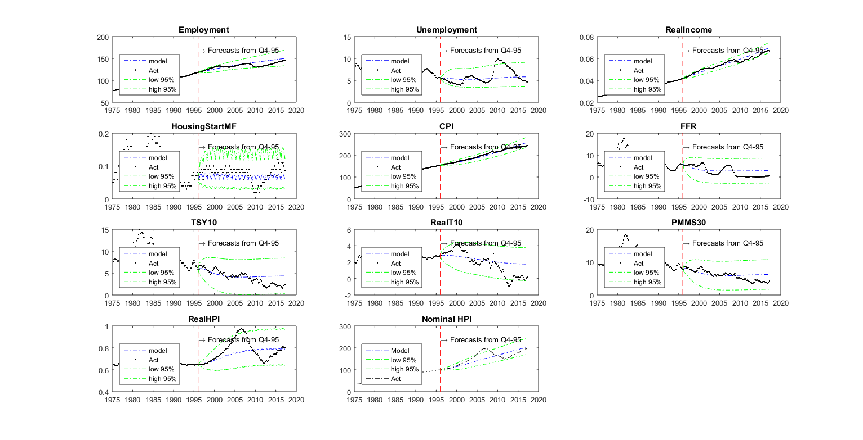

**Figure 10.2: Back Test 2000**



**Figure 10.3: Back Test 2006**

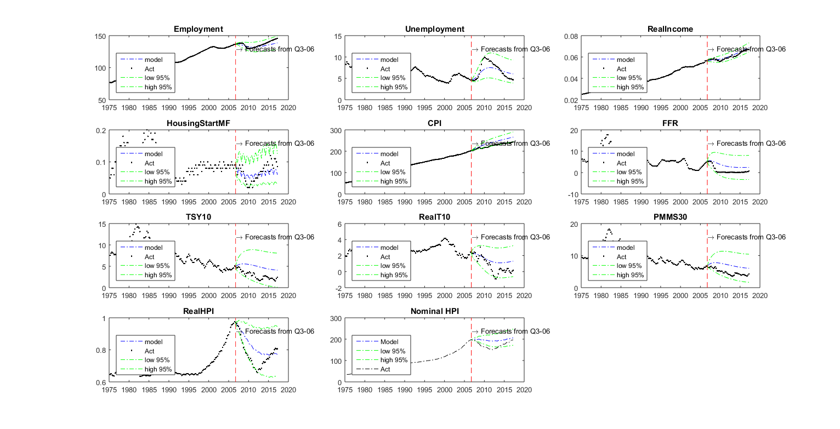

**Figure 10.4: Back Test 2009**

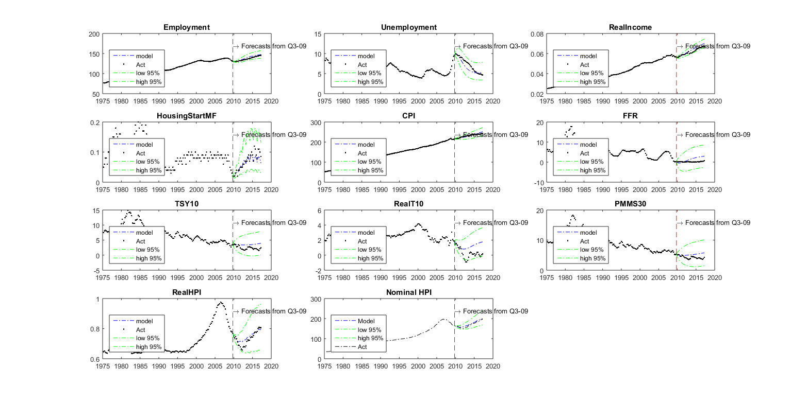

**Figure 10.5: Back Test 2012**

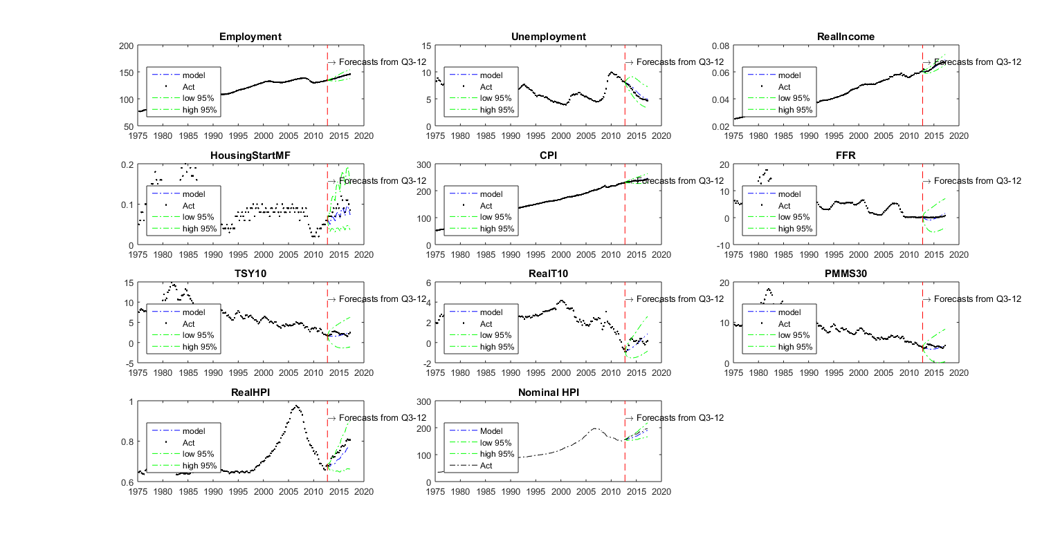

Some downstream models take inflation or HPI growth rate instead of CPI levles or HPI level as input so it makes sense to see the back-test results for inflation and HPI growth rate. Figure 10.6 to 10.13 show that the model replicates history well for these transformed variables.

**Figure 10.6: Back Test 1995 for Inflation**

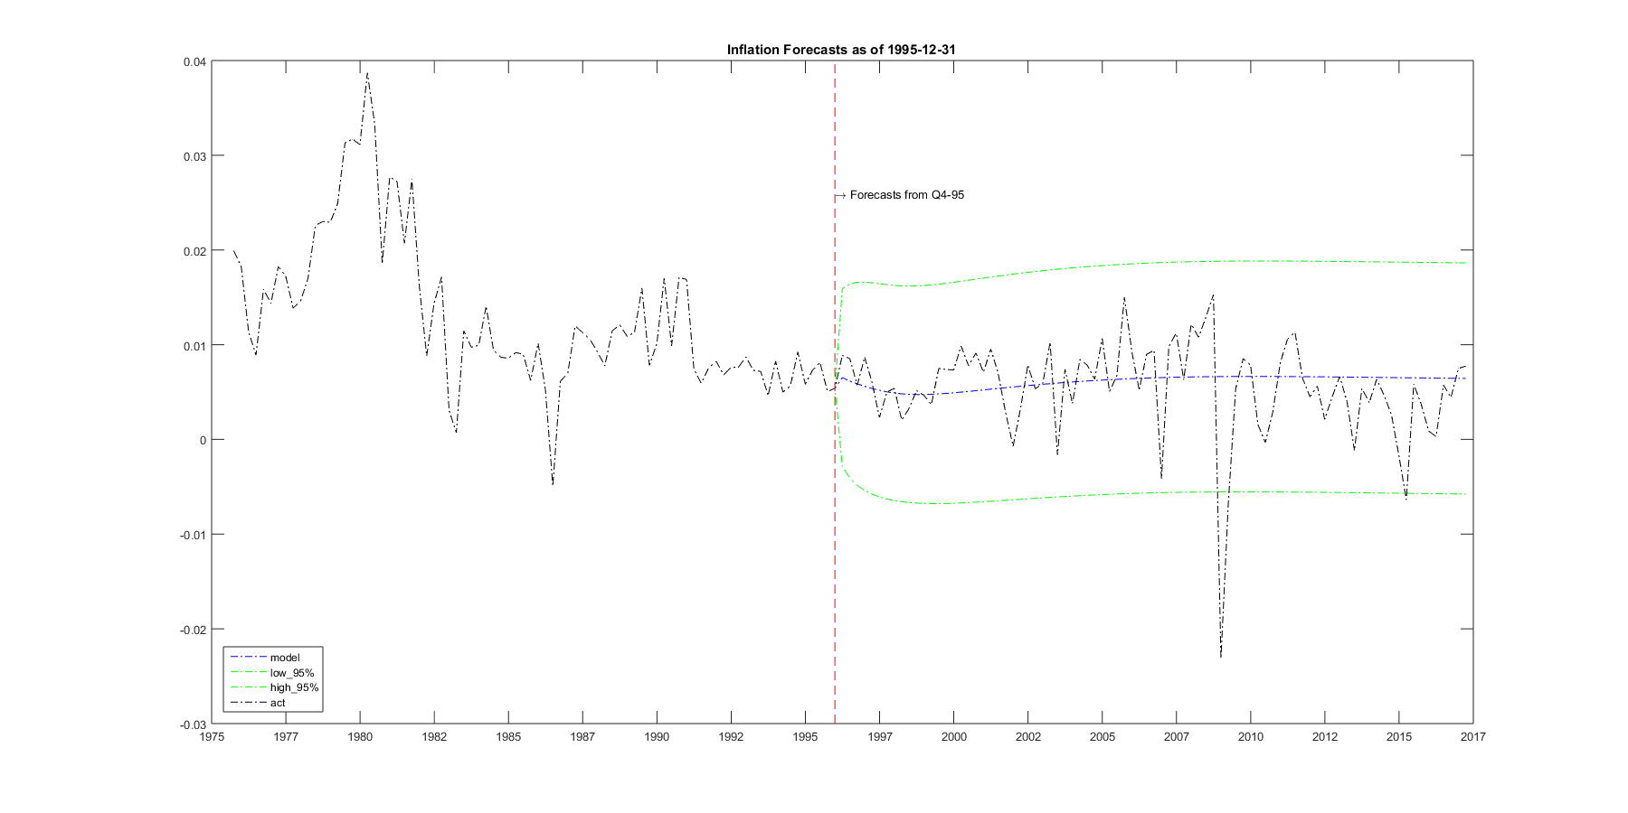

**Figure 10.7: Back Test 2000 for Inflation**

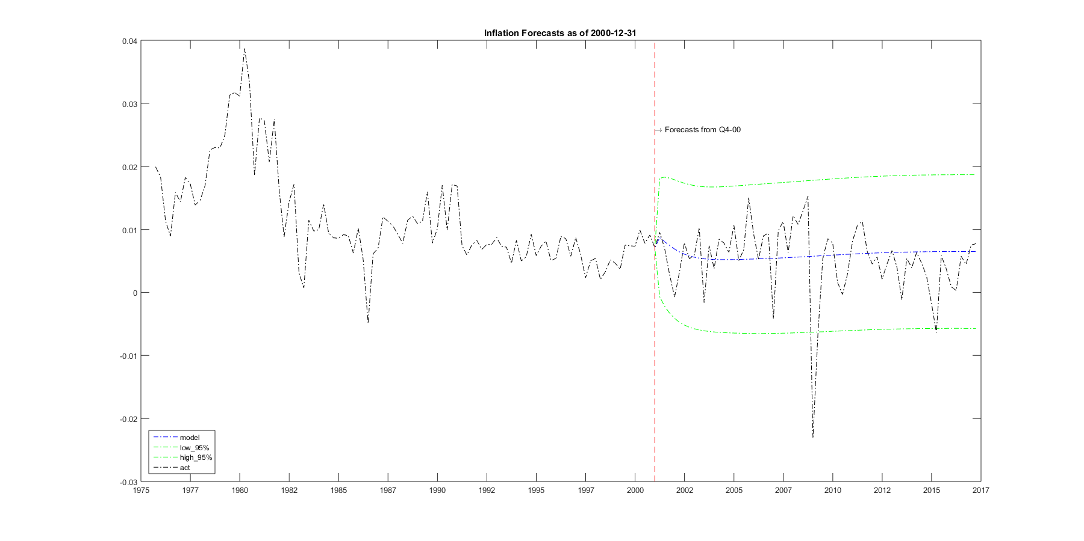

**Figure 10.8: Back Test 2006 for Inflation**

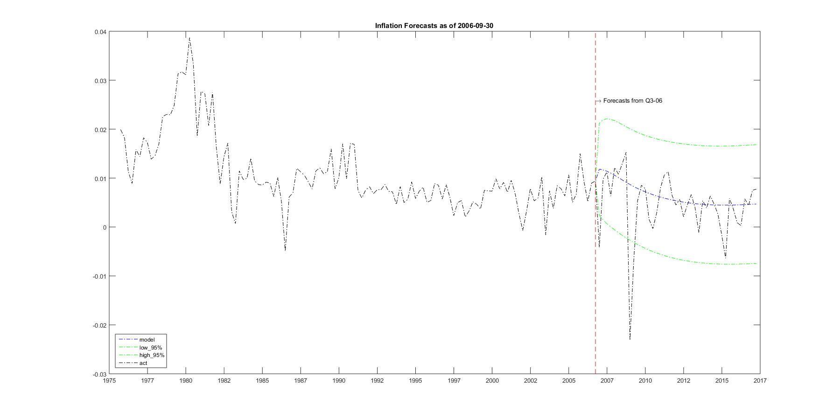

**Figure 10.9: Back Test 2009 for Inflation**

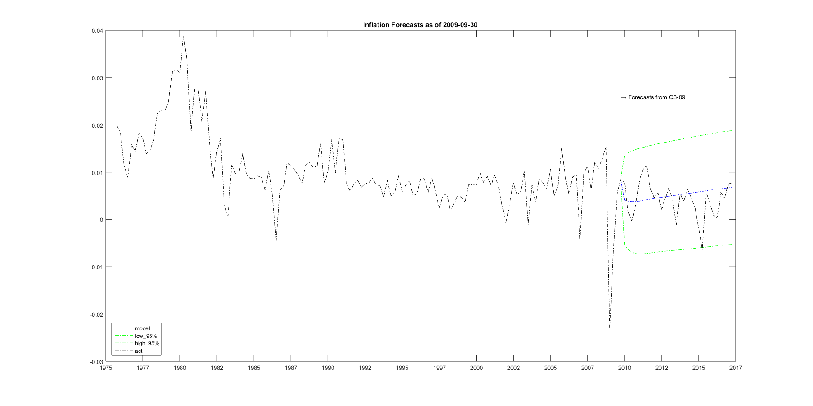

**Figure 10.10: Back Test 1995 for HPI growth rate**

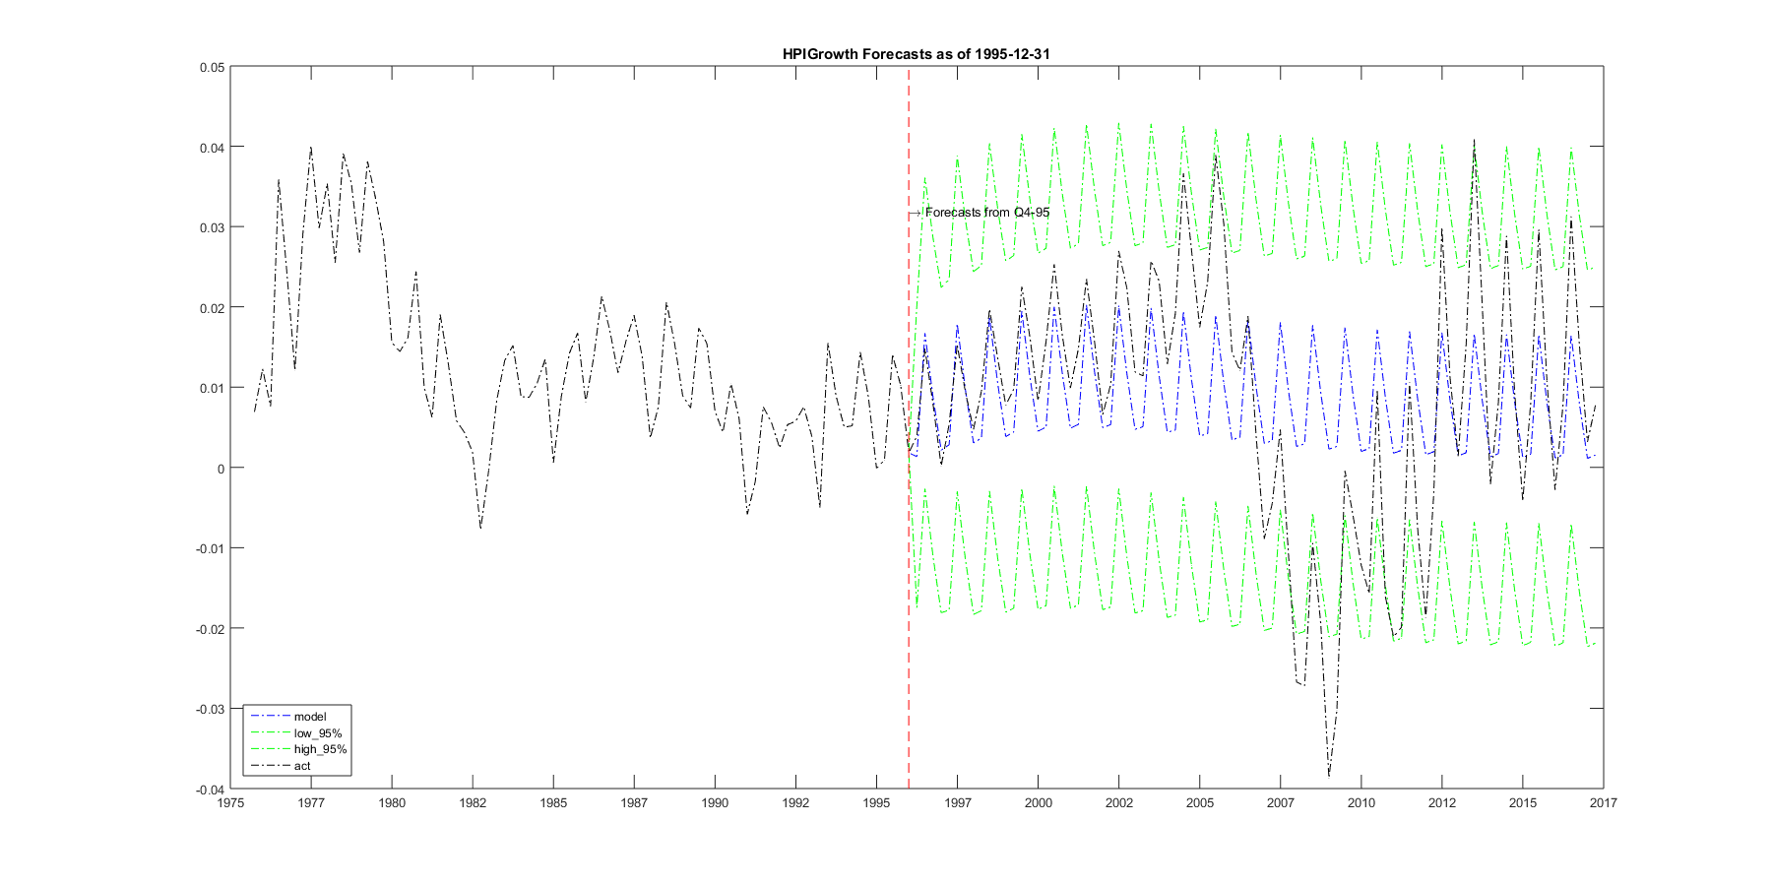

**Figure 10.11: Back Test 2000 for HPI growth rate**

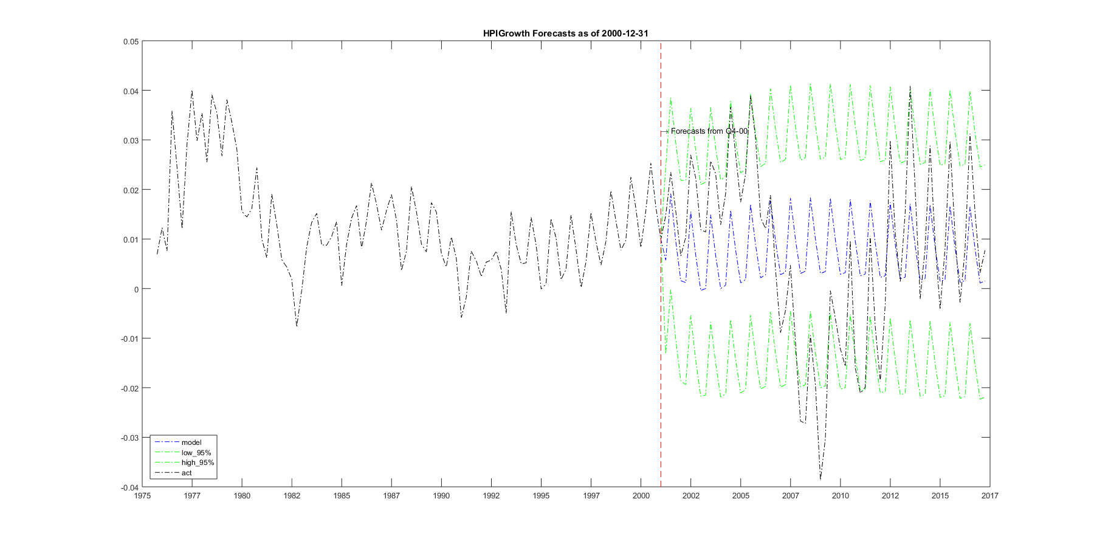

**Figure 10.12: Back Test 2006 for HPI growth rate**

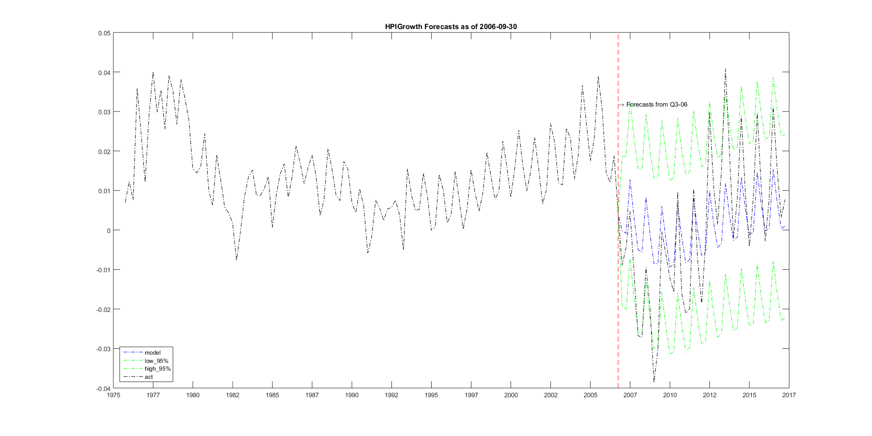

**Figure 10.13: Back Test 2009 for HPI growth rate**

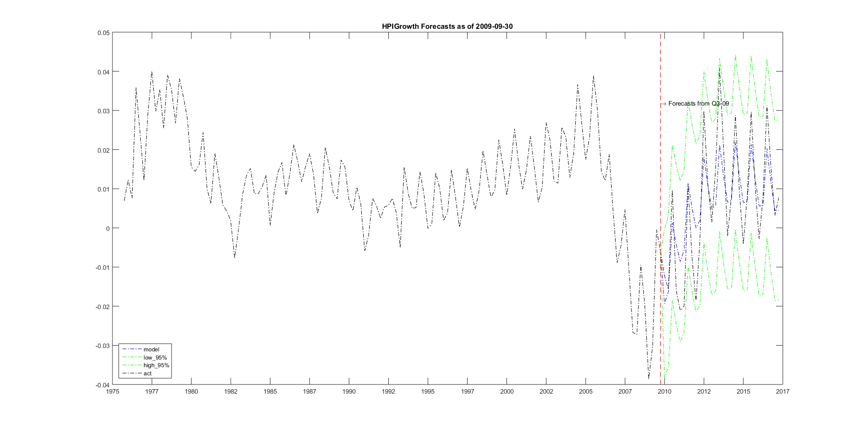

## 10.2. Multi-horizon fitting

Although the model is specified as one-horizon-ahead forecast, it is straightforward to see the multi-horizon forecasts. Figure 10.14 and 10.15 show back test results for 10-year CPI growth rate

and 5-year Nominal HPI growth rate respectively.

**Figure 10.14: Back Test for 10-year CPI growth rate**

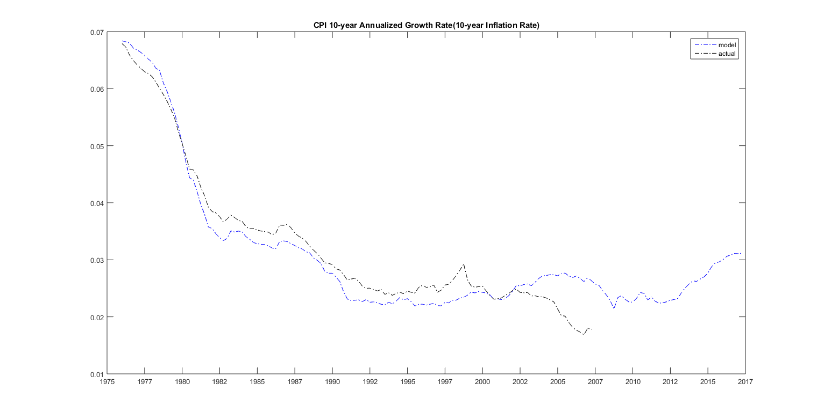

**Figure 10.15: Back Test for 5-year Nominal HPI growth rate**

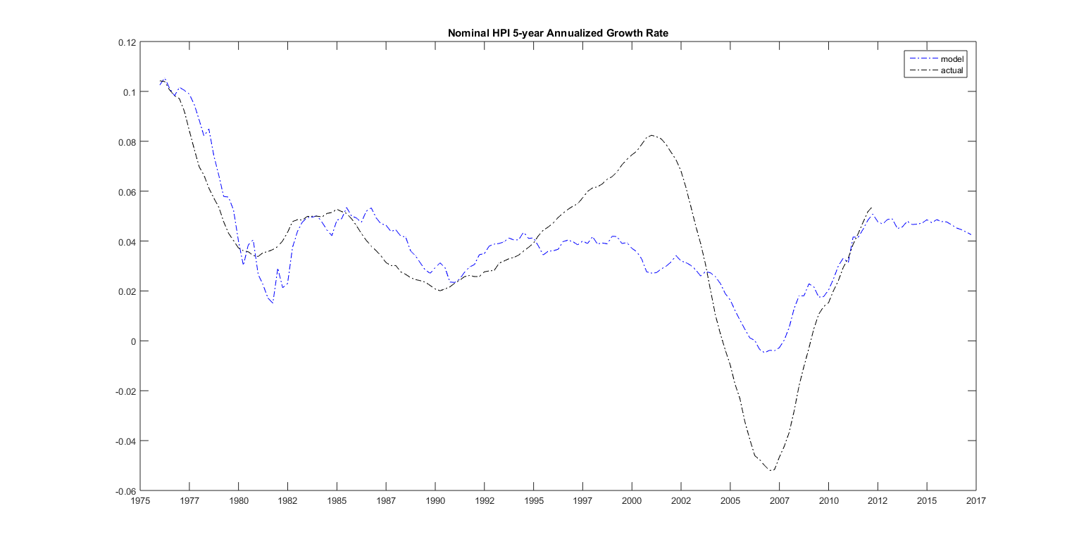

## 10.3. HPI and fundamentals

A typical questions for home price model is that, given current economic environment, is the HPI overpriced or underpriced? This question can be answered in the proposed model. In appendix 2, we show the conditional mean of one variable given the concurrent level of the rest of included variables in the VAR model. And we plot the historical HPI as well as the long run equilibrium level determined by the other economic fundamentals in figure 10.16:

**Figure 10.16: HPI and long-run equilibrium level determined by fundamentals**

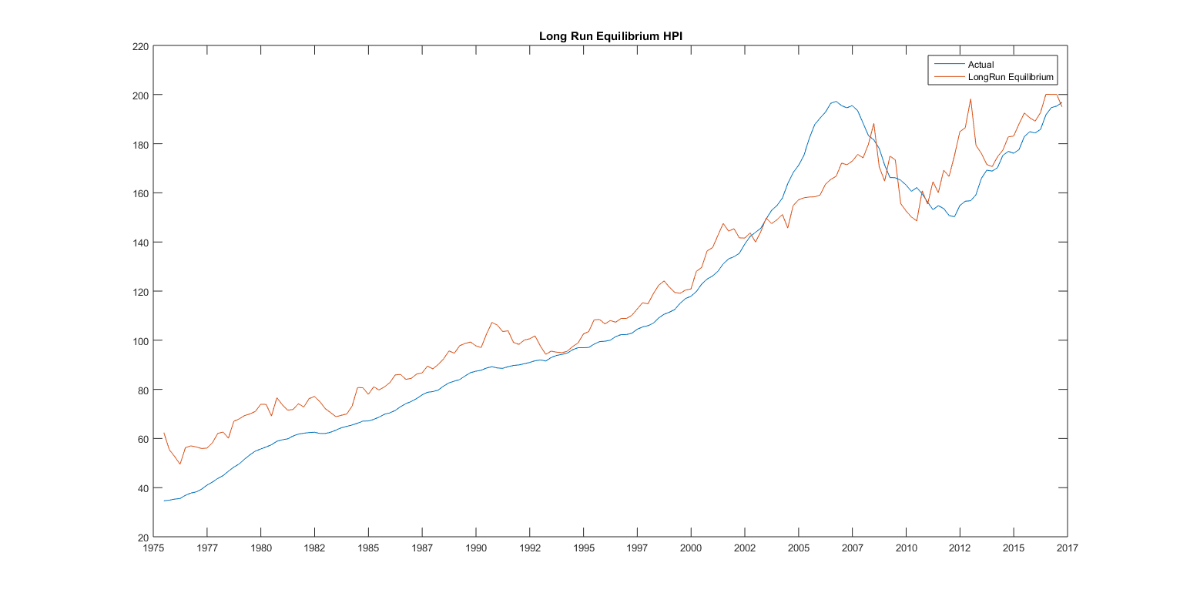

## 10.4. Sensitivity Testing

The proposed model can produce impulse responses for individual shocks. Figure 10.17 to 10.26 show how the instantaneous one standard deviation shock (with estimated error bounds) of each transformed risk drivers in time 0 propagates through the system over time.

The impulse response of a VAR model depends on the assumption on the error variance decomposition. Since innovations are contemporaneously correlated, as shown in the nonzero off diagonal terms in the variance matrix, shock in one variable is likely or more realistically to be accompanied by a shock in another variable.

The assumption on error variance decomposition is the instantaneous causal ordering of the variables. Here we follow the order of : Employment_Growth, Transformed_UnemploymentRate, Detrend_log_RealIncome, Deseason_log_MFHS, Detrend_log_CPI,FFR,NominalT10,RealT10,PMMS30, Deseason_Detrend_log_RealHPI.

**Figure 10.17: Impulse response of Employment shock to other risk drivers**

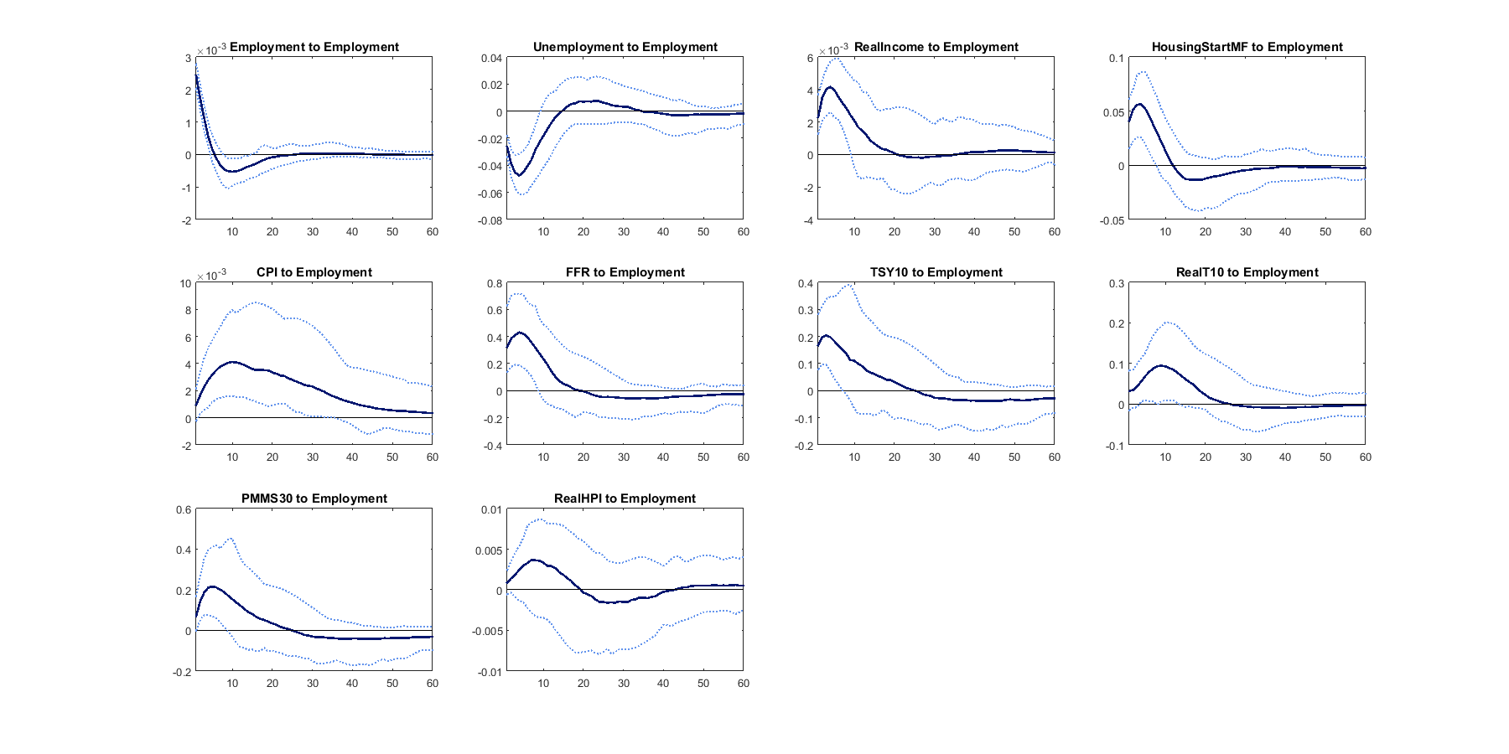

**Figure 10.18: Impulse response of Unemployment shock to other risk drivers**

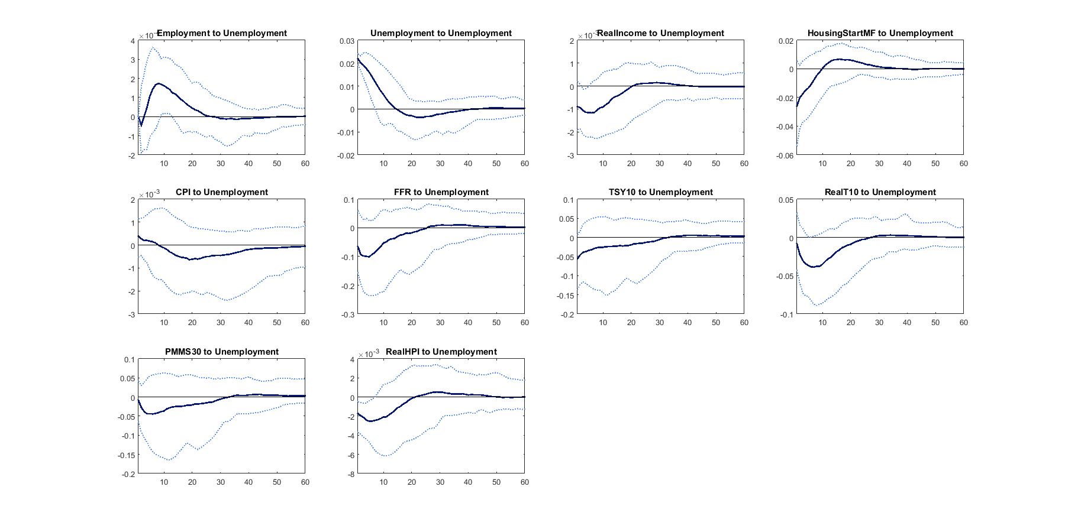

**Figure 10.19: Impulse response of Real Income shock to other risk drivers**

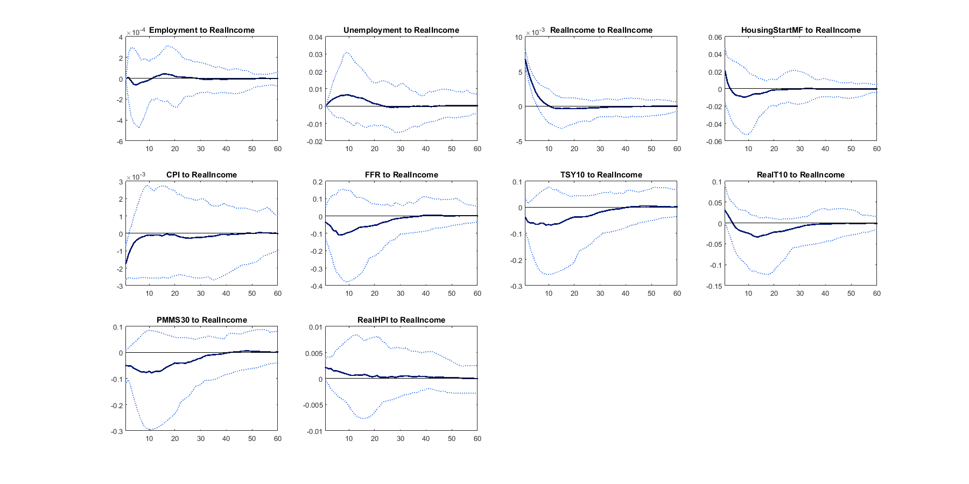

**Figure 10.20: Impulse response of HousingStart_MF shock to other risk drivers**

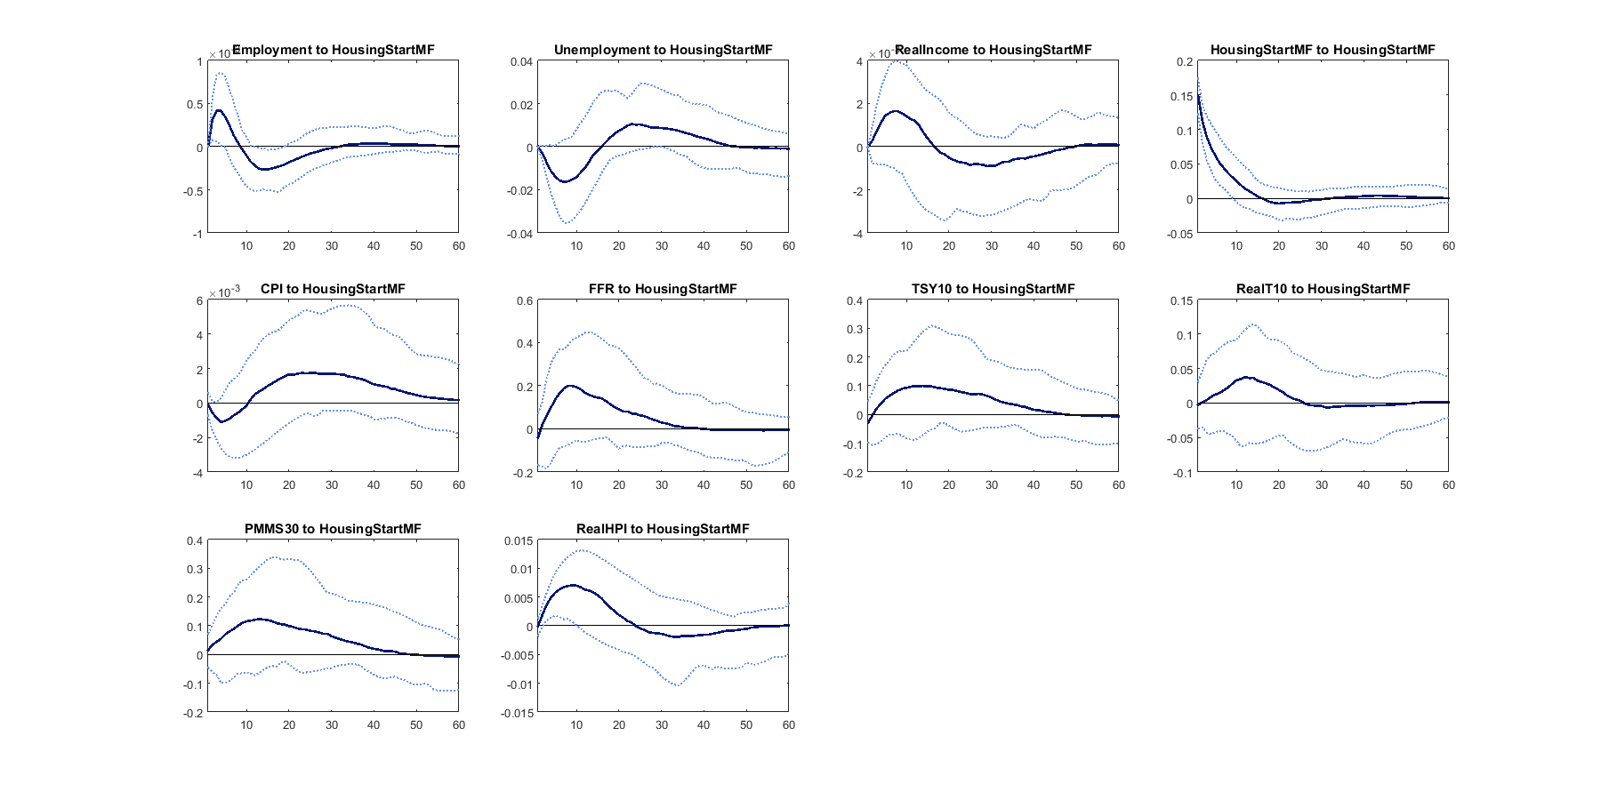

**Figure 10.21: Impulse response of CPI shock to other risk drivers**

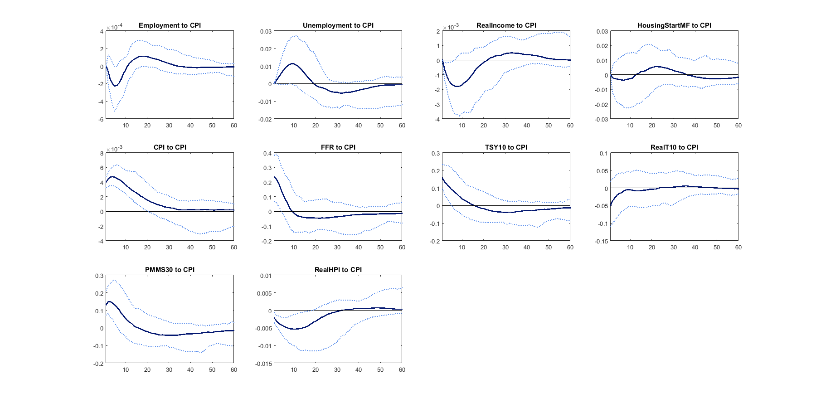

**Figure 10.22: Impulse response of FFR shock to other risk drivers**

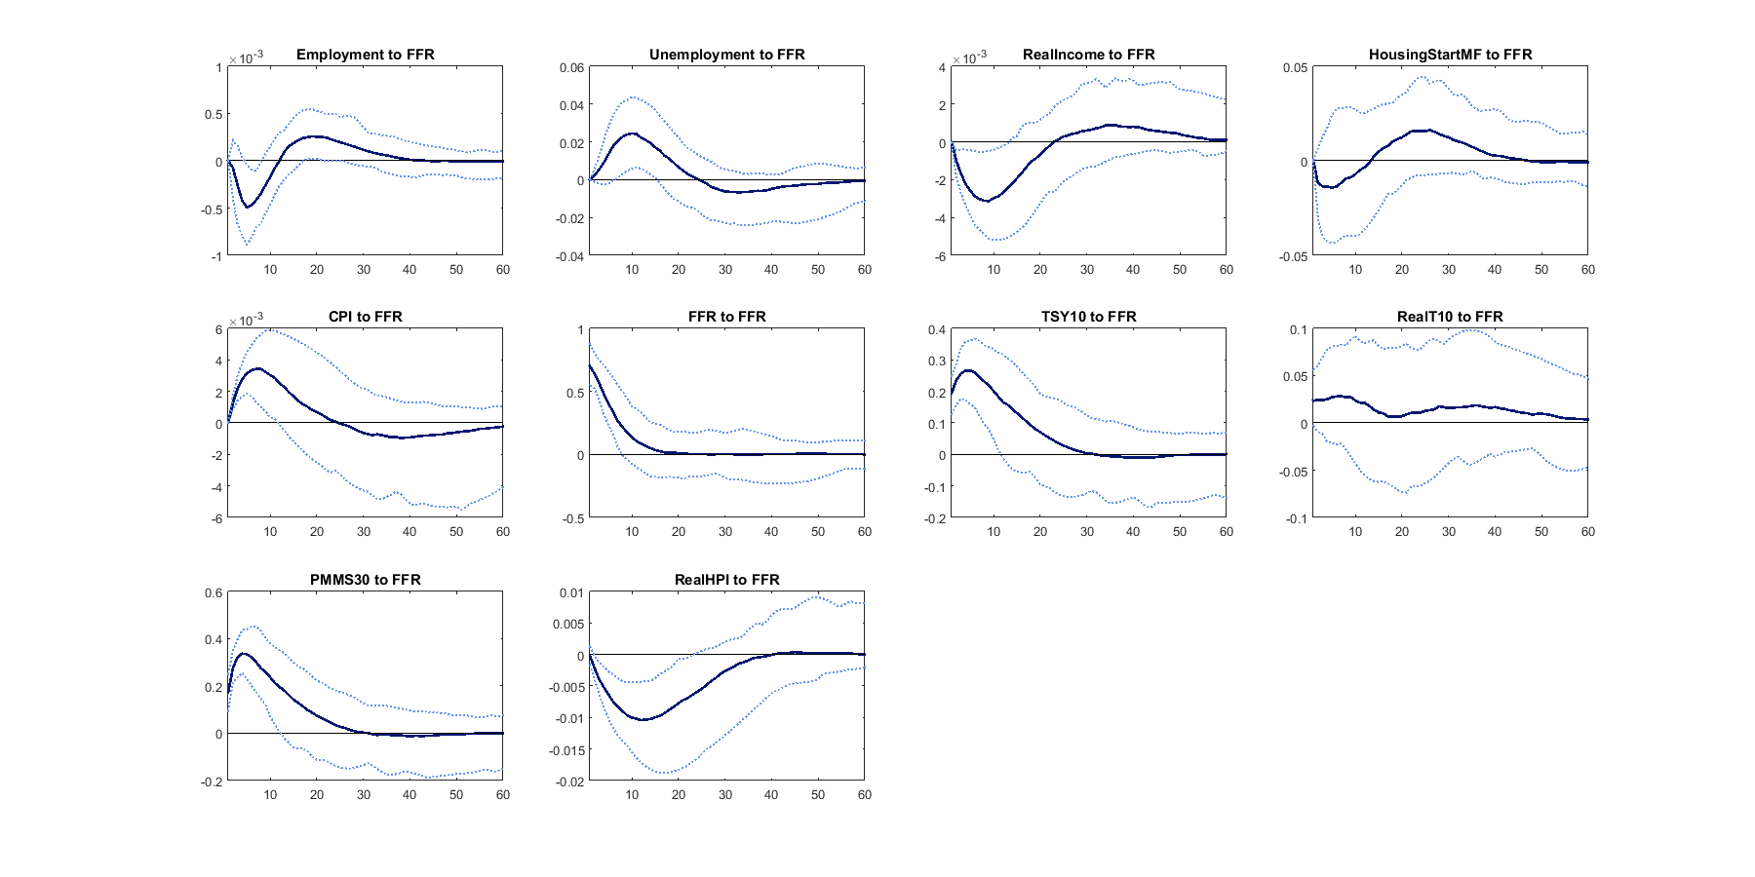

**Figure 10.23: Impulse response of TSY10 shock to other risk drivers**

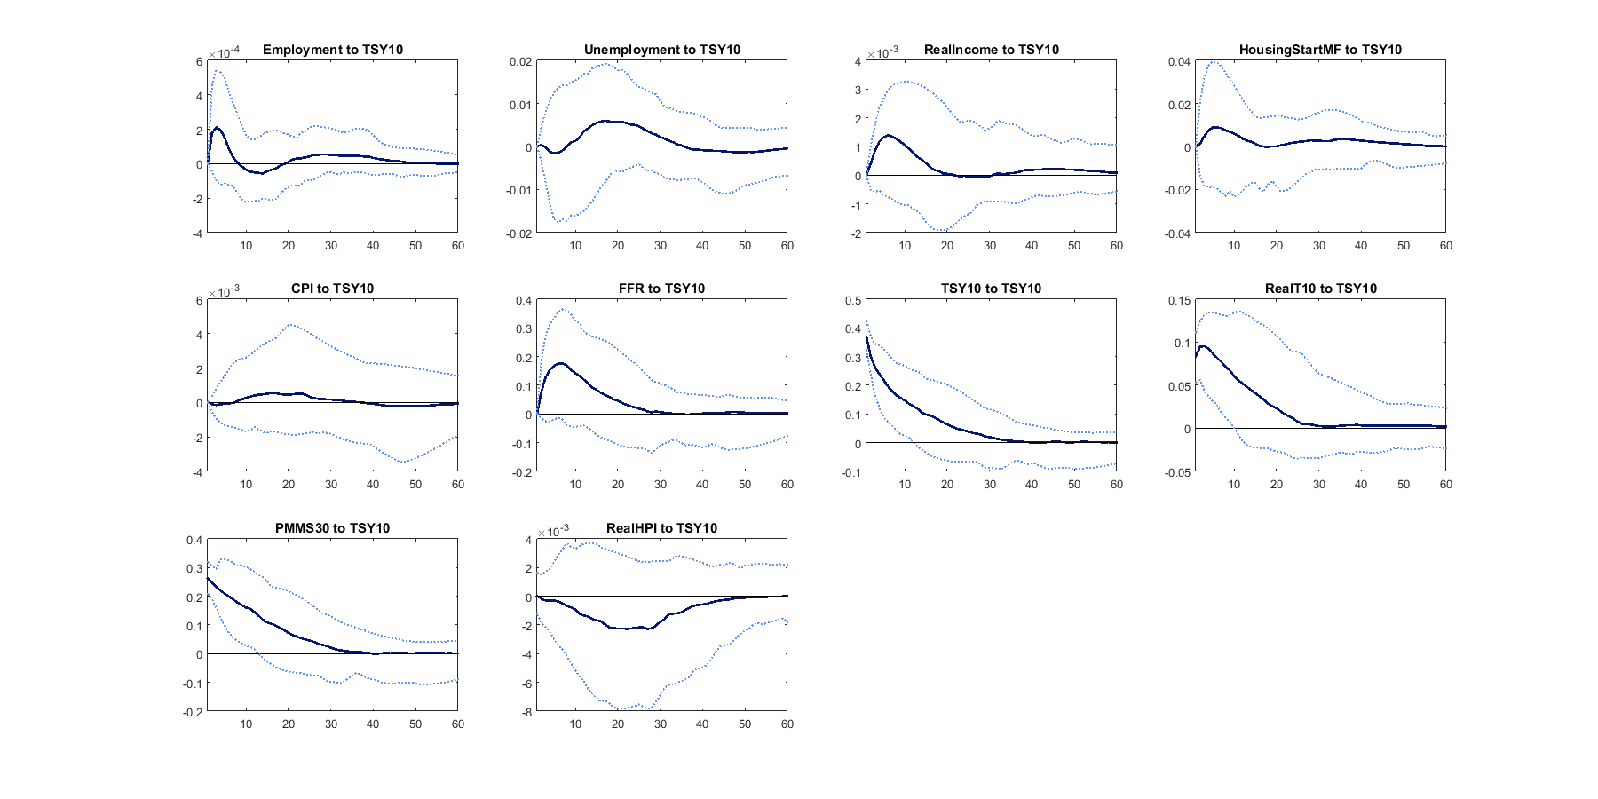

**Figure 10.24: Impulse response of RealT10 to other risk drivers**

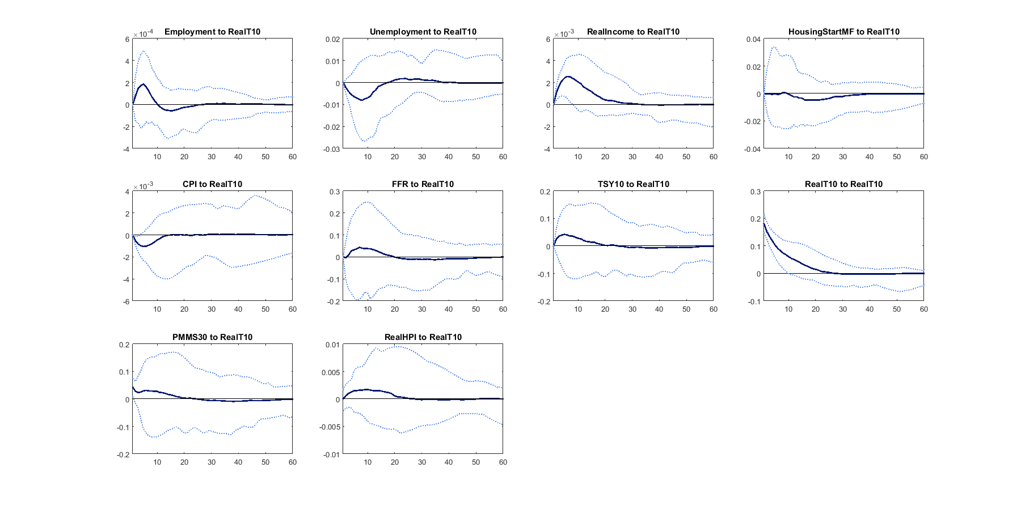

**Figure 10.25: Impulse response of PMMS30 shock to other risk drivers**

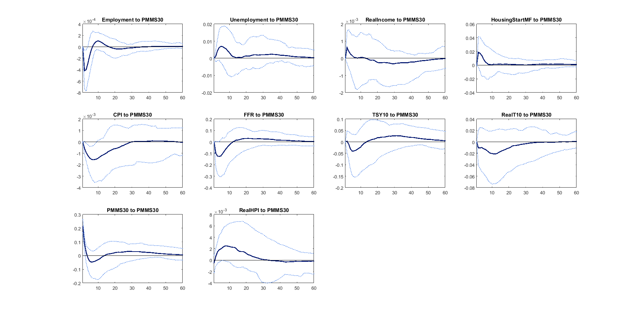

**Figure 10.26: Impulse response of Real HPI shock to other risk drivers**

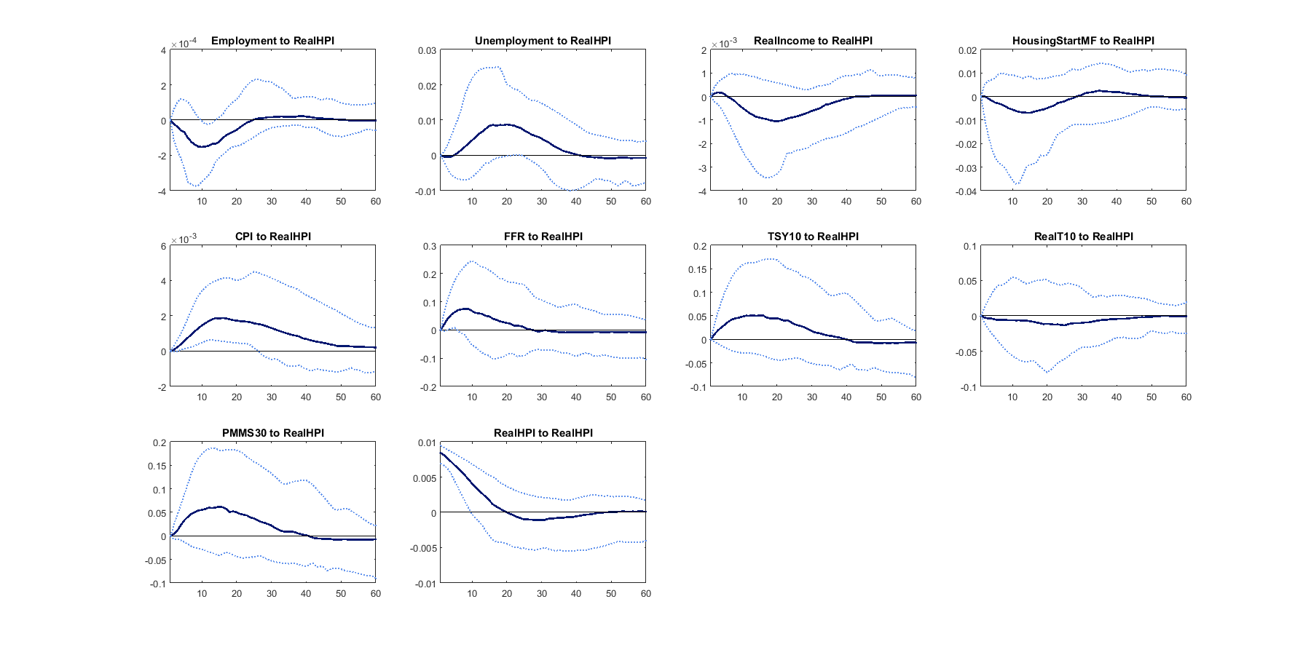

*Reviewed by:*

*Date:*

11. Model Limitations

While the model captures the intended key dynamics of the risk driver movements, certain trade-offs were made to prevent the resulting model from becoming too complex and non-transparent. Specifically, we think that the model has the following limitations:

* The model cannot predict the formation of housing bubble.
* The risk drivers are linearly dependent

*Reviewed by:*

*Date:*

12. Model Performance

In this section, we assess the forecast performance of the proposed model. The model was calibrated to the sample ending in 2015Q4. We therefore have a few quarters of sample left for out-of-sample tests.

Figure 12.1 to 12.3 show that the model performs well in out of sample periods. It captures the trends, seasonality and cycle in the data.

Since our model is intended for long-run simulation, we show 30-year forecasts results staring at 2017Q1 in Figure 12.4 to 12.6. The forecasts look reasonablly well compared to the history.

**Figure 12.1: Forecast 2015**

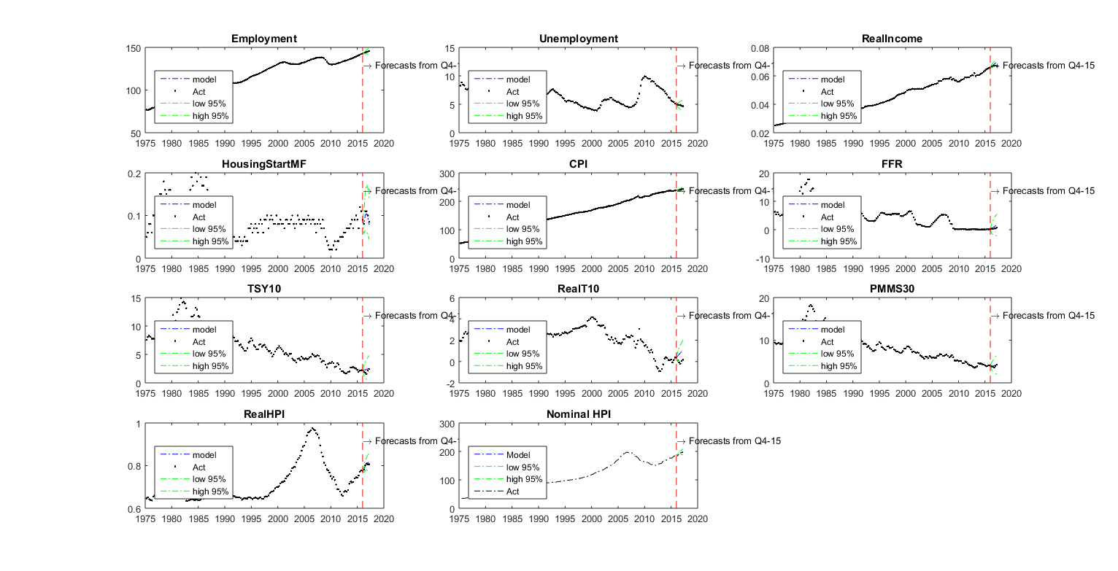

**Figure 12.2: Forecast 2015 for Inflation**

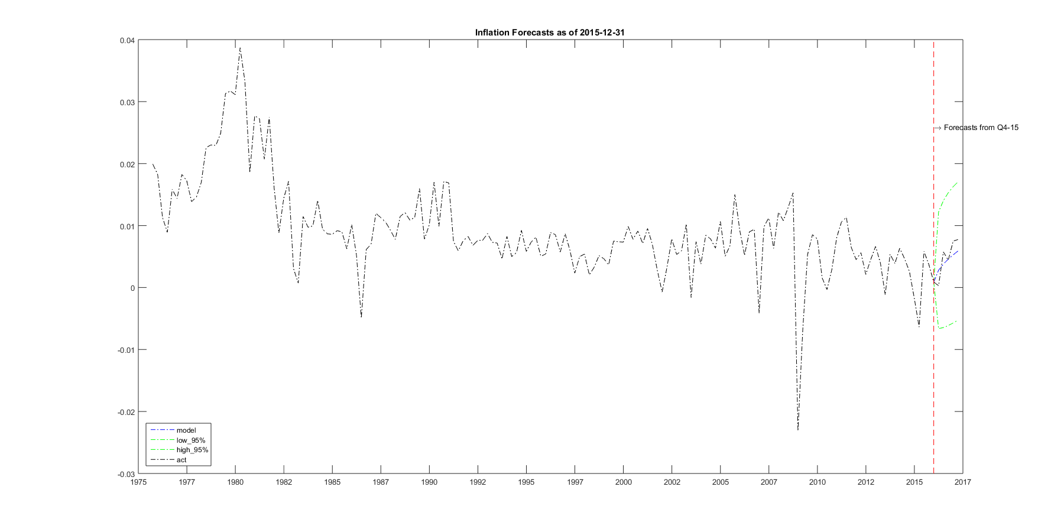

**Figure 12.3: Forecast 2015 for HPI growth rate**

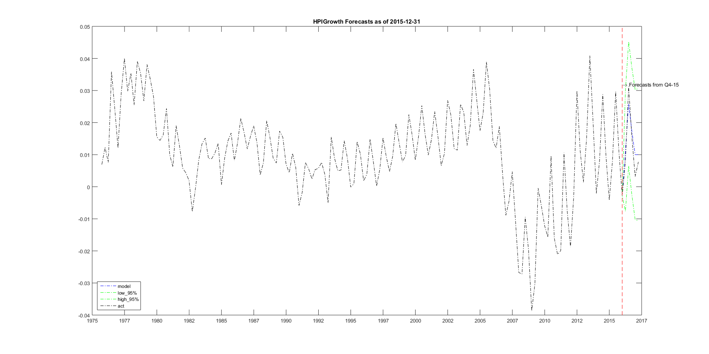

**Figure 12.4: Forecast 2017**

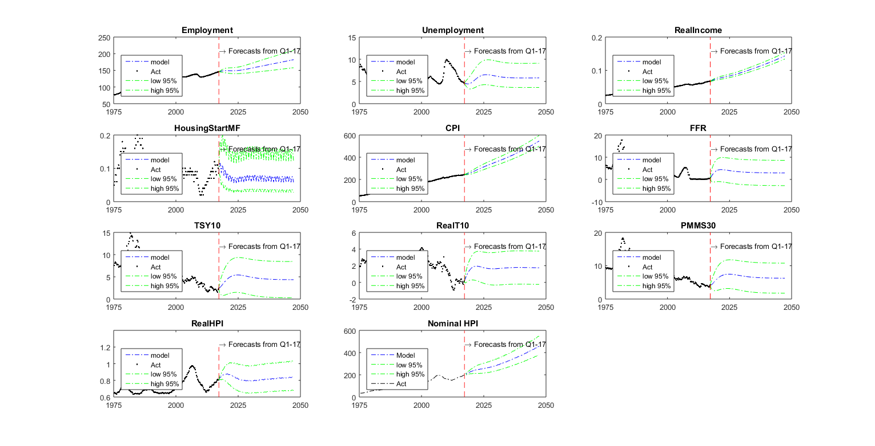

**Figure 12.5: Forecast 2017 for Inflation**

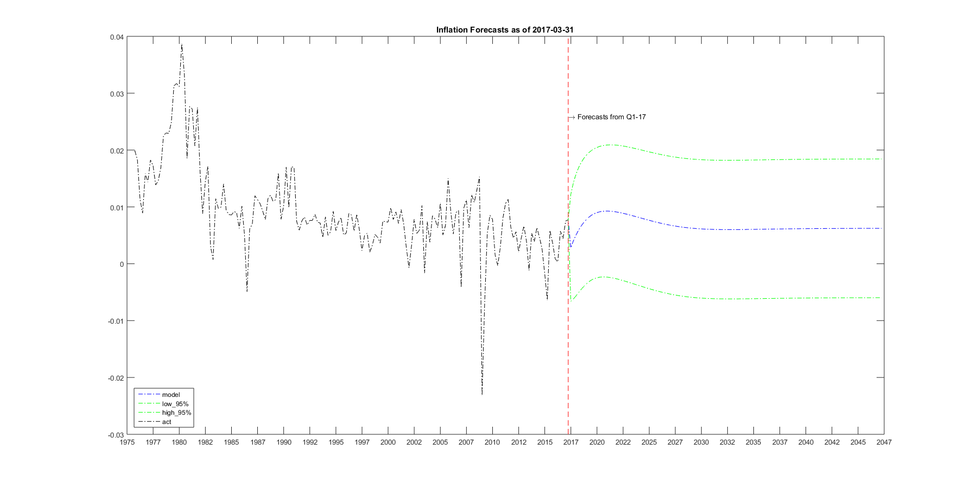

**Figure 12.6: Forecast 2017 for HPI growth rate**

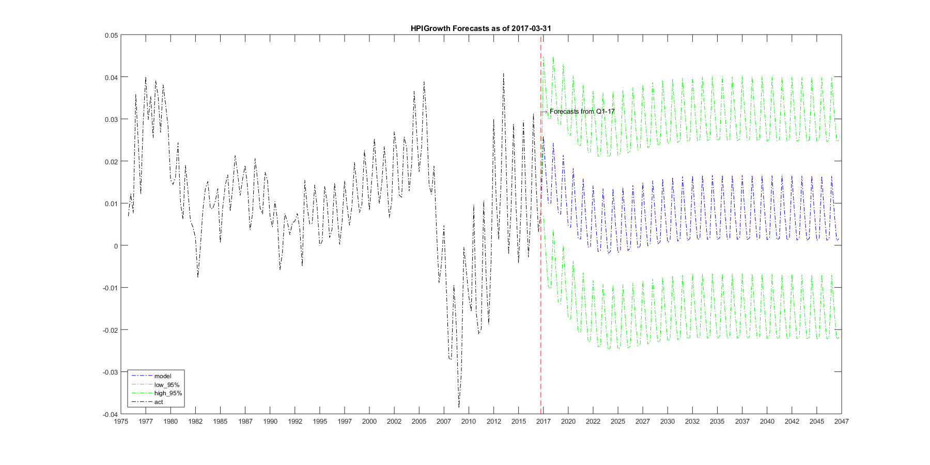

*Reviewed by:*

*Date:*

13. Simulation Process

The simulation process is straightforward as the model itself specifies the simulation equation. All we need is the initial state for any given time, i.e. value of the ten included variables at valuation date.

*Reviewed by:*

*Date:*

14. Conclusion

We propose a joint model for key macroeconomic variables that are deemed as risk drivers. The model provides a unified view of how various risk drivers interact with each other. The modelled macroeconomic variables include national home price, consumer price index (CPI), employment, personal income, unemployment rate, multifamily housing starts, federal fund rate, nominal and real 10-year treasury rate and mortgage rate.

The VAR structure adopted by the model exploits the interdependence among macroeconomic variables, and the serial dependence in time dimension. Thus, the model is self-sustainable in that it can be used to predict included macroeconomic variables for any horizon into the future.

We find that the model improves point forecasts for key risk drivers and produces more realistic simulation with appropriate cone sizes. The strengthened modelling of the interaction between risk drives betters risk management by generating distributional forecasts, providing theoretically sound simulation cones, facilitating consistent scenario-generations, and improving model risk management.

*Reviewed by:*

*Date:*

References

AA, BB, CC.

Appendices

**Appendix 1. Multi-horizon forecast uncertainty**

In order to generate distributional forecasts, we need to know the probability distributions of the variables in future time t+h. In the proposed model, the transformed variables are normally distributed. Therefore, we only need to work out the first and second moments. Here below we show the formula for multi-horizon moments defined as iterative difference equations.

Given a VAR(p) structure:

,its companion form is

,where

The h-period ahead forecast is:

.

Define a helper matrix:

we have,

.

The conditional expectation of given information at time t can be expressed as:

.

And the conditional variance is:

.

The original variable, is normally distributed with mean:

And variance

Denote cumulative and differential quantities as:

And introduce short-note for conditional covariance:

*,*

We have

. We can see that

**Appendix 2. Conditional Normality**

The long-term unconditional mean of is:

*,*

and unconditional variance is

*.*

The conditional distribution of, say, home price index on all other risk drivers, , is normal with mean and variance specified below:

, where are block components of the long run unconditional mean and variance.

*Reviewed by:*

*Date:*