**Indexing Large Spatial Data using Hadoop, a closer look at spatialhadoop and another complementary QuadTree implementation**

Donghan Miao

**Goals**

Spatial data are usually very large in volume, spatial object data sets that are of hundreds of gigabytes of are not uncommon. We want to find an efficient way to index the spatial objects set and therefore process and analyze those data efficiently.

Implementing such system in a distributed fashion is a natural choice due to scalability concerns. We hope to manage the data of that scale or even larger. And also the system could run on commodity hardware.

**Hadoop, HDFS and MapReduce**

Designing a distributed system can be very hard. We use MapReduce computing model from the hadoop to simply the work. The Apache Hadoop is an open-source project for reliable, scalable, distributed computing, which allows for the distributed processing of large data sets across clusters of computers using simple programming models. It is designed to scale up from single servers to thousands of machines, each offering local computation and storage. It is designed to detect and handle failures at the application layer, so delivering a highly available service on top of a cluster of computers.

HDFS is short for hadoop distributed file system. It is a distributed, scalable file system for the Hadoop framework. HDFS stores large files (typically in the range of gigabytes to terabytes) across multiple machines. It achieves reliability by replicating the data across multiple hosts. The file system is also fault tolerant – node failure is detected and handled in the application level. The file system uses the TCP/IP for communication between nodes.

MapReduce is a programming model for processing large data sets with a parallel, distributed algorithm on a cluster. A MapReduce program is composed of a Map() procedure that performs filtering and sorting and a Reduce() procedure that performs a summary operation. The MapReduce System orchestrates by marshalling the distributed servers, running the various tasks in parallel, managing all communications and data transfers between the various parts of the system, and providing fault tolerance.

**Spatialhadoop**

SpatialHadoop is a project developed by University of Minnesota, a MapReduce application to Apache Hadoop, it is designed specially to work with spatial data. It can be used to analyze huge spatial datasets on a cluster of machines. This report dissects spatialhadoop implementation details. In addition, using the same strategy, I implemented another fully-fledged indexing and query system using quadtree on hadoop as a complement to spatialhadoop. (Spatial Hadoop supports R+tree, rtree, and grid indexing, lacking other popular spatial indexing structures like quadtree, kdtree, etc. )

**Index Building and data persistence**

In general, database storage consists of persisted index structure and data storage. In big data environment, we leverage the advantage of data partitioning to achieve scalability. Indexing process partitions large data set into even-sized data chunks (the number of chunks is determined by the volume of spatial dataset). Each data chunk is a small but fully-fledged database storage.

Data

**Index**

Data chunk, default size limit 64MB

The reason we are doing this is because, 1) by default, the block size of Hadoop distributed file system (HDFS for short hereafter) is 64MB. Files that are smaller than that will take up 64MB actual space. 2) We want to partition the data sets over a cluster of machines. The size of each file should not infinitely scale up. Therefore, one way to solve this issue is to define the default chunk size to a value that should be close to but no larger than the block size, so that I/O performance is not harmed.

The data chunk is organized as follows, it consists of two sections, and both are in binary format. The first section is spatial index structure, which may vary in user’s own choice. In the very beginning, both parts are constructed in memory. When the total size of the two sections grows close to the maximum size limit, we serialize the two parts into persisted file on HDFS.

We implement index building as a MapReduce job. In our case, input data are formatted texts where each line represents a polygon object. Mapper input takes <line number, line text string> as key-value pairs. Mapreduce framework will split the files into smaller splits before submitting them to mappers, so that multiple mappers will work in parallel to process the input splits. The level of parallelism is determined by the volume of data set or can be customized by the user.

The following graph shows how indexing building was done is a mapreduce process.

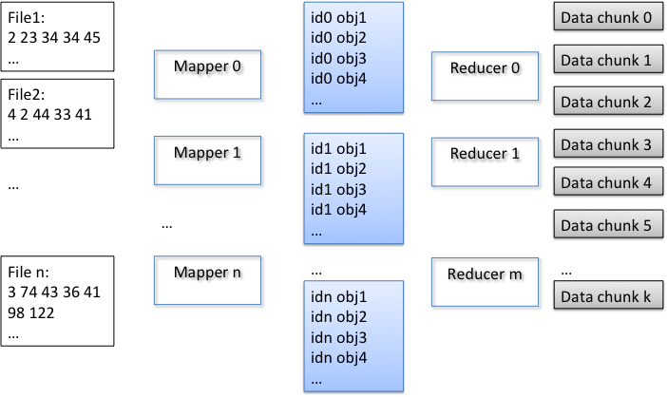

Graph 1, MapReduce process for Tree Building

Mappers convert the text string into a spatial object and emits <mapperInstanceID, object> pairs for reducers. The emitted key-value pairs sharing the same key will be sent to same reducer. It is actually during reduce phase that partitioning is performed. The reducers will collect an appropriate number of objects (a number adjusted to make data chunk close to 64MB) and build spatial index for them. Upon finishing index building, the index and raw data will be merged as a single data chunk and emit as a single binary file to the HDFS file system.

**Executing a Query**

Executing a range query is also a Mapreduce job, where input is a number of data chunks built from the first Mapreduce job. In each mapper, a customized input format reader was implemented according to our own data format to load the data chunks into memory, where their original data structure are restored – the first section of file is restored as index structures, and the second section of file is simply loaded into a large byte block.

Query was executed in the mapper phase. Each mapper will conduct a search operation in each file scope. Index structure returns a set of object ids (id is a combination of file position and length as position in binary block) for any given range search. According to the object ids, the actual data of the object will be retrieved from the byte array.

The following graph shows how query was done is a mapreduce process.

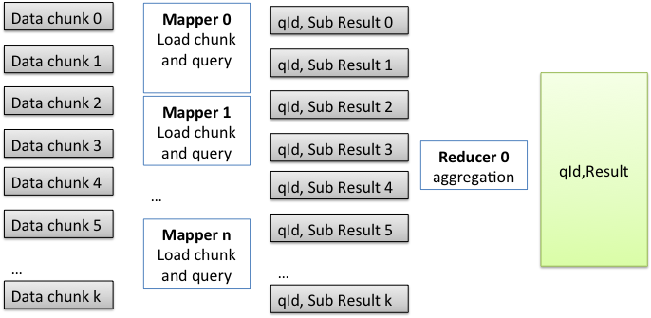

Graph 2, Query In MapReduce

After that, a set of queried objects is sent to reducer with key being the queryID, value being a spatial object. In this way, results belong to the same query will be aggregated in the same reducer.

**Spatial Indexing Data Structures**

A quadtree is a tree data structure in which each internal node has exactly four children. Quadtrees partition a two-dimensional space by recursively subdividing it into four quadrants or regions.

Some modification was made to Quadtree for space efficiency. In our real data sets, there exist clusters of objects in which objects are very close to each other geographically. They may result in over division of leaf node, as the consequence, more space are used since the depth of tree increases.

In our design, more than one objects can be stored in a leaf node if the minimal bounding rectangle of an object has intersection with another object in the same node. In this way, objects clusters will could reside on the same leaf node, avoiding over division of the quadtree.

During range query, we just need to judge each object in the node, to see if there is an intersection between each object and the query range.

**Source and Compile**

Packages

io: This package includes implementation for customized input format and output format interface of Apache hadoop MapReduce.

mapReduceTasks: This package defines two MapReduce jobs, namely, index building job, query search job.

quadIndex: this package is an overall wrap-up for different spatial objects and quadtree structure.

Additional libraries

Libraries

Minimum subset of Apache hadoop standard library are included for compilation was included in the package for convenience of compilation.

Latest source code is available on Github.

>> git clone <https://github.com/miaodonghan/QuadTreeHadoop.git>

Deploy hadoop

The hadoop version we are using is 1.2.1 stable release. Please see Apache Hadoop official website for deployment instructions.

Single node deployment

http://hadoop.apache.org/docs/r1.2.1/single_node_setup.html

Cluster deployment

<http://hadoop.apache.org/docs/r1.2.1/cluster_setup.html>

**Format**

Raw data should be in plain text format. Each line indicates a spatial Object. Points, Rectangles and Polygons are supported. Now the latest version seamlessly support spatialhadoop data format, you can directly use the data source from spatialhadoop.org

Old data format is defined as follows:

Point:

1, x, y

Rectangle:

2, x, y, width, height

Polygon:

numberOfpoints, x1, y1, x2, y2, …, xn, yn

**Commands to run the program**

**Indexing a data set**

Command:

hadoop jar tb.jar mapReduceTasks.QuadTreeIndexer

Or alternatively, you can specify your input path and output path:

hadoop jar tb.jar mapReduceTasks.QuadTreeIndexer inputPath outputPath

**Run a query on Mapreduce**

Query format

queryID,x,y,width,height

where queryID is a unique integer

Command

>> hadoop jar tb.jar mapReduceTasks.QuadTreeQuery queryID,x,y,width,height

Or alternatively, you can specify your input path and output path

>> hadoop jar tb.jar mapReduceTasks.QuadTreeQuery queryID,x,y,width,height inputPath outputPath