DFo_5_1_Practice

**Exercise 1: Creating a Glossary from the Logical Model**

**Exercise 2: Forward engineering the design to apply the Glossary and Naming Standard**

I have some questions

In this table all entity names are plural but In the relation Model just some of the names are changed into plural

DFo_5_2_Practice

**Exercise 1:**

**Observe the mapping of the unique identifiers and relationship in the Relational Model**

**Exercise 2: Define table name abbreviations in csv file**

**Exercise 3: Define Name Template**

6-1 : Introduction to Oracle Application Express Practices

**Exercise 1: Introduction to Oracle Application Express**

6-2 : Structured Query Language Practices

**Exercise 1: Using Help in Oracle Application Express**

6-3 : Defining Data Definition Language (DDL) Practices

**Exercise 1: Creating Tables Using Oracle Application Express**

**Exercise 2: Altering the Tables**

**Tasks**

1. Alter the tables in the Academic Database to define the primary key, foreign key and unique constraints

2. Alter the table AD_FACULTY_LOGIN_DETAILS and specify a default value for the column LOGIN_DATE_TIME of SYSDATE.

3. Set the AD_PARENT_INFORMATION table to a read-only status.

**Exercise 3: Creating Composite Primary, Foreign and Unique Keys**

**Task1**

Task2

Task3

**6-4 : Defining Data Manipulation Practices**

**Exercise 1: Inserting Rows in Tables**

**Tasks**

1. Insert rows into the tables created for the Academic Database based on the following tables:

Exercise2

6-5: Defining Transaction Control Practices

**Exercise 1: Controlling Transactions**

the new EMAIL_ADDR field will still be there after the ROLLBACK.

This is because a ROLLBACK TO ALTER_DONE only undoes changes made after the savepoint ALTER_DONE was created. The ALTER TABLE operation (which added the EMAIL_ADDR column) occurred **before** the savepoint was created, so it is not affected by the rollback.

Exercise 2

6-6 : Retrieving Data Practices

**Exercise 1: Retrieving Columns from tables**

**Tasks**

1. +A black rectangular object with a black stripe

   Description automatically generated

2.

3.

4.

5

6.

6-7 : Restricting Data Using WHERE Statement Practices

**Exercise 1: Restricting Data Using SELECT**

**1.**

1. A screenshot of a computer program

   Description automatically generated
2. A screenshot of a computer

   Description automatically generated
3. A screenshot of a computer

   Description automatically generated
4. A screenshot of a computer

   Description automatically generated
5. A screenshot of a computer

   Description automatically generated
6. A screenshot of a computer

   Description automatically generated
7. A black rectangular object with a black strip

   Description automatically generated
8. A screen shot of a computer

   Description automatically generated
9. A screenshot of a computer

   Description automatically generated

6-8 : Sorting Data Using ORDER BY Practices

**Exercise 1: Sorting Data Using ORDER BY**

**A**

B

C

D

3

1. 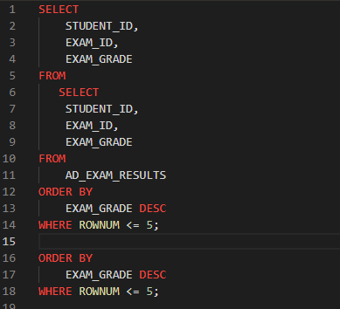
2. 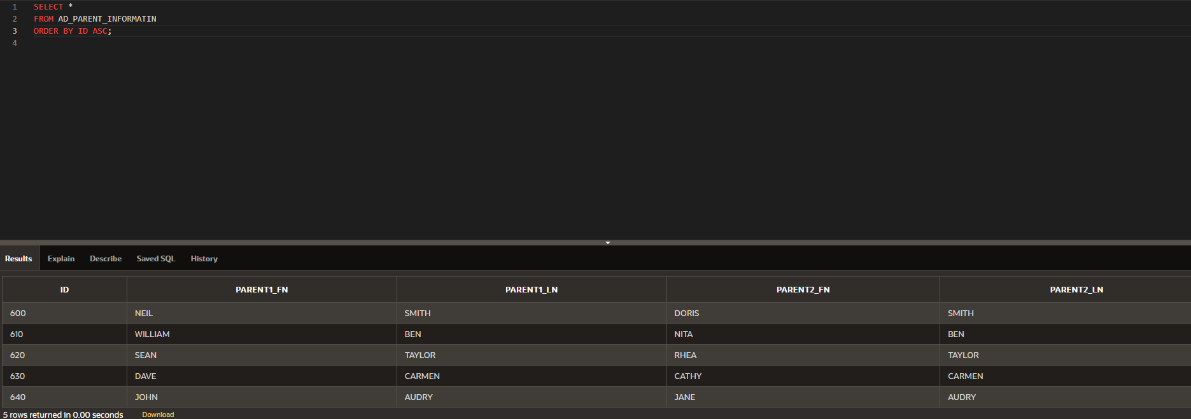

Database Foundations 6-9 : Joining Tables Using JOIN Practices

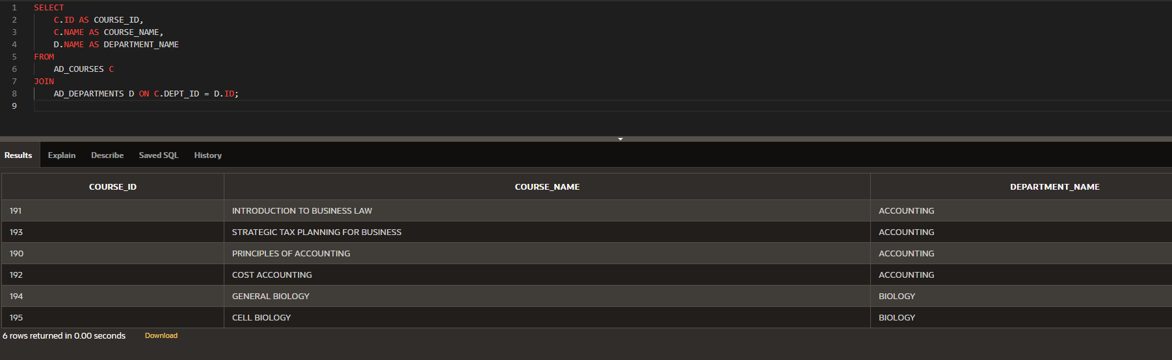

3.

4.

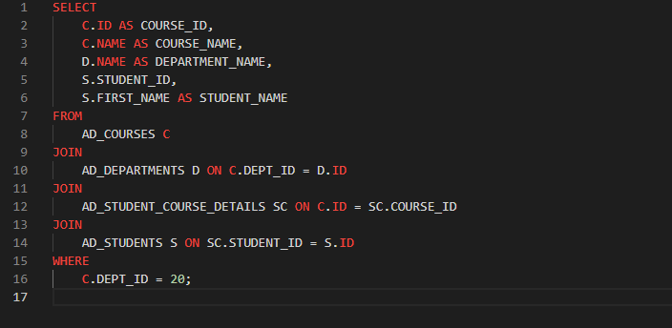

5.

6.

7.

