Scenario 1.0

First n1 and n2 send request message to n1, n1 return reply messages to n1 and n2, so n1 deal with 4 packets per request. From n3 we know there are 6 times. So n1 receive 24 packets. N2 receive 12 packets.

Scenario 1.1

1. set up 5 instances: cl1,cl2,a,b,c

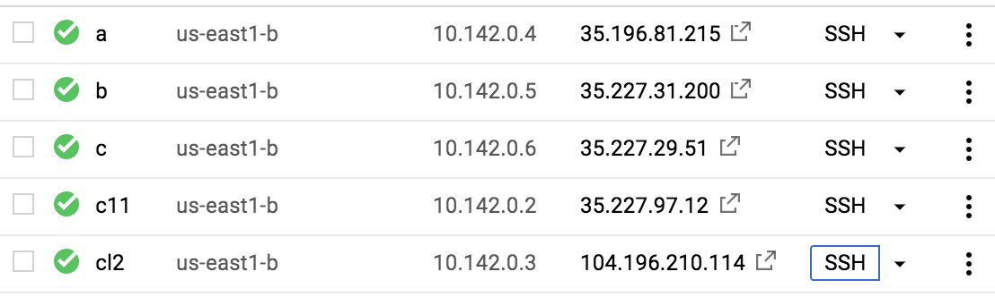

1. set up routers

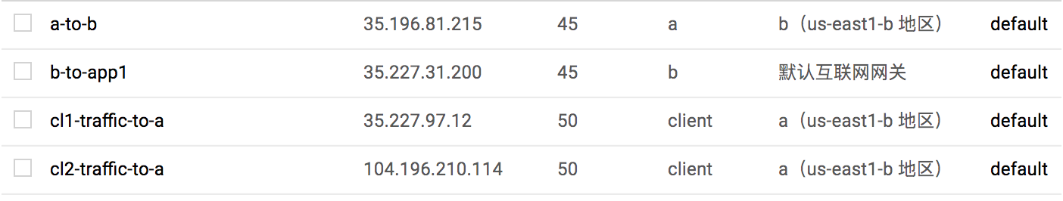

1. configure a,b

a:

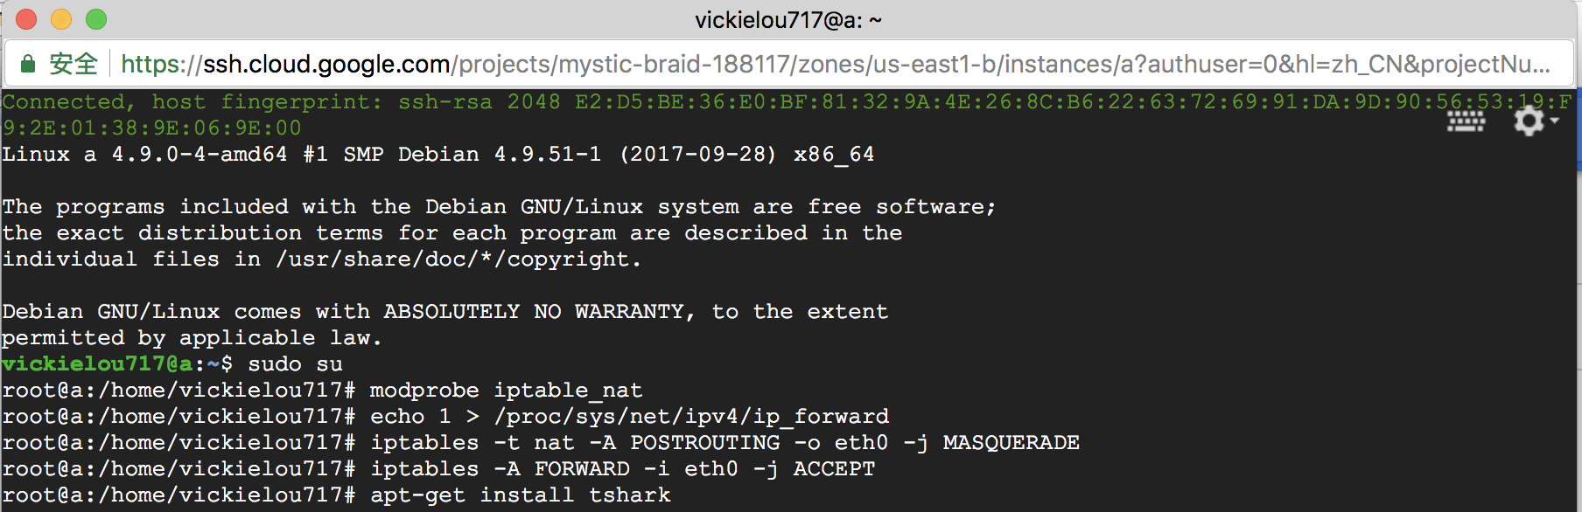

b:

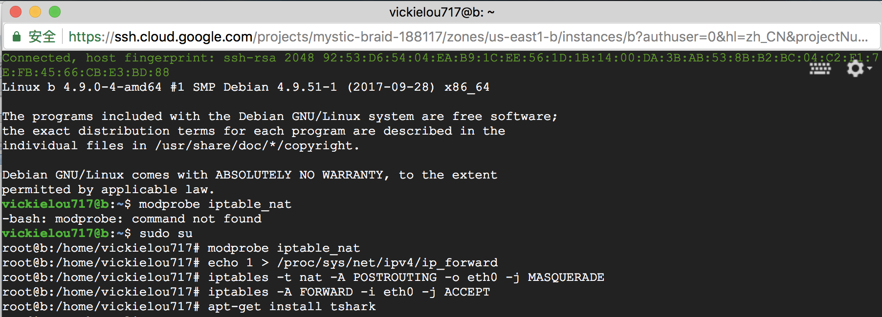

(4) install tshark on all instance

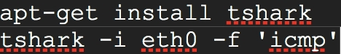

1. in cl1 ping c and in cl2 ping c





c’s results:

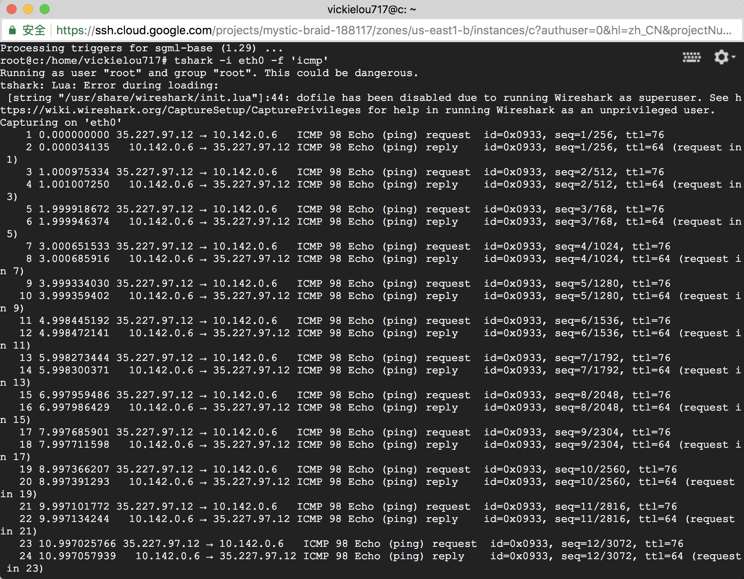

Scenario 1.2