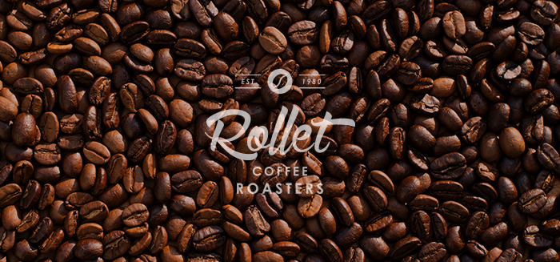Project Planning

Rollet Coffee Roasters

*Blackwater Industrial Park, Cork*

rolletcoffeedelivery@rolletcoffee.com

**COMPANY**

Concept: This is a company based in ireland, offering the best coffee roast for restaurants, coffee shops and delivery services

**GOALS**

* Website Friendly and easy to use. Try to minimize time
* Client can feel the site is showing his company in the best way
* Personality
* Social Media Integration
* Mobile Friendly Site
* Clear Navigation
* Fast Loading Speed
* Have Images of good quality
* Service/Product information
* Easy to Find Contact Information
* A well designed and have reader engagement
* Subscription Invitation
* Website Redesign, Mobile responsiveness and Platform changes
* Website is built and optimized with SEO best practices in mind

**CHALLENGES**

* Website easy to use, for the extreme user: big buttons, calling actions, not overload of information, be proactive.
* Logo style brand need to be coherent and clean design
* Easy to understand word and typewriting clear and direct
* Display the brand big but in a nice way

**Web Design Client Questionnaire**

Understanding what a client really wants is one of the most difficult tasks for the designer. Answering these key questions will be invaluable to streamlining the design process. With this information, we will be able to work quicker and more effectively to meet the desired goals and deliver satisfying results.

Please take the time to fill out as much of this form as possible. If you are unsure about a question, don't have an answer, or it seems irrelevant, don't worry.

**Note: There is unlimited space in all of the text fields and comment boxes.**

All fields under Basic Information are required ( marked by * )

**BASIC INFORMATION**

**\* Business or Organisation Name:**

*Rollet Coffee Roasters*

**\* Business Head Office Address:** *Blackwater Industrial Park, Cork*

**\* Your Name:**

*Mr. Jean Pierre Rollet*

**\* What is your position within the organisation?**

*Sales & Marketing Director*

**\* Are you the sole decision maker in relation to this project?**

Yes

**\* If no, then who else is involved in making important decisions in relation to this project and what is their position within the organisation?**

**\* Email Address:**

jprollet@rolletcoffee.com

**\* Phone Number (Office):**

*021 45 45000*

**\* Phone Number (Your Mobile):**

*087 25 25000*

**\* Please describe your organization in a few sentences.**

*Rollet Coffee Roasters are committed to quality and customer satisfaction.  We never compromise on the quality of our coffees or the efficiency of our distribution channels which feed restaurants and cafes throughout the island of Ireland.  We are proud to be a Fair Trade aligned company by ensuring we only deal with international coffee traders who provide a fair deal for smaller coffee farmers from all over the world.  Our mission is to bring the best coffee experience to Irish consumers and to constantly look for new ways to improve and enhance that experience.*

**What is your budget for this project?** *€2,000*

**What is your deadline for completing the site?**

*December 8th 2017*

**What staff will be involved? What are their roles?**

Ms. Mary McCarthy will be responsible for providing all the high quality photos that we possess.  She will also pass on all marketing graphics that currently represent Rollet Coffee Roaster in the form of company logos and colour choices. But we are open to other possibilities of design in case our photos are not the best quality.

**DESIGN**

**Would you like us to design/redesign a logo for your company?**

Yes    **X**      No        Maybe

**Are there any colors you had in mind to incorporate into the site?**

*Warm colors and nice color palette we need express cordiality, warm feeling*

*security, trust and feel comfortable also variety will be prefered.*

**Do you need Web content writing?**

Yes          No    **X**    Maybe

*Ms McCarthy (mentioned above) will pass on texts that we have drawn up which we feel convey the professional image that we wish to portray on the website.  We would appreciate if you could take the time to go through these and come back to us with any changes you recommend.*

**Will your provide high quality images and photographs about your business?**

Yes   **X**       No

*Again as stated earlier Ms McCarthy will be passing on a large range of photographs of our premises, personnel and fleet that we had taken by a professional photographer recently.*

**Would you consider buying images and photographs for your business? (like stockphoto, imageready)**

Yes     **X**     No

Yes it is envisaged that we will need to purchase some “coffee environment” type photographs.  We would appreciate if you can source your suggestions on these and then consult us for approval before using.  You can then include these in your final invoicing to us.

**Describe the site's desired look and feel by using adjectives and short phrases:**

*The site needs to provide our audience with an easy to follow experience with clear instructions and directions to the info that they they need.  We need the site to maintain current offline branding colours and fonts etc and to have a strong visual relationship with the graphics which the customer sees on our fleet and other touch points.*

**Are there any words or phrases that you have noticed commonly used by your customers & consumers to describe your industry, product or service?**

Coffee roasters / delivery office coffee / subscription coffee (month, week), wholesale coffee company, coffee beans ireland, brew coffee / fresh coffee / farmer friendly / fair deal coffee.

**BRAND/TARGET AUDIENCE**

**List any important words that you want people to associate with your company image/brand:**

*Profesional*

*Exceptional Service*

*Fast Reliable Distribution Network*

*Fair Trade*

*Smooth Rich High Quality Coffee*

*Uncompromising on taste and quality*

**Target Audience.**

*Coffee consumers from all over Ireland aged between 18 and 50 seeking to know more about Roller Coffee Roasters and its Fair Trade sources.*

*Cafe, Restaurant and Bar owner/managers seeking a recognised brand of high quality coffee supplies which are easily and reliably brought directly to their premises.*

**Where/how do people learn about your company/product/service(s)?**

*Rollet Coffee Roasters have a solid brand presence via signage and other collateral at each point of sale.  All our distribution vehicles have professionally designed informative graphics.  We run regular adverts in leading Irish magazines and have a strong social media presence on facebook, twitter and instagram.  Our corporate and sales staff also have their Linkedin profiles branded to the Rollet Coffee Roasters identity.*

**Why does your target audience need this website?***.*

*To allow cafe, bar and restaurant management and/or staff to make sales and dispatch inquiries and orders for coffee or other merchandise.*

*For our end consumers to learn about our vast coffee expertise from farm to cup and to reinforce our fair trade ethics message on how we look after our small supplier farms and co-operatives throughout the world.*

**CONTENT/SPECIAL FEATURES**

**Please check any pages/features you envision as part of your site:**

|  |  |
| --- | --- |
| **BASIC:**  Home                **X**  About (Us)            **X**  Services            **X**  Client List  Contact (Us)            **X**  Directions  News  Privacy Policy            **X**  Links  Resources  Site Map  Social Media Icons Links | **DIGITAL MARKETING:**  Seo                                                 **X**  Pay per Click  Google ads  Social media marketing                **X**  Content Creation  Increase in followers  Business Page Optimization  Ad Campaign Management  Spam monitoring  Monthly Progress report |

|  |  |
| --- | --- |
| **SPECIAL FEATURES:**  Video  Image Gallery                       **X**  Portfolio                                **X**  Illustration                             **X**  Testimonials  Quotes  Map                                       **X**  Search                                   **X**  Newsletter  Online Payment  Uploads  Downloads | **DATABASE SOLUTIONS:**  Calendar  Articles Database  Archive Database  Create Account  Login  Shop                                    **X**  Products                              **X**  Store                                    **X**  Shopping Cart                     **X**  Blog  RSS Feed  Custom Database  Content Management System |

**Other — please list any additional or custom pages you would like to add.**

**Also, feel free to ask any questions concerning the above features:**

**Will you want your site to be updated regularly?**

Yes  **X**      No        Maybe

**Would you like us to update your site or would you like to be responsible for updates?**

Update my site for me        **X**

I'll do my own updates

**Would you like to be able to easily update your own content without any special software or HTML knowledge?**

Yes         No   **X**    Maybe

Any additional comments are welcome:

**Thank you for your time!**

**Wireframing - Project per page / section**

Understanding what a client really wants for each page, information, images, links, forms, etc.

**HEADER:**

LOGO and tag line

List of hyperlink menus pages and submenu

Call action buttons

**FOOTER:**

Quick links of menu navbar

Information opening hours

Address, phone and location

Delivery Information

**MAIN**

4 link pages

Call action buttons : free delivery orders

**HOME PAGE**

* LOGO company / left
* Menu 4 links
* Background photo with slogan
* Extra info with photos
* Icons support with text
* Subscription box with form
* Shop link with photo and text

**SHOP PAGE**

* Photo and text support the page
* Product listing with photos and table descriptions
* Image optimized / Block of text and
* Shop Buttons

**COFFEE PAGE**

* Photo and text support the page
* Text about  and images
* Box link for subscription
* Box link for shop

**HISTORY PAGE**

* Photo and text support the page
* Text for the reader about history
* Box link for subscription
* Box link for shop

**CONTACT PAGE**

* Text about why contact us and trust in our services
* Times of offices open and close
* Basic contact form
* Geolocation map

**Desing and Style Brand**

**Logo Design**

After consultation with you will draw up two completely different logo design concepts for your consideration. After the client choose the preferred design, changes and approval.

**A BRANDING STYLE BOARD:**

Detail style brand

Main logo (vector file eps/ai)

Watermark logo PNG file (transparent)

Swatches color palette (CMYK and WEB codes)

Social Media Icon fonts

Fonts and family typography

**FINAL FILES:**

Receive your logo design as:

For web use in .jpg

For editable / print use in vector file .ai/.png/ .eps

File of fonts and url of web font family

Include only digital files and storage in dropbox account

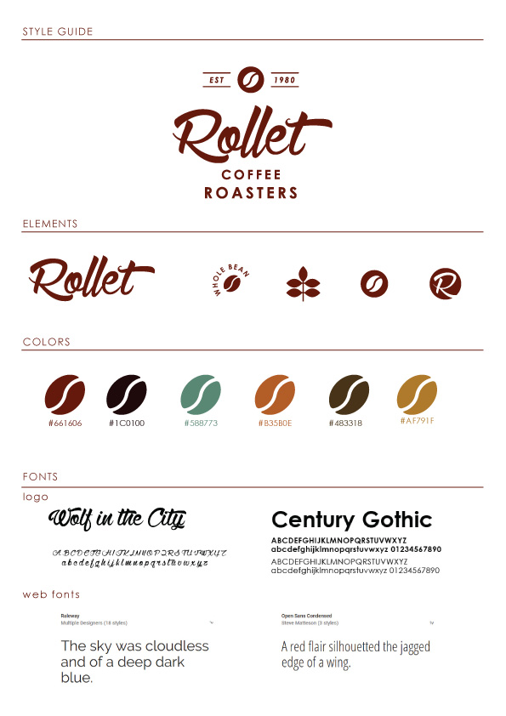

**Mockups for website**

**Photoshop & Illustrator**

* Design the site mockup in illustrator.
* Logo and style brand will be applied consistently around all the page
* Color scheme and fonts
* Photos and images client previously chosen will be in this final mockup
* Mobile interface - 1 column
* Tablet interface -  2 column
* Desktop interface - 4 column

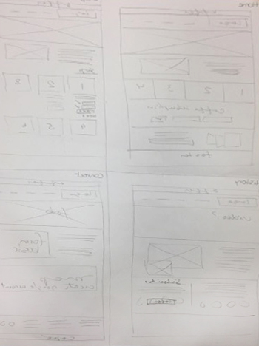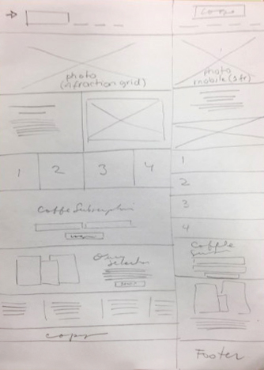

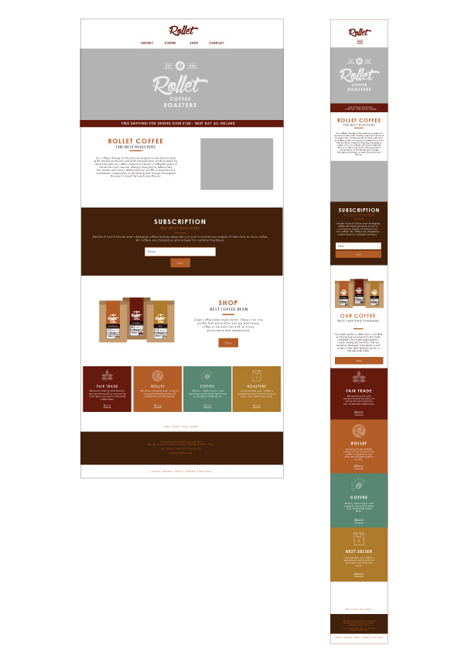

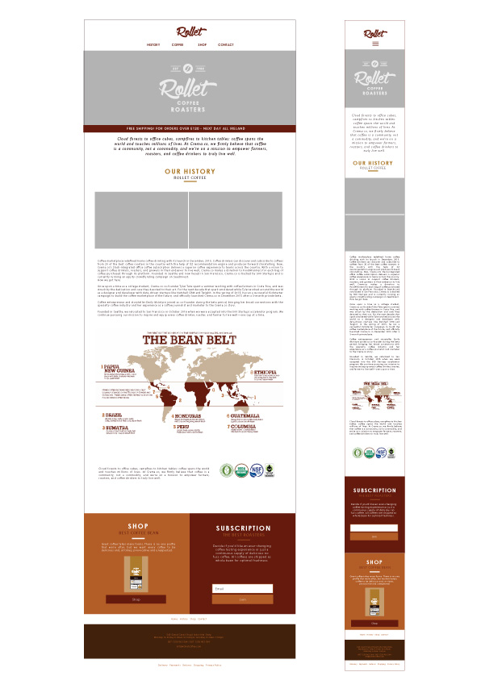

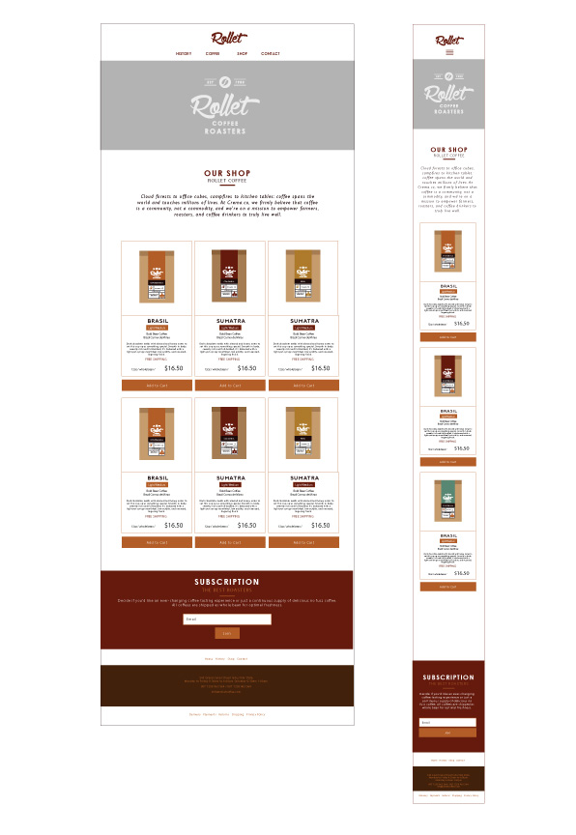

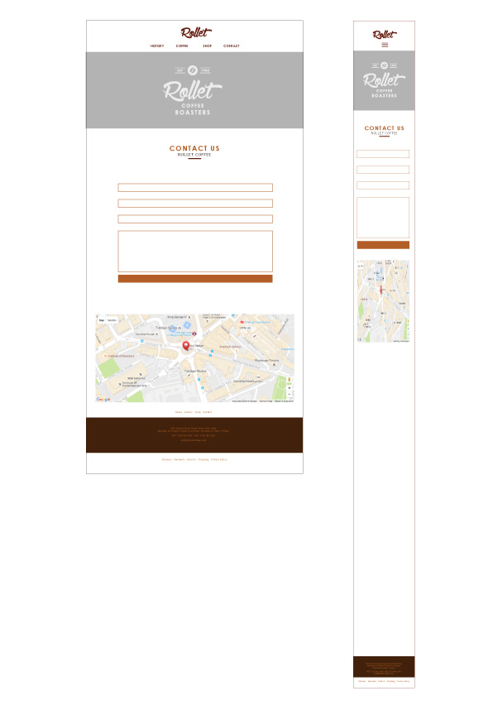

**Stock Images**

After talk with client decide research of photographs will be use in the website, social media accounts and marketing printing pieces.

Happy friendly clients drinking coffee socialization

Coffee brews and coffee display textures  (not coffee shop style)

Coffee comfort and environment

Coffee types and packaging

**Behaviours**

**Javascript & Jquery**

Banner of free shiping change of text with a loop

Description page Shop view + and view -

**Prototype**

**Zurb Foundation**

Grid based in 12 columns ideal design of wireframe of the intro page so have an idea how will look the html base grid.

**Building Files & Coding**

**Sublime editor and test browsers**

* HTML files proper code and validation of each page
* CSS Style files styling and validation
* Grid and Flex box CSS
* Box- Sizing CSS file
* Normalize CSS file
* Media, Js and JQuery Files
* Images File / optimized for viewport device

**Structure / Page Design & Content**

**STATIC ELEMENTS ON ALL THE SITE:**

**NAVBAR LINKS:**

**Logo Company: Rollet Coffee Roasters**

**HISTORY  /  COFFEE   / SHOP  /  CONTACT**

Burger Menu when reduce size Mobile

**FOOTER LINKS:**

**Quick links:  HISTORY  /  COFFEE   / SHOP  /  CONTACT**

**List of Links:** Terms and Conditions / Delivery Information / Returns / Privacy Policy

**Contanct Information:** Address / Phone / Opening Hours / Email

**Address and open hours**

**Copyrights**

**HOME PAGE**

* Background photo with hover text call wellcome
* Supportive text
* Mini banner Free Shiping
* Section of the page qualities of the business with icons and small description and button link: types of coffee and brews
* Supportive text
* Block of subscription form and link button page
* Block of shop with link page
* Icons with more information

**OUR SHOP**

* Photo with text
* List of Coffees grid of products and descriptions with photos
* Small shop forms list:

            Type of Coffee: Beans extra info

            Button + Add to Cart

            Button + View Cart

**HISTORY**

* Photo with text and hover
* Text History about Coffee and origins
* Photo Map Coffee Belt
* Qualities + photo
* Block coffee shop with link
* Block subscription with link

**CONTACT**

* Photo with text
* Text about why contact us and trust in our services
* Times of offices open and close and every form will be answered in working days
* Basic contact form: name / email / phone / message /
* Geolocation map with valid address and click find me with your phone with google maps drive or walk