Java基础练习3

1. 建立一个实体类Student类，属性：姓名，年龄，成绩，班级

建立一个list1，包含 “张三，18岁，80分，1班”，“李四，19岁，100分，1班”，“王五，17岁，59分，1班”。

建立一个list2，包含 “赵六，18岁，85分，2班”，“刘七，19岁，93分，2班”，“孙八，17岁，55分，2班”。

1. 整合两个list学生信息成一个新的list
2. 按照分数给出学生信息排名
3. 输出不及格的学生信息
4. 查找张三的信息
5. 从list剔除年龄大于18岁的学生信息

**package** test;  
  
**import** java.util.ArrayList;  
**import** java.util.List;  
  
**public class** casuel {  
 **public static void** main(String[] args) {  
 */**  
 * 1.建立一个实体类Student类，属性：姓名，年龄，成绩，班级  
 * 建立一个list1，包含 “张三，18岁，80分，1班”，“李四，19岁，100分，1班”，“王五，17岁，59分，1班”。  
 * 建立一个list2，包含 “赵六，18岁，85分，2班”，“刘七，19岁，93分，2班”，“孙八，17岁，55分，2班”。  
 */* List<Student> list1 = **new** ArrayList<>();  
 Student zhang3 = **new** Student();  
 zhang3.**name** = **"张三"**;  
 zhang3.**age** = 18;  
 zhang3.**score** = 80;  
 zhang3.**Class** = **"1班"**;  
 Student li4 = **new** Student();  
 li4.**name** = **"李四"**;  
 li4.**age** = 19;  
 li4.**score** = 100;  
 li4.**Class** = **"1班"**;  
 Student wang5 = **new** Student();  
 wang5.**name** = **"王五"**;  
 wang5.**age** = 17;  
 wang5.**score** = 59;  
 wang5.**Class** = **"1班"**;  
 list1.add(zhang3);  
 list1.add(li4);  
 list1.add(wang5);  
  
 List<Student> list2 = **new** ArrayList<>();  
 Student zhao6 = **new** Student();  
 zhao6.**name** = **"赵六"**;  
 zhao6.**age** = 18;  
 zhao6.**score** = 85;  
 zhao6.**Class** = **"2班"**;  
 Student liu7 = **new** Student();  
 liu7.**name** = **"刘七"**;  
 liu7.**age** = 19;  
 liu7.**score** = 93;  
 liu7.**Class** = **"2班"**;  
 Student sun8 = **new** Student();  
 sun8.**name** = **"孙八"**;  
 sun8.**age** = 17;  
 sun8.**score** = 55;  
 sun8.**Class** = **"2班"**;  
 list1.add(zhao6);  
 list1.add(liu7);  
 list1.add(sun8);  
  
 */**  
 * （1）整合两个list学生信息成一个新的list  
 */* List<Student> list = **new** ArrayList<>();  
 list.addAll(list1);  
 list.addAll(list2);  
*/**  
 * （2）按照分数给出学生信息排名  
 */* System.***out***.println(**"学生排名："**);  
 **int** num = 1;*//排名* **for** (**int** i = 1; i < list.size(); i++) {  
 **for** (**int** j = 0; j < list.size() - i; j++) {  
 **if** (list.get(j).**score** > list.get(j+1).**score**) {  
 Student temp = list.get(j);*//中间变量* list.set(j,list.get(j+1));  
 list.set(j+1,temp);  
 }  
 }  
 System.***out***.println(num++ +**"、"**+list.get(list.size()-i).**name**);  
 }  
 System.***out***.println(**"6、"**+list.get(0).**name**);  
 System.***out***.println(**"__________________"**);  
 */**  
 * （3）输出不及格的学生信息  
 */* System.***out***.println(**"不及格学生："**);  
 **for** (**int** i = 0;i < list.size();i++){  
 **if** (list.get(i).**score** < 60){  
 System.***out***.println(list.get(i).**name**+**","**+list.get(i).**age**+**"岁,"**+list.get(i).**score**+**"分,"**+list.get(i).**Class**);  
 }  
 }  
 System.***out***.println(**"__________________"**);  
  
 */**  
 *（4）查找张三的信息  
 */* System.***out***.println(**"查询："**);  
 System.***out***.println(**"张三，18岁，80分，1班"**);  
 System.***out***.println(**"__________________"**);  
  
 */**  
 * （5）从list剔除年龄大于18岁的学生信息  
 */* System.***out***.println(**"剔除年龄大于18岁的学生信息："**);  
 **for** (**int** i = 0;i < list.size();i++){  
 **if** (list.get(i).**age** > 18){  
 list.remove(i);  
 }  
 **else** {  
 System.***out***.println(list.get(i).**name**+**","**+list.get(i).**age**+**"岁,"**+list.get(i).**score**+**"分,"**+list.get(i).**Class**);  
 }  
 }  
 System.***out***.println(**"__________________"**);  
 }  
}

运行结果如下：

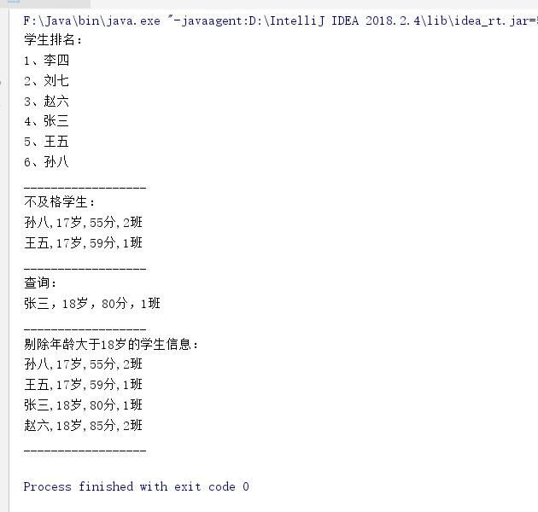

1. 使用Map 完成练习1的习题。

**package** test;  
  
**import** java.util.ArrayList;  
**import** java.util.HashMap;  
**import** java.util.List;  
**import** java.util.Map;  
  
**public class** Map_test {  
 **public static void** main(String[] args) {  
 */**  
 * 1.建立一个实体类Student类，属性：姓名，年龄，成绩，班级  
 * 建立一个list1，包含 “张三，18岁，80分，1班”，“李四，19岁，100分，1班”，“王五，17岁，59分，1班”。  
 * 建立一个list2，包含 “赵六，18岁，85分，2班”，“刘七，19岁，93分，2班”，“孙八，17岁，55分，2班”。  
 */* Map<Integer,Student> map1 = **new** HashMap<>();  
 Student zhang3 = **new** Student();  
 zhang3.**name** = **"张三"**;  
 zhang3.**age** = 18;  
 zhang3.**score** = 80;  
 zhang3.**Class** = **"1班"**;  
 Student li4 = **new** Student();  
 li4.**name** = **"李四"**;  
 li4.**age** = 19;  
 li4.**score** = 100;  
 li4.**Class** = **"1班"**;  
 Student wang5 = **new** Student();  
 wang5.**name** = **"王五"**;  
 wang5.**age** = 17;  
 wang5.**score** = 59;  
 wang5.**Class** = **"1班"**;  
 map1.put(1,zhang3);  
 map1.put(2,li4);  
 map1.put(3,wang5);  
  
 Map<Integer,Student> map2 = **new** HashMap<>();  
 Student zhao6 = **new** Student();  
 zhao6.**name** = **"赵六"**;  
 zhao6.**age** = 18;  
 zhao6.**score** = 85;  
 zhao6.**Class** = **"2班"**;  
 Student liu7 = **new** Student();  
 liu7.**name** = **"刘七"**;  
 liu7.**age** = 19;  
 liu7.**score** = 93;  
 liu7.**Class** = **"2班"**;  
 Student sun8 = **new** Student();  
 sun8.**name** = **"孙八"**;  
 sun8.**age** = 17;  
 sun8.**score** = 55;  
 sun8.**Class** = **"2班"**;  
 map2.put(4,zhao6);  
 map2.put(5,liu7);  
 map2.put(6,sun8);  
  
 */**  
 * （1）整合两个list学生信息成一个新的list  
 */* Map<Integer,Student> map = **new** HashMap<>();  
 map.putAll(map1);  
 map.putAll(map2);  
*/**  
 * （2）按照分数给出学生信息排名  
 */* System.***out***.println(**"学生排名："**);**int** num = 1;*//排名* **for** (**int** i = 1; i < map.size(); i++) {  
 **for** (**int** j = 1; j <= map.size() - i; j++) {  
 **if** (map.get(j).**score** > map.get(j+1).**score**) {  
 Student temp = map.get(j);*//中间变量* map.replace(j,map.get(j+1));  
 map.replace(j+1,temp);  
 }  
 }  
 System.***out***.println(num++ +**"、"**+map.get(i).**name**);  
 }  
 System.***out***.println(**"6、"**+map.get(1).**name**);  
 System.***out***.println(**"__________________"**);  
 */**  
 * （3）输出不及格的学生信息  
 */* System.***out***.println(**"不及格学生："**);  
 **for** (**int** i = 1;i <= map.size();i++){  
 **if** (map.get(i).**score** < 60){  
 System.***out***.println(map.get(i).**name**+**","**+map.get(i).**age**+**"岁,"**+map.get(i).**score**+**"分,"**+map.get(i).**Class**);  
 }  
 }  
 System.***out***.println(**"__________________"**);  
  
 */**  
 *（4）查找张三的信息  
 */* System.***out***.println(**"查询："**);  
 System.***out***.println(**"张三，18岁，80分，1班"**);  
 System.***out***.println(**"__________________"**);  
  
 */**  
 * （5）从list剔除年龄大于18岁的学生信息  
 */* System.***out***.println(**"剔除年龄大于18岁的学生信息："**);  
 **for** (**int** i = 1;i < map.size();i++){  
 **if** (map.get(i).**age** > 18){  
 map.remove(i);  
 }  
 **else** {  
 System.***out***.println(map.get(i).**name**+**","**+map.get(i).**age**+**"岁,"**+map.get(i).**score**+**"分,"**+map.get(i).**Class**);  
 }  
 }  
 System.***out***.println(**"__________________"**);  
 }  
}

运行结果如下：

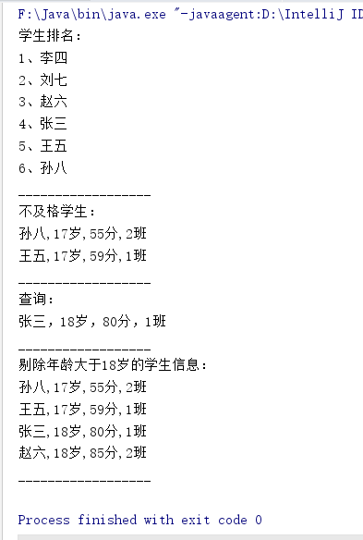

1. 仿照手机淘宝，设计订单和商品的实体类。

订单实体类：

**package** test;  
  
*/**  
 * 3.仿照手机淘宝，设计订单的实体类。  
 * 编写人：缪松添  
 * 编写时间:2020.3.5.12:00  
 */***public class** Order {  
 **private** String **orderState**;*//订单状态* **private** String **orderNumber**;*//订单号码* **private** String **logisticsInformation**;*//物流信息* **private** String **logisticsTime**;*//物流时间* **private** String **recipientsName**;*//收件人名字* **private** String **recipientsPhoneNumber**;*//收件人电话号码* **private** String **recipientAddress**;*//收件人地址* **private** String **shopName**;*//商户名称* **private** String **shopNumber**;*//商户编号* **private** String **commodityName**;*//名称* **private** String **commodityInformation**;*//商品信息* **private** String **commodityState**;*//商品状态* **private int commodityPrice**;*//商品价格* **private int logisticsPrice**;*//商品物流价格* **private int ActualPay**;*//商品实际付款* **public** String getOrderState() {  
 **return orderState**;  
 }  
  
 **public void** setOrderState(String orderState) {  
 **this**.**orderState** = orderState;  
 }  
  
 **public** String getOrderNumber() {  
 **return orderNumber**;  
 }  
  
 **public void** setOrderNumber(String orderNumber) {  
 **this**.**orderNumber** = orderNumber;  
 }  
  
 **public** String getLogisticsInformation() {  
 **return logisticsInformation**;  
 }  
  
 **public void** setLogisticsInformation(String logisticsInformation) {  
 **this**.**logisticsInformation** = logisticsInformation;  
 }  
  
 **public** String getLogisticsTime() {  
 **return logisticsTime**;  
 }  
  
 **public void** setLogisticsTime(String logisticsTime) {  
 **this**.**logisticsTime** = logisticsTime;  
 }  
  
 **public** String getRecipientsName() {  
 **return recipientsName**;  
 }  
  
 **public void** setRecipientsName(String recipientsName) {  
 **this**.**recipientsName** = recipientsName;  
 }  
  
 **public** String getRecipientsPhoneNumber() {  
 **return recipientsPhoneNumber**;  
 }  
  
 **public void** setRecipientsPhoneNumber(String recipientsPhoneNumber) {  
 **this**.**recipientsPhoneNumber** = recipientsPhoneNumber;  
 }  
  
 **public** String getRecipientAddress() {  
 **return recipientAddress**;  
 }  
  
 **public void** setRecipientAddress(String recipientAddress) {  
 **this**.**recipientAddress** = recipientAddress;  
 }  
  
 **public** String getShopName() {  
 **return shopName**;  
 }  
  
 **public void** setShopName(String shopName) {  
 **this**.**shopName** = shopName;  
 }  
  
 **public** String getShopNumber() {  
 **return shopNumber**;  
 }  
  
 **public void** setShopNumber(String shopNumber) {  
 **this**.**shopNumber** = shopNumber;  
 }  
  
 **public** String getCommodityName() {  
 **return commodityName**;  
 }  
  
 **public void** setCommodityName(String commodityName) {  
 **this**.**commodityName** = commodityName;  
 }  
  
 **public** String getCommodityInformation() {  
 **return commodityInformation**;  
 }  
  
 **public void** setCommodityInformation(String commodityInformation) {  
 **this**.**commodityInformation** = commodityInformation;  
 }  
  
 **public** String getCommodityState() {  
 **return commodityState**;  
 }  
  
 **public void** setCommodityState(String commodityState) {  
 **this**.**commodityState** = commodityState;  
 }  
  
 **public int** getCommodityPrice() {  
 **return commodityPrice**;  
 }  
  
 **public void** setCommodityPrice(**int** commodityPrice) {  
 **this**.**commodityPrice** = commodityPrice;  
 }  
  
 **public int** getLogisticsPrice() {  
 **return logisticsPrice**;  
 }  
  
 **public void** setLogisticsPrice(**int** logisticsPrice) {  
 **this**.**logisticsPrice** = logisticsPrice;  
 }  
  
 **public int** getActualPay() {  
 **return ActualPay**;  
 }  
  
 **public void** setActualPay(**int** actualPay) {  
 **ActualPay** = actualPay;  
 }  
}

商品实体类：

**package** test;  
*/**  
 * 3.仿照手机淘宝，设计商品的实体类。  
 * 编写人：缪松添  
 * 编写时间:2020.3.5.12:00  
 */***public class** Goods {  
 **private** String **shopName**;*//商户名称* **private** String **shopNumber**;*//商户编号* **private** String **commodityNumber**;*//商品编号* **private** String **commodityName**;*//名称* **private** String **commodityInformation**;*//商品信息* **private int commodityPrice**;*//商品价格* **private int logisticsPrice**;*//商品物流价格* **private** String **mouthNumber**;*// 月销量* **private** String **sentGoodsAddress**;*//发货地址* **private** String **discountInfomation**;*//优惠信息* **private** String **createTime**;*//创建时间* **private** String **createPerson**;*//创建人* **private** String **updateTime**;*//更新时间* **private** String **getUpdatePerson**;*//更新人* **private** String **rank**;*//等级* **private** String **parentCode**;*//父级编码* **public** String getShopName() {  
 **return shopName**;  
 }  
  
 **public void** setShopName(String shopName) {  
 **this**.**shopName** = shopName;  
 }  
  
 **public** String getShopNumber() {  
 **return shopNumber**;  
 }  
  
 **public void** setShopNumber(String shopNumber) {  
 **this**.**shopNumber** = shopNumber;  
 }  
  
 **public** String getCommodityNumber() {  
 **return commodityNumber**;  
 }  
  
 **public void** setCommodityNumber(String commodityNumber) {  
 **this**.**commodityNumber** = commodityNumber;  
 }  
  
 **public** String getCommodityName() {  
 **return commodityName**;  
 }  
  
 **public void** setCommodityName(String commodityName) {  
 **this**.**commodityName** = commodityName;  
 }  
  
 **public** String getCommodityInformation() {  
 **return commodityInformation**;  
 }  
  
 **public void** setCommodityInformation(String commodityInformation) {  
 **this**.**commodityInformation** = commodityInformation;  
 }  
  
 **public int** getCommodityPrice() {  
 **return commodityPrice**;  
 }  
  
 **public void** setCommodityPrice(**int** commodityPrice) {  
 **this**.**commodityPrice** = commodityPrice;  
 }  
  
 **public int** getLogisticsPrice() {  
 **return logisticsPrice**;  
 }  
  
 **public void** setLogisticsPrice(**int** logisticsPrice) {  
 **this**.**logisticsPrice** = logisticsPrice;  
 }  
  
 **public** String getMouthNumber() {  
 **return mouthNumber**;  
 }  
  
 **public void** setMouthNumber(String mouthNumber) {  
 **this**.**mouthNumber** = mouthNumber;  
 }  
  
 **public** String getSentGoodsAddress() {  
 **return sentGoodsAddress**;  
 }  
  
 **public void** setSentGoodsAddress(String sentGoodsAddress) {  
 **this**.**sentGoodsAddress** = sentGoodsAddress;  
 }  
  
 **public** String getDiscountInfomation() {  
 **return discountInfomation**;  
 }  
  
 **public void** setDiscountInfomation(String discountInfomation) {  
 **this**.**discountInfomation** = discountInfomation;  
 }  
  
 **public** String getCreateTime() {  
 **return createTime**;  
 }  
  
 **public void** setCreateTime(String createTime) {  
 **this**.**createTime** = createTime;  
 }  
  
 **public** String getCreatePerson() {  
 **return createPerson**;  
 }  
  
 **public void** setCreatePerson(String createPerson) {  
 **this**.**createPerson** = createPerson;  
 }  
  
 **public** String getUpdateTime() {  
 **return updateTime**;  
 }  
  
 **public void** setUpdateTime(String updateTime) {  
 **this**.**updateTime** = updateTime;  
 }  
  
 **public** String getGetUpdatePerson() {  
 **return getUpdatePerson**;  
 }  
  
 **public void** setGetUpdatePerson(String getUpdatePerson) {  
 **this**.**getUpdatePerson** = getUpdatePerson;  
 }  
  
 **public** String getRank() {  
 **return rank**;  
 }  
  
 **public void** setRank(String rank) {  
 **this**.**rank** = rank;  
 }  
  
 **public** String getParentCode() {  
 **return parentCode**;  
 }  
  
 **public void** setParentCode(String parentCode) {  
 **this**.**parentCode** = parentCode;  
 }  
}